Module Name: Selenium WebDriver
Trainer Name: Ankush Vankore
Total no of Session: 19

- Selenium WebDriver
  - Introduction to Automation
  - Introduction to Selenium
  - Components of Selenium
  - Configuration / Installation of Selenium
  - Launching browsers
    - Chrome
    - Firefox
    - Edge
  - Common methods of WebDriver
    - get()
    - getTitle()
    - getCurrentUrl()
    - getPageSource()
  - Locators
    - Id
    - Name
    - ClassName
    - CssSelector
    - XPath
    - LinkText
    - PartialLinkText
    - TagName
  - Handling controls
    - Text box
    - Command button
    - Radio button
    - Check box
    - Link
    - Dropdown list
    - List box
  - Synchronization
    - Thread.sleep()
    - ImplicitWait
    - ExplicitWait
    - FluentWait
    - PageLoadTimeout
  - Handling tables
    - Simple table
    - Dynamic table
    - Pagination table
  - Handling multiple windows
  - Handling alerts
  - JavascriptExecutor interface
    - Scrolling the page
    - Clicking on some control
    - Entering the text on text box
  - Handling File upload
  - Robot class
  - Handling menus
  - Mouse Actions
    - Hover
    - Click
    - Double click
    - Right click
    - Drag and drop
  - Handling frame
  - Handling #shadow-root element
  - Screenshot
- TestNG
  - Introduction / advantages
  - Installation & Configuration
  - Executing single test
  - Executing multiple tests
  - Annotations
    - @Test
    - @BeforeTest
    - @AfterTest
    - @BeforeMethod
    - @AfterMethod
    - @DataProvider
    - @Parameters
  - Assigning the priority to tests
  - Data driven testing
  - Generating reports
  - Executing tests in group
  - Keyword driven framework
  - Page Object Model
  - Data Driven Framework (Excel Handling)
- Introduction to Maven
  - Introduction
  - Creating project
  - Adding dependencies
  - Introduction to pom.xml file
  - Extent report
  - Execution
- Introduction to Cucumber
  - Introduction to BDD
  - Installation and creating project
  - Components of BDD
    - Feature file
    - Step definition
    - Runner class
  - Keywords
  - Passing parameters to step definition
  - Tags in cucumber
  - Reporting in cucumber
  - Hooks in cucumber
  - Data driven testing in cucumber

Java Revision
- Language basics
  - Data types
  - Variables
  - Conditional statements
    - If
    - If else
    - Nested if else
    - Switch case
  - Loops
    - For
    - Enhanced for loop (for each loop)
    - While loop
  - Functions / methods
  - Arrays (2D Array)
- Class and object
  - Creating class
  - Creating object of class
  - Writing constructor
  - Static members and static methods
- Inheritance
  - extends keyword
- Interface
- Exception handling
  - throws keyword
- Collection framework
  - List<>
  - Set<>
  - Map<>

What is software testing?
It is the process of identifying Correctness, Completeness, Security and Quality of developed software application.

Steps for Manual Testing
- Requirements
- Creating Test Scenarios
- Creating Test Cases
- Creating Test Data
  - Synthetic Data
    - ECP
    - BVA
    - EG
  - Real Data
- Execution
- Reporting

Steps involved during testing (execution)
- Entering data in text box
- Click on button
- Navigation from one page to another via links
- Selecting option/s from multiple option/s like radio button, check box, drop down list, list box etc.
- Uploading the file
- Comparing expected result with actual result
- Marking the test case as pass or fail

What is automation testing?
- Automation testing is to perform all above actions via a machine.
- Machine in this context is test automation tool / automation testing tool.
- Every tool is a software.
- Instructions to the tool can be provided via any one of the supporting programming language (like Java, JavaScript, Python, C#, Ruby, TypeScript)

Advantages of Automation Testing
- Saves time
- Less man power
- Faster execution
- Less human errors
- Accuracy
- Cost saving
- 100% test coverage
- Reusability
- Generates reports
- Helps in regressing testing
- Early bug detection

When to Automate?
- Stable requirements
- Repeated test scenarios
- High volume of test data to be tested
- Faster regression testing
- Compability testing
- Load testing
- Performance testing
- Security testing

Types of Automation Testing Tools
- Unit testing
  - JUnit
  - NUnit
  - TestNG
- API Testing
  - Postman
  - REST API
- GUI Testing / Functional Testing
  - Selenium WebDriver
  - Tosca
  - Playwright
  - Appium
  - Cypress

Process of Automation
- Planning
- Selection of tool
  - Type of application (AUT / SUT)
  - Cost of tool
  - Popularity of the tool
  - Easy to use
  - Availability of testers those can use this tool
- Test script creating
- Test data creating
- Test execution
- Generating report
- Maintance

Selenium
It is suite / bundle of test automation tools that can test any browser based application
Components of Selenium
- Selenium IDE – Record and playback
- Selenium Grid – Parallel execution
- Selenium RC – Remote Control
- Selenium WebDriver

Selenium WebDriver
- Selenium WebDriver is an open-source automation testing tool used to test browser based / web applications.
- Supports multiple programming languages
  - Java
  - C#.Net
  - Python
  - Ruby
  - JavaScript
- WebDriver is an API
- Supports multiple browsers
  - Chrome
  - Firefox
  - Safari
  - Opera
  - Edge
- WebDriver is an Interface
- Supports multiple Operating Systems
  - Windows
  - Linux
  - Ubuntu
  - Mac
- Community support
- Can be integrated with the frameworks like TestNG, Cucumber etc.

Pre-Requisite for Selenium WebDriver
- Minimum Window 10
- Minimum Java (JDK) 11
  - On Command prompt fire a command as java –version
- Any one Updated browser
- Editor (IDE) for Java
  - Eclipse
  - Idea Intellij
  - VS Code
- Selenium Jar File

Configuration
Create 2 folders
- YourName_SeleniumDemos (Lakshmi_SeleniumDemos)
- Selenium Jar Files

Download Selenium Jar File
- Open selenium.dev website
- Click on Downloads link
- Download Latest stable version 4.41.0
- Open Downloads folder from your system.
- Copy this file (selenium-server-4.41.0.jar) and paste in 2nd folder (Selenium Jar Files)

Eclipse Configuration
- Launch Eclipse
- Select 1st folder as your workspace
- Click on Launch button
- Creating Project
  - Click on File menu New
  - Click on Java Project
  - Give the name to project
  - Make sure that the java version is selected
  - Uncheck Create module-info.java file checkbox
  - Click on Finish
- Create a package
  - Right click on Project
  - New Package
  - Give the name
  - Click on Finish button
- Create a class inside above package
  - Right click on Package
  - New Class
- Configuration of Selenium WebDriver to project
  - Right Click on Project
  - Build Path Configure Build Path
  - Click on Libraries
  - Click on Class path
  - Click on Add External JARs…
  - Select the file (selenium-server-4.41.0.jar) stored in the 2nd folder

Methods of WebDriver
- Launching Browser Creating object of WebDriver interface will launch the blank browser window.
- get() Will launch the website. Here you need to pass the Absolute URL.
- driver.manage().window().maximize() Will maximize the browser window.
- close() Will close the current browser window.
- getTitle() Will return the title of the page which is opened in the browser. (String)
- getCurrentUrl() Will return the URL of the page. (String)
- getPageSource() It returns the HTML code of the page. (String)
- findElement() Will read and return single control on the page. Will locate the first occurrence. (WebElement)
- findElements() Will read and return multiple controls. (List<WebElement>)
- getWindowHandles() Will return the name / handles of windows those are opened by WebDriver object. (Set<String>)
- quit() will close all the windows / tabs those are opened by current WebDriver object.
Common Exceptions
- InvalidArgumentException The URL is not in the correct format. The URL must be absolute. It should start with http/https
- InvalidSelectorException The locator value is not in the correct format.
- NoSuchElementException Selenium is unable to locate the control due to
  - The locator value may be wrong.
  - The locator value may be dynamic.
  - The control is not available on the page.
  - Synchronization issue
  - The control may be inside iframe or #shadow-root
- TimeoutException The wait condition in ExplicitWait or FluentWait is fail.
- SessionTimeOutException Selenium waits for maximum 30 seconds till the page get loaded while calling driver.get(). But if the page is not getting loaded within 30 seconds then Selenium will throw SessionTimeoutException.
- NoAlertPresentException You are trying to handle an alert, but there is no any alert on the page.

WebElement
- Every control (like text box, radio button, text, checkbox, dropdown list, link etc.) on the page is treated as WebElement in Selenium WebDriver.
- WebElement is an interface.
- Object of WebElement can hold single control on the web page.
- Methods
  - sendKeys() Will enter the data in the text box. It will append the text.
  - click() Will click on the control.
  - getText() Will return the text on the control. (String)
  - getAttribute() Will return the value of any attribute (String)
  - isSelected() Will check that a checkbox and radio button is selected or not. (boolean)
  - isEnabled() Will check whether the control is enabled or disabled. (boolean)
  - isDisplayed() Will check whether the control is visible or not. (boolean)
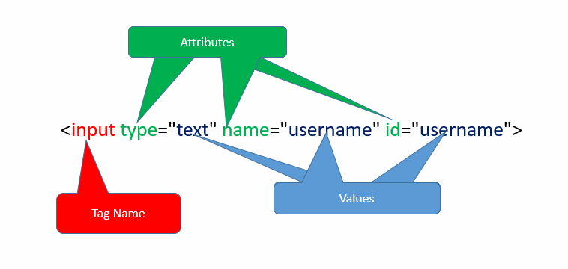
Locators in Selenium
Locators are the ways of locating any control on the web page. These are the strategies to identify any control / WebElement on the page.
- Id
- Name
- ClassName
- CssSelector
- XPath
- LinkText
- PartialLinkText
- TagName

Locator ClassName
- Used to locate a control using the value of attribute class.
- A control may having multiple classes applied. Multiple classes are separated via space.
  - In such case use any single class as a value for className locator.

Locator LinkText
- If the control is having <a> tag, such a control is treated as hyperlink
- To read such a controls you can use LinkText locator
- For LinkText simply pass the inner text of such link
Locator PartialLinkText
- For locating links you can use this locator
- Pass the partial text of the link as a locator value

Locator CssSelector:
- It is the technique to locate any control on the page using any single or multiple attributes of the control
- Types
  - Using Single Attribute
Syntax:
tagName[attribute=’value’]
input[placeholder=’Username’]
  - Using Multiple Attributes
Syntax:
tagName[attribute1=’value’][attribute2=’value’]
  - Using Special Characters
    - ^ Starts With
    - $ Ends With
    - * Contains
    - .
    - #

Pattankodoli Bus Stand Lake a Right Turn Hupare Nagar Water Tank Lane No 9 House no 1128 (Ankush Vankore House)

XPath Locator (XML Path)
- XPath is the way of locating the control using the exact path of the control from the html tag
- Even you can locate the control using attributes as well.
- Types
  - Absolute XPath
Starts with html
  - Relative XPath
    - Taking the reference of parent tag
//div[@id='form']/div[1]/input[1]
    - Using any attribute to the control
//input[@type='password']

Handling Dropdown List / List Box
- If the control is having <select> tag then such a control is treated as drop down list / list box by Selenium.
- Select class from Selenium is used to handle such a drop down list / list box.
- Methods
  - getFirstSelectedOption() Will return the selected option / element from the dropdown list. (WebElement)
  - getOptions() Will return the list of all elements / options from the dropdown list or list box. (List<WebElement>)
  - selectByVisibleText() Selects the option by using the inner text of any option.
  - selectByContainsVisibleText() Selects the option by using the partial part of inner text.
  - selectByValue() Selects the option by using the String value of the attribute value.
  - selectByIndex() Selects the option by using zero based index number of option.
  - getAllSelectedOptions() Return list of all selected options from the list box. (List<WebElement>)
  - isMultiple() Checks that whether the control allows to select multiple controls or not. (boolean)
  - deselectByVisibleText()
  - deselectByContainsVisibleText()
  - deselectByIndex()
  - deselectByValue()
  - deselectAll()

Synchronization (Waits in Selenium)
It is the process of adjusting the speed of tool with speed of application.
- Thread.sleep() Will pause the execution of script for specified milliseconds.
  - It is applicable to single statement only.
  - It takes mandatory delay.
- ImplicitWait Will wait implicitly till the control get visible / loaded.
  - It is applicable throughout the script
  - It doesn’t take mandatory delay.
- ExplicitWait (WebDriverWait class)
  - It is applicable to single statement only.
  - It doesn’t take mandatory delay
  - Allows to wait till some condition is satisfied (like element is clickable, alert is present, element is visible etc.)
- FluentWait It is the next version of ExplicitWait that can handle the exception as well.
  - It is applicable to single statement only.
  - It doesn’t take mandatory delay
  - Allows to wait till some condition is satisfied (like element is clickable, alert is present, element is visible etc.)
  - Allows to handle the exception.
  - Parameters to be passed
    - w – withTimeout
    - i – ignoring
    - p – pollingEvery
    - u – until
- PageLoadTimeout We can increase the load time for loading the page to avoid SessionTimeoutException.

Handling TOAST Elements (ONE TIME SETTING)
These are the controls those get disappeared after right clicking on the control.
- Open DOM (Inspection Window)
- Click somewhere in DOM
- Type Ctrl + Shift + P
- Type Focus in text box displayed at top of DOM
- Click on Emulate a focused page

Handling Table
<table>
<thead>
<tr>
<th>Roll No</th>
<th>Name</th>
</tr>
</thead>
<tbody>
<tr>
<td>1</td>
<td>Diksha</td
</tr>
<tr>
<td>2</td>
<td>Dilshad</td>
</tr>
</tbody>
<table>

Handling File Upload
- If any one of the control is having <type=”file”> attribute, then such a control is called as File Upload Control
- To upload any file on such control simply call .sendKeys() method on this control. And pass the path of file as a parameter to sendKeys() method.

JavascriptExecutor Interface
- Interface provided by Selenium to execute any JavaScript method.
- This interface is used to
  - Scroll the page
  - Click on some control without scrolling
  - Entering the data in text box
  - Highlighting the control

Handling Alert
Alert is
- The kind of popup that is displayed on the top of window
- Can’t be inspected
- Doesn’t allow to perform any action on the page while Alert is present
- Don’t have close (x) button
- Types
  - Normal alert (Having Ok button)
  - Confirmation alert (Having Ok and Cancel button)
  - Prompt alert / Input Box (Allows to enter some text on alert)
For handling alert in Selenium, we have a special interface called as Alert. You can handle any alert using this interface.
Methods
- driver.switchTo().alert() Will switch to the alert
- getText() will return the text on the alert (String)
- accept() Will click on Ok button
- dismiss() Will click on the Cancel button of alert
- sendKeys() Will enter some text in the prompt box.

Mouse Actions
- Hover
- Right Click
- Left Click
- Double Click
- Drag and Drop

To perform above mouse actions, Selenium has provided a special class called as Actions.
Methods of Actions class
- moveToElement() Will hover the mouse on the control.
- perform() To perform the said action like hover, click, right click, drag and drop etc.
- contextClick() Will right click on the control
- doubleClick() Will double click on the control
- dragAndDrop() Will drag the source control on target control
- dragAndDropBy() will drag the source control and will drop at some location

TestNG (Test Next Generation)
It is open source testing framework which will make automation testing more easy.

Framework:
Set of rules, guidelines, standard practices for automation testing.

Advantages of TestNG
- Allows to create multiple tests in single class
- Allows to set priority (order of execution) to test cases
- Allows to execute / skip single test / multiple tests
- Generates reports
  - Normal Report
  - HTML Report
- Uses Annotations
  - @Test
  - @BeforeTest
  - @AfterTest
  - @BeforeMethod
  - @AfterMethod
  - @DataProvider
  - @Parameters
- Allows Data Driven Testing via @DataProvider
- Allows Assertion (Marking the test as pass or fail)
- Allows Parameterization
- Allows to execute tests via groups
- Allows to implement different frameworks
  - Data Driven Framework
  - Keyword Driven Framework
  - Page Object Model
  - Linear Framework
  - Hybrid Framework

Annotations:
- @Test This method will be treated as Test Case. And this method will get executed by TestNG
By default all tests are having priority as 0 (zero).
If two or more tests are having same priority, then tests will get executed in the alphabetic order
- @BeforeTest This is the method that will get executed only once before executing 1st test case
- @AfterTest This is the method that will get executed only once after executing last test
- @BeforeMethod This is the method which will get executed before every test case
- @AfterMethod This is the method which will get executed after every test case.

Points to be noted about configuration methods (BeforeTest, AfterTest etc.)
- They can appear anywhere in the class. The sequence of these methods doesn’t matter
- They need not to be in pair.

BeforeTest
BeforeClass
BeforeMethod
Test 1
AfterMethod
BeforeMethod
Test 2
AfterMethod
BeforeMethod
Test 3
AfterMethod
BeforeMethod
Test 4
AfterMethod
AfterClass
BeforeClass
Test 1
Test 2
Test 3
AfterClass
AfterTest

Data Driven Testing
- It is the technique via which you can execute single test case for multiple times with multiple data set
- Can be implemented via @DataProvider
- @DataProvider is the method that will pass the data to @Test case. So the single test will get executed for multiple times.

Assertion
- This is the technique via which you can mark any test case as pass or fail in report.
- Types
  - Hard Assertion (Assertion)
    - Will terminates the execution of test case if assertion is fail.
  - Soft Assertion (Verify)
    - Will not terminate the execution and Exception will be thrown when you are calling AssertAll() method
- Will throw the exception as AssertionError if @Test is getting fail.

XML Execution (Execution of test(s) via xml file)
- You can execute / skip single test / multiple tests via XML file
- You can execute only TestNG classes via XML file
- Points to be noted
  - All the tags are pre-defined
  - All the tags are case sensitive
  - You cannot alter the flow / sequence of tags

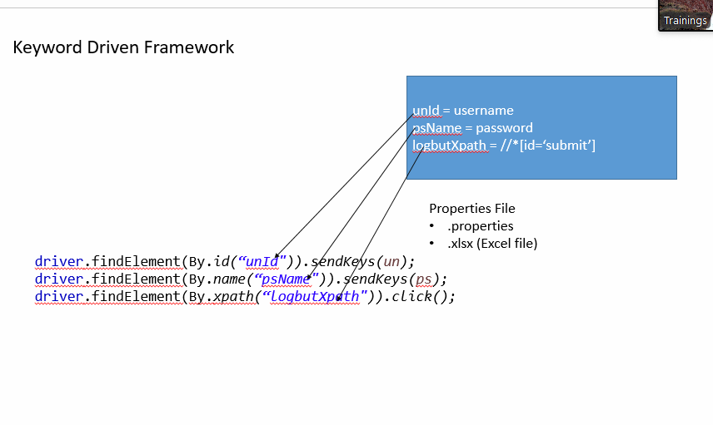

Page Object Model (POM)
- This is the design pattern to make your automation script more modular
- Here we are separating our script in 2 parts
  - Utility Class / Page Class Contains the WebElement and methods which represents the script
  - Client Class Contains @Test cases that will execute the methods from Utility class.
- You can create multiple utility classes to represent multiple web pages / modules

Page Factory
- It is sub-set of Page Object Model
- This represents the Object Repository, that can store all the controls in various objects.
- Here we are using @FindBy annotation to identify any WebElement on the page.
- There is no restriction on locator, you can use any locator to read the control

Data Driven Framework
- Launch https://archive.apache.org/dist/poi/release/bin/
- Download last 4th file (poi-bin-5.2.3-20220909.zip)
- Copy this .zip file to 2nd folder (Selenium Jar Files)
- Extract (Unzip) this file
- There are total 21 jar files in this unzipped folder
- You need to add all these 21 jar files to your project. (Use the same process which we have used to configure Selenium WebDriver jar file)

Maven
- Maven is build management tool.
- It is open source tool
- It is Apache product
- Can be used by both developer and tester.
- Single project can be shared by both developer and tester
- Easy configuration via pom.xml file.
- Uses dependencies (is a code of 6 to 7 lines that will automatically download and add the required jar files to your project.)

Creating Maven Project
- File Menu New Maven Project
- Select 1st Check Box (Create simple project skip archetype selection)
- Click on Next Button
- Enter GroupID (Name of Company) & ArtifactId (Name of Project)
  - Generally both should be same
- Click on Finish button

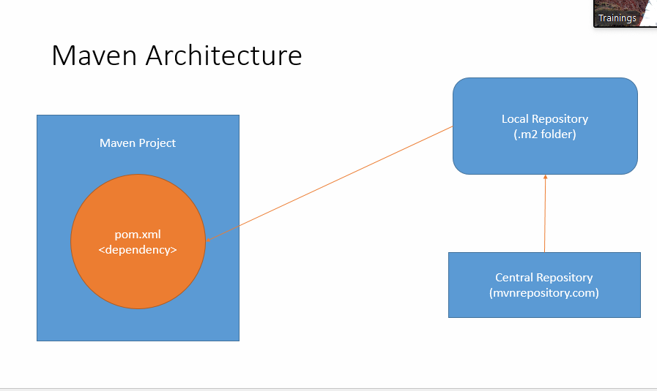

Plugins for Maven Execution
- Maven Compiler Plugin
- Maven Surefire Plugin

BDD (Behavior Driven Development)
- BA, Development Team & Testing Team will gather the requirements from client.
- The finalized requirements will be shared with QA team.
- QA team will create Feature File (1st Component of BDD)
  - Feature file is collection of test scenarios
- Now the feature file will be shared with
  - Development team
  - Manual testers
  - Automation testers
- Automation tester will execute this feature file and they will get Glue Code / Step Definition (2nd Component of BDD)
  - Glue code is the skeleton for automation script
- Runner Class (3rd Component of BDD) used to execute the automation script.

Cucumber is the tool for implementation of BDD Approach

