About Us

Our Contributors
Meet the outstanding individuals responsible for bringing you the most compelling stories across the globe.
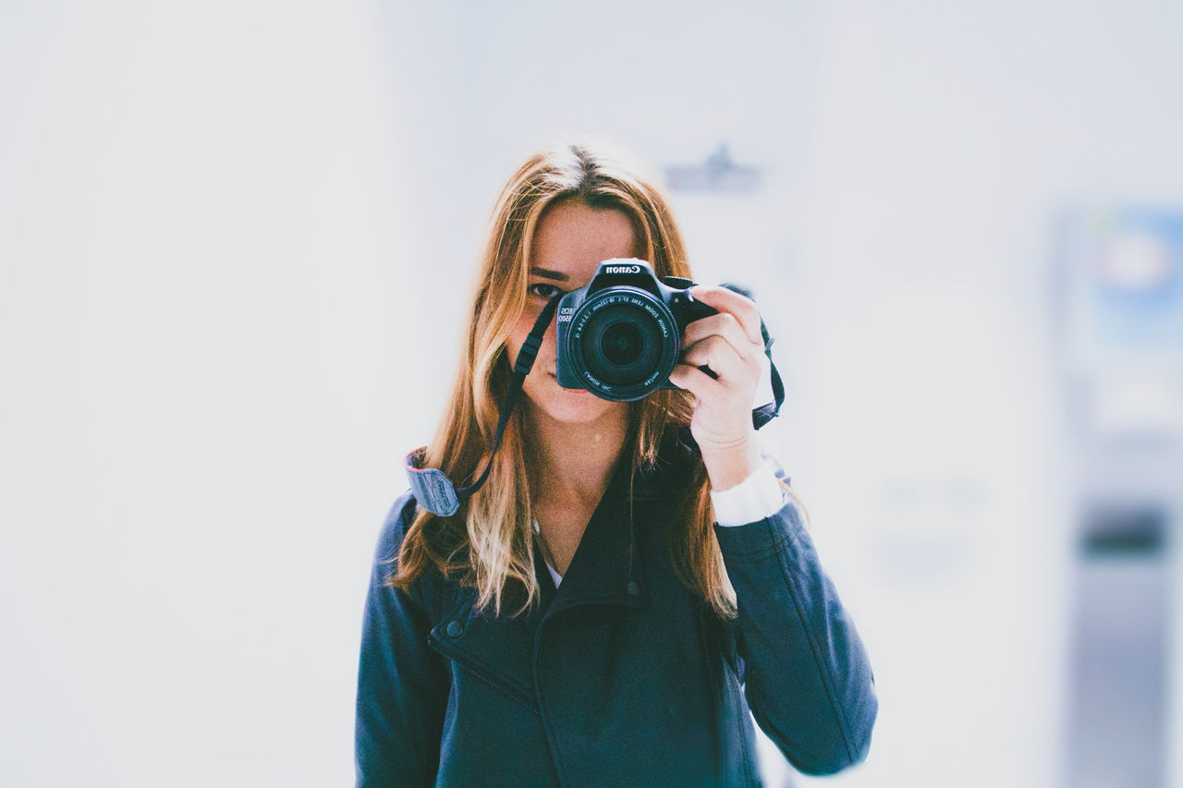

Stacey Roswells

Artist | Photographer | Traveler
Facebook
Twitter
Instagram
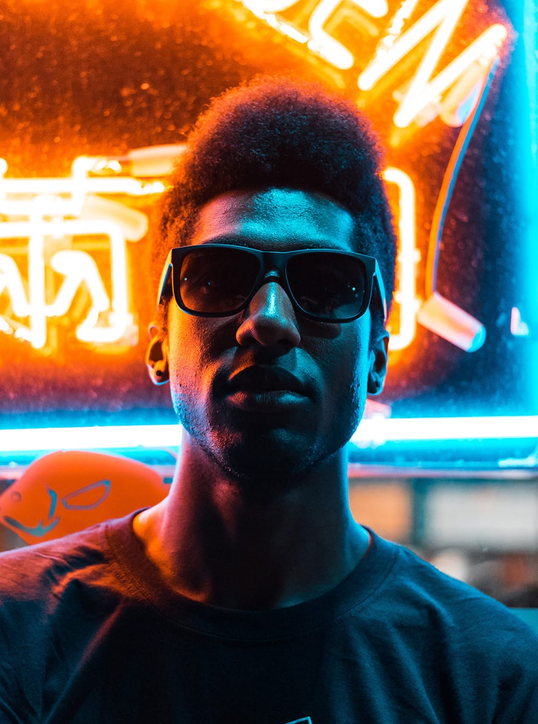

Jake Hammer

Influencer | Writer
Facebook
Twitter
Instagram
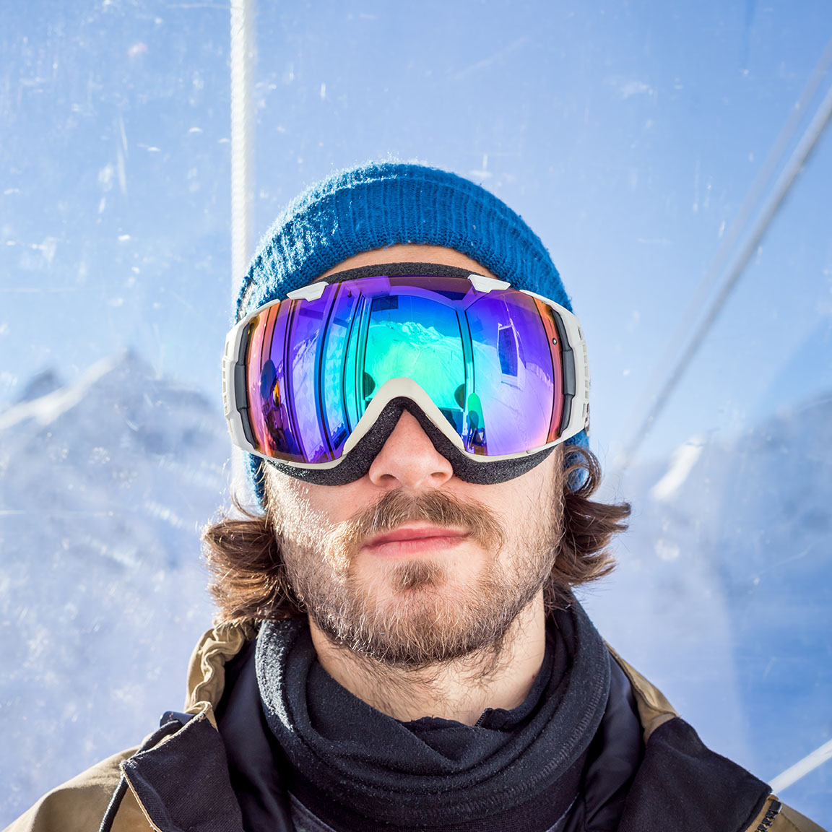

Ian Provo

Photographer
Facebook
Twitter
Instagram
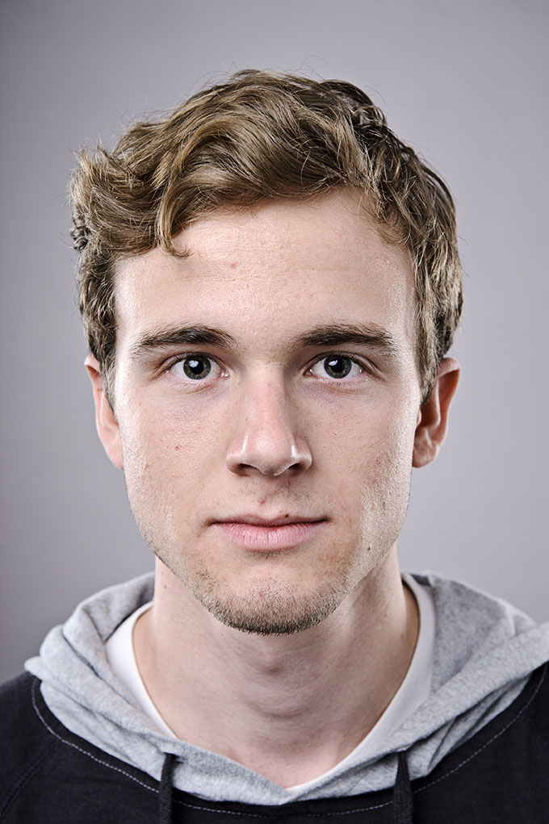

Jacob Wester

Skater | Writer
Facebook
Twitter
Instagram

WKND Guides
Meet our extraordinary travel guides. When you travel with a certified WKND guide you gain access to attractions and perspectives not found on the pages of a guide book.
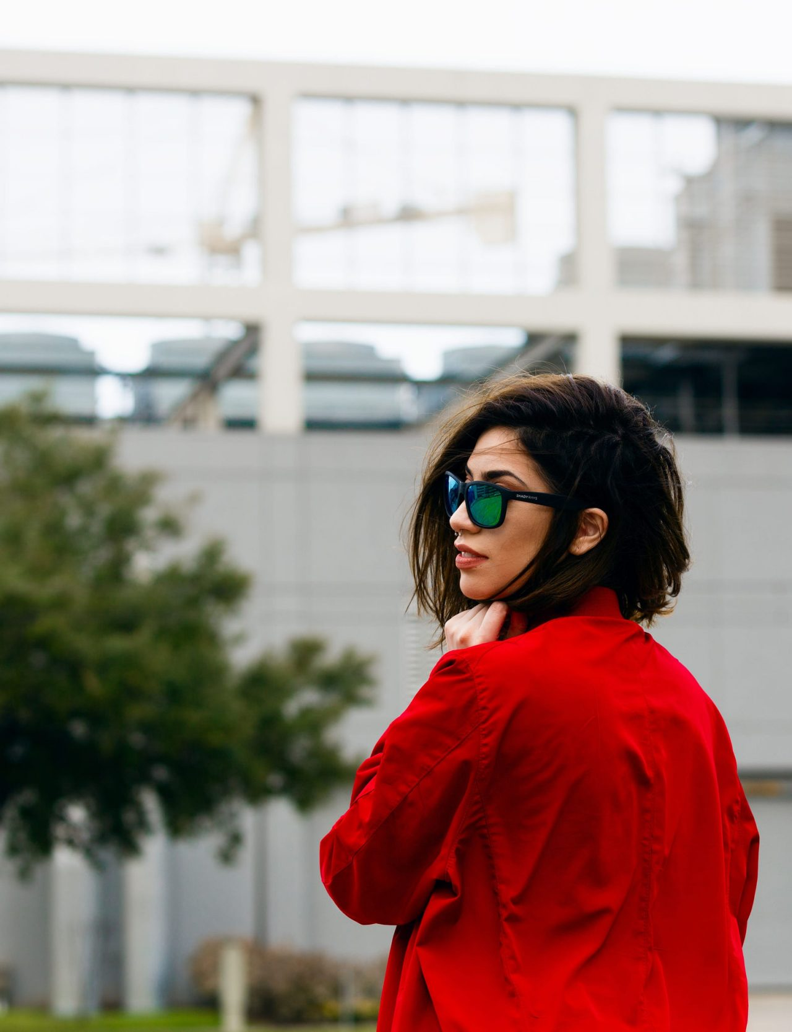

Sofia Sjöberg

Photographer | Youtuber
Facebook
Twitter
Instagram
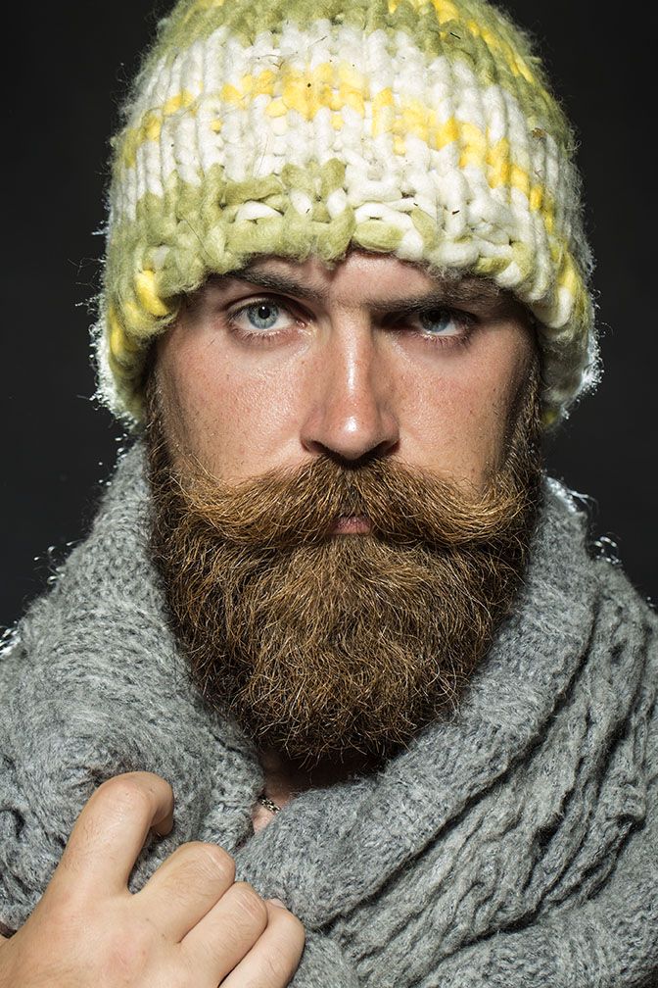

Justin Barr

Artist | Rock Climber
Facebook
Twitter
Instagram
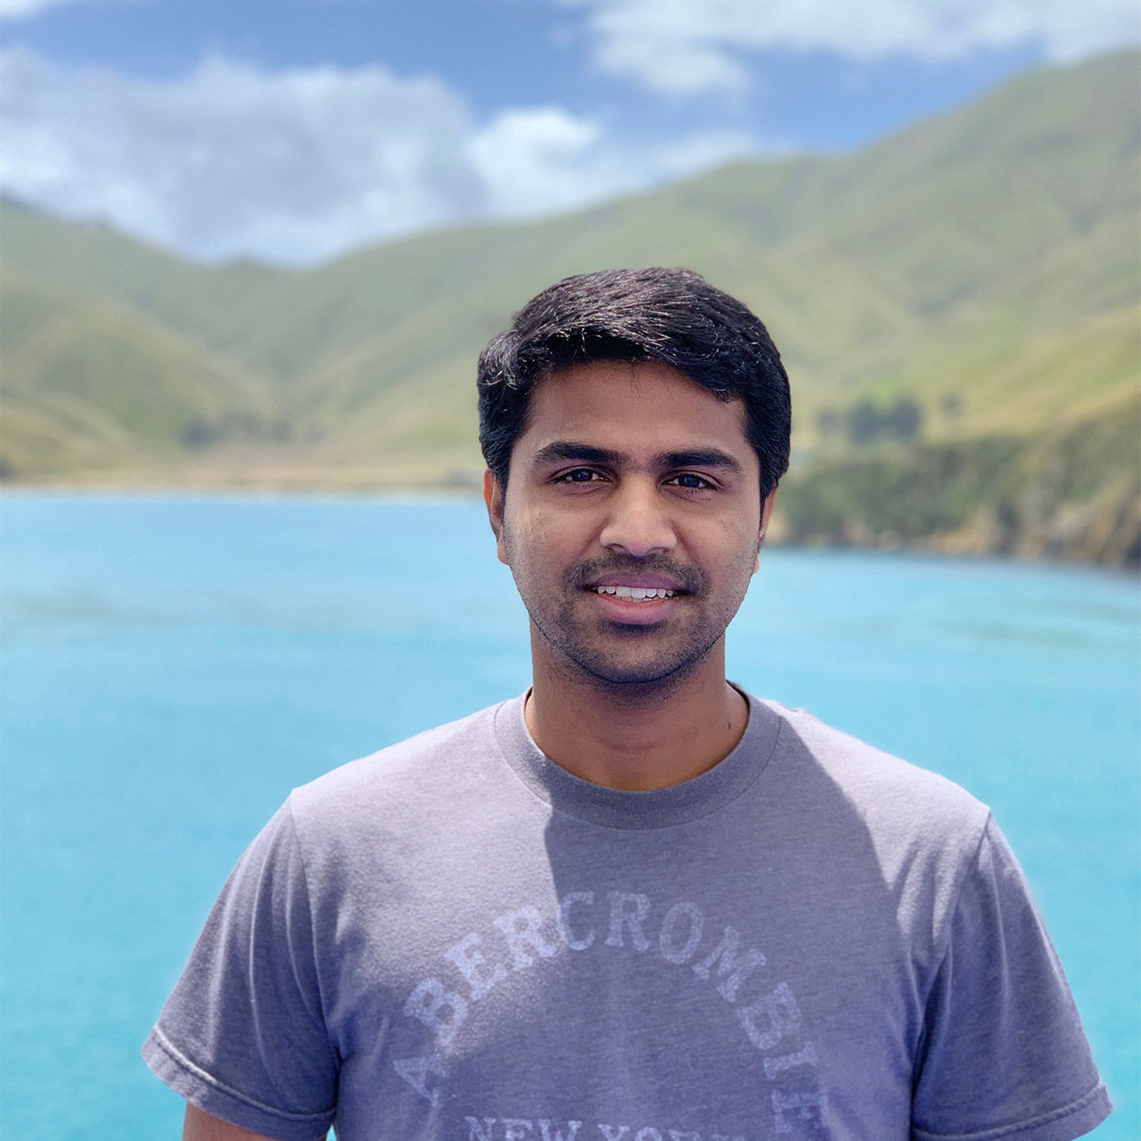

Kumar Selveraj

Photographer | Surfer
Facebook
Instagram
Twitter
Metadata
Title | About Us
Description | WKND is a collective of outdoors, music, crafts, adventure sports, and travel enthusiasts that want to share our experiences, connections, and expertise with the world.

