SUMMER TRAINING / INTERNSHIP REPORT
on
MAZE-SOLVING ROBOT SIMULATOR
Submitted in partial fulfillment of the requirements for the degree of
Bachelor of Technology
in
Computer Science and Engineering

Submitted By:
Name: Aniket Dilip Bhadke
Registration Number: 12406853
Under guidance of
Mr Gaurav Sharma

Computer Science and Engineering
Lovely Professional University, Phagwara
July 2026

DECLARATION
I hereby declare that the summer training project work entitled "Maze-Solving Robot Simulator" submitted to Lovely Professional University is an authentic record of my own original work carried out during the training period. This project has not been submitted previously, in part or in full, to any other institution or university for the award of any degree or diploma.
Date: July 19, 2026

Aniket Dilip Bhadke

CERTIFICATE
This is to certify that the project report entitled "Maze-Solving Robot Simulator" submitted by Aniket Dilip Bhadke, bearing Registration Number [Insert Registration Number], in partial fulfillment of the requirements for the award of the degree of Bachelor of Technology in Computer Science and Engineering from Lovely Professional University, is a record of training work completed under academic evaluation.

ACKNOWLEDGEMENT
I map out my deepest sense of gratitude and sincere appreciation to Lovely Professional University for granting me the framework and learning resources required to fulfill this summer training curriculum.
I am heavily indebted to the faculty members and mentors within the Department of Computer Science and Engineering who provided foundational theoretical knowledge, constructive feedback, and the technical standard constraints necessary to bring this simulator to life. Their guidance helped bridge the gap between abstract computational logic and physical robotics navigation constraints.
Lastly, I extend my heartfelt thanks to my peers for their collaborative insights, and to my family for their continuous support during this rigorous training period.

TABLE OF CONTENTS
DECLARATION 2
CERTIFICATE 3
ACKNOWLEDGEMENT 4
TABLE OF CONTENTS 5
1. Introduction of Organization 6
2. Summer Training Course/Internship Content Detail 6
3. Summer Training/Internship Project Detail 6
3.1 Problem Statement 6
3.2 Project Outcomes 7
3.3 Technologies Used 7
4. Source Code or System Snapshots 7
Core Pathfinding Engine Logic 7
System Interface Placement 8
12. Bibliography 9

1. Introduction of Organization
Lovely Professional University (LPU), situated in Phagwara, Punjab, stands as one of India's largest and most technologically progressive higher education institutions. The Department of Computer Science and Engineering (CSE) at LPU is dedicated to fostering deep engineering competencies, combining fundamental computational theories with modern full-stack development paradigms.
The primary objective of the department's training infrastructure is to simulate real-world technical environments, pushing students to construct robust applications based on exact architectural guidelines. This independent training module serves as an advanced sandbox where students transition algorithms into responsive web visualizers, ensuring that high-level computer science engineering matches the demands of contemporary industries.

2. Summer Training Course/Internship Content Detail
The technical core of this summer training course was dedicated to mastering algorithmic problem-solving patterns, structural memory efficiency, and complex multi-state mapping systems. The curriculum systematically advanced through the following foundational segments:
- Recursive Problem Solving: Deconstructing broad computational tasks into self-referential steps while establishing strict programmatic base cases to manage system memory and mitigate stack overflow errors.
- Backtracking Design Patterns: Implementing systematic searching logic that traverses complex tree or matrix spaces, marking invalid execution paths as dead ends, and rewinding the application state cleanly back to previous decision intersections.
- 2D Matrix & Coordinate Space Manipulation: Structuring real-world environments mathematically inside discrete multi-state matrices to keep constant-time access updates to spatial coordinates.
- Asynchronous Interface Execution: Coordinating background logical pathfinders with immediate UI rendering modules to maintain fluid, interactive visual frame steps without blocking the application user flow.

3. Summer Training/Internship Project Detail

3.1 Problem Statement
In automated industrial logistics and autonomous drone systems, mobile robots must map unknown grid frameworks, calculate optimal routes, and bypass physical wall barriers safely. Testing these raw pathfinding paradigms directly on actual mechanical hardware poses massive physical risks, slows down debugging speed, and increases equipment deployment costs.
To overcome this bottleneck, a reliable testing simulation framework must be engineered. The primary challenge of this project is to construct an interactive, lightweight web visualizer that models an autonomous robot traversing a discrete matrix. The system must natively generate solvable paths and showcase the robot's real-time physical decisions as it evaluates valid steps, recognizes dead ends, backtracks dynamically, and confirms the valid path to the destination target.

3.2 Project Outcomes
- Algorithmic Grid Synthesis: Designed a functional randomized maze carver utilizing Depth-First Search patterns across a 21x21 array layout, ensuring complete, mathematically isolatable paths for navigation.
- Live State Discrimination: Built a high-contrast visualizer that dynamically tracks exploration frames, coloring rejected dead-end avenues distinctively from the definitive winning path vectors.
- Asynchronous Speed Moderation: Deployed an elastic time-delay mechanism linked to an active UI slider component, giving users the ability to throttle execution velocities between 10ms and 200ms dynamically mid-run.

3.3 Technologies Used
- Core Logic Implementation: Built using native Object-Oriented patterns to cleanly mimic C++ matrix tracking loops and functional call-stack structures.
- HTML5 Canvas Rendering: Utilized high-performance 2D context drawing mechanisms to draw layout updates without causing display stutter.
- Modern Web Architecture: Structured completely via responsive CSS3 grids, flexible flexing models, and modern semantic layouts.
- Git Deployment Pipelines: Managed and pushed via systematic commit versioning directly to GitHub Pages for instant open-source distribution.

4. Source Code or System Snapshots

Core Pathfinding Engine Logic
JavaScript
// Structural Implementation of the Recursive Backtracking Matrix Solver
function solveMaze() {
let visited = Array(rows).fill().map(() => Array(cols).fill(false));
visitHistory = [];

function backtrack(r, c) {
// Validation Constraint Layer: Out of bounds, obstacle collisions, or cyclic visits
if(r < 0 || r >= rows || c < 0 || c >= cols || grid[r][c] === 1 || visited[r][c]) {
return false;
}

visited[r][c] = true;
visitHistory.push({ r, c, type: 2 }); // Push state index for Explored Path (Type 2)

// Goal Condition Reached
if(r === goalPos.y && c === goalPos.x) {
visitHistory.push({ r, c, type: 3 }); // Push state index for Final Successful Path (Type 3)
return true;
}

// Structural Traversal Directions: [Down, Right, Up, Left]
const directions = [[1,0], [0,1], [-1,0], [0,-1]];
for(let [dr, dc] of directions) {
if(backtrack(r + dr, c + dc)) {
visitHistory.push({ r, c, type: 3 }); // Recursive trace-back: confirm path vector
return true;
}
}
return false;
}
backtrack(1, 1); // Launch root execution frame at origin
}

System Interface Placement
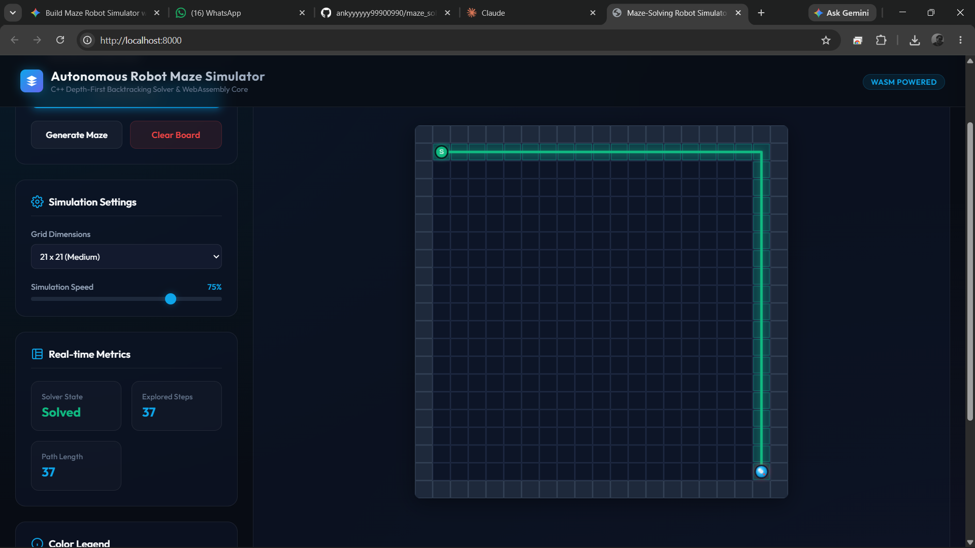

12. Bibliography
Cormen, T. H., Leiserson, C. E., Rivest, R. L., & Stein, C. (2009). Introduction to Algorithms (3rd ed.). MIT Press.
MDN Web Docs. Canvas API: Tutorial and Core Reference Guidelines. Mozilla Developer Network. Available at: https://developer.mozilla.org
Bhadke, A. D. (2026). Maze-Solving Robot Simulator Source Repository. GitHub Ecosystem. Available at: https://github.com/ankyyyyyy99900990/maze_solving_robot_simulator

