

**本科生实验报告**

**实验课程 移动应用开发技术_ ________**

**学院名称 网络安全学院_________________**

**学生姓名 _______________________**

**班内序号 2班15号 _________________**

**学生学号 201613160616_________________**

**指导教师 刘恒_________________________**

**实验成绩________________________________**

**二〇 18 年 12 月**

目录

实验一：初探连连看 4

内容 4

要求 4

目的 4

实现 4

1.实现Fragment的切换 4

2.全局变量（MyApplication.java） 6

3.生成游戏地图 8

4.菜单 9

5.bfs用于判断点击的Image是否连通 10

6.判断是否可消除 10

7.重新排列 12

运行结果 14

实验二：多线程+广播 17

内容 17

要求 17

目的 17

实现 17

1.多线程背景音乐 17

2.多线程点击音效 18

3.广播接收器 19

4.注册广播接收器 19

5.弹出对话框 20

6.发送广播 20

运行结果（假设两次点击消除是全部消除） 21

实验三：持久化存储 23

内容 23

要求 23

目的 23

实现 23

1. preference存储 23

2.本地存储 24

3. DatabaseHelper 24

4.SQLite存储 25

运行结果 27

# 实验一：初探连连看

## 内容

设计完成一个8*9的连连看小游戏。

## 要求

1、具备25种不同的连连看动物（或其他图标）

2、当手指点击相同的动物，动物消失

3、当手指点击不同的动物，动物不消失

4、小图标出现的时候是随机出现的

5、可以设置不同的难度，不同难度级别对应不同的动物种类数量，难：25种，中等,15种，简单10种

6、遵守连连看规则，如果图片无阻塞的方能连接（可以不出现关联的线段）

7、具备胜负判断、打乱重拍的功能

8、在界面上点击右键菜单，选择打乱重拍功能

9、系统选项菜单中可以选择难度

10、在导航中可以切换显示游戏说明和游戏界面以及参数设置界面。

## 目的

1、掌握图片文件的加载和布局

2、掌握鼠标单击事件的发生和判断

3、熟悉利用fragment和导航

4、掌握选项菜单、弹出菜单（或上下文菜单）的设计开发。

## 实现

### 1.实现Fragment的切换

|  |
| --- |
| public void onClick(View v) {  FragmentTransaction fTransaction = fManager.beginTransaction();  myApplication.hideAllFragment(fTransaction);  switch (v.getId()){  case R.id.txt_game:  setSelected();  txt_game.setSelected(true);  if(myApplication.getFgGame() == null){  GameFragment fgGame = new GameFragment();  myApplication.setFgGame(fgGame);//修改全局变量  fTransaction.add(R.id.ly_content,fgGame);  }else if(myApplication!=null && myApplication.getLevle()!=level){  fTransaction.remove(myApplication.getFgGame());  level = myApplication.getLevle();  GameFragment fgGame = new GameFragment();  myApplication.setFgGame(fgGame);  fTransaction.add(R.id.ly_content,fgGame);  }  else{  fTransaction.show(myApplication.getFgGame());  }  if(sp.getBoolean("swhBgMusic",false)){  bmt = new BgMusicThread();  bmt.start();  }  break;  case R.id.txt_rank:  setSelected();  txt_rank.setSelected(true);  if(myApplication.getFgRank() == null){  RankFragment fgRank = new RankFragment();  myApplication.setFgRank(fgRank);  fTransaction.add(R.id.ly_content,fgRank);  }else{  fTransaction.show(myApplication.getFgRank());  }  if(bgMusic!=null){  stopMusic();  }  break;  case R.id.txt_info:  setSelected();  txt_info.setSelected(true);  if(myApplication.getFgInfo() == null){  InfoFragment fgInfo = new InfoFragment();  myApplication.setFgInfo(fgInfo);  fTransaction.add(R.id.ly_content,fgInfo);  }else{  fTransaction.show(myApplication.getFgInfo());  }  if(bgMusic!=null){  stopMusic();  }  break;  }  fTransaction.commit();  } |

### 2.全局变量（MyApplication.java）

|  |
| --- |
| package club.anlan.lab1;  import android.app.Application;  import android.support.v4.app.FragmentTransaction;  public class MyApplication extends Application {  private int levle;  private boolean isConunterPaused = false;  private InfoFragment fgInfo;  private RankFragment fgRank;  private GameFragment fgGame;  private ChangLevelFragment fgLevel;  private static MyApplication instance;  public MyApplication(){  }  @Override  public void onCreate() {  super.onCreate();  this.setLevle(10);  instance = this;  }  public static MyApplication getInstance() {  return instance;  }  public int getLevle() {  return levle;  }  public void setLevle(int levle) {  this.levle = levle;  }  public InfoFragment getFgInfo() {  return fgInfo;  }  public void setFgInfo(InfoFragment fgInfo) {  this.fgInfo = fgInfo;  }  public RankFragment getFgRank() {  return fgRank;  }  public void setFgRank(RankFragment fgRank) {  this.fgRank = fgRank;  }  public GameFragment getFgGame() {  return fgGame;  }  public void setFgGame(GameFragment fgGame) {  this.fgGame = fgGame;  }  public ChangLevelFragment getFgLevel() {  return fgLevel;  }  public void setFgLevel(ChangLevelFragment fgLevel) {  this.fgLevel = fgLevel;  }  public boolean isConunterPaused() {  return isConunterPaused;  }  public void setConunterPaused(boolean conunterPaused) {  isConunterPaused = conunterPaused;  }  //隐藏所有Fragment  public void hideAllFragment(FragmentTransaction fragmentTransaction){  if(this.getFgInfo() != null)  fragmentTransaction.hide(this.getFgInfo());  if(this.getFgLevel() != null)  fragmentTransaction.hide(this.getFgLevel());  if(this.getFgGame() != null)  fragmentTransaction.hide(this.getFgGame());  if(this.getFgRank() != null){  fragmentTransaction.hide(this.getFgRank());  }  }  } |

### 3.生成游戏地图

|  |
| --- |
| int curImageViewNum = imageViewIds.length;  while (curImageViewNum > 0) {  // 随机选择一张图片  level = 2;  MyApplication application = (MyApplication) MyApplication.getInstance();  if (application != null) {  level = application.getLevle();  }  int imageInArray = (int) (Math.random() * level); //难度  // 随机选择两个ImageView并加载这同一张图片  for (int i = 0; i < 2; i++) {  int ImageViewInArray = (int) (Math.random() * curImageViewNum);  ImageView view = getActivity().findViewById(curImageViews[ImageViewInArray]);  curImageViewNum -= 1;  curImageViews[ImageViewInArray] = curImageViews[curImageViewNum]; //已经有Image的ImageView 不再参与随机  view.setImageResource(imageIds[imageInArray]);  view.setTag(imageIds[imageInArray]); // 用于判断点击的是否是同一张图片  view.setOnClickListener(new View.OnClickListener() {  @Override  public void onClick(View v) {  GameFragment.this.onClick(v);  }  });  }  } |

### 4.菜单

|  |
| --- |
| btnMenu = getActivity().findViewById(R.id.btn_menu);  btnMenu.setOnClickListener(new Button.OnClickListener() {  @Override  public void onClick(View v) {  final MyApplication myApplication = MyApplication.getInstance();  myApplication.setConunterPaused(true);  PopupMenu popup = new PopupMenu(getActivity(), v);  popup.inflate(R.menu.menu_main);  //绑定菜单项的点击事件  popup.setOnMenuItemClickListener(new PopupMenu.OnMenuItemClickListener() {  @Override  public boolean onMenuItemClick(MenuItem item) {  switch (item.getItemId()) {  case R.id.rePlay:  rePlay();  break;  case R.id.changeLevel:  changeLevel();  break;  case R.id.reSet:  reSet();  break;  default:  break;  }  myApplication.setConunterPaused(false);  return false;  }  });  popup.show();  }  }); |

### 5.bfs用于判断点击的Image是否连通

|  |
| --- |
| protected boolean bfs(int x, int y, int targetX, int targetY){  initUsedNode();  int nx = 0;  int ny = 0;  Queue<Node> q = new LinkedList<Node>();  Node node = new Node(x,y,null);  q.add(node);  while (!q.isEmpty()){  Node curNode = q.poll();  for(int i=0;i<4;i++){  nx = curNode.x+moveXY[i][0];  ny = curNode.y+moveXY[i][1];  if (nx < 0 || nx > 8 || ny < 0 || ny > 7) {  continue;  } else if (curMap[nx][ny] == true && usedNode[nx][ny] == false) {  usedNode[nx][ny] = true;  node = new Node(nx,ny,curNode);  q.add(node);  }  if (nx==targetX && ny ==targetY){  return true;  }  }  }  return false;  } |

### 6.判断是否可消除

|  |
| --- |
| protected boolean judge(ImageView first, ImageView second){  boolean flag = false;  if(first.getId() == second.getId()){ // 两次点击的是一个地方  second = null;  }  else if(first.getTag().equals(second.getTag())){ // 两次点击的图片是一样的  int idFirst = first.getId();  int idSecond = second.getId();  int firstX=0,firstY=0;  int secondX=0,secondY=0;  // 得到两次点击的图片在虚拟地图的位置  for(int i=0;i<map.length;i++){  for(int j=0;j<map[i].length;j++){  if(idFirst==map[i][j]){  firstX = i;  firstY = j;  }  else if(idSecond==map[i][j]){  secondX = i;  secondY = j;  }  }  }  // 判断这两张图片是否是可连通的  if((firstX==0 && (secondX==0 || secondY==0 || secondY==7)) || (firstX==8 && (secondX==8 || secondY==0 || secondY==7)) || (firstY==0 && (secondY==0 || secondX==0 || secondX==8)) || (firstY==7 && (secondY==7 || secondX==0 || secondX==7))){ // 如果都在四周  flag = true;  }  else{  curMap[secondX][secondY] = true;  flag = bfs(firstX,firstY,secondX,secondY);  curMap[secondX][secondY] = false;  }  if(flag==true){  curMap[firstX][firstY] = true;  curMap[secondX][secondY] = true;  }  }  return flag;  } |

### 7.重新排列

|  |
| --- |
| protected void reSet() {  if (imgFirstClicked != null) {  imgFirstClicked.setBackgroundResource(0);  }  int imageNum = curImageNum; //得到此时未消除的图像数目  curImages = new int[imageNum];  // 获取所有的Image id  for (int i = 0; i < curMap.length; i++) {  for (int j = 0; j < curMap[i].length; j++) {  if (curMap[i][j] == false) {  ImageView view = getActivity().findViewById(map[i][j]);  imageNum--;  curImages[imageNum] = (int) view.getTag();  }  }  }  // 打乱顺序  for (int i = 0; i < curImages.length; i++) {  int swapId = (int) (Math.random() * curImages.length);  int temp = curImages[swapId];  curImages[swapId] = curImages[i];  curImages[i] = temp;  }  // 将乱序后的id赋给ImageView  int allImageViewNum = 0;  for (int i = 0; i < map.length; i++) {  for (int j = 0; j < map[i].length; j++) {  if (curMap[i][j] == false) {  ImageView view = getActivity().findViewById(map[i][j]);  view.setImageResource(curImages[imageNum]);  view.setTag(curImages[imageNum]);  imageNum++;  }  }  }  } |

8.选择关卡

|  |
| --- |
| protected void changeLevel(){  MyApplication myApplication = MyApplication.getInstance();  FragmentTransaction fTransaction = getActivity().getSupportFragmentManager().beginTransaction();  myApplication.hideAllFragment(fTransaction);  ChangLevelFragment fgChangeLevel;  if(myApplication.getFgLevel()==null){  fgChangeLevel = new ChangLevelFragment();  fTransaction.add(R.id.ly_content,fgChangeLevel);  myApplication.setFgLevel(fgChangeLevel);  }  else  fgChangeLevel = myApplication.getFgLevel();  fTransaction.show(fgChangeLevel);  fTransaction.commit();  } |

9.重新开始游戏

|  |
| --- |
| protected void rePlay(){  for(int i=0;i<map.length;i++){  for(int j=0;j<map[i].length;j++){  if(curMap[i][j]==true){  ImageView view = getActivity().findViewById(map[i][j]);  view.setBackgroundResource(0);  view.setVisibility(View.VISIBLE);  curMap[i][j]=false;  }  }  }  curImageNum = imageViewIds.length;  GameFragment.this.baseTimer = SystemClock.elapsedRealtime();  } |

## 运行结果

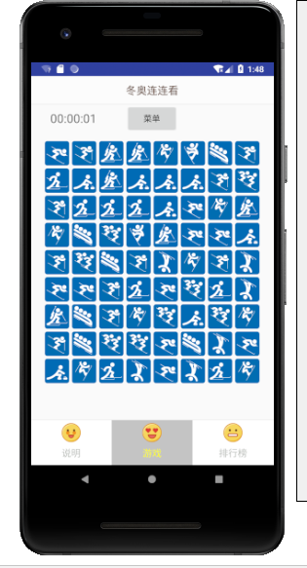

图1-1 游戏界面

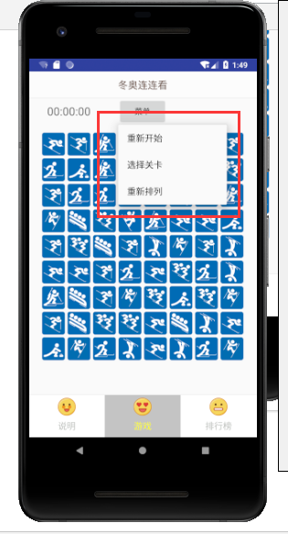

图1-2 弹出菜单

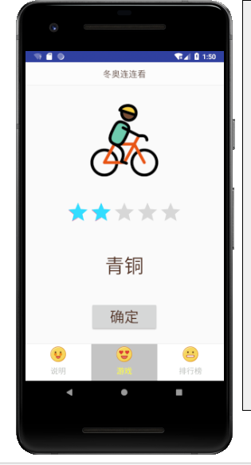

图1-3 选关界面

# 实验二：多线程+广播

## 内容

为连连看添加背景音乐和点击特效，发送广播生成排行榜。

## 要求

在第一次上机的基础上完成

1、利用多线程机制，为连连看程序添加背景音乐（圣诞快乐）和点击音效（点重、消除、点错）

2、当成功完成一局后，发出一个广播，广播内容包含你的个人信息，完成祝贺语，耗时时长，程序收到广播后，显示排名页面（现在排名页面中只显示你自己的个人信息，排名操作属于后续实验操作）

排名页面包括：序号、名字、耗时、上榜时间。

## 目的

1．熟悉多线程的应用。

2. 掌握广播技术。

## 实现

### 1.多线程背景音乐

|  |
| --- |
| public class BgMusicThread extends Thread {  private boolean isAlive;  @Override  public void run() {  if(bgMusic==null){  bgMusic = MediaPlayer.create(MainActivity.this, R.raw.bg_music);  }  bgMusic.setLooping(true);  bgMusic.start();  }  }  public void stopMusic(){  bgMusic.setLooping(false);  bgMusic.stop();  bgMusic.reset();  bgMusic.release();  bgMusic = null;  } |

### 2.多线程点击音效

|  |
| --- |
| public class ClickMusicThread extends Thread {  private int musicType;  @Override  public void run() {  clickMusic.start();  }  public void setMusciType(int musicType) {  this.musicType = musicType;  switch (musicType){  case 0:  clickMusic = MediaPlayer.create(getActivity(),R.raw.clear);  break;  case 1:  clickMusic = MediaPlayer.create(getActivity(),R.raw.error);  break;  case 2:  clickMusic = MediaPlayer.create(getActivity(),R.raw.repeat);  break;  }  }  public int getMusciType() {  return musicType;  }  } |

### 3.广播接收器

|  |
| --- |
| public class MyReceiver extends BroadcastReceiver {  private MsgCallBack msgCallBack;  @Override  public void onReceive(Context context, Intent intent) {  msgCallBack.setRankInfo(intent.getStringExtra("usedTime"),intent.getStringExtra("userName"));  }  public interface MsgCallBack{  public void setRankInfo(String usedTime, String userName);  }  public void setMsgCallBack(MsgCallBack msgCallBack) {  this.msgCallBack = msgCallBack;  }  } |

### 4.注册广播接收器

|  |
| --- |
| FragmentTransaction fTransaction = fManager.beginTransaction();  if(myApplication.getFgRank()==null){  RankFragment fgRank = new RankFragment();  fTransaction.add(R.id.ly_content,fgRank);  fTransaction.commit();  myApplication.setFgRank(fgRank);  }  IntentFilter intentFilter = new IntentFilter();  intentFilter.addAction("updateRank");  MyReceiver myReceiver = new MyReceiver();  registerReceiver(myReceiver,intentFilter);  myReceiver.setMsgCallBack(myApplication.getFgRank()); |

### 5.弹出对话框

|  |
| --- |
| protected void popAlert(){  MyApplication.getInstance().setConunterPaused(true);  String sTime = timerView.getText().toString();  int hour = Integer.parseInt(sTime.substring(0,2));  int minute = Integer.parseInt(sTime.substring(3,5));  int second = Integer.parseInt(sTime.substring(6,8));  int allTime = hour*3600+minute*60+second;  usedTime.setText(allTime+"s");  alert.show();  } |

### 6.发送广播

|  |
| --- |
| btnSendBroadCast.setOnClickListener(new View.OnClickListener() {  @Override  public void onClick(View v) {  //将名字存储到本地  FileOutputStream fileOutputStream = null;  try {  fileOutputStream = getActivity().openFileOutput(filename, Context.MODE_PRIVATE);  fileOutputStream.write(userName.getText().toString().getBytes());  } catch (FileNotFoundException e) {  e.printStackTrace();  } catch (IOException e) {  e.printStackTrace();  }  try {  fileOutputStream.close();  } catch (IOException e) {  e.printStackTrace();  }  Intent intent = new Intent();  intent.setAction("updateRank");  intent.putExtra("usedTime",usedTime.getText().toString());  intent.putExtra("userName",userName.getText().toString());  getActivity().sendBroadcast(intent);  MyApplication.getInstance().setConunterPaused(false);  alert.dismiss();  }  }); |

## 运行结果（假设两次点击消除是全部消除）

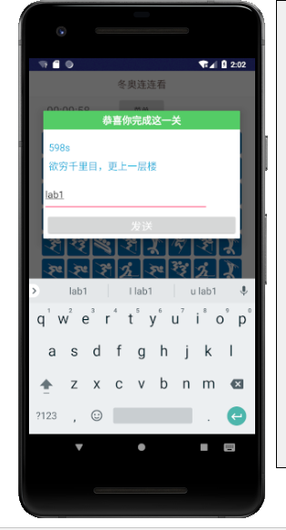

图2-1 完成发送广播

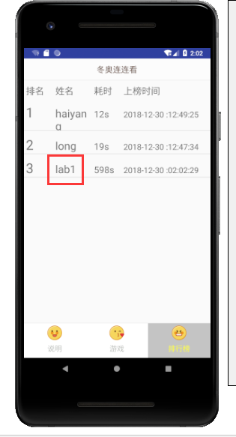

图2-2 收到广播并展示

# 实验三：持久化存储

## 内容

为游戏设置数据存储。

## 要求

1、采用preference 存储用户关于背景音乐的个人设置，允许用户设置默认音效和背景音乐的开关

2、采用本地存储存储用户的个人信息：用户名、头像

3、用SQLite存储排行榜。

## 目的

1. 掌握preference的基本操作。
2. 熟悉并应用本地存储。
3. 实现通过SQLiteOpenHelper管理sqlite数据库。

## 实现

### 1. preference存储

|  |
| --- |
| public void onActivityCreated(Bundle savedInstanceState) {  super.onActivityCreated(savedInstanceState);  sp = getActivity().getSharedPreferences("config", Context.MODE_PRIVATE);  swhBgMusic = getActivity().findViewById(R.id.swh_bg);  swhClickMusic = getActivity().findViewById(R.id.swh_click);  swhBgMusic.setChecked(sp.getBoolean("swhBgMusic",false));  swhClickMusic.setChecked(sp.getBoolean("swhClickMusic",false));  swhBgMusic.setOnCheckedChangeListener(this);  swhClickMusic.setOnCheckedChangeListener(this);  }  @Override  public void onCheckedChanged(CompoundButton buttonView, boolean isChecked) {  switch (buttonView.getId()){  case R.id.swh_bg:  saveData("swhBgMusic",isChecked);  break;  case R.id.swh_click:  saveData("swhClickMusic",isChecked);  break;  }  }  private void saveData(String swhBtn, Boolean isChecked) {  SharedPreferences.Editor editor = sp.edit();//获取编辑器  editor.putBoolean(swhBtn, isChecked);//写入数据  editor.commit();//提交  } |

### 2.本地存储

|  |
| --- |
| FileOutputStream fileOutputStream = null;  try {  fileOutputStream = getActivity().openFileOutput(filename, Context.MODE_PRIVATE);  fileOutputStream.write(userName.getText().toString().getBytes());  } catch (FileNotFoundException e) {  e.printStackTrace();  } catch (IOException e) {  e.printStackTrace();  }  try {  fileOutputStream.close();  } catch (IOException e) {  e.printStackTrace();  } |

### 3. DatabaseHelper

|  |
| --- |
| public class DatabaseHelper extends SQLiteOpenHelper {  static final String userTable = "rank";  static final String colNumber ="number";  static final String colUserName ="username";  static final String colUsedTime ="usedTime";  static final String colCreatedTime ="createdTime";  public DatabaseHelper(Context context, String name, SQLiteDatabase.CursorFactory factory, int version) {  super(context, name, factory, version);  }  @Override  public void onCreate(SQLiteDatabase db) {  db.execSQL("CREATE TABLE "+userTable+"("+colNumber+" INTEGER PRIMARY KEY,"  +colUserName+" Text,"  +colUsedTime+" Text,"  +colCreatedTime+" Text)");  }  @Override  public void onUpgrade(SQLiteDatabase db, int oldVersion, int newVersion) {  }  } |

### 4.SQLite存储

|  |
| --- |
| public void onActivityCreated(Bundle savedInstanceState) {  super.onActivityCreated(savedInstanceState);  helper = new DatabaseHelper(getActivity(),"rankDB.db",null,1);  db=helper.getWritableDatabase();  list_rank = getActivity().findViewById(R.id.list_rank);  if(userRankList==null){  userRankList = new LinkedList<UserRank>();  Cursor cursor = db.rawQuery("select * from rank",null);  cursor.moveToFirst();  int dbNumber = 0;  String dbUserName = "";  String dbUsedTime = "";  String dbCreatedTime = "";  while (!cursor.isAfterLast()){  dbNumber=cursor.getInt(0);  dbUserName=cursor.getString(1);  dbUsedTime=cursor.getString(2);  dbCreatedTime=cursor.getString(3);  userRankList.add(new UserRank(dbNumber,dbUserName,dbUsedTime,dbCreatedTime));  cursor.moveToNext();  }  }  myAdapter = new MyAdapter(userRankList, getContext());  list_rank.setAdapter(myAdapter);  }  @Override  public void setRankInfo(String usedTime, String userName) {  //do  Date date = new Date();  SimpleDateFormat dateFormat= new SimpleDateFormat("yyyy-MM-dd :hh:mm:ss");  String currentTime = dateFormat.format(date);  list_rank = getActivity().findViewById(R.id.list_rank);  userRankList.add(new UserRank(userRankList.size()+1,userName,usedTime,currentTime));  Collections.sort(userRankList);  // 插入数据库  ContentValues cv = new ContentValues();  cv.put("number",userRankList.size());  cv.put("username",userName);  cv.put("usedTime",usedTime);  cv.put("createdTime",currentTime);  db.insert("rank",null,cv);  myAdapter = new MyAdapter(userRankList, getContext());  list_rank.setAdapter(myAdapter);  } |

## 运行结果

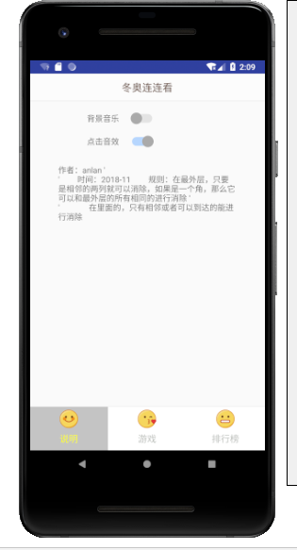

图3-1说明与参数设置界面，

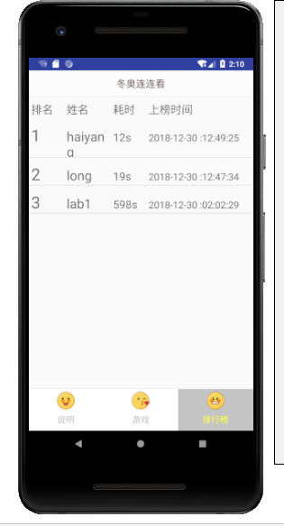

图3-2 排行榜界面

|  |  |
| --- | --- |
| **学生**  **实验**  **心得** | 这学期的移动开发课成学习的挺快乐的，做实验前期挺慢的，虽然难度不大，但是由于不熟悉，总是边做实验边复习知识点，边看老师的示例代码，当遇到自己实在没啥想法时，也会去求助网上的资源；做第二个试验时就好很多了，但是依然在多线程哪里卡了很久，因为想实现切换Fragment时自动实现对背景音乐的停止或者播放，而且由于做第一次实验时计划好，第二次实验修改了很多第一次实验的代码，这是很让人头疼的；第三次实验的时候就得心应手的很多了；最后谢谢老师的悉心教导，喜欢老师这种上课模式。  学生（签名）：龙海洋  2018年12月30日 |
| **指导**  **教师**  **评语** | 成绩评定：  指导教师（签名）：  年 月 日 |