**FPT ACADEMY INTERNATIONAL**



**FPT ACADEMY INTERNATIONAL**

**FPT – APTECH COMPUTER EDUCATION**

**SHRADHA BOOK STORE**

|  |  |  |
| --- | --- | --- |
| **Supervisor:** | Mr. TRAN PHUOC SINH | |
| **Semester:** | 03 | |
| **Batch No:** | T1.1907.M0 | |
| **Group No:** | 04 | |
| **Team Member:** | **FULL NAME** | **ROLL NO.** |
| 1. | NGUYEN VAN TRAN HOA | Student1215606 |
| 2. | LE THANH AN | Student1208504 |
| 3. | VO HOANG TRUNG | Student1208490 |
| 4. | BUI DINH HUNG | Student1215631 |

**Centre Name: ACE-HCMC-2-FPT.**

**Address: 590 Cach Mang Thang 8, District 3, Ho Chi Minh City, Viet Nam.**

**REVIEW 1**

1. **ACKNOWLEDGEMENT**

We would like to thank all those who have given us support and helped, especially our teacher Tran Phuoc Sinh who has given us good guideline for project throughout numerous consultations and useful materials. Many people, especially our classmates and team members itself, have made valuable comments, suggestions which gave us an inspiration to improve our project.

We thank all the people for their help directly and indirectly to complete our project.

1. **PROBLEM DEFINITON**
2. **Introduction**

Our client is a retail dealer for the books and sells the books at his shop Shradha General Book Stores . He sells different types of books of different publications of stories, school related text books, note books, essay writing books, some of books for the competitions like General Knowledge, Essay Writing, and also novels, books to improve vocabulary, for learning other languages, etc and also he sells some of the book related materials like covers, pens, pencils, etc .. Also the slam books, Files, etc . are available at his shop.

1. **Customer Requirement Specification**
   1. **Existing Scenario:**

* Actually the client deals directly with some of the publications for purchasing the books, and for some of the publications he purchases the books through the other dealers. Also some of the dealers and the book sellers purchase the books from our client. The customers either visit the dealer or call him for purchasing. Similarly is the case with the client. Because of no automation in the system, the orders placed get delayed, due to which the customer dissatisfaction happens. Also in this competitive world where the number of publications and the dealers are increasing, it becomes difficult to retain the customers. In order to retain the customers, he has placed some of the discount schemes such as if the customer places an order in bulk then that customer can get the discount based on the quantity of orders. Also he has provided a home delivery which will be free, provided the distance is < 3 KMs and for the distance > 3 KMs, the charges are as per the delivery charges as per the service chosen.
  1. **Proposed Solution:**
* To bring the Automation in the system and to cope up in this competitive world, our client now want to incorporate an online sale system where the customers can directly interact and place their orders through online itself. So he has approached us for developing the website. He wants the following list to be maintained and implemented for the website.
  1. **Non-Financial:**
* The website to be navigated through different pages like contact information, About Us (information about the dealer), Products (Books, etc), FAQ s, Order Tracking, Buying a product, Feedback and Queries and the ADMIN.
* The products are classified.
* The website which we build must have the following functionalities.

1. The website should have the following modules:

* Administrator
* User

1. In the home page, the details of products, contact information, information about the dealer will be displayed.
2. Through the administrator module, one can perform the following functionalities.

* Maintain (update, disable, search and retrieve) the details of the user along with the login details (not included password), persional details, history details.
* Maintain (insert, update, search and retrieve) the details of the products.
* Maintain (search and retrieve) the details of sales history.

1. Throught the user module, one should be able to perform the following.

* View the details of the product.
* View the details of account.
* Maintain (insert, update, cancelled, search and retrieve) the details of order
* The subcategory of the Products are to be assigned with a unitque 7 Digit Code (The first 2 digit alpha numeric is product category,next three Digits being the first three acronyms of Manufacturer and the remaining two being the Numeric degit) For exam: “B0KD042” where B0 mean Genera Books, KD0 is representing the manufacturer, KD being the first two acronyms of the manufacturer and the digit zero being added as the third one, as the manufacturer is having only two acronyms, and the remaining two will be the numeric order, which can be in the order you maintain the list of the products of that manufacturer.

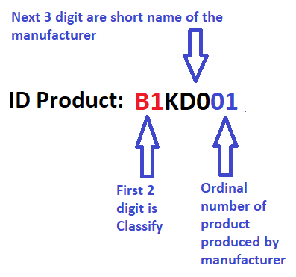

* Order must accept payment through 1 of the following 3 payment methods:
* Payment before delivery
* Pay after recieve
* Online payment
* Maintain (search and retrieve) the products.
* Maintain add the products to cart.
* Maintain (insert, update, delete, search and retrieve) FAQs.
  1. **Financial:**
* The charges for the delivery will be as per the distance and the quantity ordered and will be only the delivery charges and the total price of the products ordered. In case of any cancellation, the charges will be the delivery charges (to and fro) alone. Also the delivery charges are applicable only if the distance is >3 KMs.

1. **Functional Requirements Specifications**
2. **Function of Admin:**
   1. Login, Logout.
   2. Change Password.
   3. Manage users.
   4. Manage products.
   5. Manager orders history.
   6. Manager FAQs.
3. **Function of Users:**
4. Register / Login / logout account
5. Update personal information
6. Create, update, cancel, search, retrieve orders
7. Create,update,search,retrieve SupportRequest
8. **Non-Functional Requirements Specifications**

* Fast Performance.
* Good UX/UI.

1. **System Requirement Specifications**
2. **Server requirements:**

* **Hardware:**

|  |  |
| --- | --- |
| Component | Requirement |
| CPU | Processor type: Pentium IV-compatible processor or faster.  Processor speed recommended: 2.0 GHz or faster. |
| OS | Microsoft Windows 7 or higher with IIS. |
| Memory (RAM) | Minimum: 2 GB.  Recommended: 4 GB or more. |
| Hard Drive | Free space minimum: 200 MB.  Recommended: 50 GB or more  Maximum: Operating system maximum. |

* **Software:**

|  |  |
| --- | --- |
| Component | Requirement |
| Microsoft .NET Core | Version 4.5.x |
| Microsoft Visual Studio | Microsoft Visual Studio 2019 |
| RDBMS | SQL Server 15.0.18206.0 |
| Hosting | IIS 8.0 or higher |
| Web Browser | Chrome (recommended), Firefox, IE 7 or higher |

1. **Client requirements:**

* **Hardware:**

|  |  |
| --- | --- |
| Component | Requirement |
| CPU | Processor type:  Pentium III-compatible processor or faster.  Processor speed:  Recommended: 1.0 GHz or faster. |
| OS | All OS (Window, Linux, Android, Mac OS, …). |
| Memory (RAM) | RAM:  Minimum: 512 MB  Recommended: 1 GB or more  Maximum: Operating system maximum |
| Hard Drive | Free space minimum: 10 MB.  Recommended: 500 MB or more  Maximum: Operating system maximum. |

* **Soft ware:**

|  |  |
| --- | --- |
| Component | Requirement |
| Web Browser | IE 4.0, Firefox 3.0, Chrome or Higher… |

1. **Development Software**

* SQL Server 2014/ Higher
* Microsoft Visual Studio 2019.

1. **Technology**

* ASP.NET MVC
* Net CORE 3.1.9
* HTML5 / CSS
* Boostrap

**REVIEW 2**

1. **Architecture and Design of the eProject:**

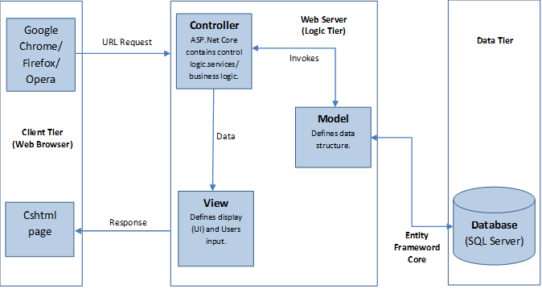

1. **Data Flow Diagram (DFD):**
2. **DFD context**

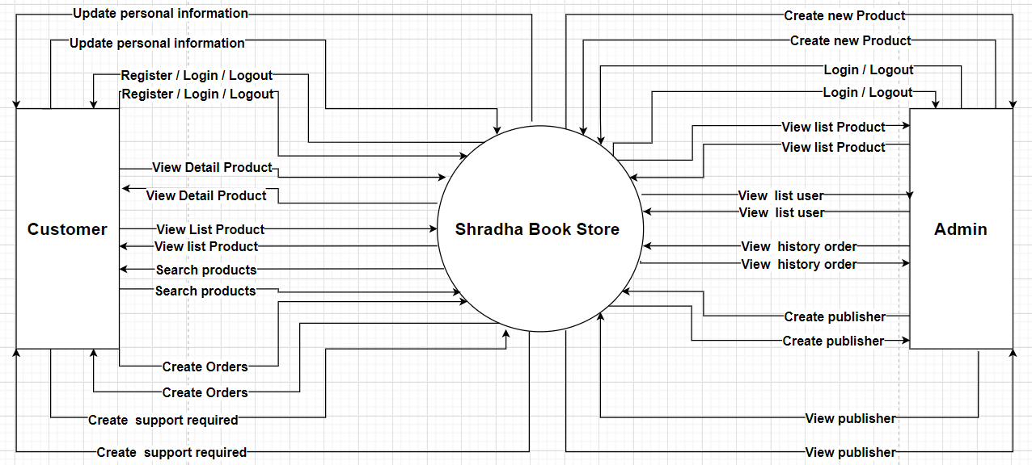

1. **Level 1 DFD ( For Administrator )**

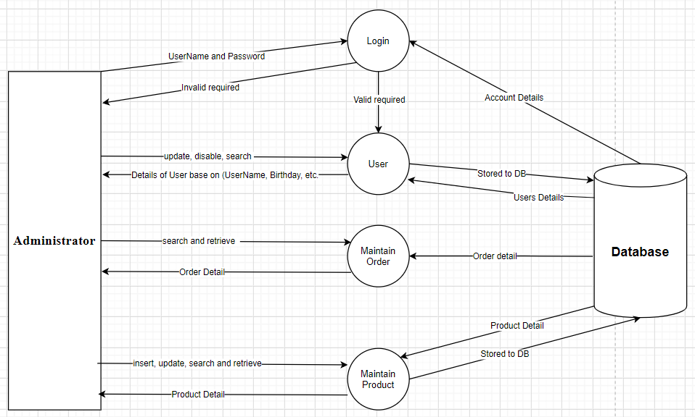

1. **Level 1 DFD ( For User )**
2. **Member**

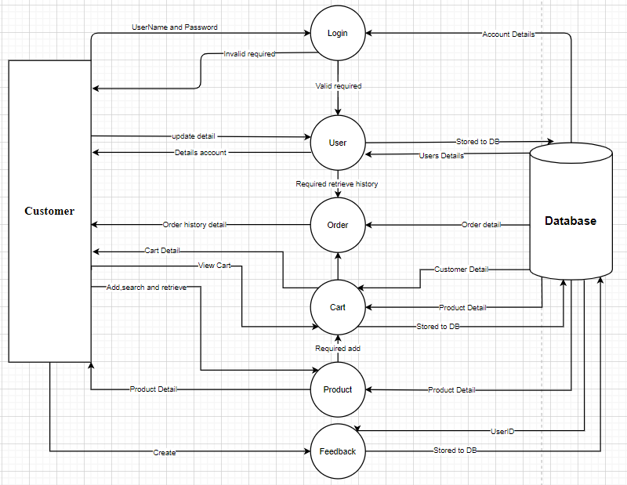

1. **Visitors**

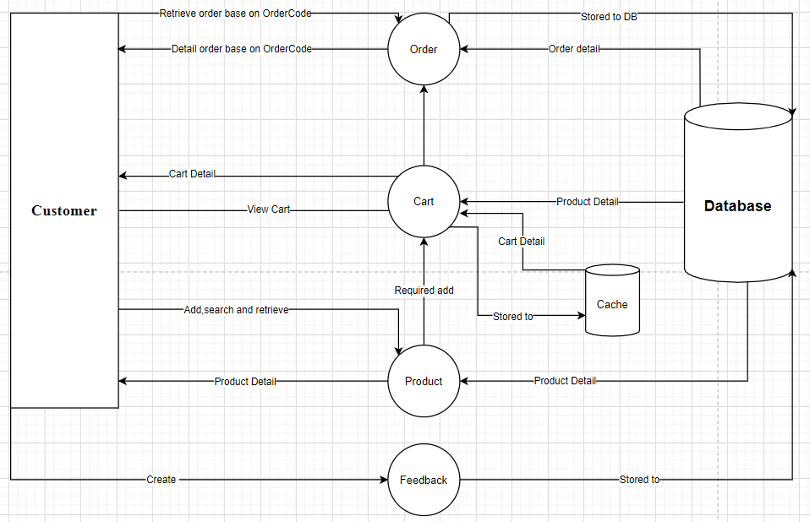

1. **Level 1 DFD (Cart)**

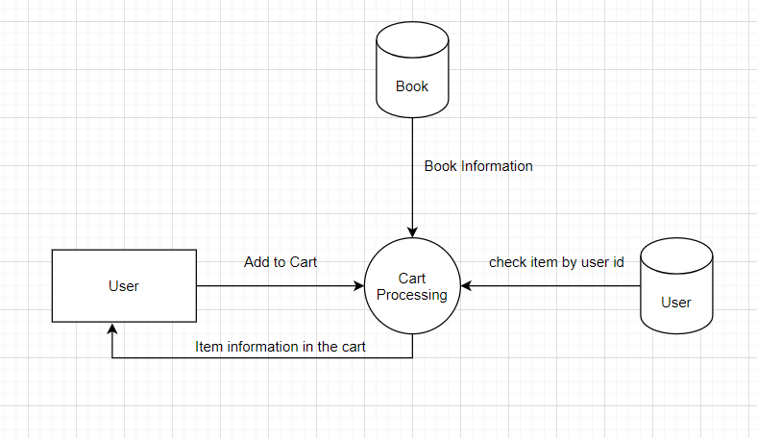

1. **Level 1 DFD (Order)**

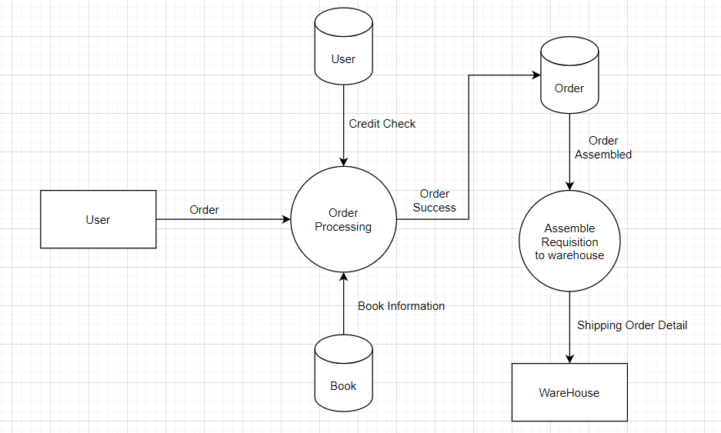

1. **Level 1 DFD (Feedback)**

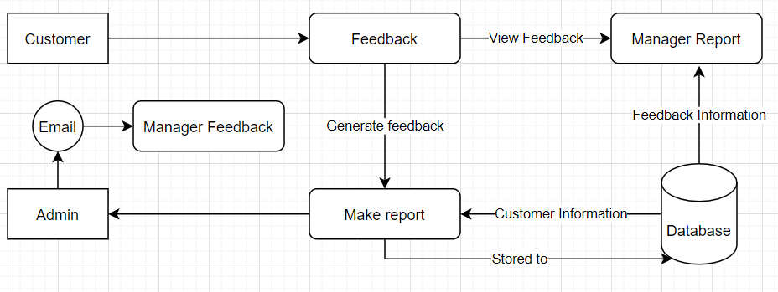

1. **Level 1 DFD (Login)**

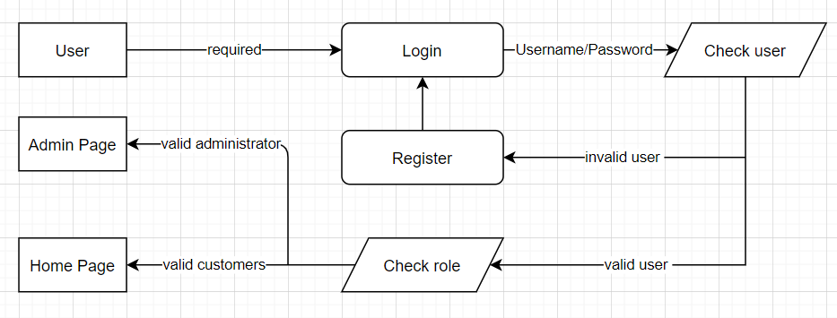

1. **Algorithm and Flow Charts:**
2. **Entities & Attributes:**