Economics; 14.11.2022

4 Analyzing changes within a model

4.1 Income Changes

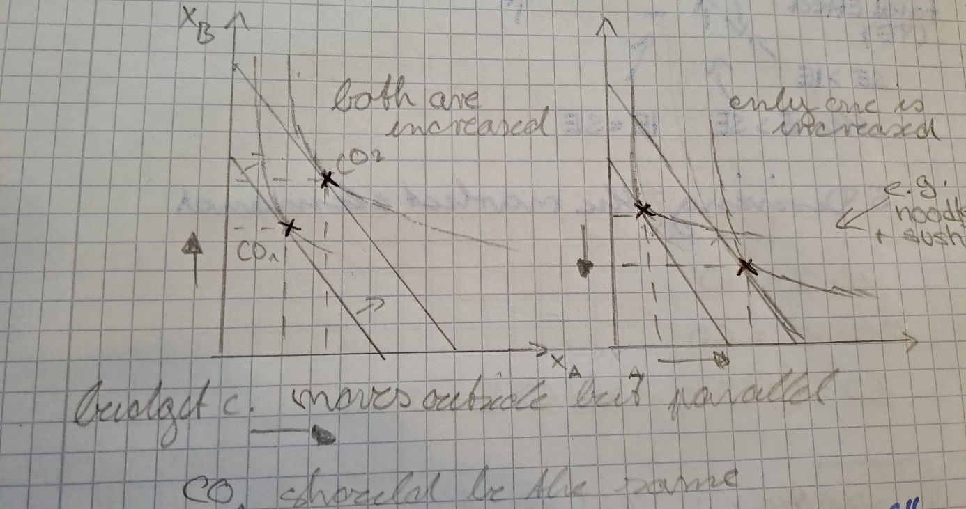

Graph 1:

* Both goods are normal goods

Normal Goods:  
Income increases 🡪 Consumption Increases  
Income decreases 🡪 Consumption decreases

Graph 2:

* A is a normal good   
  B is an inferior good

Inferior Goods :   
Income increases 🡪 Consumption decreases  
Income decreases 🡪 Consumption increases

* for example : sushi (normal goods) and noodles (inferior goods)
  + if you have not much money you will probably buy cheap noodles and less of the expensive sushi; but if you are well off you will probably buy less of the cheap noodles and rather treat yourself to expensive sushi

4.2 A change in price

A change in price effects two (2!) different effect

Substitution Effect:

* price B goes down 🡪 product is relatively cheaper (compared two other product) 🡪 people will rather buy product B than product A 🡪 demand rises
* price B goes up 🡪 product is relatively more expensive (compared to other good) 🡪 people will rather buy product A than B, because they can afford more of a than of b 🡪 demand for b drops
* Gut 1 wird mit Gut 2 substitutiert (ausgetauscht)
* on the same indifference curve like the first optimal consumption, but at the the steigung (marginal utility) like the budget constraint line of the new prices 🡪 parallel to it
* substitution effect measures how much the higher price encourages consumers to buy different goods, assuming the same level of income.

“Now that the price of Pepsi has fallen, I get more liters of Pepsi for every pizza that I give up. Because pizza is now relatively more expensive, I should buy less pizza and more Pepsi.”

Income Effect (IE)

* price B drops 🡪 people save some of their income for each banana 🡪 if they buy the same amount of product A and B as before : they have money left 🡪 can spent it on product a and product b 🡪 demand rises
* price b increases 🡪 people “loose” some money for each banana 🡪 if they buy the same quantity of product A and B like before: they have to spend more money 🡪 they can afford less of product a and product b, because they have to save up the additionally needed amount somewhere 🡪 demand drops
* higher real income (“how much you really have”)
* parallel shift outwards on the new budget constraint line

(from the SE point)

* consumer moves to a higher (if price for a product drops) or lower (if price for a product increases) indifference curve 🡪 higher or lower satisfaction possible, because consumer can afford more/less goods

“Great news! Now that Pepsi is cheaper, my income has greater purchasing power. I am, in effect, richer than I was. Because I am richer, I can buy both more pizza and more Pepsi.” (This is the income effect.)

Total Effect (TE)

* the sum of the Substitutional Effect and the Income Effect
* if SE is stronger than IE 🡪 SE determines the direction  
  if IE is stronger than SE 🡪 IE determines the direction
* both the effects happen simultaneously

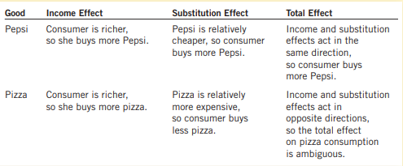

* if it’s an income change only the income effect is happening

