Economics; 28.10.2022

2 theory of consumer choice

* Ranking called „utility function“

1.2. Total and marginal utility

Total utility function:

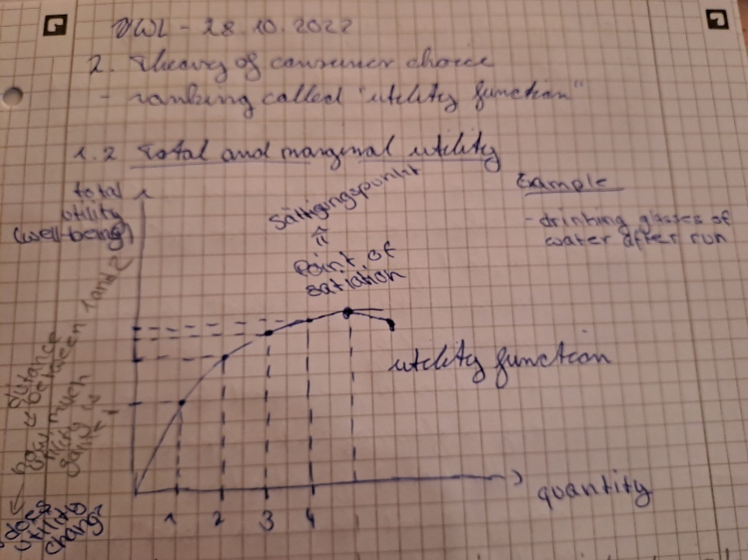

Maximum = Point of Satiation (Sättigungspunkt)

Marginal utility function:

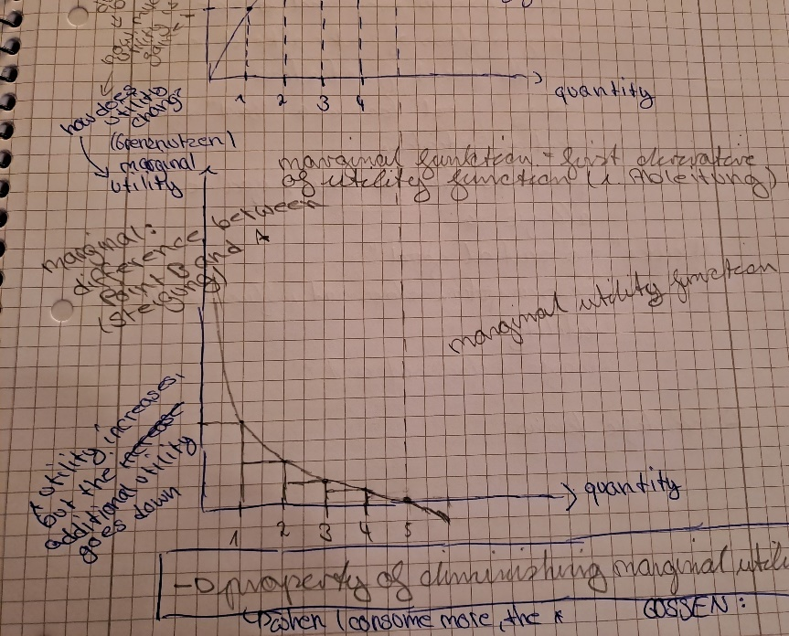

* Shows how the utility does change from X1 to X2
* Shows the difference between Point A and Point P (Steigung)
* Curve of the derivative
* Marginal utility function = first derivative of the utility function (erste ableitung)
* Property of diminishing marginal utility
* When People consume more the utility increases, but the additional utility gained from consuming an additional unit of a product decreases
* 1. Gossen’sche Gesetz : Gesetzt vom abnehmenden Grenzverlauf

1.3. Types of Goods (good, bad, neuter)

“Good” = a “good good”

* Consumption of a good increases your utility 🡪 more is preferred to less
* When we consume a “good” we feel better

“Bad” = a “bad good”

* Consumption of a “Bad” decreases your utility 🡪 less is preferred to more
* Every “good” becomes a “bad” after reaching the point of satiation
* Products you’re allergic to/that are toxic

“Neuter” = a “neutral good”

* Consumption does not influence the utility
* Maybe does not even exist

“Good”/”Bad”/”Neuter” are the correct scientific terms

1.4 Indifference Curves:

a.) Definiton:

Indifference Cuve : A Curve that shows all consumption bundles that give the consumer the same level of satisfaction (=the same level of utility)  
🡪 Combinations that give the same level of utility (e.g. peas, apples, cherry vs. plums, bananas, mango)

Consumption bundle = Einkaufskorb

b)

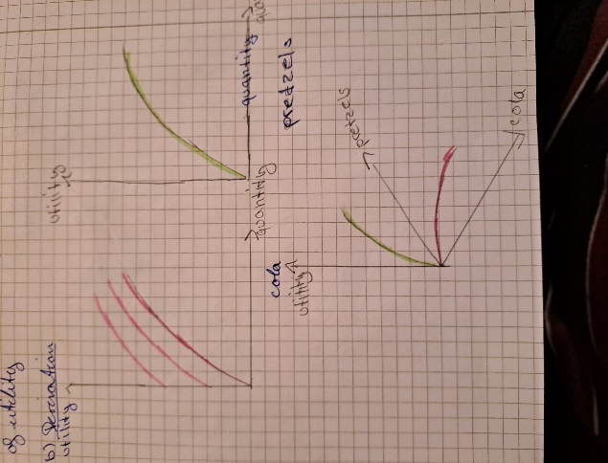

* Pdf derivation of indifference curves anschauen

c) characteristics of indifference curves (for good goods)

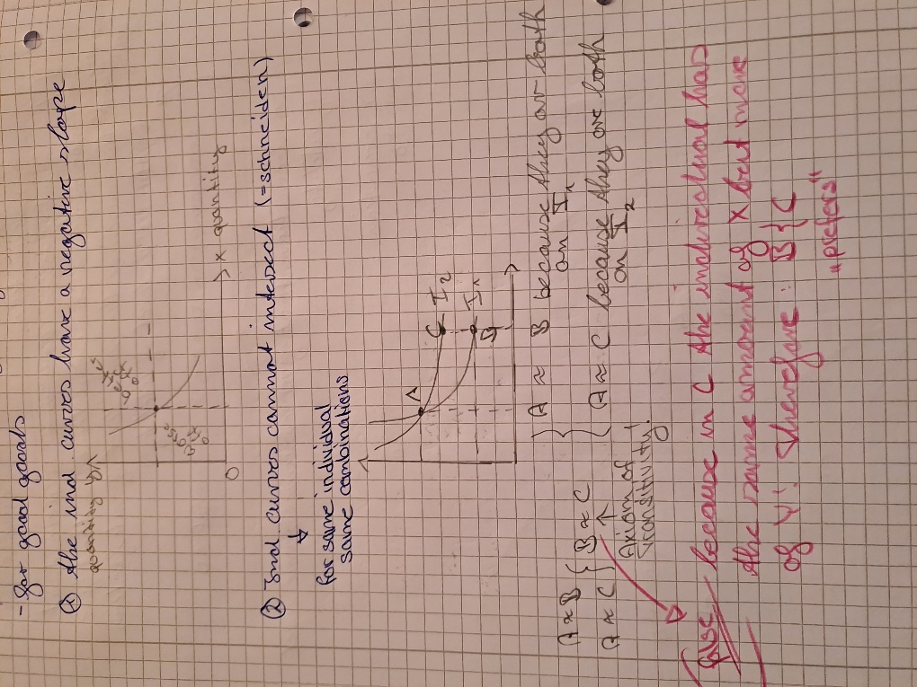

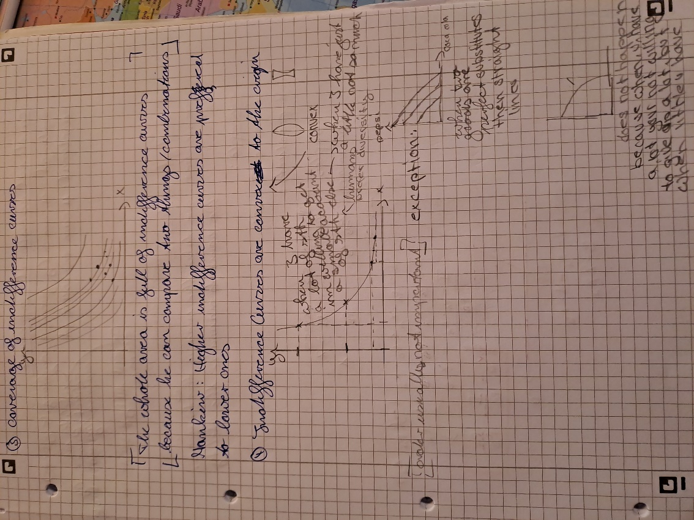

Cardinal vs. ordinal magnitude

*Like we learnt in statistics*

Ordinal : you can only form a ranking (e.g. favorite movies)

* Utility in the strictest sense only ordinally rankable 🡪 in economics also cardinal utility possible

Cardinal: you can also measure it (or use it mathematically)

2. Budget Constrains

Remember : we take the income as given  
 we want to maximize the utility

Example: again simplified: happens with more than 2 products in the real world 🡪 but easier to understand with two

Income (I) = 300

Two products

|  |  |  |
| --- | --- | --- |
|  | Quantities | Price |
| Apples  Bananas | x1  x2 | p1  p2 |

Berechnung I :   
I = p1 * x1 + p2 * x2 ; - (p1 * x1)

I – p1 * x1 = p2 * x2 ; :p2  
(I – p1 * x1) = xb

Xb = I/p2 – p1/p2

Below : curve of how much of the exemplary goods we can afford with the exemplary income at the exemplary price

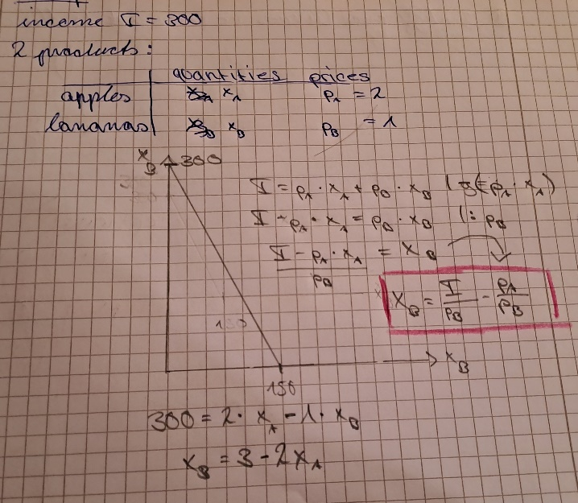

And this (below) is how changes affect the curve of what we can buy with a certain income

