Marketing; 02.11.2022

**Price**

Value: Balance between what you have to give up and what you get (time, money, effort, etc)

Price:

narrow definition:

* Amount of money exchanged
* Only element of the marketing mix reflecting value 🡪 other 3P reflect the cost

Consumer PoV:

* What is given up in exchange for the product
* Represents the perceived value (in mind of the costumer; not measured)

Marketers/Company PoV:

* Creates value
* Revenue : price * units (sold)  
  profit: revenue – costs
* Right price:
  + Make profits
  + Must represent the perceived value in the eyes of the customer

“amount the customer is willing to pay”

How to prevent costly pricing mistakes:

* Set proper and relevant pricing objectives (and goals)
* Select the most fitting pricing strategy and revise prices trough PLC  
  adjust pricing using pricing tactics
* Need to plan ahead
* Need to know how much the customer is willing to pay

Pricing objectives (& goals)

* Combination is possible; mostly one really strong one
* Profit oriented
  + Profit-maximization:
    - Highest profit possible
    - Total revenue as high as possible
    - Disregard other factors
    - Requires mathematical prediction
  + Satisfactory
    - Get a certain (satisfactory) amount of profits
    - Allows to better compete
    - Makes prices possible the market is able to afford
  + Return on Investment (ROI)
    - Get at least as much back as invested
* Sales oriented (Sales Volume Oriented)
  + Market share (Sales % in relation to total sales of industry)
    - Goal: increase the market share of a product
    - Sell as much as possible
  + Sales maximization:
    - Short term strategy
    - Sell as much as possible
    - Ignores profits, competition, etc
    - Used to get rid of excess stuff (e.g. summer sales, “Schlussverkauf”)
* Status Quo - Pricing
  + Keep in line with the competition
  + Requires little planning 🡪 passive strategy
  + Risk : you don’t know why your competition is doing what its doing 🡪 can lead to catastrophe

General Pricing Strategy

* Strategy != Goals
* Goal and strategy should be aligned

For established Products

* Customer-Value based pricing
  + Priced based on how valuable the product is to the customer
    - “What is the customer willing to pay”
  + Ignores the competition
  + Is Product “worth” the amount of money
  + Likely to have market orientation
  + Price has a ceiling : certain point the customers refuse to buy the product
    - They deem the product “too expensive”
  + Acceptable/good value is not necessarily the cheapest (e.g. Steinwell Pianos; “Why is the meat so cheap 🡪 is it bad?”
  + Difficult to accurately set the prices 🡪 you cant objectively measure value
    - Each person sees it differently 🡪 sth. Is worth a lot more to person A than to Person B
* Cost Based Pricing
  + Costs set the floor of possible prices (return of costs = lowest possible price)
    - Includes variable (changing depending on production) and fixed (not changing e.g. rent) cost
  + No ceiling
* Competition Based Pricing
  + Price is based on what the competition is doing
  + If higher price: Company has to offer something of additional value
  + Risk: you don’t know the competitors objective

For new products:

* Price skimming:
  + Metaphor: the cream at the top of the milk used to make butter/cheese
  + Introduction at higher prices
  + Overtime (as competitors enter market) the prices fall
  + Used when “new-to-the-world” product or little competition
  + Aimed at the innovaters (people who buy early/buy new stuff)
    - Laggers (those who buy late/when product is nearly off market)
  + High price limits growth opportunity
  + More time for competitors to develop similar product
  + Quickly recover development and production costs
  + Used for electronic innovations
* Penetration:
  + Metaphor: a wave covering the whole beach
  + Relatively low price when launching
    - Quickly get a good share of the market
  + May discourage competition 🡪 they cannot offer something at a lower/similar price
  + Requires facility allowing for large scale operations/large production volumes   
    🡪 as your prices are low, a lot of people will buy it and if you cant offer the product they will be unhappy
  + Lower profits per unit 🡪 need to sell more units to cover cost
  + Difficult to raise prices (when competitors enter) 🡪 if customers are accustomed to a certain price you cannot raise them without angering the customers
* Status-quo (competitive pricing)
  + Simple
  + Risky (you do not take demand or cost into the account)
  + Maybe costly mistakes
* Base price: “everyday” price; price you enter the market with
* Pricing tactics:
  + Leader pricing (loss leaders) 🡪 get someone into shop for a certain sale and then they’ll buy more
  + 3 for 2
  + Break even

**Place/Distribution**

* Move product from the plant to store 🡪 how its moved/handled
* Distribution channel:
  + Pipeline trough which product goes from producer to consumer (supply chain)
    - Product
    - Ownership
    - Financing and payments
    - Risk
* Channel Member:
  + Interdependent institution that helps with the transfer of ownership
  + What do they do?
    - Buy and sell
    - Negotiate with one another
    - Facilitate the change of ownership
  + Who:
    - Retailer : sells directly to customers
    - Wholesaler: Großhändler/Komissionär
    - Distributor: producer sends product to him (and he distributes it)
    - Producer: produces Product (and sometimes sells directly)
* Agents = does not take ownership; just stores it/aids the process
* Main objective :
  + Make product available to customer
  + Right place/time/quantities
* 4 key questions
  + Where do the customer buy (online, shops)
  + How do they buy (odering online; go physical)
  + Does the company sell directly or use intermediaries
  + Is technology changing the traditional distribution methods
* Intermediary
  + Party in the distribution channel
  + Some businesses the producer sells to rather than selling to the customers
  + Take a part of the profit
  + Take responsibility for things like distribution
* Multi-channel distribution
  + Using more than 1 type of arrangement to distribute products

Functions of distribution

1. Division of labour

* Breaking up complex tasks into smaller ones (e.g. storage, delivery)[division]
* Task are being performed by specialists (e.g. cooling or overnight delivery)[specialisation]

= greater efficiency and therefore lower production costs 🡪 everybody can focus on what they do best

1. To ensure right place/time/quantity
2. Temporal discrepancy:

* Difference between when a product is produced and when its required/demanded

1. Spatial discrepancy:

* Difference between where a product is produced vs. where the product is required

1. Discrepancy of Quantity:

* Difference between how many are produced vs. how many are needed

1. Discrepancy of Assortment

* Difference between what is produced vs. what is needed
* E.g. Johnson & Johnson : we do not need all the product, but we can buy what we want

1. Provide efficiency

* Reduce number of interactions/transactions required to get products to customer
* Retailers can buy from wholesaler instead of needing to buy from every producer one by one
* Assortment of goods available to consumer increases

Channel conflicts :

* Horizontal conflict
  + Two channel members on the same level (e.g. between two retailers [A wants to expand into B territory]
* Vertical Conflict:
  + Between different levels of the supply chain (between producers and wholesaler [products arrive later than scheduled at retail shops]

**Promotion:**

* Interrelated to other P
* About communication
  + Share message/meaning trough transmission of information with common symbols (language, facial/body expression, pictures, sounds)
  + Meaning of color, shape, picture, mimics, etc
* Includes messages, media (tv, social media, print),
* activities to inform/create awareness (introductory phase), promote, persuade (growth face), remind (maturity/decline) customers about product
* used to influence the customer to get them to buy/to build relation

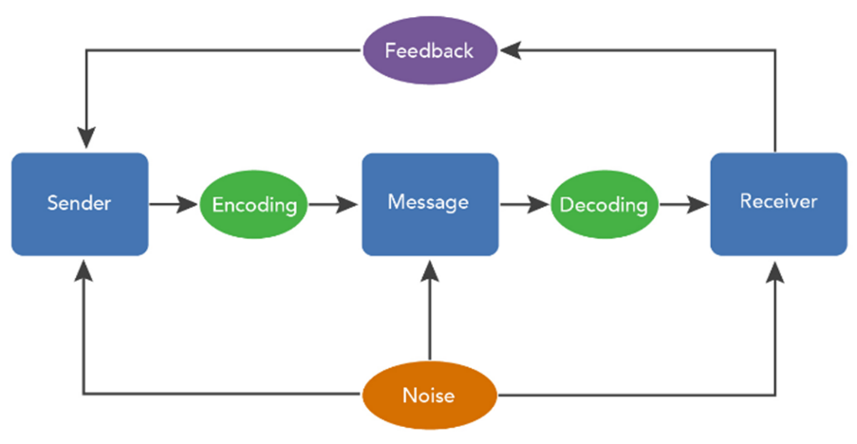🡨 be able to draw this

* encode = put message into format (written, spoken, etc)
  + “just utter something”
* Decode = interpret; the message is understood by the receiver; most mistakes happen because the receiver is unable to decode the message correctly
* Noise = everything influencing/disrupting a message; can also be distracting; can be other ads, different language, physical noise
  + Symbols not understood in target market = noise
* Feedback = response/non-response from target market
  + Success of promotion is analysed based on the feedback given
  + Even no feedback is feedback

Promotion:

* Based on communication

1. Objectives of promotion:

* Make customers aware of existence of the product & its positioning
* Persuade the customers to buy the product/remind them

1. Promotional mix:

* Put together the right blend to achieve the goal

1. Name + briefly explain 5 methods of promotion

* Advertising 🡪 paid for promotion
* Online
* Sales promotion 🡪 e.g. 2 for 1
* Direct marketing
* Personal sale 🡪 go from door to door
* Public relations (PR)
* Branding

1. 5 key factors influencing promotional decisions:

* Stage in PLC 🡪 intro : awareness; decline: reminder (buy more)
* Nature of product 🡪 what info do the customers need before buying
  + Is it an impulse, convenience, shopping, speciality product
* Competition: what are competitors doing
  + What methods are proven effective in the target market
* Marketing objectives & budget: what do we want and how much can we spend on it
  + What does the marketing need to achieve
  + How much can the business afford 🡪 marketing is expensive
* Target market: how can the target market best be reached
  + “When, where, what”
  + Appropriate ways to reach the target market 🡪 old people cannot be reached via internet
  + E.g. when local market 🡪 no sense advertising in national tv

Categories of Communication:

1. Interpersonal communication:

* Between two person 🡪 person to person basis
* E.g. direct promotion; door-to-door-selling, Tupperware parties, call centers

1. Mass Communication:

|  |  |
| --- | --- |
| **Traditional media** | **More modern media** |
| 1. Television 2. Radio 3. Newspapers 4. Magazines 5. Brochures 6. Direct mail 7. Outdoor advertising, e.g. billboards, transit advertising (advertising in trains, busses, etc) 8. Other, e.g. print on T-shirts | 1. Internet 2. Mobile 3. Social media 4. Video marketing 5. QR codes 6. Others? |

Public Relations:

* Inform public to influence the attitudes towards the company/brand
  + Earn acceptance & understanding
* Examples/methods:
  + Written material (e.g. newspapers, annual reports)
  + Corporate identity material (business cards, signs)
  + Speeches
  + Event sponsorships/special events (football stadium)
  + Publicity
    - New story of communication
    - From somebody external about the company
    - E.g. feature article, photograph, press conference

Sales Promotion:

* Short term tactics
* Maximize sales
* Support advertisement strategy/publicity

4 types of sales promotion

* + Different incentives to buy
  + Inspire purchases/drive excitement

1. Loyalty program

* Expensive (high cost)
* Customers come back to company 🡪 build loyalty
* Inspire to repurchase

2) contests

* Enter and have a chance to win something
* Gets people excited 🡪 everybody wants to win and imagines he has chances
* Gets customers back to the store
* Have to be monitored by company 🡪 need to ensure equal chances

3) coupon

* High costs 🡪 when used by customers : company looses money/does not make as much as it could have
* Inspire purchases
* Delayed money for retailers 🡪 they have to send the coupon code in and then after around a month they get money for it

4) rebate

* Customer pays full price and can get a rebate after buying trough filling out forms
* Delayed rebate for customers and a lot don’t use it because it’s a lot of hustle
* Stores like it because a) they get there money directly b) not a lot of costumers use it

1. Product placement

* A product is seen in a movie or film show (e.g. apple smartphones)
* People tend to see how it works
* People buy it, because if “my favorite super hero uses it, it must be good”

1. Deals

* Inspire to buy/go into store (e.g. 50% off)
* Can have a negative effect on the brand
  + Is something wrong with the product
  + Do I need a sale to sell my product
  + Especially dangerous for luxury brands (reduce status) and food (is there something wrong with it)
* Cost of additional inventory 🡪 am I cannibalizing other sales
* Increase in sales
* Possible long-term-impact
  + If customers grow accustomed to 99ct it becomes the perceived value 🡪 will not be bought at higher price
* Cost of promotion can either be carried by producer or shared between producer and supply chain
* Pull-promotion: ads to pull customers to retailers (e.g. Real Werbung with Coca Cola)

Promotional mix:

