A Decrease in Crime and a Decrease in Time: Looking at trends of crime in the city of Chicago over 15 years

Allison MacDonald

*Abstract:* For many years, the city of Chicago, located in the state of Illinois, has been known as a crime-ridden city. As the years have progressed, reported crime has decreased dramatically and continues to show a decreasing trend for the future. But with this decrease in total crime, the city still struggles with making arrests in cases overall. Whether it be petty theft or first degree murder, there is a noticable drop in arrests being made, especially in cases that involve the harming of another person.

Since the 1950s, Chicago’s homicide count specifically has fluctuated greatly, where the lowest numbers are just below 300 homicides in one year and the highest numbers are reaching 1,000. With the number of total crimes reported in the city of Chicago reaching over one hundred thousand, homicides make up only a small fraction of all crime. But even with the small fraction that they take up, the number of arrests for homicides has decreased over time.

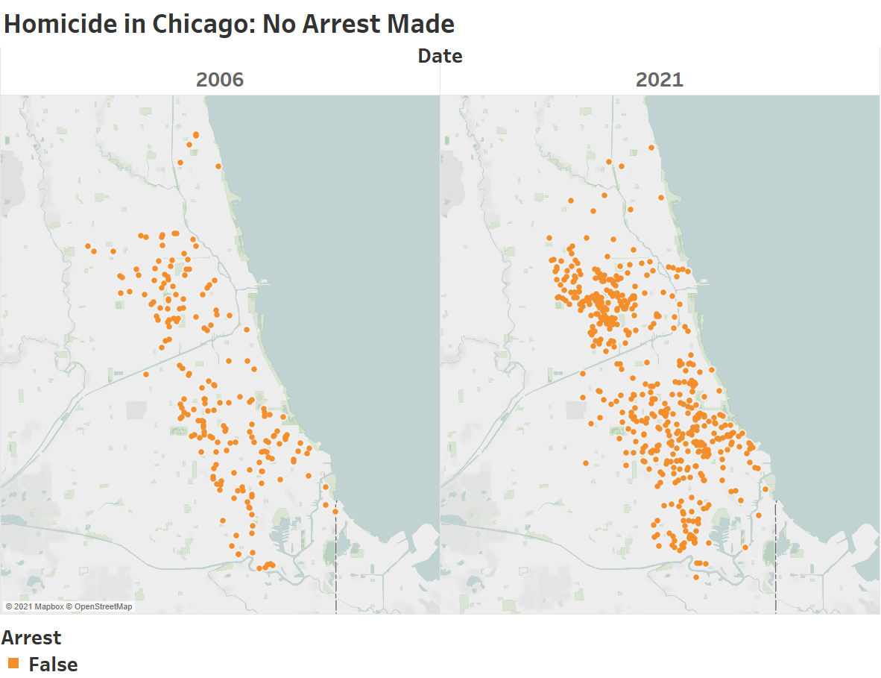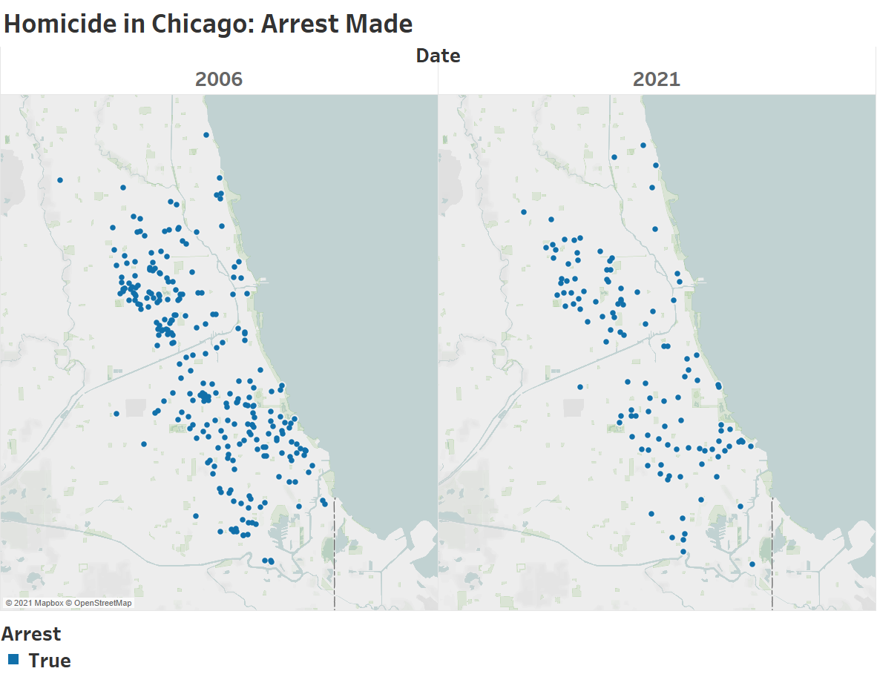

**Figure 1:** Homicide density in the Chicagoland area 15 years apart.

Figure 1 shows the change in the amount of arrests made in homicides in 2006 versus 2021. In 2006, there is a smaller number of homicides reported without arrests made, whereas in 2021, there is a distinctly smaller number of homicides reported that resulted in an arrest. What is more shocking between these two years is the data for 2021 has yet to be updated for a full 365 days.

Homicides aren’t the only crime that has seen a lack of arrests over the last 15 years. Looking at the total number of crimes reported in Chicago alone, there is a trend of less and less arrests for the number of crimes committed. In Figure 2, there’s a promising image of crime in total slowly decreasing over the last 15 years. However, that decrease of crime has not improved the percentage of arrests being made.

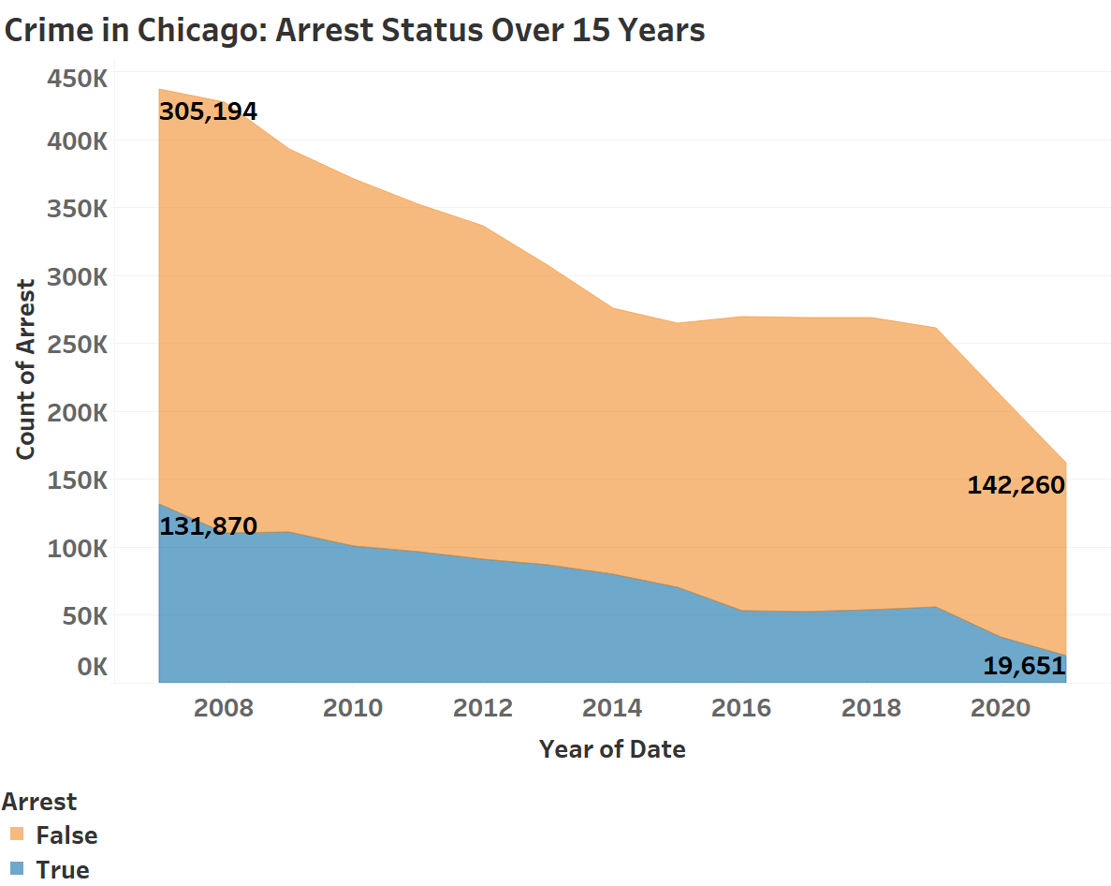

**Figure 2:** Total crime count in Chicago over 15 years. Orange shows no arrest made. Blue shows arrests made.

In 2006, about 30% of all crimes reported resulted in an arrest. In 2021 so far, only 12% of all crimes reported have ended in an arrest. This number will most likely change once the new year has happened. Looking at recently completed years, 2019 and 2020 have seen a 21% and a 16% arrest rate respectively. In less than 15 years, the arrest rate has been halved when in theory, the arrest rate should stay the same, if not increase because of the decrease in overall crime. This creates the question of why the arrest rates are so much lower now with better surveillance videos, advanced technology in DNA testing and with crime rates less than half of what they were in 2006?

Some crimes being committed are much harder to solve and make an arrest on than others. Examples of this are theft and burglary where the perpetrator is never seen or they don’t steal items that are able to be traced i.e. a smartphone or a car. Figure 3 shows the change in the amount of burglary crimes being committed in Chicago along with the very low arrest rate.

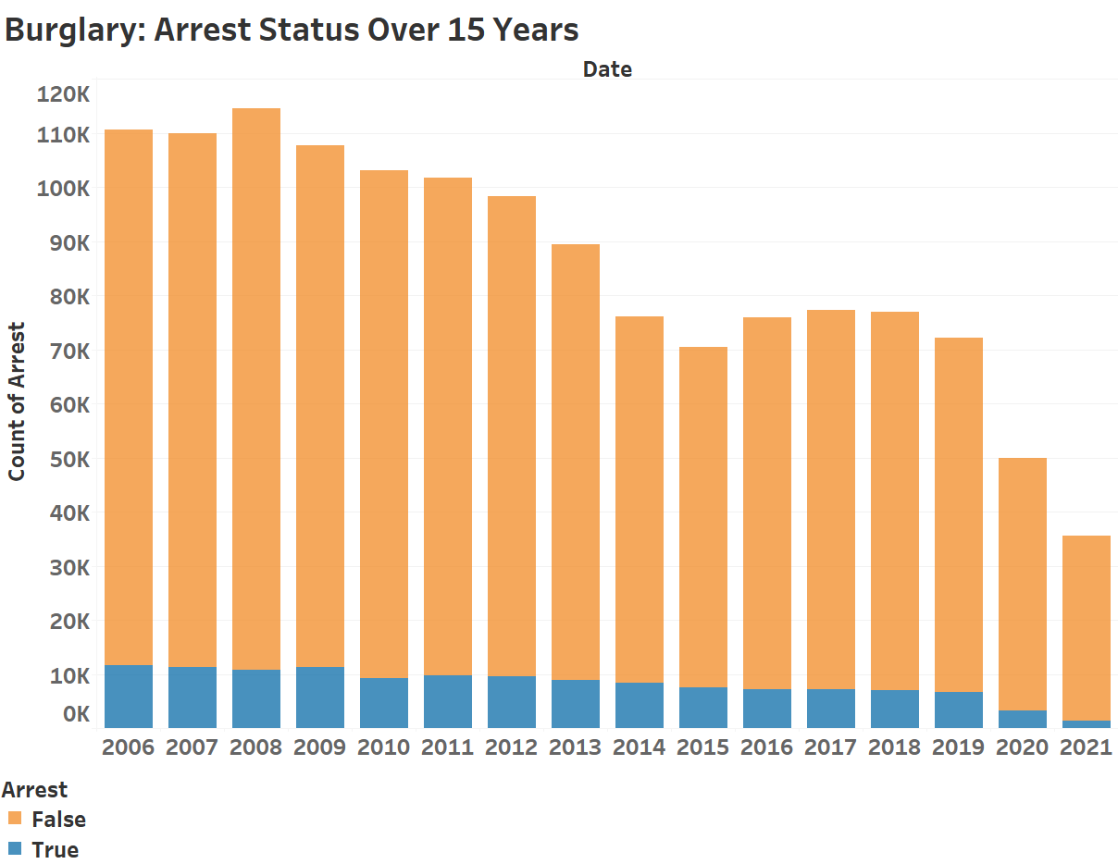

**Figure 3:** Burglary reports in Chicago. Blue is arrests made, orange is no arrests made.

Other crimes, such as many drug possession crimes, show an abnormally high rate of arrests being made. This is from police officers pulling cars over and finding drugs in their possession and being able to book the perpetrator right then and there. And while the number of Narcotics reports go down, the lack of arrests stays constant.

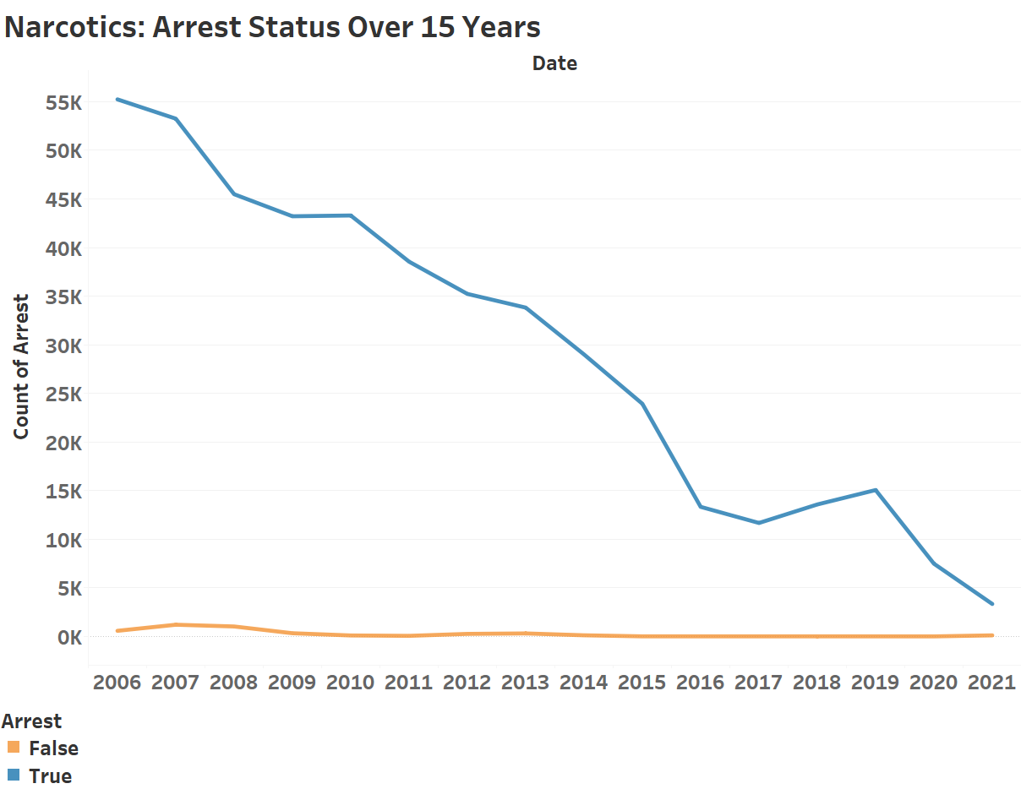

**Figure 4:** Narcotics reports in Chicago. Blue is arrests made, orange is no arrests made.

Looking at the results of overall crime being reported and seeing that certain crimes still have very high arrest rates, there is still the alarming question of why homicides arrest rates have been decreasing. According to Figure 5, the total number of homicide reports have been slowly increasing since 2006. There is even a strange pattern of spiking homicide numbers in the years that correspond with presidential elections. One thing to note is how high the number is in 2021, with the year still having two months left.

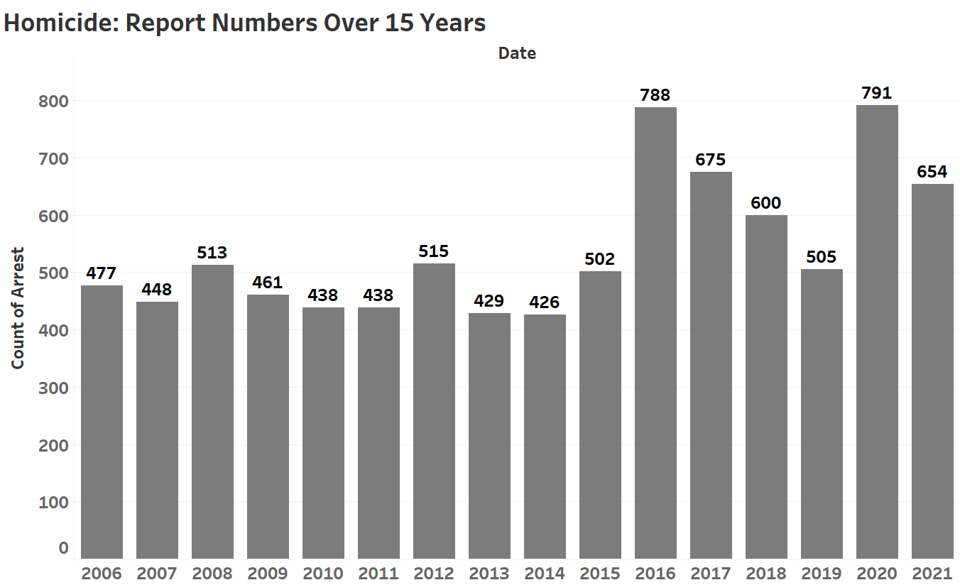

**Figure 5:** Homicide report count in Chicago from 2006-2021.

While increasing homicide cases are nothing new to the city of Chicago, being able to make an arrest on those ame cases has been more of a problem. Over time, the amount of no arrests for homicide cases overtakes the amount of arrests made.

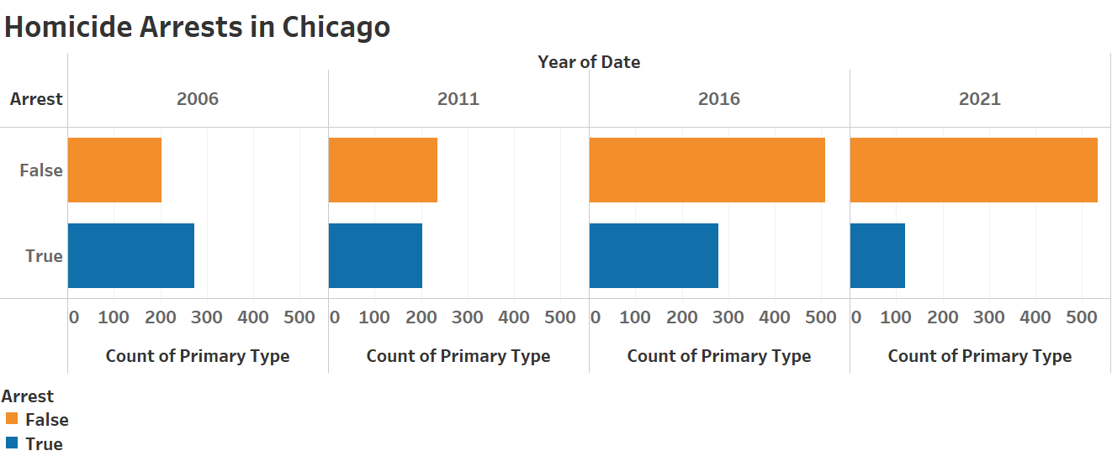

**Figure 6:** Arrest v. No Arrest in Chicago in 5 year increments.

*Conclusion*: Taking in all of the data from the city of Chicago and its problem with crime, there is something going on that has caused this lack of effort by the police to make arrests. This data doesn’t take into account the number of cases that haven’t been reported nor does it say if the cases without arrests include the group of cases where the victim doesn’t press charges. This also doesn’t explain if arrests made end with the perpetrator going to prison or if they arrested the wrong person. Instead, this data set shows the number of cases, whether or not an arrest was made, the location of where the report was made and the type of crime being committed. But even without the additional information that comes with crime cases, the lack of action by the police in Chicago is confusing. Even before the Defund the Police “movement”, police activity was dropping off and arrests made have been plummeting in comparison to the small number of cases. It would make more sense if the arrest rate stayed nearly constant over the years, no matter the number of total cases.

There is hope, however. Not every category of crime has seen a rapid decrease in arrests being made. This makes it more frustrating to see the lack of work being done when crimes like Narcotics and and others are seeing no change, if not an increase in arrest rate, as the years have gone on. Why are police not able to make arrests in more dangerous crimes like homicide or battery?

*How I chose my graphics*: The data set I chose took a very long time to download from the internet and then into Tableau so I knew I wasn’t going to be able to have nice, simple graphics. The data itself went back to 2001, but I chose to look at the data from 2006 and on to help declutter graphics and to narrow the image that I was trying to show with the graphics.

When creating the graphics, I wanted to stick with the same theme of colors to show arrests and no arrests as they were the major focal point of the data. My first thought was to choose red and non-arrests and have green and the arrests since our culture sees red as bad or stop and green as go or good. But I’m also aware that many people are colorblind to both those colors so instead, I chose blue and orange to represent arrests and non-arrest respectively. Because orange is the more popping color, I made that as the non-arrests because, in the case of this data set, an arrest not being made is something that I would consider “bad” and orange makes the number of non-arrests more shocking. I also kept the color the same to not confuse the reader of what the graphic was trying to show. The only graphic I used a neutral color was when I was showing the total number of reports for homicides and it was a combination of arrests and non-arrests.

Something I had to do for myself was do some exploratory data visualization because of how many different categories there were in my chosen data set. I definitely didn’t know what I wanted to show, I just knew that the city of Chicago is a place I’ve hated going because of how dangerous it is and I heard plenty of information being blasted on the news that tries to make Chicago sound like it’s not riddled with crime. Looking through this data confirms that Chicago is even more dangerous because while the number of reported crimes are going down, police aren’t doing their jobs to arrest criminals and put them behind bars.

In terms of the approach I took, I think I would say I went more persuasive with some aspect of informative visualization. Like I mentioned, I strongly, strongly dislike cities, especially Chicago because of the things I experienced there and I wanted to, in a way, prove why it’s not a good place to be. It may not be the murder capital of the United States, but murders in Chicago have recently sky-rocketed, which means there’s a city out there that’s even worse.

What I want the reader to take away from these graphics is for them to question why our law enforcement has begun failing in places where Americans need them the most. High crime areas need more law enforcement, otherwise maybe they wouldn’t be high crime areas. Hopefully this did the job; I know the premise of murder can be quite persuasive, especially with people who fear their death or their family’s death. And just because crime is down overall doesn’t make Chicago a place to be without being very careful.

*References*:

Chicago Tribune. (2021, April 27). *40,000 homicides: Retracing 63 years of murder in Chicago.* [Online]. Available: <https://www.chicagotribune.com/news/breaking/ct-history-of-chicago-homicides-htmlstory.html>

*Data Source*: Chicago Police Department’s CLEAR (Citizen Law Enforcement Analysis and Reporting). *Crimes - 2001 to Present,* Chicago, Illinois: data.cityofchicago.org, 2021. Accessed on: October 25, 2021. [Online]. Available: <https://catalog.data.gov/dataset/crimes-2001-to-present>