**Issues**

1. **Description:** Options are not available in screens much higher like computer. Only mobile screens

**Steps to reproduce:**

* + Open the “Quibka Sports Club Management” webpage in any mobile device.
  + Login into webpage.
  + Check the user options located at the top of webpage
  + Open the same webpage but in a computer screen (much higher than mobile device)
  + Login into webpage.

**Actual Result:**

The user options located at the top of webpage are hidden for a computer screen.

**Expected Result:**

The user options are shown at the top of webpage for a computer and mobile screens.

**Evidence:**

**Mobile’s Screen: (Simulation of iPhone 12 Pro).**

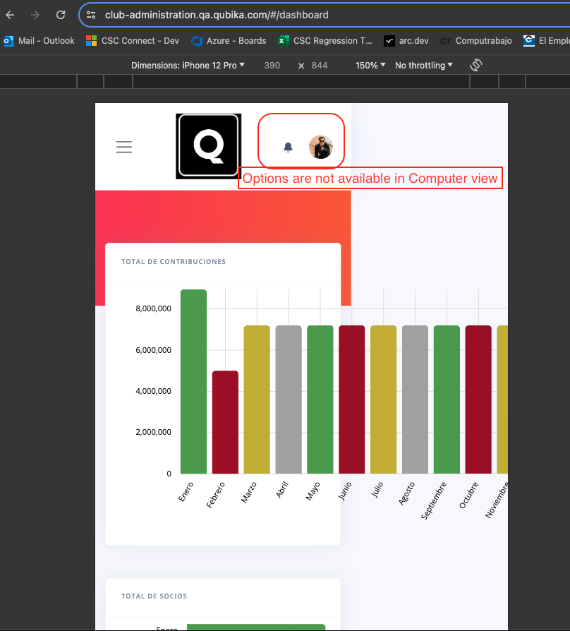

**Computer screen. (The user options are not available).**

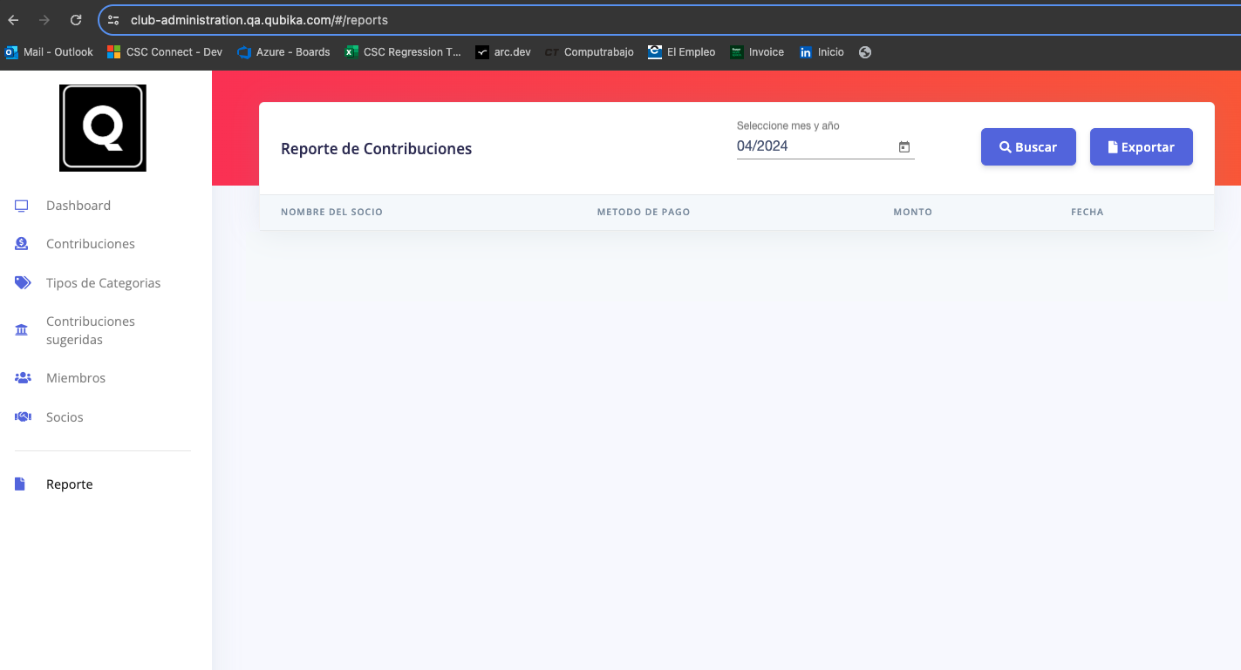

1. **Description: the application is not Responsive webpage, due to in mobile devices are broken the graphics and buttons (overlapping)**

**Steps to reproduce:**

* + Open the “Quibka Sports Club Management” webpage in any mobile device.
  + Login into webpage.
  + Check Dashboard graphics.
  + Click on side menu icon.
  + Click on “Reports” option.
  + Check Buttons.

**Actual Result:**

Buttons are overlapping and graphics is broken the width of webpage.

**Expected Result:**

Buttons, graphics and whole components of webpage should be shown properly, it doesn’t matter if it’s a mobile device or computer device.

**Evidences:**

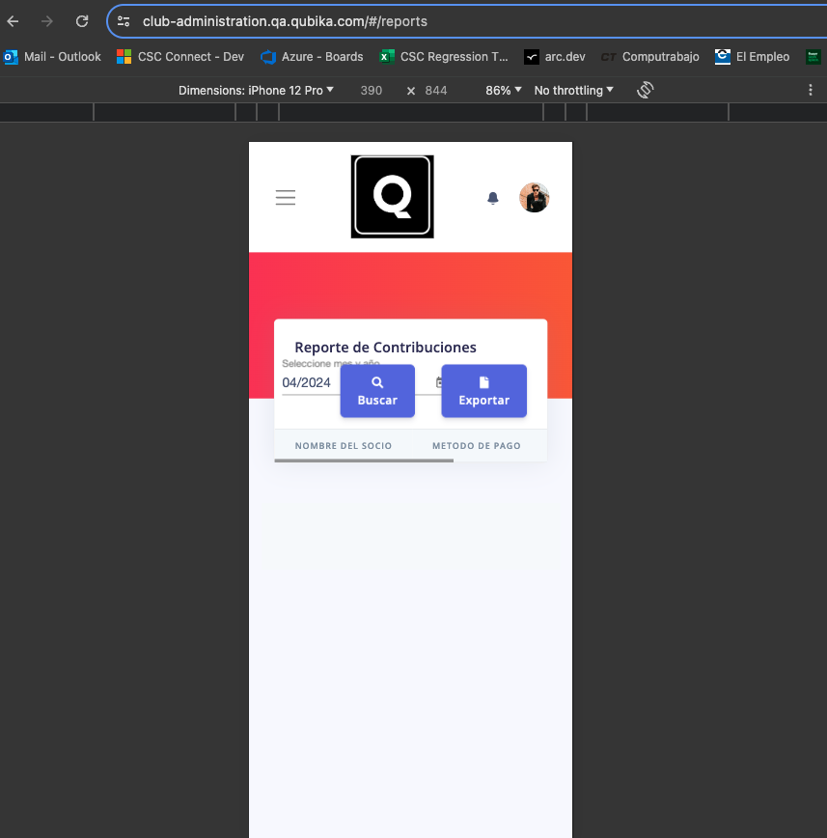

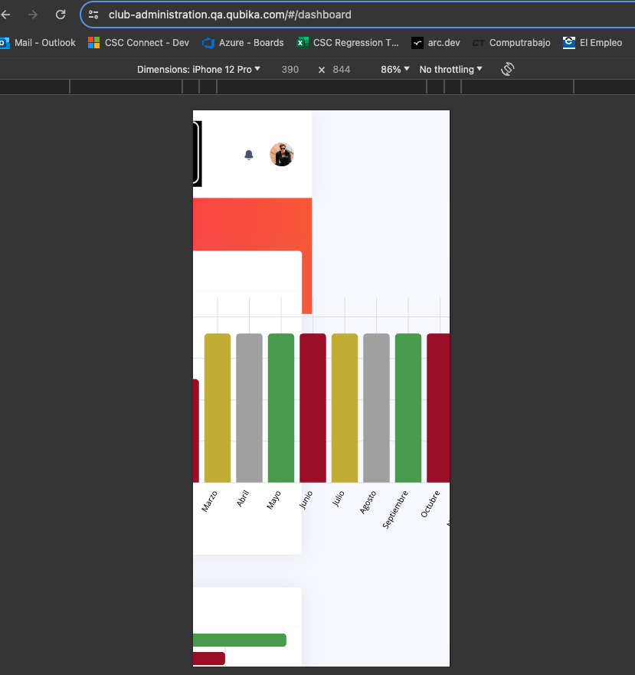

1. **Description: Notification bell contains misunderstanding options**

* **Steps to reproduce:** 
  + Open the “Quibka Sports Club Management” webpage in any mobile device.
  + Login into webpage.
  + Click on Notifications bell icon.
* **Expected Result:**

The notification bell options contain correct and understanding options for the user.

* **Actual Results:**

**The notification bell options are misunderstood for the user.**

* **Evidence:**

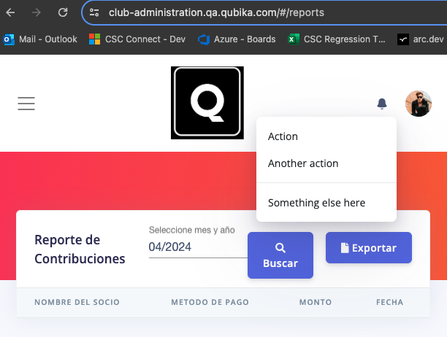

1. **Description: Pager of category types is not being shown correctly.**

* **Steps to reproduce:**
  + Open the “Quibka Sports Club Management” webpage in any device.
  + Login into webpage.
  + Click on “Category types” option located in menu side.
  + Check Pager component
* **Expected Result:**

The Pager is not being shown correctly. Whole pages number are shown into webpage.

* **Actual Result:**

The pager should have a maximum of pages to shown initially (for instance 1 – 15 pages) and there should be other button to get the latest pages of category types so I click it, the user should be taken to the “148” page.

* **Evidences:**

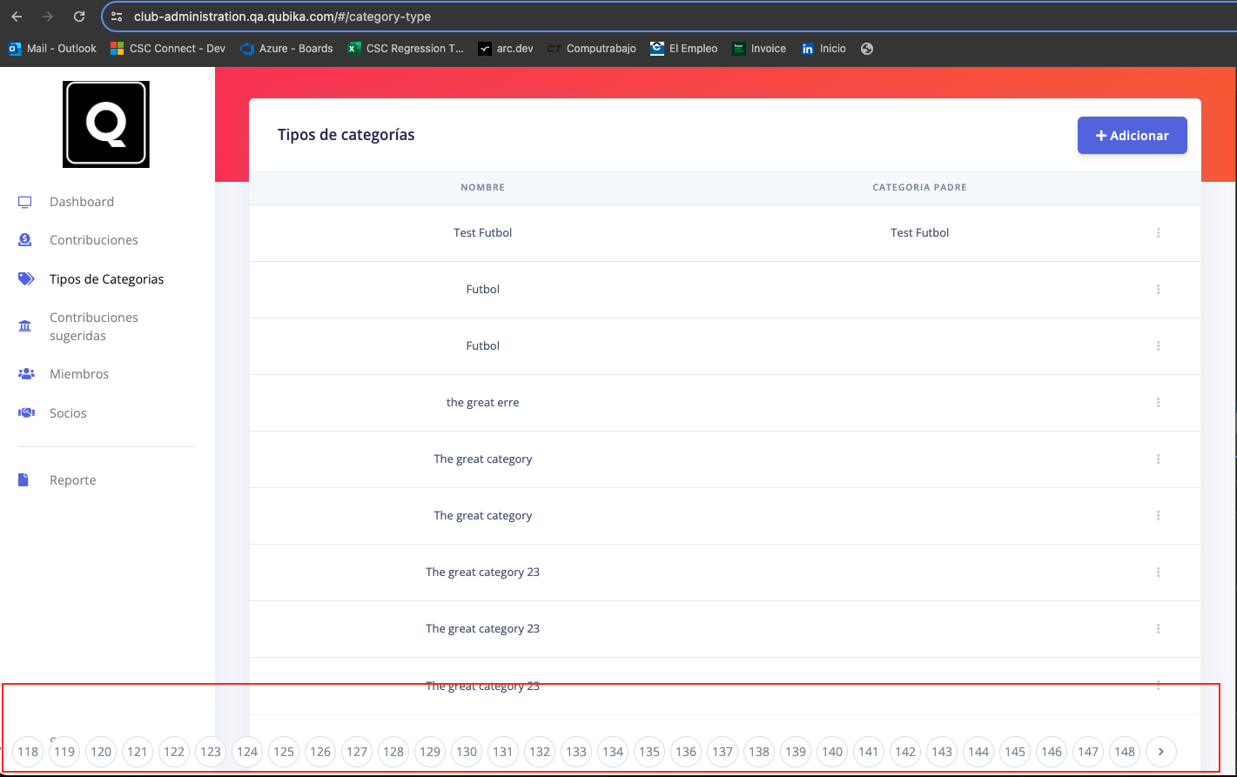

1. **Description: Authentication token and user credentials are exposed in browser console. When I inspect the browser and then I login into web application. So, the authentication token is being exposed and I can use it for other requests. Moreover I can get the email and password into Request Payload.**

* **Steps to reproduce:**
  + Inspect the browser console
  + Click on “Network” tab of console browser
  + Open the “Quibka Sports Club Management” webpage in any device.
  + Login into webpage.
  + Check the “Login” and “Account” requests

**Expected Result:**

The authentication token and user credentials are not exposed to get a greater security into application.

**Actual Result:**

The authentication token and user credentials are exposed so any person can use the other API request easily or can use the credentials to login directly into browser.

**Evidences:**

