# Linked Capacity Plus Design and Deploy

# Lab 3 – Connecting the Sites

## Objective of Lab:

In this lab, you will:

* Initiate the connection between Site 1 (Eastbrook Medical Center) and Site 2 (Northbrook Medical Center)

# Directions

## Activity 1: Review

In the previous labs, you deployed a Capacity Plus site (Site 1, Eastbrook Medical Center). You gathered the necessary information to plan the system linking Site 1 with Site 2 (Northbrook Medical Center). In this lab, you will initiate the connection between Sites 1 and 2.

You will need Case Studies 1 and 2, as well as the site planning information you created in Lab 2.

## Activity 2: Program the Repeater (Does this need to be done for LCP? Should it be replaced by “Program the Master Repeater”?)

Use the data you collected in your Fleetmap spreadsheet in Lab 1, and program the repeater. The illustrations below will guide you, but use your own information; the information in the illustrations is for example, only.

**Step 1: Device Information**

Ensure that the master repeater is at least firmware version R01.05.00.

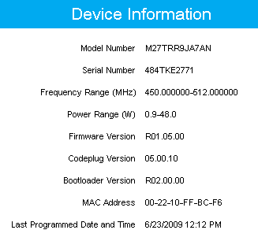

Repeaters must be at least firmware version R01.05.00.

**Step 2: General Settings**

Use the guidelines in the following illustrations to configure the general settings.

Start by selecting the **General Settings** menu on the left side of the screen.

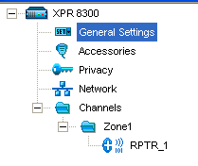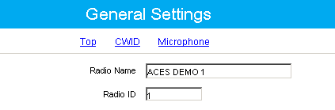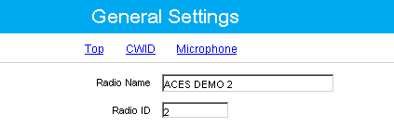

Each repeater is required to have a unique Radio ID.

Recommended:

Master Repeater is

Radio ID: 1

Voice Peer Repeaters as Radio ID: 2 – 6

Data Peer Repeaters as

Radio ID: 7 – 18

You can adjust group call hang times.

For true transmission trunking, hang times would be 0ms.

To account for fade into the receiver, however, DO NOT set these lower than 1000ms.

To let private calls remain active to the users, private call hang time should be ~4000ms.

Emergency call hang time should also have a value of 1000ms, so that a voice slot is reserved to answer the call.

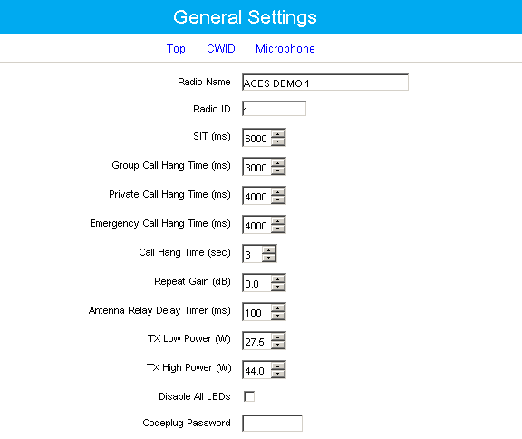

**Step 3: IP Site Connect**

Use the guidelines in the following illustrations to configure the IP Site Connect Repeater. This step includes optimizing capacity.

In the **Network** menu, under the **Link Establishment** banner, set **Link Type** to **Master**.

Enter the assigned **Authentication Key** to prevent unauthorized peers and RDAC from accessing the Capacity Plus system.

The Authentication Key should be the same for every peer.

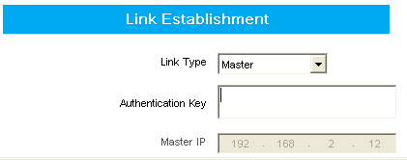

Assign **Ethernet IP**, **Gateway IP**, and **Gateway Netmask** address to the Master Repeater.

Recommended:

IP: 192.168.1.11

GW: 192.168.1.1

NM: 255.255.255.0

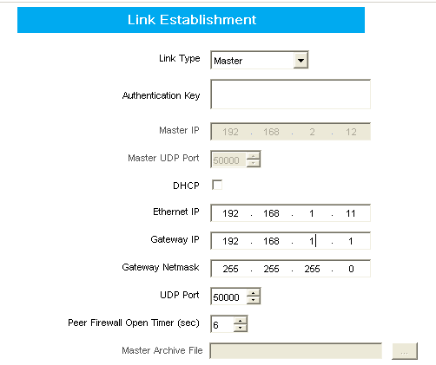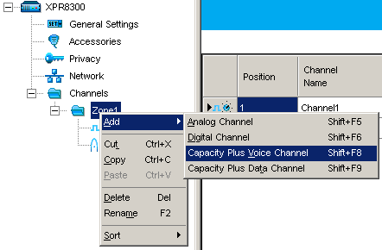

Right-click the **Zone** folder, select **Add**, then select **Capacity Plus Voice Channel**.

You can adjust the preference, depending upon which repeaters should be used before the others. By default, all repeaters should have the same setting.

Recommended:

Preference Level 3

(If a single repeater needs to have a higher priority, it is easier than moving all others to a lower priority.)

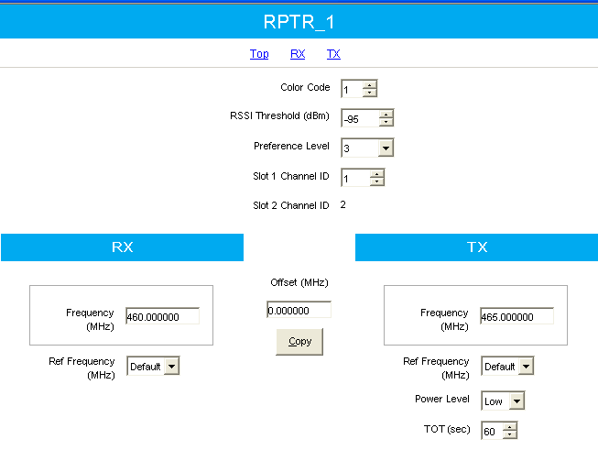

Assign Channel IDs to Slot 1 and Slot 2. This is used to match Channel ID to Frequency Pair in the subscriber programming.

Recommended:

Master: 1&2

Peer: 3&4

Peer: 5&6

Peer: 7&8

Peer: 9&10

Peer: 11&12



To program each peer:

In the **Network** menu, under the **Link Establishment** banner, set **Link Type** to **Peer**.

Enter the assigned **Authentication Key** to prevent unauthorized peers and RDAC from accessing the Capacity Plus system.

The Authentication Key should be the same for every peer.

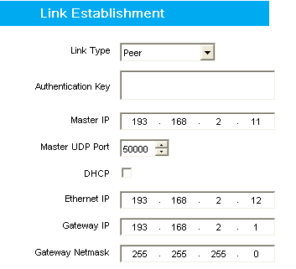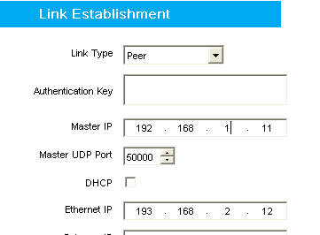

Configure the peer repeater with the location of the Master Repeater on the IP Network.

Recommended:

IP: 192.168.1.11

Configure the peer repeater with the location of the Master Repeater on the IP Network.

Recommended:

IP: 192.168.1.11

Assign **Ethernet IP**, **Gateway IP**, and **Gateway Netmask** address to each peer repeater.

Recommended:

IP: 192.168.1.12 to …1.28

GW: 192.168.1.1

NM: 255.255.255.0

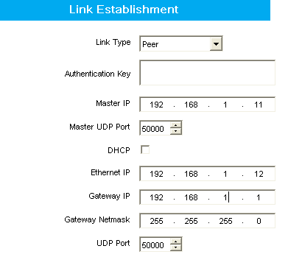

Adjust preference level according to which repeaters should be used before the others. By default, all repeaters should have the same settings.

Recommended:

Preference Level: 3

(If a single repeater needs to have a higher priority, it is easier than moving all others to a lower priority.)

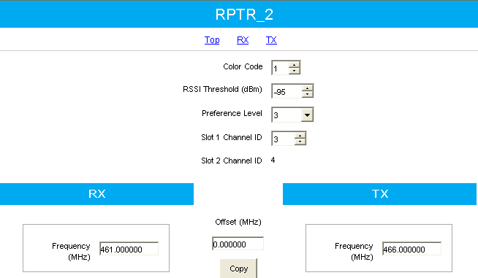

Assign channel IDs to Slot 1 and Slot 2. This is used to match channel ID to frequency pair in the subscriber programming.

Recommended:

Master: 1&2

Peer: 3&4

Peer: 5&6

Peer: 7&8

Peer: 9&10

Peer: 11&12



## Activity 3: Configure the Master Repeater Neighboring Site List

Using the information you have gathered, configure the Master Repeater Neighboring Site List. As with Activity 2, the illustrations below will guide you, but use the information you have gathered; the information in the illustrations is for example, only.

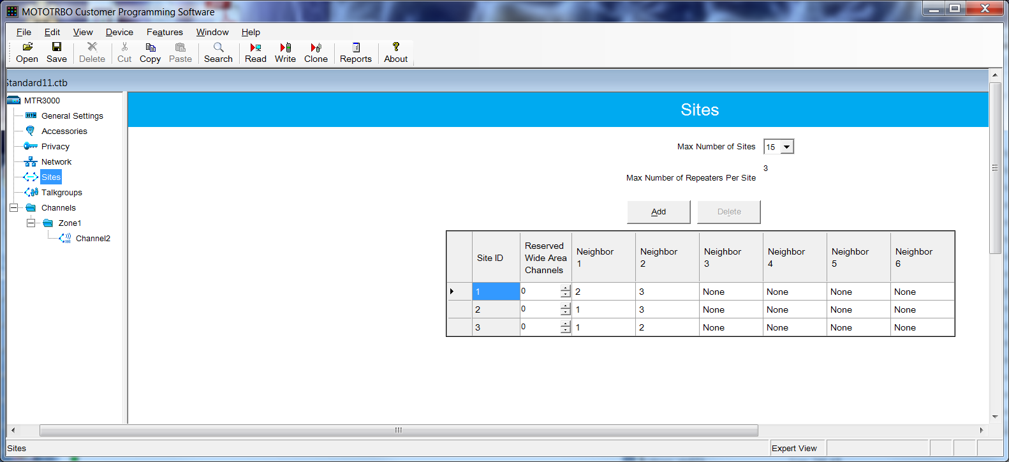

## With automatic roaming, a site only needs to configure its RF overlapping neighboring sites.



## Remember that the maximum number of repeaters per site must be either 3 or 6 for North America customers.



## Remember that the maximum number of sites must be either 3 or 5 for North America customers.



## Click Add or Delete to add or delete the number of sites.



## Remember that the Site ID is the same as the Site Number.



## Neighbors are dictated by the maximum number of repeaters.

## Activity 4: Program the Subscribers

Use the information from Lab 2, and program the subscribers. As with the previous activity, the illustrations below will guide you, but use the information you have gathered; the information in the illustrations is for example, only.

Set up the zone with the desired channels.

NOTE: LCP Personalities are the same as LCP channels.

The channel list is the list of all voice and data channels at each site.

The site list is what distinguishes Linked Capacity Plus. It shows which sites are contained within the Linked Capacity Plus system.

Site list – all of the sites

Channel list at each site

LCP Personalities

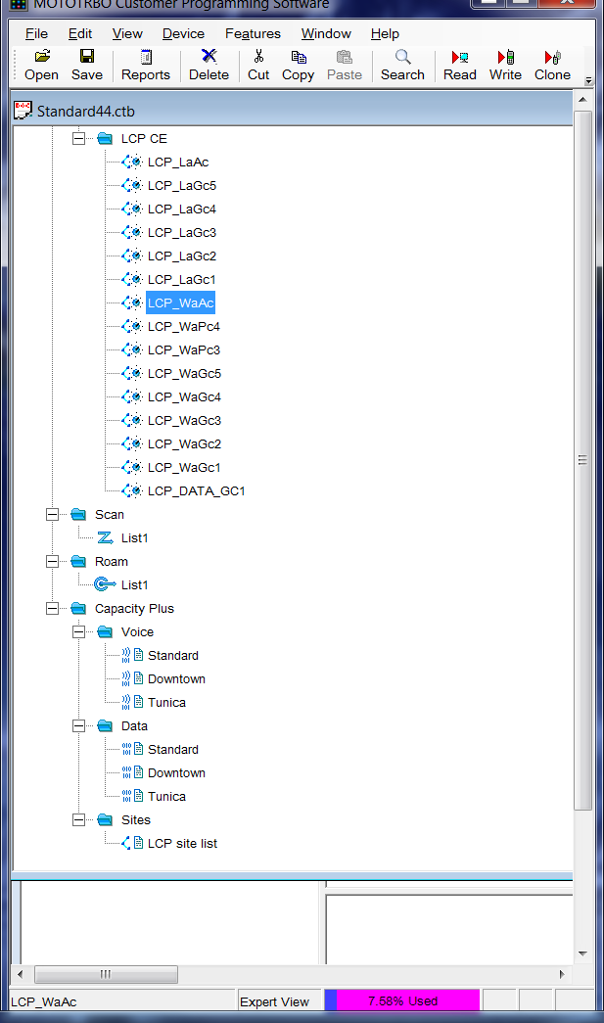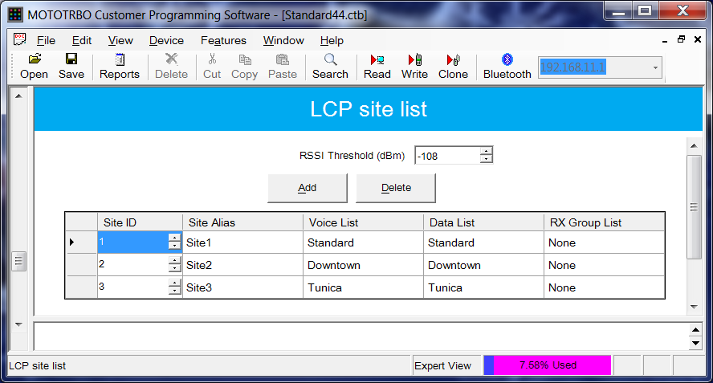

Build the Site List and set the RX Talkgroup and RSSI Threshold.

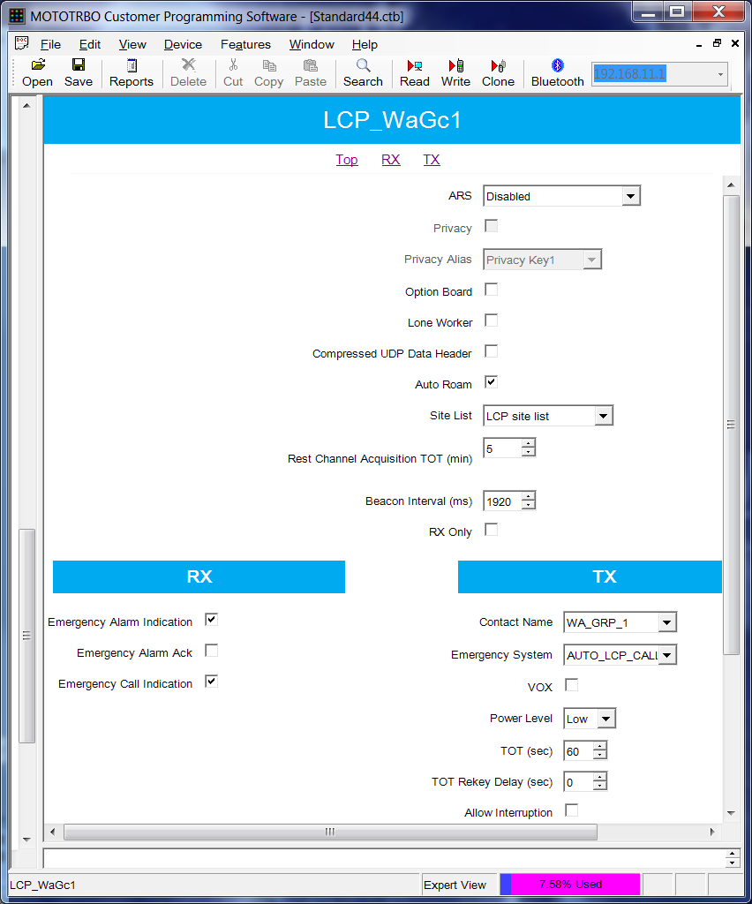

The Site List defines all Sites on which the radio is required to operate.

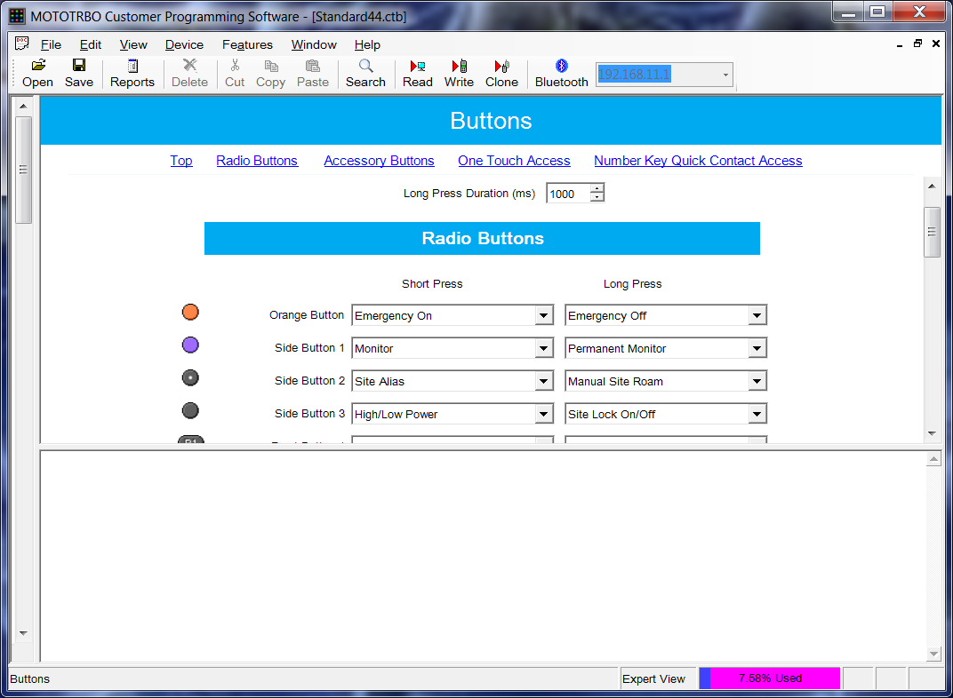

Configure the programmable buttons for locking the site, roaming to the site, and checking the site alias.

***Activity 5: Use RDAC to Confirm System Connections***

With the data you collected in Lab 2, use RDAC to confirm the system connections. As with the previous activities, the illustrations below will guide you, but use your own information; the information in the illustrations is for example, only.

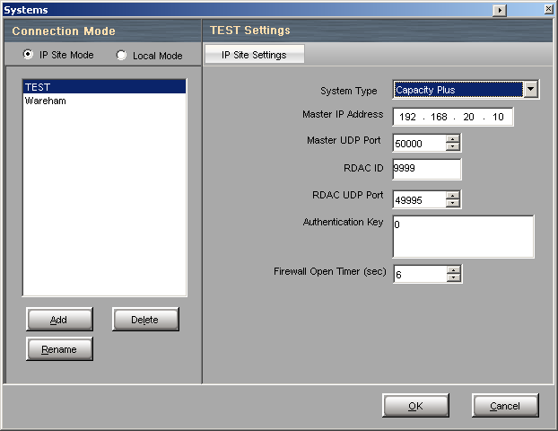

Use RDAC to confirm that all repeaters have joined the Capacity Plus system.

Multiple systems can be saved in the RDAC configuration.

For RDAC 2.0 and newer, select **Linked** **Capacity Plus** as the **System Type**.

Use RDAC to confirm that inbound RSSI is less than the RSSI Threshold programmed into the repeater codeplugs.

If the site noisefloor is higher than the RSSI Threshold, repeater will not be used as a rest channel.

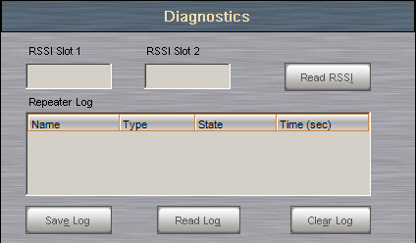

## Activity 6: Configure the Data Revert Settings

With the data you collected in Lab 2, configure the Data Revert control stations. As with the previous activities, the illustrations below will guide you, but use your own information; the information in the illustrations is for example, only.

**NOTES:**

* A data revert repeater requires a channel ID.
* Channel IDs must start at 33, and may be numbered up to 253.
* Capacity Plus and IP Site Connect data revert repeaters do not need channel ID configuration.

**Step 1: Configure the Data Revert Control Station.**

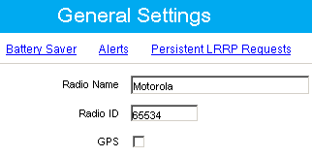

Each control station attached to the same server must have the same RadioID.

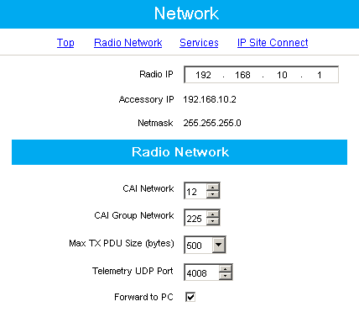

Each control station attached to the server must have the **Forward to PC** checkbox checked.

Each control station attached to the same server must have a different Radio IP.

i.e. 192.168.10.1, 192.168.20.1, 192.168.30.1

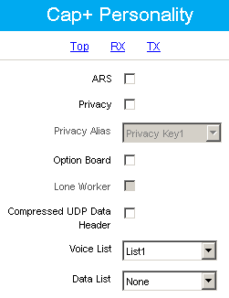

Leave the **ARS** checkbox unchecked. Control stations do not register to themselves.

Only include the voice repeaters, and leave **Data List** set to **None**.

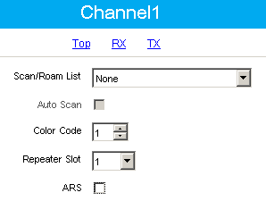

Each Data Revert Control station is programmed as a digital channel.

Leave the **ARS** checkbox unchecked. Control stations do not register to themselves.

**Step 2: Configure the Data Revert Subscribers.**

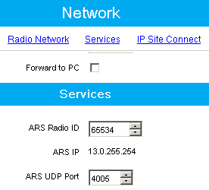

This is the RadioID of control stations attached to application server.

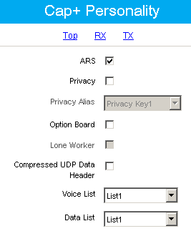

Check the **ARS** checkbox so that subscribers will register with the application server and receive update time instructions.

Subscribers will have both voice lists and data lists.

## Activity 7: Site Optimization and Validation

**Step 1: List and describe the tasks involved in site optimization. Include any remote devices.**

**Step 2: List and describe the tasks involved in validation (acceptance testing).**

**Step 3: List and describe the final steps in the deployment process, which ends when the system is handed over to the customer.**

## Conclusion

You have completed Linked Capacity Plus Design and Deploy Lab 3. You should now be able to complete the steps involved in linking two Capacity Plus systems, using Linked Capacity Plus.