INFORMACIÓ COMPLEMENTARIA:

Consum energètic per a fabricar una samarreta i uns pantalons

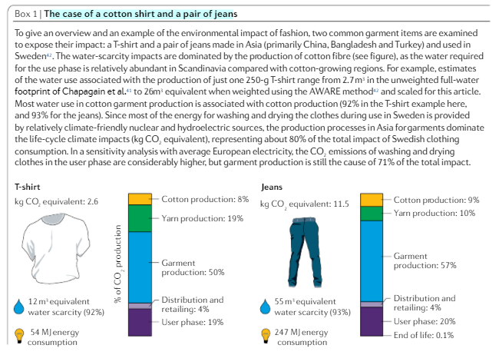

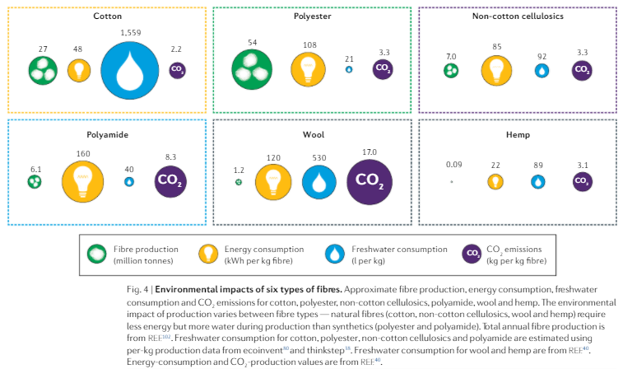

Font: <https://www.researchgate.net/publication/340635670_The_environmental_price_of_fast_fashion>

KG of CO2 emissions per ton of spun fiber:

| **Tables** | **crop cultivation** | **fiber production** | **TOTAL** |
| --- | --- | --- | --- |
| polyester USA | 0.00 | 9.52 | 9.52 |
| cotton, conventional, USA | 4.20 | 1.70 | 5.90 |
| hemp, conventional | 1.90 | 2.15 | 4.05 |
| cotton, organic, India | 2.00 | 1.80 | 3.80 |
| cotton, organic, USA | 0.90 | 1.45 | 2.35 |

Embodied Energy used in production of various fibers:

| **Tables** | **energy use in MJ per KG of fiber:** |
| --- | --- |
| flax fibre (MAT) | 10 |
| cotton | 55 |
| wool | 63 |
| Viscose | 100 |
| Polypropylene | 115 |
| Polyester | 125 |
| acrylic | 175 |
| Nylon | 250 |

Font: <https://oecotextiles.blog/2011/01/19/estimating-the-carbon-footprint-of-a-fabric/>

Densitat dels materials:

Font: <http://www.fao.org/3/AH827S03.htm>

Tela necessària per a cada peça:

| **Peces** | **Ample [m]** | **Larg [m]** | **TOTAL [m2]** |
| --- | --- | --- | --- |
| minifaldilla | 0,50 | 1,50 | 0,750 |
| faldilla mitja cama | 0,75 | 1,50 | 1,125 |
| faldilla llarga | 1,00 | 1,50 | 1,500 |
| Pantalons llargs | 1,10 | 1,50 | 1,650 |
| Jaqueta | 1,50 | 1,50 | 2,250 |
| Brusa maniga curta / samarreta | 1,25 | 1,50 | 1,875 |
| Brusa maniga llarga / samarreta | 1,50 | 1,50 | 2,250 |
| Vestit curt | 1,25 | 1,50 | 1,875 |
| Vestit maniga | 1,75 | 1,50 | 2,625 |

Font: <https://www.ohmotherminediy.com/aprender-coser-cuanta-tela-comprar-para/>