Interim Report
Student Name: Muhammad Ameer Hamza
Student ID: 2317058
Course: BEng (Hons) Computer Science
Supervisor: Razvan Dinita
Campus: Cambridge
Date: Nov 6, 2025

1. Project Proposal
Project Title: AI-Powered Study Planner with Assessment & Deadline Tracking

This project, therefore, will seek to design and develop an AI-driven web-based application to be used by students for the effective management of their modules, coursework, and daily study goals. The system will create adaptive, well-rounded study schedules that will prioritize urgent tasks and intelligently distribute workload by allowing users to input assessments, deadlines, and personal routines.

The application is to be built using React.js for the frontend and Firebase for backend services, including authentication, a database, and notifications. A rule-based AI algorithm will automate task prioritization and reminders. The dashboard will also include calendar views, insights into studies, and progress tracking to let users manually make adjustments in the schedules whenever needed.

It aims to better students' time management and productivity by providing personalized study recommendations and intelligent scheduling.

2. Work Plan / Gantt Chart
Week | Dates | Task / Milestone | Description
Week 1 | 10 – 16 Nov 2025 | Project Setup & Planning | Confirm project scope with supervisor, setup GitHub repo, outline deliverables, and finalize initial design approach.
Week 2 | 17 – 23 Nov 2025 | Requirements Gathering | Elicit user needs, identify system features, and propose requirement specifications.
Week 3 | 24 – 30 Nov 2025 | System Design (Architecture + UI) | Create system architecture, ER diagrams, and wireframes in Figma. Define Firebase database schema.
Week 4 | 1 – 7 Dec 2025 | Frontend Development (Phase 1) | Build UI components: login, registration, and dashboard layout using React + Tailwind CSS.
Week 5 | 8 – 14 Dec 2025 | Backend Setup | setup Firebase:Authentication, Firestore DB. implement basic CRUD operations on task and schedule data.
Week 6 | 15 – 21 Dec 2025 | AI Scheduling Logic (Phase 1) | Design and testing of a rule-based algorithm to prioritize tasks by urgency and load.
Week 7 | 22 – 28 Dec 2025 | Integration & Testing (Phase 1) | Integrate AI logic with frontend; conduct Initial functional testing. Run concurrently with updating documentation.
Week 8 | 29 Dec 2025 – 4 Jan 2026 | Winter Break / Light Documentation | Minimal work—refine design and document completed modules.
Week 9 | 5 – 11 Jan 2026 | AI Scheduling Logic (Phase 2) | Add adaptive adjustments and optional OpenAI prompt integration for study recommendations.
Week 10 | 12 – 18 Jan 2026 | Notifications & Reminders Module | Implement either Firebase Cloud Messaging or any email scheduler for task reminders.
Week 11 | 19 – 25 Jan 2026 | Dashboard & Calendar Integration | Integrate visual progress tracking and calendar view for deadlines and completed tasks.
Week 12 | 26 Jan – 1 Feb 2026 | Manual Control & Editing Features | Allow users to manually add/edit/remove tasks and override auto-schedules.
Week 13 | 2 – 8 Feb 2026 | System Testing & Debugging | Perform unit and integration testing, fix bugs, optimize performance.
Week 14 | 9 – 15 Feb 2026 | testing Setup | Use dummy data for usability testing via supervisor approval.
Week 15 | 16 – 22 Feb 2026 | User Testing & Data Collection | Conduct usability sessions, gather anonymous feedback, and document results.
Week 16 | 23 Feb – 1 Mar 2026 | Refinement & Improvements | Refine UI/UX and AI logic based on feedback; Update Documentation.
Week 17 | 2 – 8 Mar 2026 | Final Integration & Security Review | Review Firebase authentication, secure data handling, final integration checks.
Week 18 | 9 – 15 Mar 2026 | Final Testing & Project Completion | full system testing, prepare final demo version, backup repository.
Post-Submission Phase | 16 Mar – 24 Apr 2026 | Poster Presentation & Final Report | Prepare final report, visual poster, and reflection document for submission.

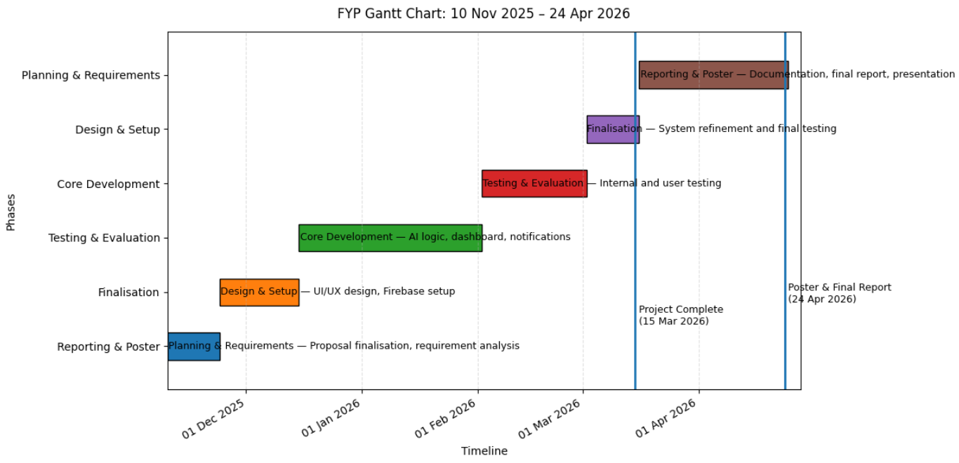

3. Ethics Approval Confirmation
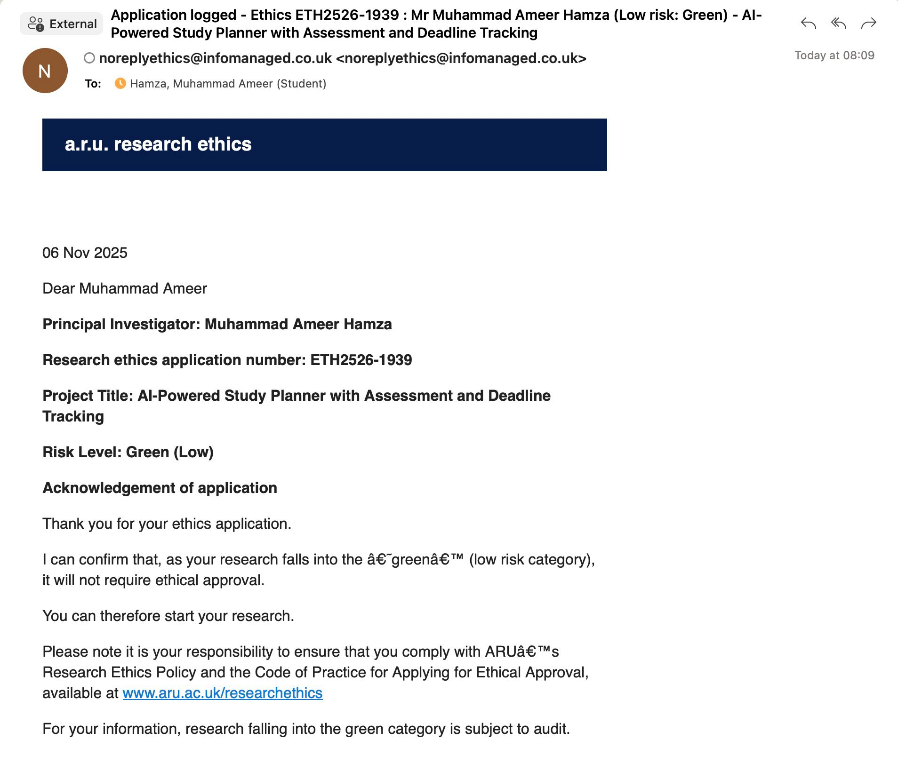

4. CV & Exit Plan
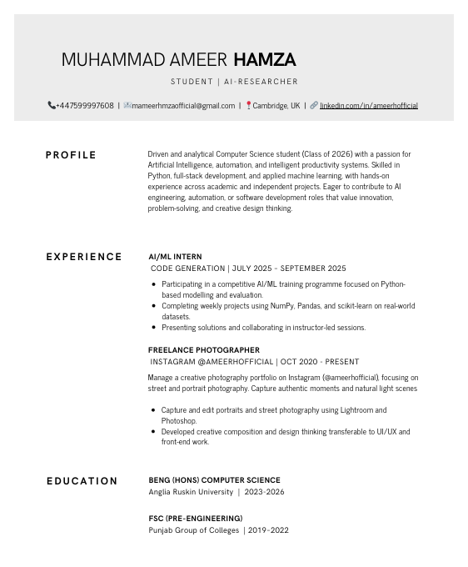
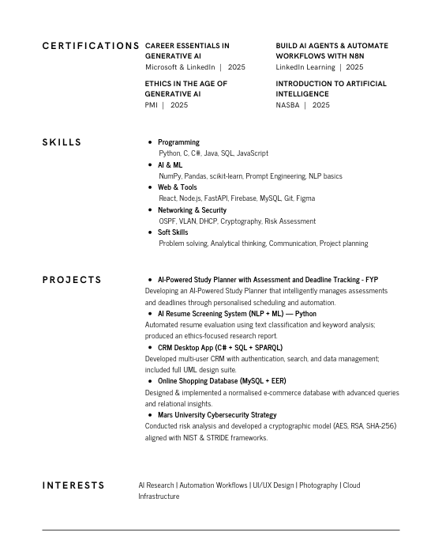

Exit Plan

I wish to pursue a professional career in Artificial Intelligence and Software Engineering after receiving my BEng (Hons) in Computer Science from Anglia Ruskin University. My objective is a graduate-level position as an AI Engineer, Automation Developer, or Full-Stack Developer where, by applying technical expertise in Python, React, Firebase, and machine learning, I can build intelligent, user-focused systems.

Long-term, I want to develop specialties in AI automation and product development by contributing to research and innovation efforts within the tech industry. Additionally, I would like to advance my academic and professional competencies with postgraduate study or a specialized certification in Artificial Intelligence and Machine Learning.

I focus on developing impactful solutions that integrate AI, automation, and user experience for practical, real-world applications through continuous learning, hands-on projects, and collaboration within industry teams.

5. Employability Activities

