LAB EXERCISE-5(GDB DEBUGGING)

K.HEMA ANMISHA

17MIS1059

1)BEFORE DEBUGGING

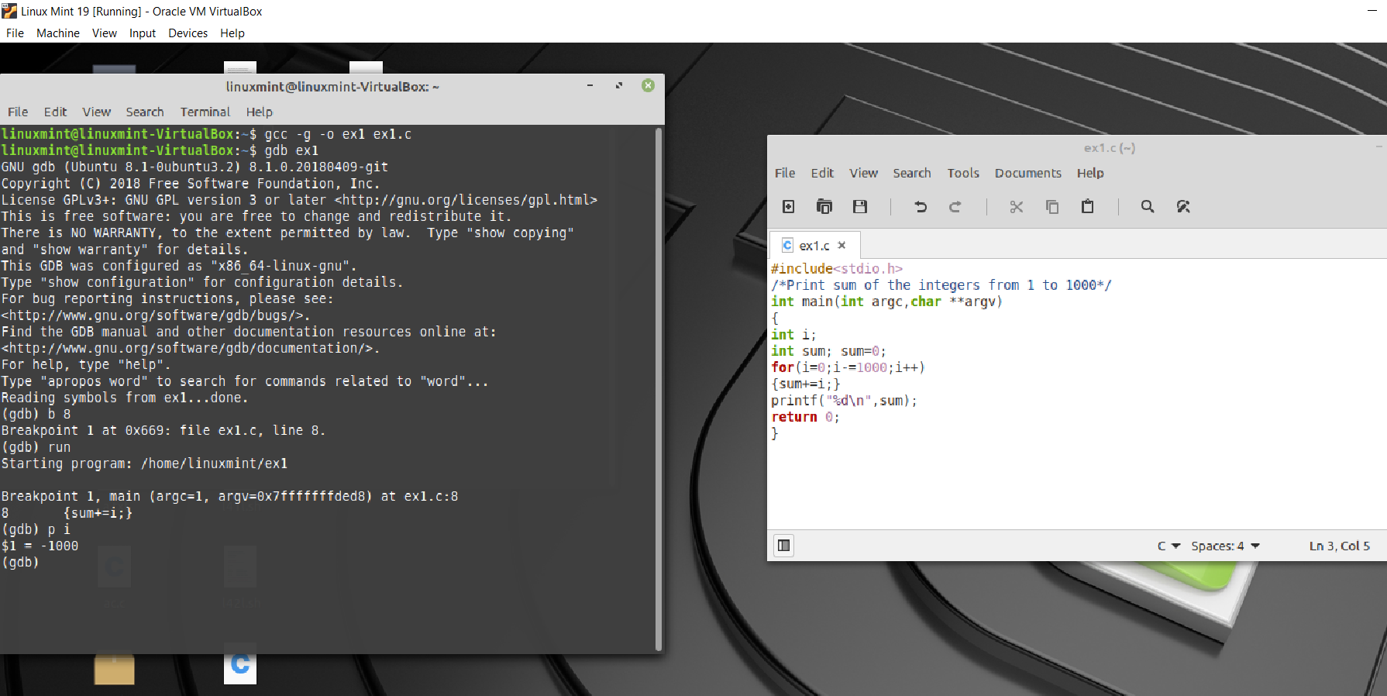

AFTER DEBUGGING

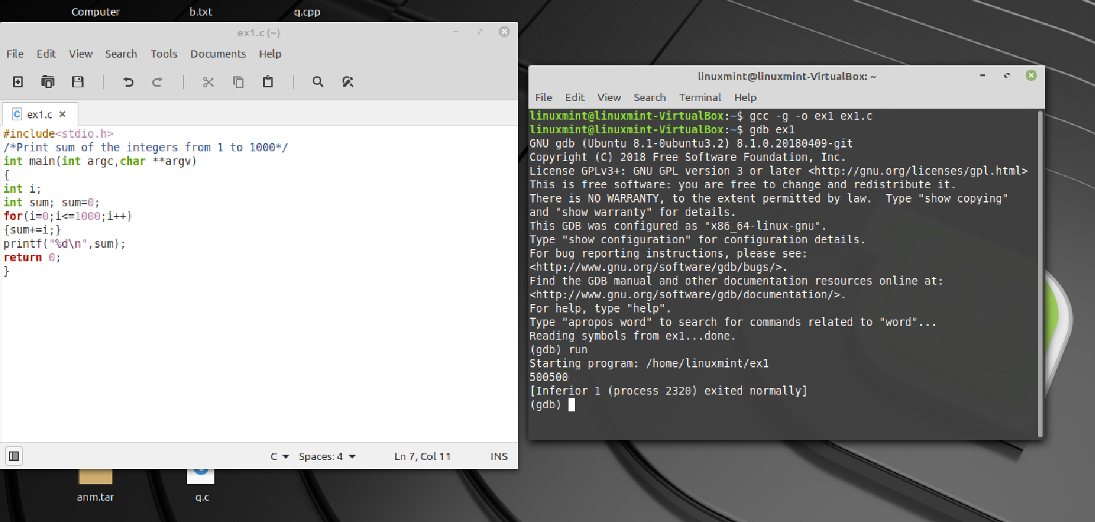

2) BEFORE DEBUGGING

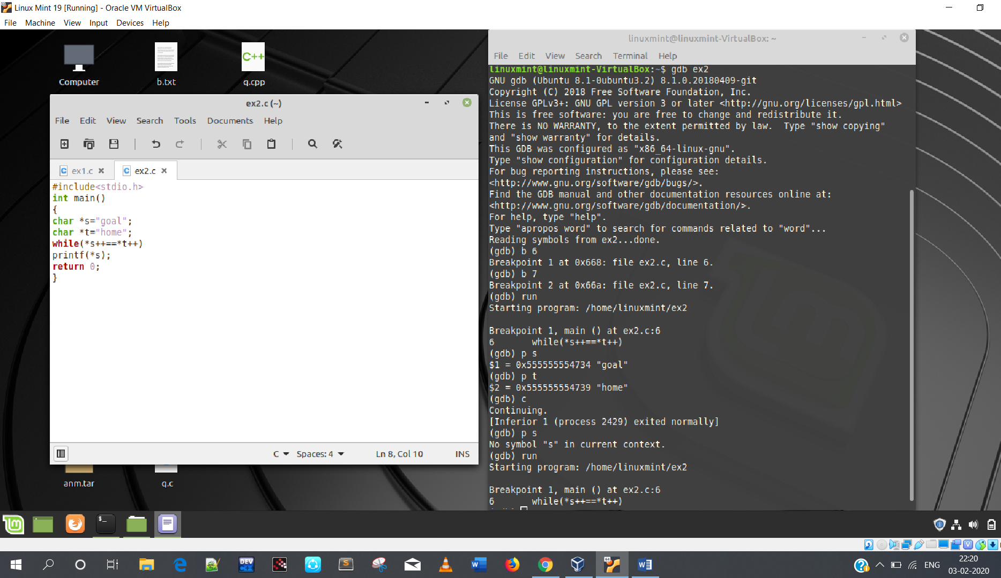

AFTER DEBUGGING

