LAB EXERCISE-6 (file permissions)

K.HEMA ANMISHA

17MIS1059

1. Write a program to open read and write operations on a file

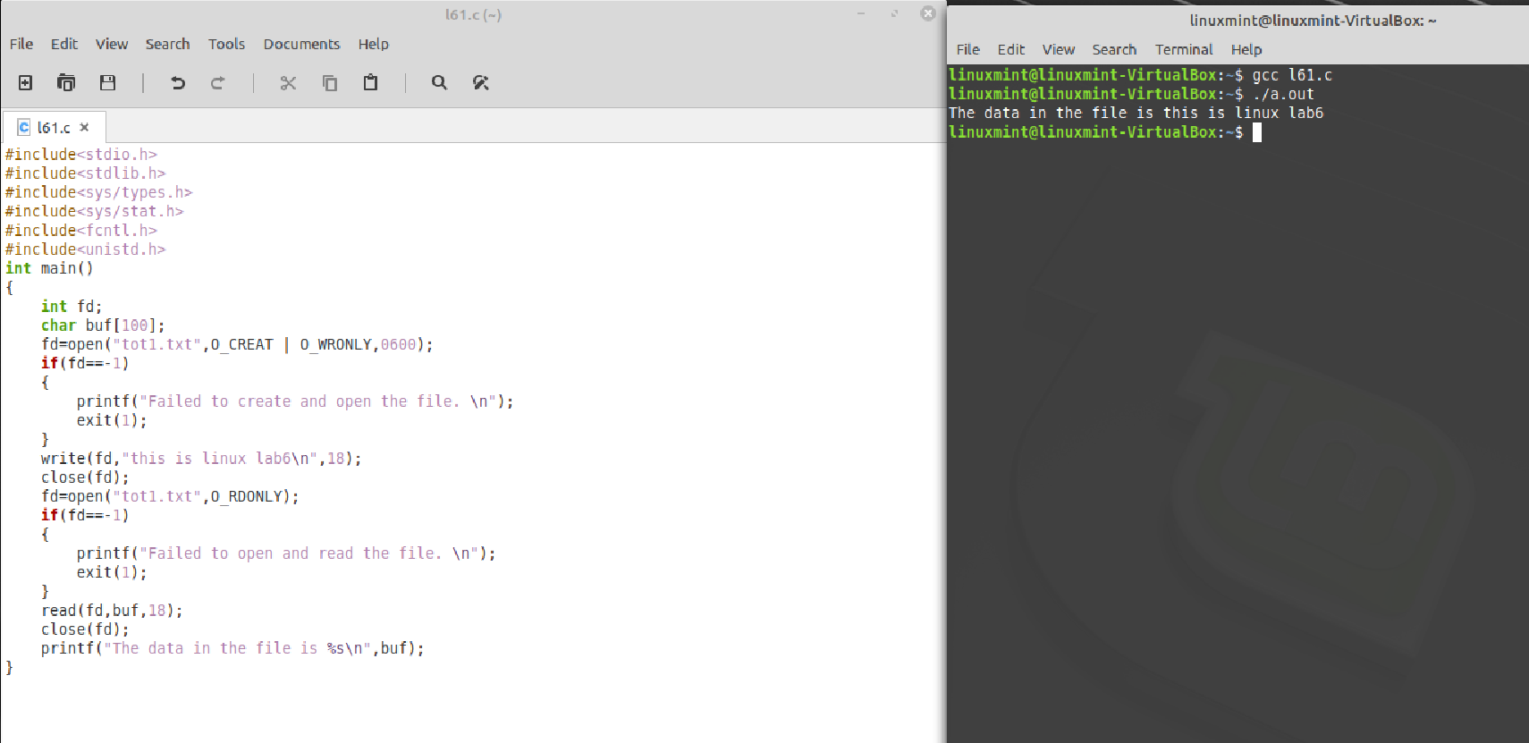

1. Write a program to write in a file and encounter an EINTR error in file reading

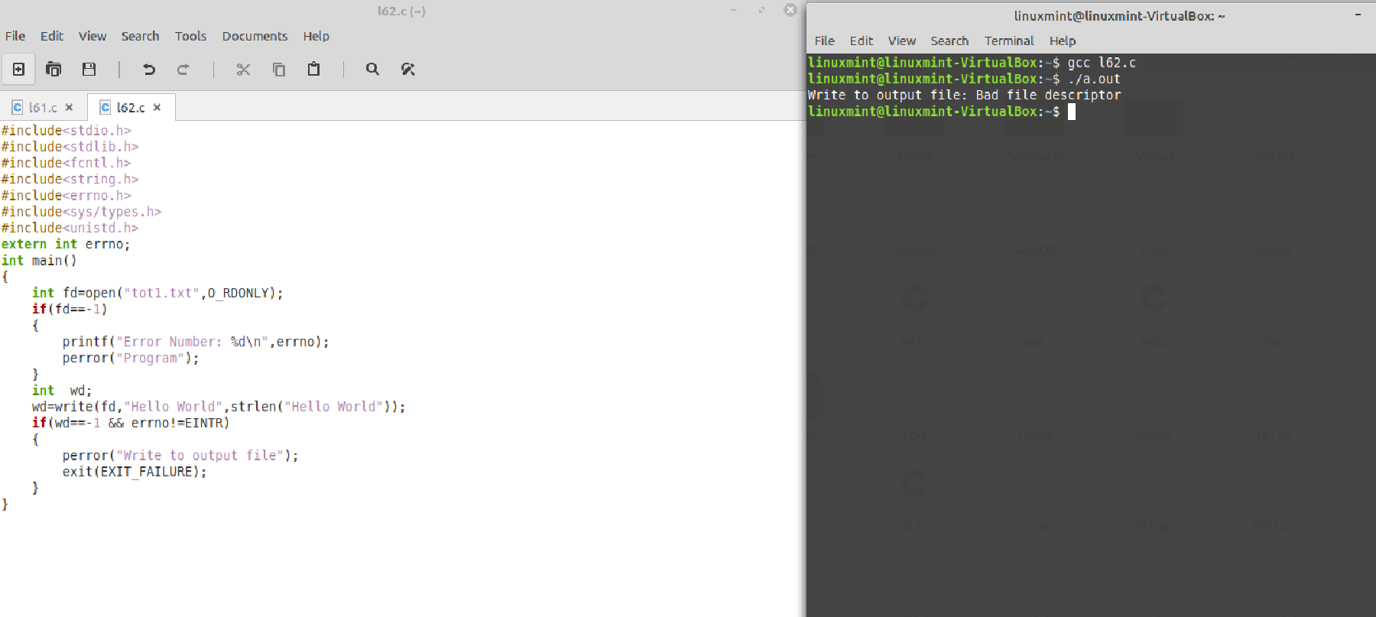

1. Non blocking read and write

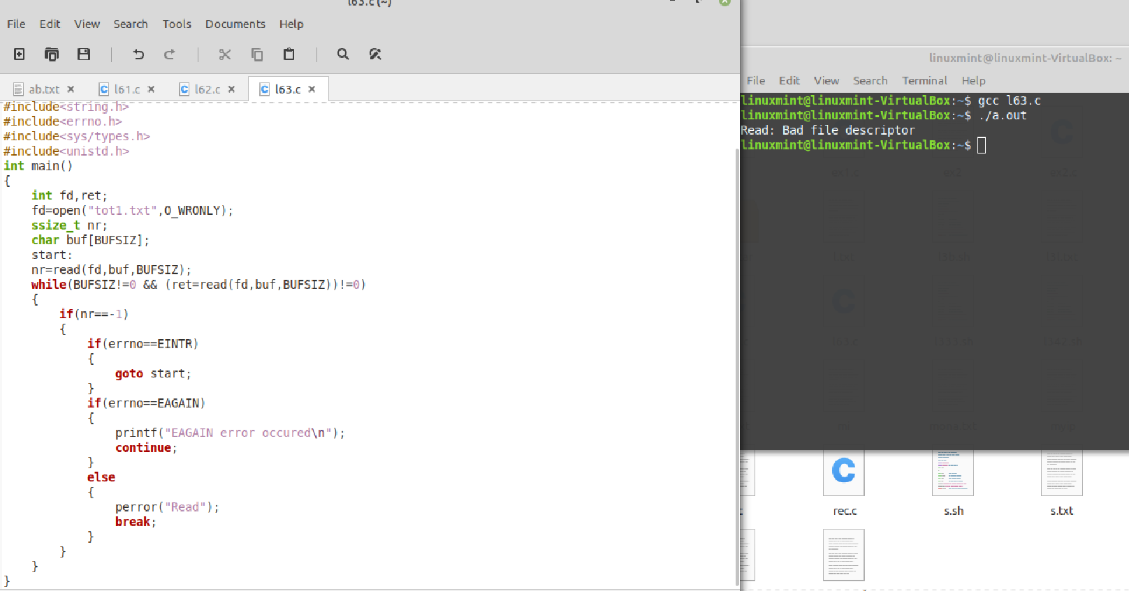

1. shell scripting for adding permissions for a file

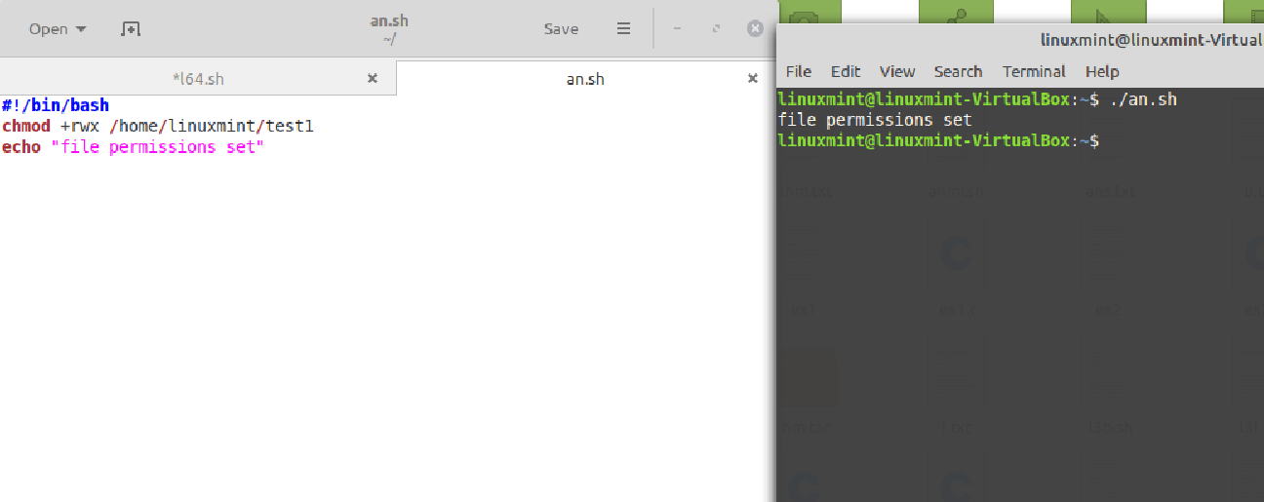

Shell scripting for removing permissions of a file

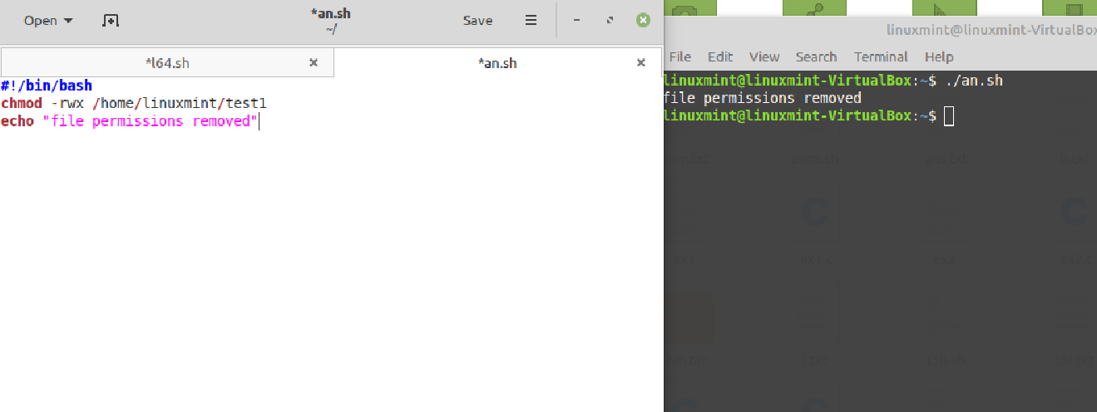

1. Set write permission for only one user on a file

