LINUX PROGRAMMING

LAB EXERCISE

K.HEM ANMISHA

17MIS1059

1. sl funny train running in the terminal

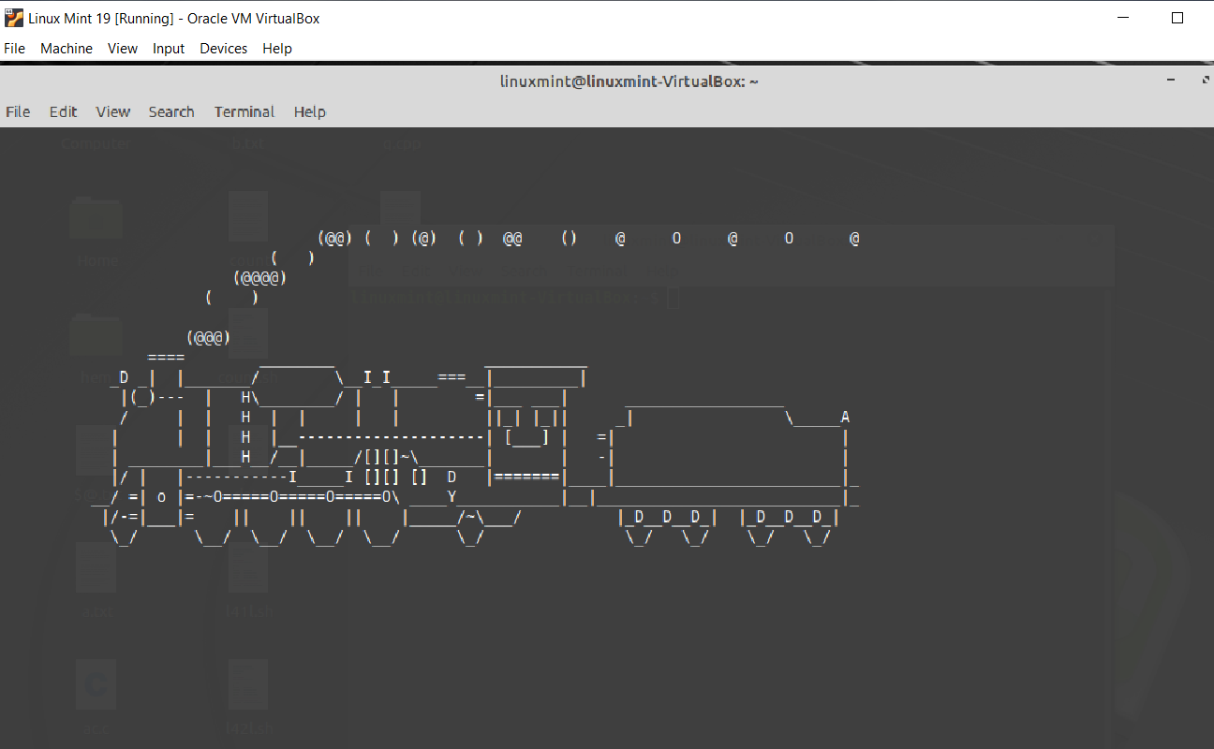

1. reverse command in linux

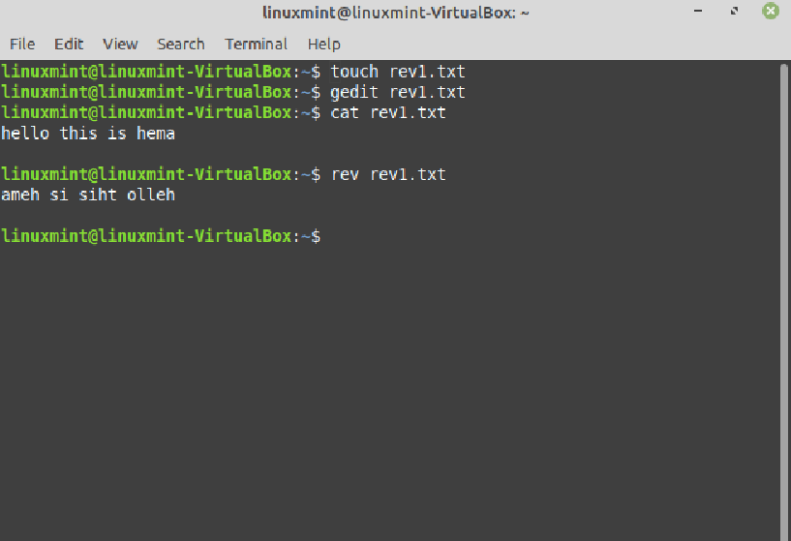

1. factor command in linux

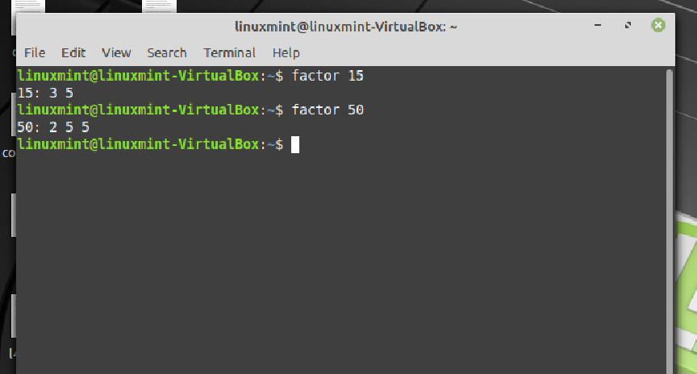

1. a shell script to monitor health of the system. Let the details be sorted and archieved in any folder of your choice.

