LAB EXERCISE-8

K.HEMA ANMISHA

17MIS1059

1. Using fork() method to create a child process

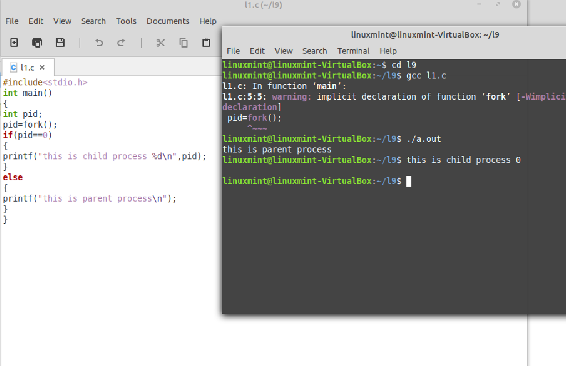

1. Using execve

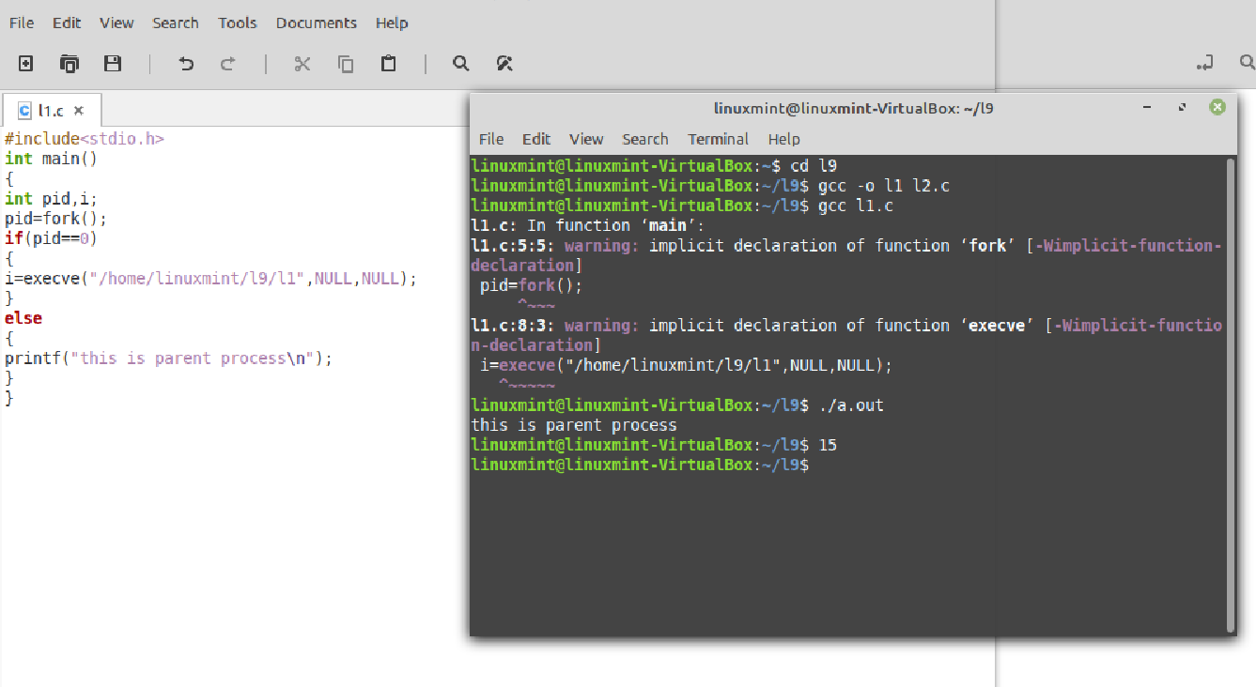

l2.c 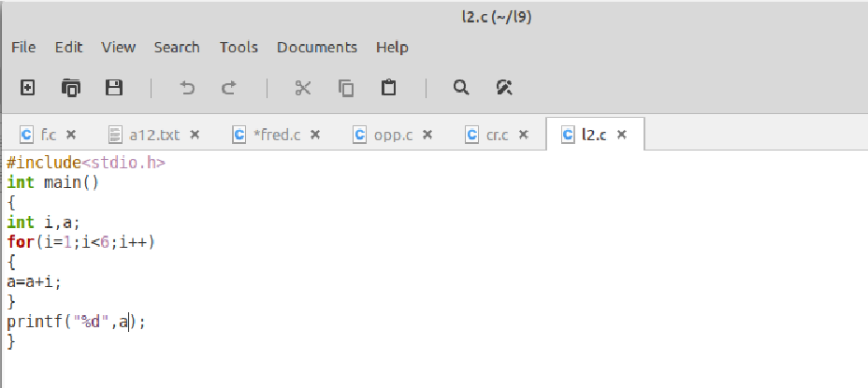

1. Blocking the parent process

