Automatic Segmentation of Thyroid Nodules in Ultrasound Imagery
Authors: Anamika J[AM.SC.U4AIE24008] , Shreya J[AM.SC.U4AIE24045]

1. Clinical Motivation and Dataset Rigor
Thyroid nodule assessment via ultrasound is clinically vital but heavily complicated by acoustic speckle noise, fuzzy nodule boundaries, and severe size variation across patients. Standard semantic segmentation architectures typically struggle to cleanly separate pathological tissue from surrounding healthy neck structures.
Dataset Configuration: We utilized the open TN3k dataset. To guarantee absolute experimental reproducibility, we locked the random seed (seed=42) and utilized a strict split: 2,303 training, 576 validation, and 614 test images. The test set was strictly isolated from all training loops.
Exploratory Data Analysis: Our EDA pipeline revealed an extreme foreground-to-background class imbalance. Approximately 85.78% of pixels represent background tissue, while foreground nodules average only 14.22%. Furthermore, the median nodule size occupies just 8.57% of the frame, with micro-nodules as small as 0.20%, presenting a major challenge for standard pooling operations.

2. Architectural Depth and Mathematical Formulation
To address the challenges identified during EDA, we developed a three-stage experimental protocol.

Mandatory Baseline
We established our performance floor using a 4-stage convolutional Vanilla U-Net trained entirely from scratch. Optimized with standard Binary Cross-Entropy (BCE), this model served as the required benchmark.

Proposed Architecture: AttentionResNet-34 U-Net
To directly combat ultrasound acoustic noise, we engineered a hybrid architecture employing an ImageNet-pretrained ResNet-34 encoder. The deeper residual connections act as robust low-level texture detectors, preventing the loss of micro-nodules that typically vanish in shallow pooling layers.

Compound Loss Formulation
Standard BCE loss fundamentally favors the majority class (the 85% background). We corrected this by utilizing a compound loss function: L = BCEWithLogitsLoss + SoftDiceLoss. The Dice component directly optimizes region overlap independent of absolute pixel volume, forcing the network to respect tight boundaries.

3. Experimental Rigor and Comparative Results
We executed a strict ablation study by training our proposed architecture twice: once with the full compound loss, and once relying solely on BCE. This controlled experiment isolates the exact quantitative contribution of the Dice loss mechanism.
Experiment | Model Architecture | Loss Function | Test Dice (Primary) | Test IoU (Secondary)
Run 1: Mandatory Baseline | Vanilla U-Net (Scratch) | BCE Only | 0.7838 | 0.6906
Run 2: Ablation Study | ResAttentionUNet -34 | BCE Only | 0.8025 | 0.7114
Run 3: Proposed Solution | ResAttentionUNet -34 | BCE + Soft Dice | 0.8342 | 0.7485

Qualitative Evidence

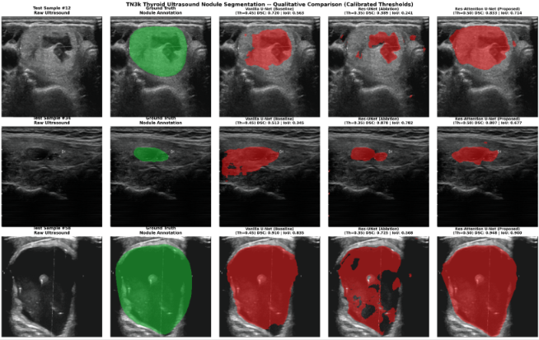

4. Failure Analysis and Limitations
- Acoustic Shadowing: High-density artifacts occasionally trigger false-positive segmentations in our proposed model, mistaking dark acoustic shadows for pathological tissue boundaries.
- Compute Constraints: Batch size was restricted to 16 due to the 16GB VRAM limitation on the Google Colab T4 hardware, preventing higher-resolution preprocessing.

5. Citations
- TN3k Dataset / TRFE-Net repository for open-source ultrasound arrays.
- PyTorch Core and Torchvision.
- Segmentation Models PyTorch (smp) for the ResNet-34 implementation.
- Albumentations for medical imaging data augmentation transforms.

