RentAFit Model A Handbook (V2 Rerun, Fully Synced)

1) Document objective
This document is the complete technical record of Model A (Rental Price Range Prediction) in RentAFit, updated after a fresh v2 rerun.
It covers: - problem statement, - datasets and rule logic, - model evolution from baseline to v2, - exact formulas, - libraries and implementation details, - fresh run outputs, - graph generation and graph-by-graph interpretation, - inference behavior and safety controls.
This version is intended to be both beginner-readable and technically correct for academic review.

2) Problem definition
Model A predicts a rental price range for a listing: - min_price - max_price
Input attributes: - brand - category - material - size - condition - age_months - original_price
Why range (min/max) and not one value: - rental prices are naturally uncertain, - a range is safer for platform moderation, - a range supports provider flexibility while keeping prices realistic.

3) Code and artifact locations

3.1 Main code
- /Users/mypc/RentAFit/code/model_a/training/train_model_a_baseline.py
- /Users/mypc/RentAFit/code/model_a/training/train_model_a_rf_abs.py
- /Users/mypc/RentAFit/code/model_a/training/train_model_a_rf_pct.py
- /Users/mypc/RentAFit/code/model_a/training/train_model_a_rf_pct_tier_split.py (current v2 model)
- /Users/mypc/RentAFit/code/model_a/inference/predict_price_range_simple_input.py
- /Users/mypc/RentAFit/code/model_a/analysis/model_a_full_report.py
- /Users/mypc/RentAFit/code/model_a/utils/feature_builder.py
- /Users/mypc/RentAFit/code/pricing_rules.py

3.2 Data snapshot used
- /Users/mypc/RentAFit/data/frozen/v1_final/model_a_train_ready.csv
- /Users/mypc/RentAFit/data/frozen/v1_final/brand_tier_master_project_final.csv

3.3 Model outputs
- /Users/mypc/RentAFit/models/model_a/rf_pct_tier_split/*.pkl
- /Users/mypc/RentAFit/models/model_a/rf_pct_tier_split/model_a_rf_pct_tier_split_metadata.json

3.4 Reports and charts
- /Users/mypc/RentAFit/reports/model_a/metrics/*.json
- /Users/mypc/RentAFit/reports/model_a/analysis/*.csv
- /Users/mypc/RentAFit/reports/model_a/charts/*.png

4) Dataset profile (used in this rerun)
From model_a_train_ready.csv: - Total rows: 1500 - Total columns: 20 - Split: - train: 1082 - val: 287 - test: 131 - Tier distribution: - Tier 1: 269 - Tier 2: 275 - Tier 3: 292 - Tier 4: 380 - Tier 5: 284 - Data source mix: - manual: 375 - synthetic: 1125
From brand_tier_master_project_final.csv: - Brand rows: 79 - Tier distribution: - Tier 1: 5 - Tier 2: 13 - Tier 3: 21 - Tier 4: 21 - Tier 5: 19 - Missing avg_price_max rows (open-ended price bands): 13

5) Pricing rule foundation (supervised target source)
Model A is trained on labels generated from deterministic rules.
Rule file: - /Users/mypc/RentAFit/code/pricing_rules.py

5.1 Tier assignment by original price
- <= 1200 -> Tier 1
- <= 2500 -> Tier 2
- <= 5000 -> Tier 3
- <= 15000 -> Tier 4
- > 15000 -> Tier 5

5.2 Base percentages
BASE_MIN - Tier 1: 0.05 - Tier 2: 0.06 - Tier 3: 0.07 - Tier 4: 0.09 - Tier 5: 0.11
BASE_MAX - Tier 1: 0.06 - Tier 2: 0.07 - Tier 3: 0.09 - Tier 4: 0.11 - Tier 5: 0.14

5.3 Multipliers
Condition multiplier: - New -> 1.00 - Like New -> 0.90 - Used -> 0.70
Age multiplier: - <=3 -> 1.00 - <=6 -> 0.90 - <=10 -> 0.80 - <=15 -> 0.70 - >15 -> 0.60
Category multiplier: - Saree / Lehenga / Ethnic Wear -> 1.10 - Dress / Jacket -> 1.05 - Shirt / Top / Kurta -> 1.00 - Activewear / Jeans -> 0.95
Material multiplier: - Silk / Leather -> 1.05 - Linen -> 1.03 - Others -> 1.00

5.4 Core rule formulas
Let: - OP = original_price - bmin = BASE_MIN[tier_primary(OP)] - bmax = BASE_MAX[tier_primary(OP)] - cm = cond_mult(condition) - am = age_mult(age_months) - catm = cat_mult(category) - matm = mat_mult(material)
Then: - raw_min = OP * bmin * cm * am * catm * matm - raw_max = OP * bmax * cm * am * catm * matm
Capping rule: - cap_min = min(raw_min, 0.20*OP, OP) - cap_max = min(raw_max, 0.20*OP, OP)
Rounding buckets: - value < 200 -> nearest 10 - 200 <= value <= 1000 -> nearest 50 - value > 1000 -> nearest 100
Final constraints: - rule_min = bucket_round(cap_min) - rule_max = bucket_round(cap_max) - if rule_max < rule_min, force rule_max = rule_min
Model targets: - target_rule_min = rule_min - target_rule_max = rule_max

6) Why Model A evolved in multiple stages

Stage 1: Linear Regression baseline
Purpose: - establish a baseline reference.
Issue: - weak non-linear fit, - many invalid range order cases before post-fix.

Stage 2: RF with absolute targets
Purpose: - capture non-linear interactions better.
Issue: - price scales across tiers are very different (Tier 1 vs Tier 5), reducing consistency.

Stage 3: RF with percentage targets
Key idea: - predict % of original price instead of absolute price directly.
Benefit: - scale normalization, - major MAE drop.

Stage 4 (current): RF % tier split + Tier5 residual + oversampling
Why: - error concentration in Tier 5 remained higher in absolute terms.
V2 improvements: - separate models for Tier 5 and Tier 1-4, - Tier 5 sparse-brand oversampling, - Tier 5 residual correction model for max% prediction, - confidence-based fallback to deterministic rule range.

7) Libraries used and why

Core Python
- json: saves metrics, metadata, and route summaries.
- argparse: creates command-line style inference scripts.
- pathlib: stable path handling for models, datasets, and reports.
- math: supports utility-style numeric logic.

Data handling
- pandas: reads CSV files, merges brand master information, prepares feature tables, and builds report summaries.
- numpy: handles numeric transformations, vectorized operations, quantiles, and error calculations.

Machine learning
- scikit-learn is the main ML framework for Model A.
Used components: - LinearRegression: baseline model for simple first comparison. - RandomForestRegressor: main non-linear regression engine. - ColumnTransformer: separates categorical and numeric preprocessing cleanly. - OneHotEncoder(handle_unknown='ignore'): safely encodes brand/category/material/size/condition/tier without crashing on unseen values. - Pipeline: keeps preprocessing and model together as one trainable and savable unit. - mean_absolute_error and mean_squared_error: used for evaluation.

Serialization
- joblib: saves trained sklearn pipelines as .pkl files so the same preprocessing and model structure can be reused during inference.

Visualization
- matplotlib: generates parity, residual, tier-error, and model-comparison charts.

Why this technology stack is suitable
This stack is practical for a student ML pricing project because: - sklearn is strong for tabular regression, - pandas and numpy make structured data easy to manage, - joblib keeps deployment simple, - matplotlib makes the results explainable.

One-hot encoding used in Model A
One-hot encoding is used for all categorical Model A inputs: - brand - category - material - size - condition - tier_primary
These encoded columns are stored inside the fitted sklearn pipelines and were also exported separately for inspection in: - /Users/mypc/RentAFit/data/frozen/v1_final/model_a_onehot_exports/model_a_final_onehot_combined.csv - /Users/mypc/RentAFit/data/frozen/v1_final/model_a_onehot_exports/model_a_final_onehot_tier1to4.csv - /Users/mypc/RentAFit/data/frozen/v1_final/model_a_onehot_exports/model_a_final_onehot_tier5.csv

8) Feature engineering in v2

8.1 Main feature set
- brand
- category
- material
- size
- condition
- tier_primary
- age_months
- original_price
- base_min_pct
- base_max_pct
- cond_mult
- age_mult
- cat_mult
- mat_mult
- brand_avg_price_min
- brand_avg_price_max
- is_open_ended_brand_price
- brand_known_in_master

8.2 Target transformation
- target_min_pct = target_rule_min / original_price
- target_max_pct = target_rule_max / original_price

8.3 Tier 5 residual correction
- base Tier 5 max model predicts base_pred_max_pct
- residual target: target_max_pct - base_pred_max_pct
- residual model input includes all features + base_pred_max_pct
- final correction:
  - pred_max_pct = base_pred_max_pct + residual_scale * residual_pred
  - current residual_scale = 0.35

8.4 Oversampling in Tier 5
- sparse Tier 5 brands are duplicated with replacement in training only.
- current run:
  - added rows: 113
  - target per brand: 22
  - Tier 5 train rows: 213 -> 326

8.5 Model A training architecture
File: - /Users/mypc/RentAFit/reports/model_a/model_a_training_architecture.png
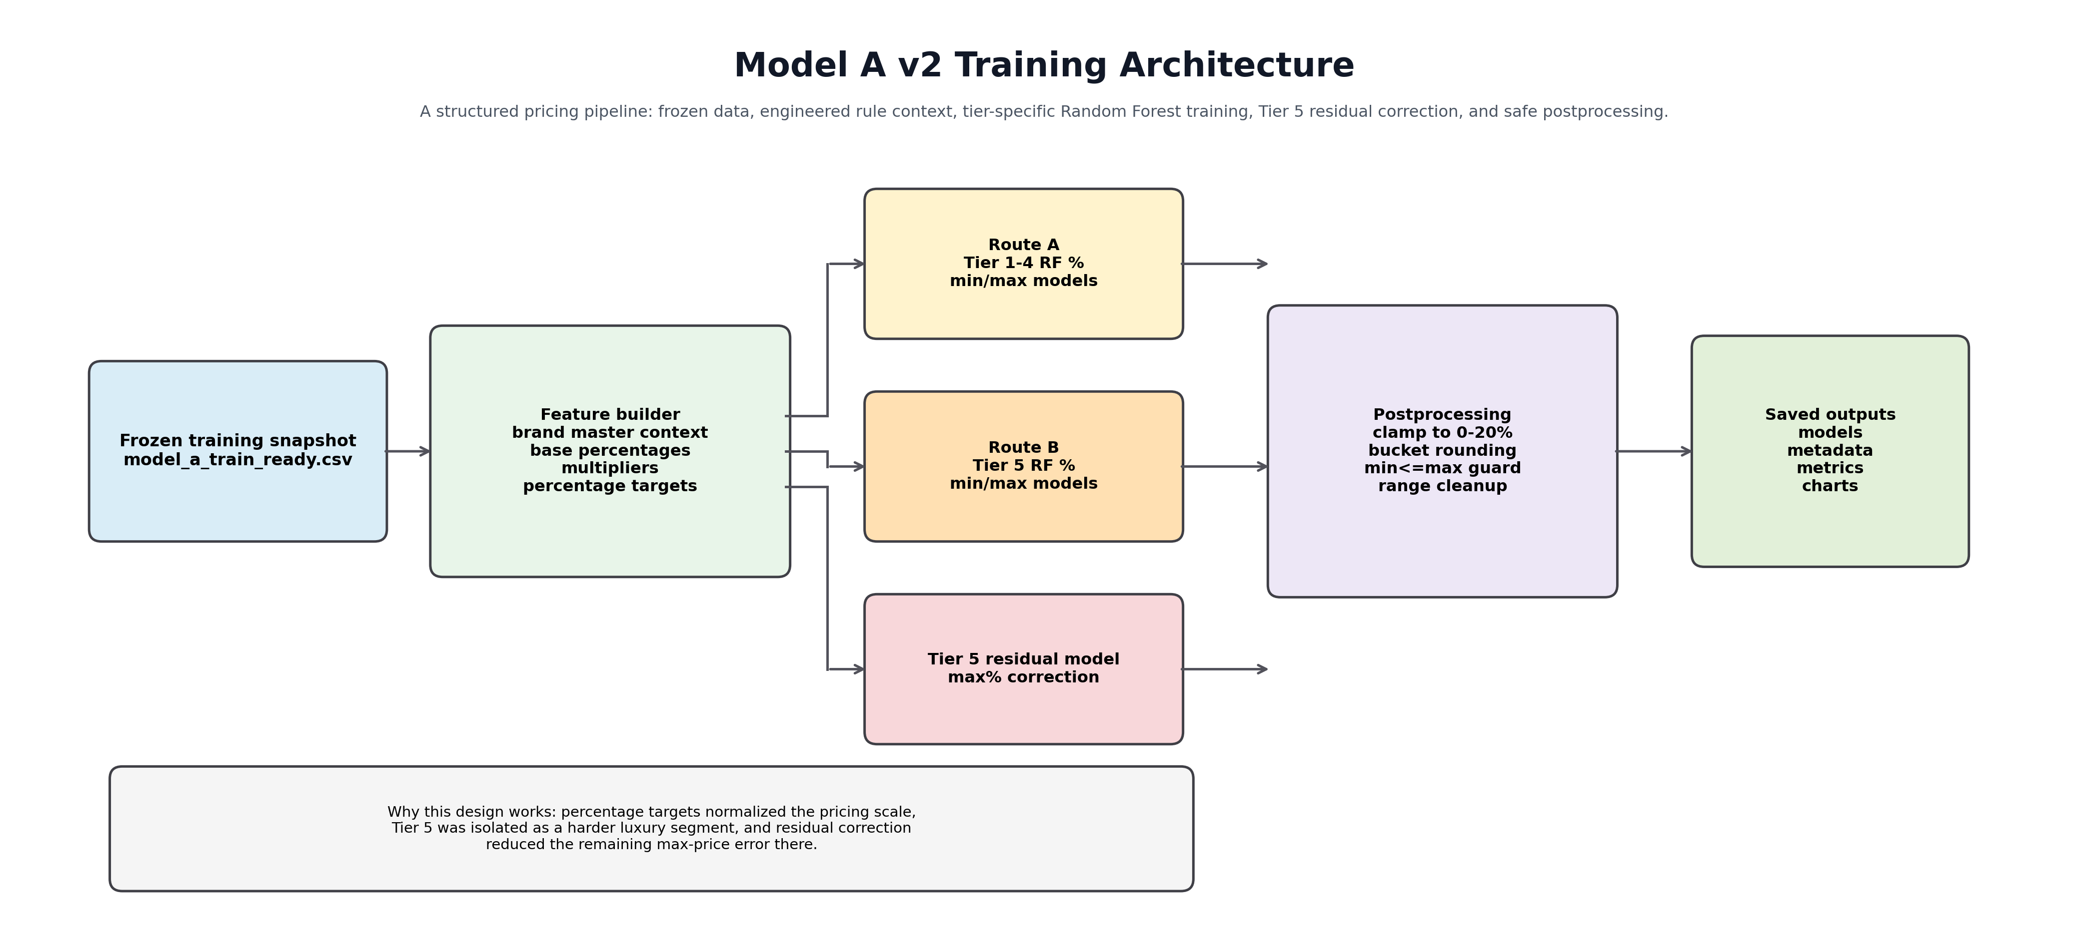
Model A Training Architecture
Quick pointers: - Read this left to right: data and feature building happen first, then route-specific training happens, then outputs are postprocessed and saved. - The Tier 5 path is separated because luxury items behaved differently and needed extra correction. - This image explains why the final Model A system is more structured than a single plain regressor.
How to read this diagram: - the left side is the frozen training dataset and feature-building layer. - the middle separates the two main learning routes: Tier 1-4 and Tier 5. - the lower Tier 5 residual block exists because luxury/max-price behavior is harder and needed a correction layer. - the right side shows that predictions are still postprocessed before artifacts are saved.
Why this matters: - it shows that Model A is not a single random regressor. - it is a structured system built around percentage targets, route-specific training, and rule-safe postprocessing. - this is the clearest visual explanation for why the final v2 model outperformed the earlier simpler versions.

9) Fresh v2 rerun execution logs

9.1 Training command executed
python3 /Users/mypc/RentAFit/code/model_a/training/train_model_a_rf_pct_tier_split.py
Training output:
Model A Tier-Split RF (% target, v2 with Tier5 residual + oversampling) Metrics
train_mae_min: 2.855822550831793
train_rmse_min: 23.62484046244874
train_mae_max: 3.068391866913124
train_rmse_max: 25.871143796339364
train_range_violations_after_fix: 0
val_mae_min: 13.066202090592334
val_rmse_min: 34.69629306731831
val_mae_max: 15.993031358885018
val_rmse_max: 47.53505949857537
val_range_violations_after_fix: 0
test_mae_min: 8.931297709923664
test_rmse_min: 25.06480151146544
test_mae_max: 13.816793893129772
test_rmse_max: 31.634844061234535
test_range_violations_after_fix: 0
Oversample info: {'oversample_added_rows': 113, 'target_per_brand': 22, 'brands_in_tier5_train': 14}
Saved models in: /Users/mypc/RentAFit/models/model_a/rf_pct_tier_split
Saved metrics: /Users/mypc/RentAFit/reports/model_a/metrics/model_a_rf_pct_tier_split_metrics.json
Saved analysis files in: /Users/mypc/RentAFit/reports/model_a/analysis

9.2 Analysis/report command executed
python3 /Users/mypc/RentAFit/code/model_a/analysis/model_a_full_report.py
Analysis output:
Saved metrics: /Users/mypc/RentAFit/reports/model_a/metrics/model_a_full_metrics.json
Saved analysis CSVs in: /Users/mypc/RentAFit/reports/model_a/analysis
Saved charts in: /Users/mypc/RentAFit/reports/model_a/charts
Overall metrics: {'train_mae_min': 2.855822550831793, 'train_rmse_min': 23.62484046244874, 'train_mae_max': 3.068391866913124, 'train_rmse_max': 25.871143796339364, 'train_range_violations_after_fix': 0, 'val_mae_min': 13.066202090592334, 'val_rmse_min': 34.69629306731831, 'val_mae_max': 15.993031358885018, 'val_rmse_max': 47.53505949857537, 'val_range_violations_after_fix': 0, 'test_mae_min': 8.931297709923664, 'test_rmse_min': 25.06480151146544, 'test_mae_max': 13.816793893129772, 'test_rmse_max': 31.634844061234535, 'test_range_violations_after_fix': 0}

9.1) What improvements were made across Model A versions
Model A did not become strong in one step. It improved through a series of engineering decisions.

Improvement 1: Move beyond the linear baseline
The linear baseline was useful only as a reference point. It could not represent the non-linear relationship between: - tier, - age, - condition, - category, - material, - original price.
This is why Random Forest was introduced.

Improvement 2: Shift from absolute rupee targets to percentage targets
Predicting direct rupee values made the model struggle across very different scales. For example: - a Tier 1 listing may be in the hundreds, - a Tier 5 listing may be in the tens of thousands.
Using percentage targets normalized the learning problem: - target_min_pct = rule_min / original_price - target_max_pct = rule_max / original_price
This was one of the biggest improvements in the whole Model A journey.

Improvement 3: Split Tier 1-4 and Tier 5 into separate routes
Even after percentage modeling, Tier 5 remained harder because: - luxury prices vary more, - open-ended price bands are more common, - fewer rows exist per luxury brand.
So the model was split into: - Tier 1-4 route, - Tier 5 route.
This reduced interference between normal listings and luxury listings.

Improvement 4: Oversample sparse Tier 5 brands
Some Tier 5 brands had too few examples. Instead of leaving them weakly represented, we oversampled sparse Tier 5 brands during training. This improved route stability for luxury predictions.

Improvement 5: Add Tier 5 residual correction for max percent
Tier 5 max-price prediction was still the hardest part. So a second residual model was added to learn the remaining error after the base Tier 5 max model. This is why the current v2 setup is not just one model; it is a coordinated tiered system.

Improvement 6: Add confidence scoring and rule fallback
Even a strong model should not always be trusted blindly. So confidence logic was added to penalize risky situations such as: - unseen brand in route training, - missing user-provided original price, - open-ended brand price bands, - unusually wide predicted ranges.
If confidence falls below threshold, the system switches from model output to deterministic rule output. This makes the pricing engine safer for website use.

Why these improvements matter together
The final Model A works well because it combines: - rule-grounded supervision, - scale normalization, - tier-aware routing, - luxury-route stabilization, - postprocessing safety, - confidence-based fallback.
So the final system is stronger than a plain regression model.

10) Stage-wise results (all model versions)

10.1 Linear baseline (model_a_baseline_metrics.json)
metric | value
val_mae_min | 380.973257442866
val_rmse_min | 697.9598748378612
val_mae_max | 457.769222575888
val_rmse_max | 874.1685110901807
val_range_violations_before_fix | 54
test_mae_min | 224.4191169316718
test_rmse_min | 286.98259137636444
test_mae_max | 253.29067785758937
test_rmse_max | 323.0178603027541
test_range_violations_before_fix | 41

10.2 RF absolute targets (model_a_rf_abs_metrics.json)
metric | value
val_mae_min | 165.50994438947623
val_rmse_min | 729.2948217566039
val_mae_max | 211.5428165615841
val_rmse_max | 934.5921128864004
val_range_violations_before_fix | 0
test_mae_min | 23.771652002577547
test_rmse_min | 46.32132928670161
test_mae_max | 28.588010248339458
test_rmse_max | 51.83592785172331
test_range_violations_before_fix | 1

10.3 RF percentage targets (model_a_rf_pct_metrics.json)
metric | value
val_mae_min | 13.066202090592334
val_rmse_min | 36.26749247539677
val_mae_max | 18.32752613240418
val_rmse_max | 51.817153738919195
val_range_violations_after_fix | 0
test_mae_min | 9.16030534351145
test_rmse_min | 25.412625340911895
test_mae_max | 12.290076335877863
test_rmse_max | 29.122012345534007
test_range_violations_after_fix | 0

10.4 RF percentage tier split v2 (model_a_rf_pct_tier_split_metrics.json)
metric | value
train_mae_min | 2.855822550831793
train_rmse_min | 23.62484046244874
train_mae_max | 3.068391866913124
train_rmse_max | 25.871143796339364
train_range_violations_after_fix | 0
val_mae_min | 13.066202090592334
val_rmse_min | 34.69629306731831
val_mae_max | 15.993031358885018
val_rmse_max | 47.53505949857537
val_range_violations_after_fix | 0
test_mae_min | 8.931297709923664
test_rmse_min | 25.06480151146544
test_mae_max | 13.816793893129772
test_rmse_max | 31.634844061234535
test_range_violations_after_fix | 0
Key interpretation: - baseline to v2 shows large MAE reduction, - postprocessing keeps range violations at zero in v2, - Tier 5 still has the highest absolute error due price scale, which is expected and managed by fallback logic.

11) Graphs (regenerated after v2) and detailed interpretation

11.1) Parity plot: predicted max vs actual max
File: - /Users/mypc/RentAFit/reports/model_a/charts/model_a_tier_split_parity_val_max.png
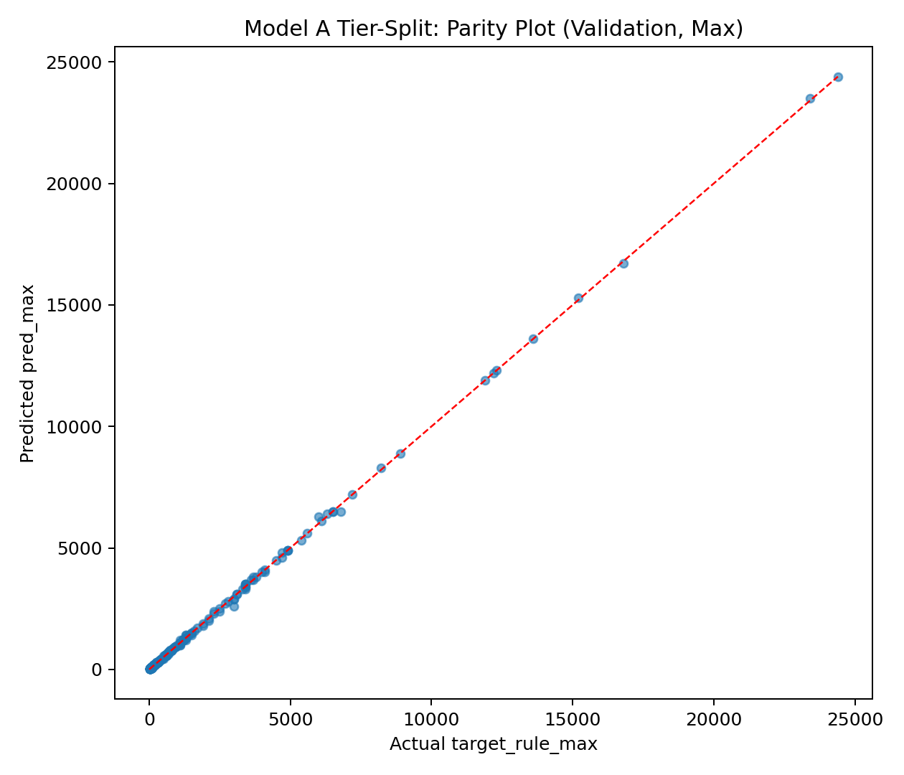
Model A Parity Plot
Quick pointers: - Each point compares predicted max price to true max price on validation data. - Points near the diagonal indicate strong agreement between prediction and target. - Wider spread at the high end is expected because Tier 5 prices magnify small percentage errors.
What it shows: - each point compares predicted max_price with true target_rule_max on the validation set. - the closer the points are to the diagonal line, the better the prediction alignment.
How to interpret it: - dense clustering near the diagonal means the model captures the main pricing relationship well. - wider spread is expected for high-value Tier 5 items because a small percentage error becomes a larger rupee error. - this plot is useful for checking whether the model is biased too high or too low.
Why it matters: - it gives a direct visual answer to the question: “Are predicted max prices matching target max prices?”

11.2) Residual histogram: validation max error distribution
File: - /Users/mypc/RentAFit/reports/model_a/charts/model_a_tier_split_residual_hist_val_max.png
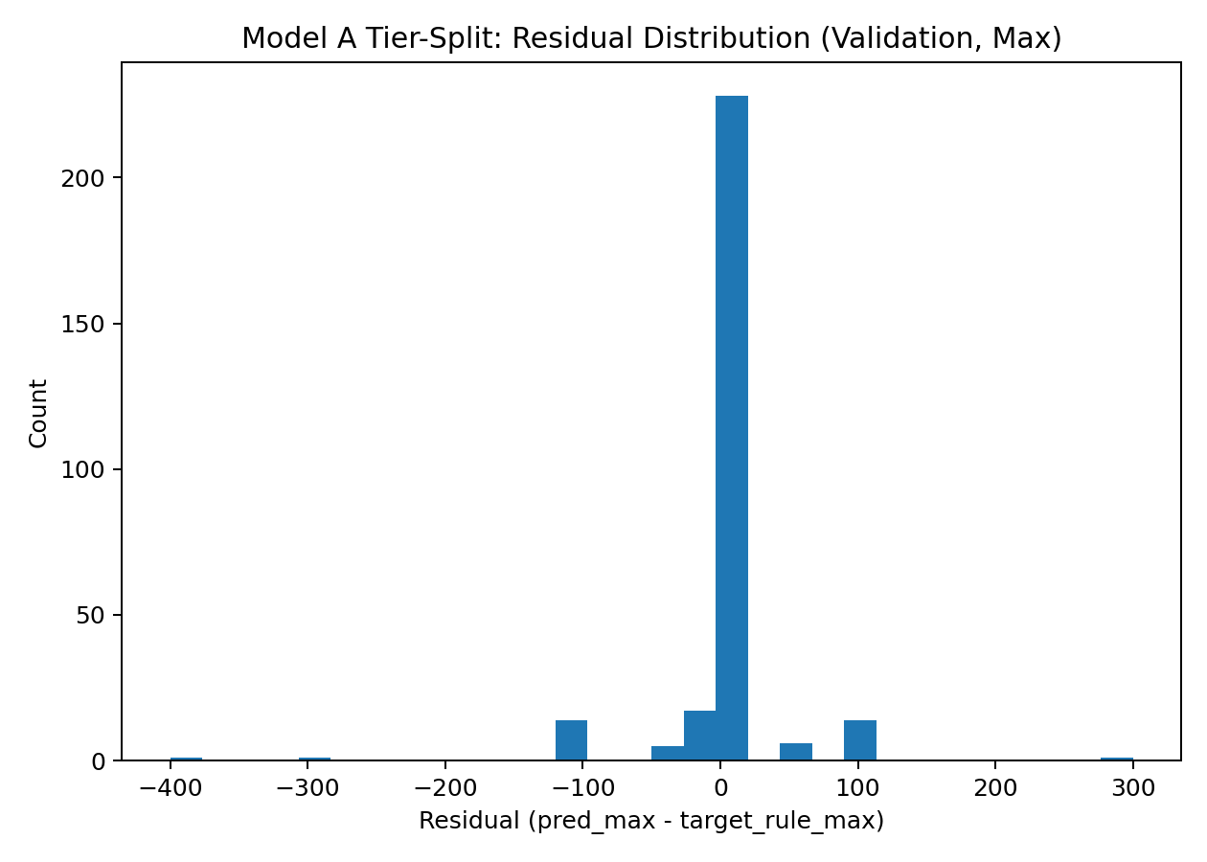
Model A Residual Histogram
Quick pointers: - This chart shows how prediction error is distributed around zero. - A center near zero means the model is not strongly biased high or low overall. - The tails reveal that only a smaller set of cases remain difficult.
What it shows: - distribution of predicted_max - actual_max error on the validation set.
How to interpret it: - values near zero mean good predictions. - a symmetric distribution around zero suggests low systematic bias. - long tails indicate a small number of harder cases.
Why it matters: - it shows whether the model is generally overpredicting or underpredicting. - it also shows whether remaining errors are concentrated in a small tail instead of everywhere.

11.3) Tier-wise MAE chart
File: - /Users/mypc/RentAFit/reports/model_a/charts/model_a_tier_split_tier_mae_val_max.png
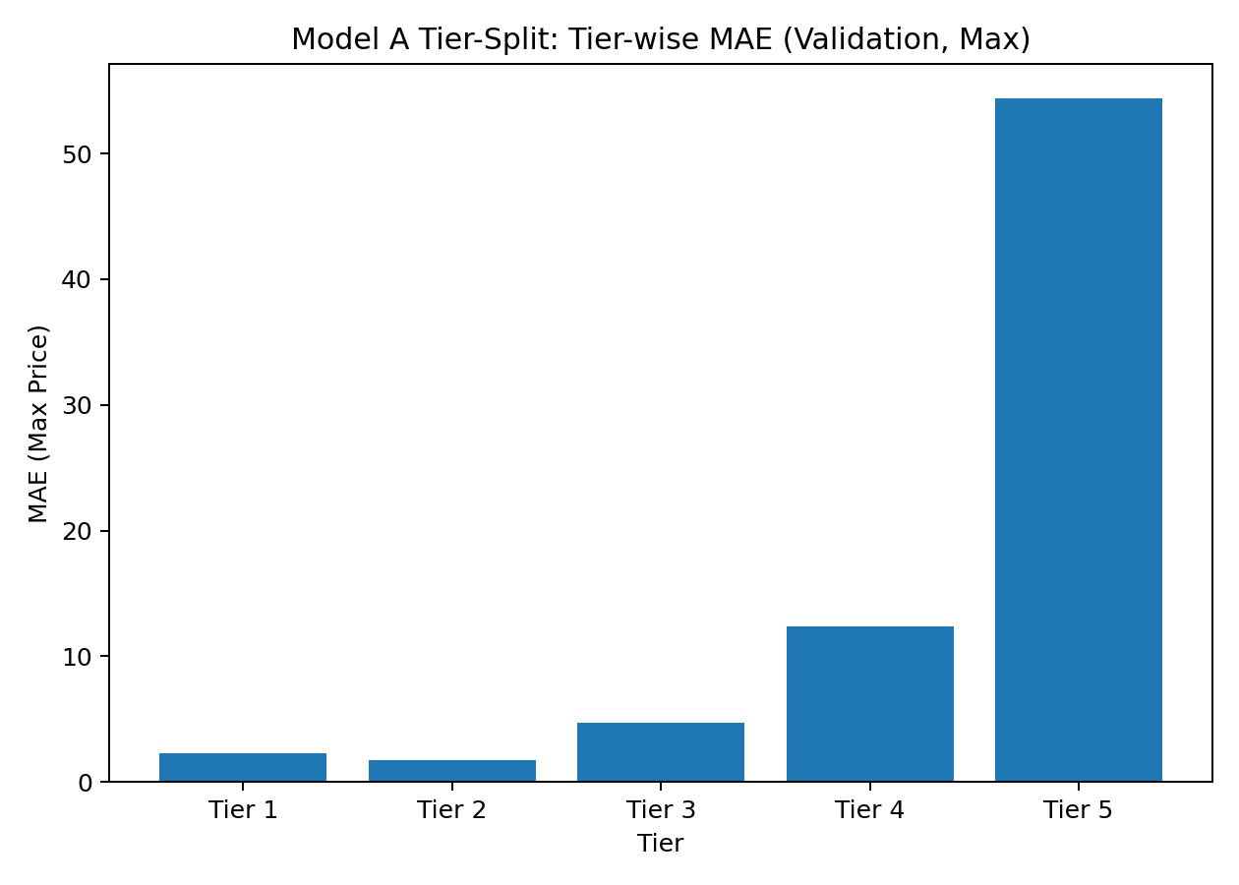
Model A Tier-wise MAE
Quick pointers: - This compares error by tier instead of averaging everything together. - Higher Tier 5 error is expected because luxury prices have larger absolute scale. - The chart helps justify why separate Tier 5 handling was necessary.
What it shows: - average absolute rupee error in max_price per tier.
How to interpret it: - lower tiers should naturally have lower absolute rupee error because prices are smaller. - Tier 5 usually has the highest absolute error because price magnitude is much larger.
Why it matters: - it tells us where the model is most difficult to stabilize. - this is one of the main reasons the Tier 5 split and residual correction were introduced.

11.4) Model-comparison chart
File: - /Users/mypc/RentAFit/reports/model_a/charts/model_a_tier_split_comparison_val.png
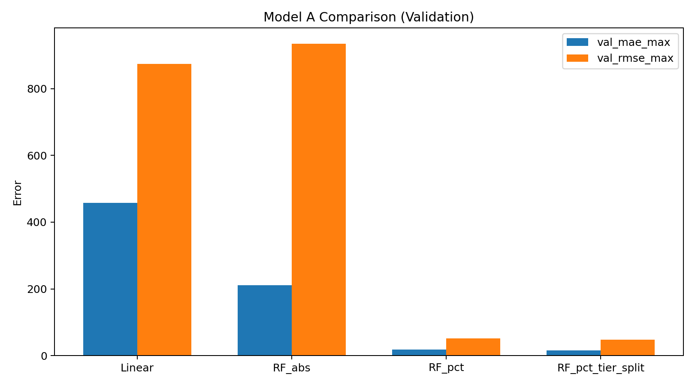
Model A Model Comparison
Quick pointers: - This is the improvement story of Model A in one view. - It shows why the project moved from linear baseline to RF absolute, then RF percentage, then tier-split v2. - The final bar being best is the evidence behind the final architecture choice.
What it shows: - comparison of major validation metrics across: - linear baseline, - RF absolute, - RF percentage, - RF percentage tier-split v2.
How to interpret it: - each later stage should reduce validation error and improve stability. - the chart proves the journey was evidence-based, not random experimentation.
Why it matters: - this is the clearest graph for explaining why the project moved from baseline to the current final version.

12) Route-level validation interpretation (v2)
From model_a_rf_pct_tier_split_val_route_summary.csv:
- tier_split_tier1to4
  - rows: 230
  - mae_max: 6.4783
  - p90_pct_error_max: 0.090909
  - p95_pct_error_max: 0.162719
- tier_split_tier5
  - rows: 57
  - mae_max: 54.3860
  - p90_pct_error_max: 0.041391
  - p95_pct_error_max: 0.048095
Important nuance: - Tier 5 absolute error is high because amounts are high, - relative percentile errors are still tight, - this confirms the need to evaluate both absolute and relative metrics.

13) Inference pipeline behavior (runtime)
Inference script: - /Users/mypc/RentAFit/code/model_a/inference/predict_price_range_simple_input.py
Pipeline steps: 1. accept simple input fields, 2. normalize condition label, 3. derive engineered features internally, 4. route to Tier 5 or Tier 1-4 model pair, 5. apply Tier 5 residual correction if applicable, 6. compute model candidate range, 7. compute deterministic rule range, 8. compute confidence score, 9. if confidence below threshold, return rule fallback.

13.1 Confidence scoring logic
Start score = 1.0 and deduct: - unseen brand in route training: -0.35 - original price not user-provided: -0.35 - open-ended brand price band: -0.10 - brand missing in brand master: -0.20 - unusually high predicted range width: -0.15
Threshold: - 0.55
If score < 0.55: - final source = rule_fallback

13.2 Runtime inference flow
File: - /Users/mypc/RentAFit/reports/model_a/model_a_inference_flow.png
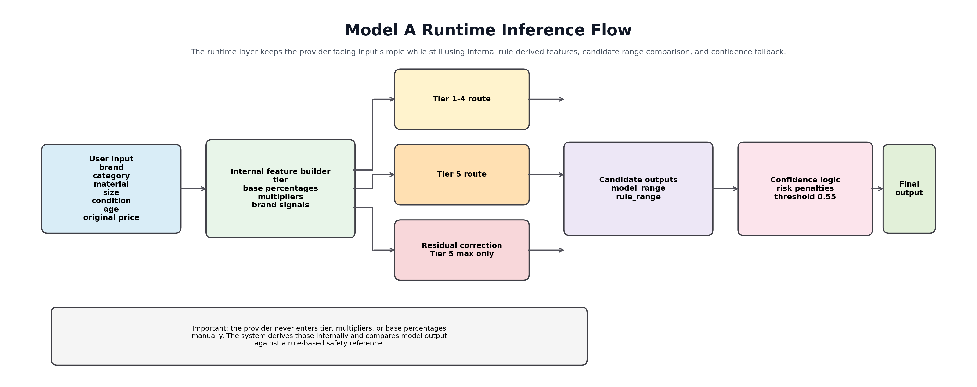
Model A Inference Flow
Quick pointers: - The user enters only simple listing fields; technical features are derived internally. - Both model and rule outputs are computed so the system can compare them safely. - Confidence logic decides whether to trust the model result or return a safe rule fallback.
How to read this diagram: - user-facing inputs stay simple; hidden engineered fields are derived internally. - the system routes the request into the correct pricing path based on tier. - model and rule outputs are both computed so they can be compared. - confidence logic decides whether the model output is trusted or whether the safe rule fallback should be returned.
Why this matters: - it explains how Model A can be production-friendly without asking users for technical fields like multipliers or base percentages. - it also shows why the final system is safer than a plain regression model: the rule engine still protects the output at runtime.

14) Fresh inference run outputs (v2)

14.1 Known Tier 5 brand example
Command:
python3 /Users/mypc/RentAFit/code/model_a/inference/predict_price_range_simple_input.py \
--brand "Prada" --category "Dress" --material "Silk" --age_months 6 \
--size "M" --condition "Like New" --original_price 95000 --json
Result summary: - route: tier_split_tier5 - model output %: min 0.0981, max 0.1254 - final range: 9300 to 11900 - confidence: 0.9 - source: model_output

14.2 Known Tier 3 brand example
Input: Zara / Jacket / Denim / 8 months / Like New / 4999 Result summary: - route: tier_split_tier1to4 - final range: 250 to 350 - confidence: 1.0 - source: model_output

14.3 Known Tier 5 aged/used example
Input: Anita Dongre / Lehenga / Silk / 12 months / Used / 65000 Result summary: - route: tier_split_tier5 - residual correction applied: true - final range: 4000 to 5200 - source: model_output

14.4 Unknown brand fallback example
Input: Unknown Brand / Top / Cotton / 4 months / Used / 1800 Result summary: - confidence: 0.45 (<0.55) - reasons: unseen brand + brand missing in master - source: rule_fallback - final range: 70 to 80

15) Safety constraints guaranteed in v2
After prediction, v2 enforces: - clamp predicted percentages into [0, 0.20], - min <= max ordering, - bucket rounding (10/50/100), - non-negative outputs, - fallback to deterministic rule range under low confidence.
These constraints keep outputs aligned with business rules even in uncertain cases.

16) Why this v2 design is technically justified
- Rule-derived targets provide stable supervision when public real rental labels are unavailable.
- Percentage targets improve learning across wide price scales.
- Tier split isolates premium behavior from mass-market behavior.
- Residual correction reduces systematic Tier 5 max errors.
- Confidence fallback prevents low-trust model responses from reaching final output unchecked.
This combination balances: - predictive quality, - explainability, - operational safety.

17) Limitations and next engineering steps
Current limitations: - Tier 5 absolute errors remain the largest (expected with high-value items). - Brand master has open-ended price bands for some premium brands. - Model A currently uses metadata only (no image input).
Next improvements: - increase real Tier 5 labeled coverage, - calibrate residual scaling by brand clusters, - add uncertainty calibration/quantile layer, - maintain periodic retraining with accepted listing feedback.

18) Final status after rerun
- v2 training rerun: completed successfully.
- v2 analysis rerun: completed successfully.
- charts regenerated from latest v2 outputs.
- document synchronized with current formulas, metrics, charts, and inference outputs.
This handbook now reflects the latest model state and can be used as the primary technical submission for Model A.

19) Cross-check test cases (2026-03-14)
Cases: 6 Anomalies: 0
Case | Brand | Category | Condition | Age | Original | Final Min | Final Max | Source | Confidence | Note
A1 | Zara | Top | New | 2 | 1200 | 60 | 70 | model_output | 1.00
A2 | H&M | Jeans | Like New | 6 | 2400 | 120 | 140 | model_output | 1.00
A3 | Biba | Kurta | Like New | 4 | 4200 | 250 | 300 | model_output | 1.00
A4 | Anita Dongre | Lehenga | New | 2 | 22000 | 2800 | 3500 | model_output | 0.90
A5 | Uniqlo | Jacket | Used | 12 | 8000 | 400 | 450 | model_output | 1.00
A6 | BrandX | Dress | Like New | 3 | 3000 | 200 | 250 | rule_fallback | 0.45 | rule fallback (unknown brand)

