RentAFit Model B Handbook
Date: 2026-03-14

1. Purpose Of This Document
This document is the full working handbook for Model B in the RentAFit project.
It is written for two kinds of readers:
- a teacher or evaluator who wants technical clarity,
- a student or beginner who wants to actually understand how the model works from the beginning.
So this document tries to do both:
- keep the explanation simple,
- keep the content technically correct,
- explain the model with real datasets, real code files, real outputs, real graphs, and real reasoning.
This handbook covers:
- what Model B does,
- why it exists,
- what data it uses,
- how labels are created,
- how the LSTM is used,
- how the tabular branch works,
- why the final model is hybrid,
- how the model was trained,
- what results were obtained,
- how to read every graph,
- how the model drives reapproval and listing lifecycle,
- what is fully implemented,
- what still belongs to later backend integration.

2. One-Page Summary
Model B is the listing moderation model of RentAFit.
Its job is to classify a listing into one of three classes:
- Approve
- Review
- Reject
It uses a hybrid model:
- an LSTM branch for a short sequence based on condition and age,
- a tabular branch for normal listing and pricing features.
The model is trained on:
- structured listing features from pricing_features,
- human-reviewed labels from the gold-label dataset.
The current implementation is fully working on the Python/ML side and includes:
- training,
- inference,
- stale-listing logic,
- review-queue generation,
- date-based listing-age handling,
- website-ready status suggestions,
- gender-aware moderation policy.
Current final test performance:
- Test accuracy: 0.9771986970684039
- Test macro F1: 0.976529133762697
Important honest interpretation:
- the model is strong,
- the implementation is valid,
- but many features are strongly connected to rule-based moderation logic,
- so the result should be presented as a hybrid operational moderation classifier, not as free-form human reasoning.

3. What Model B Actually Does
Model B is different from Model A.
- Model A predicts rental price range.
- Model B decides whether a listing is good enough to go live, should go to review, or should be rejected.
So Model B is a classification model, not a regression model.

Final class meaning
- Approve: listing is acceptable and can move toward activation.
- Review: listing is not clearly bad, but should be checked manually or rechecked.
- Reject: listing is too risky, too poor, or too unrealistic to go live.

Why Model B is needed
A rental marketplace should not accept every listing automatically. Problems Model B is designed to help with:
- poor-condition items,
- very old or stale listings,
- unrealistic provider rental prices,
- borderline listings that need manual moderation,
- lifecycle reapproval for older listings.
So Model B protects:
- platform quality,
- renter trust,
- moderation workflow,
- long-term listing hygiene.

4. What Inputs Model B Uses

4.1 Current V1 inputs
Model B currently uses metadata and pricing behavior, not text descriptions and not image features.
Main input fields:
- brand
- category
- gender
- material
- size
- condition
- age_months or garment_age_months
- original_price
- provider_price
- tier_primary
- deviation_M
- condition_penalty
- age_penalty
- deviation_penalty
- total_penalty
- older_listing_flag
- age_policy_override_applied
- gender_conflict_flag
- gender_policy_override_applied

4.2 Gender-aware moderation policy
Model B now includes a shared gender policy.
Project-wide gender values:
- Women
- Men
- Unisex
Current category policy:
- Women: Saree, Lehenga, Dress, Top
- Unisex: Shirt, Jacket, Jeans, Activewear, Ethnic Wear, Kurta
Runtime behavior:
- if user leaves gender blank, Model B derives it from category
- if category is unisex, explicit Men and Women are both allowed
- if user-selected gender conflicts with the current category policy, Model B pushes the listing to Review
- runtime also returns a popup recommendation so the website can warn the user immediately
Training behavior:
- base rows keep their category-derived gender
- unisex rows are expanded into explicit Women and explicit Men training variants
- women-specific rows are expanded into explicit Men conflict variants
- conflict variants are operationally relabeled to Review unless the row was already Reject

4.3 What is not used in current V1
Not used in current Model B:
- listing text description,
- image embeddings,
- CNN features,
- NLP features.

4.4 Why we intentionally kept it this way
This was the right decision for your project because:
- the team is learning ML for the first time,
- metadata was already enough to build a strong moderation baseline,
- adding image or text modeling would make the pipeline much heavier,
- the project needed a realistic path under deadline.
So current Model B is a metadata-first moderation model.

5. Where Model B Fits In The Full RentAFit System
Basic system flow:
- provider submits listing,
- Model A suggests rental price range,
- Model B predicts listing moderation class,
- backend converts that into website status,
- old listings later re-enter the review workflow,
- reviewer/admin decides whether they remain active.
This means Model B is not only a first-time moderation tool. It is also part of the listing lifecycle control system.

6. Main Files Used In Model B

6.1 Data files
- /Users/mypc/RentAFit/data/frozen/v2_gender/pricing_features.csv
- /Users/mypc/RentAFit/data/frozen/v2_gender/gold_labels_model_b_full_manual.csv
- /Users/mypc/RentAFit/data/frozen/v2_gender/model_b_train_manual.csv
- /Users/mypc/RentAFit/data/frozen/v2_gender/model_b_train_manual_gender_policy.csv
- /Users/mypc/RentAFit/data/generated/model_b_expansion_candidates_manual_review.csv
- /Users/mypc/RentAFit/data/generated/gold_labels_model_b_expanded.csv
- /Users/mypc/RentAFit/data/generated/model_b_train_expanded_gender.csv
- /Users/mypc/RentAFit/data/generated/model_b_train_expanded_gender_policy.csv
- /Users/mypc/RentAFit/data/generated/model_b_train_expanded_gender_ready.csv
- /Users/mypc/RentAFit/data/generated/model_b_live_listings_sample.csv
- /Users/mypc/RentAFit/data/templates/model_b_live_listings_template.csv

6.2 Code files
- /Users/mypc/RentAFit/code/model_b/prepare_model_b_dataset.py
- /Users/mypc/RentAFit/code/model_b/prepare_model_b_expansion_candidates.py
- /Users/mypc/RentAFit/code/model_b/prepare_model_b_expanded_dataset.py
- /Users/mypc/RentAFit/code/model_b/prepare_model_b_gender_policy_dataset.py
- /Users/mypc/RentAFit/code/model_b/prepare_model_b_splits.py
- /Users/mypc/RentAFit/code/model_b/gender_policy.py
- /Users/mypc/RentAFit/code/model_b/training/train_model_b_lstm.py
- /Users/mypc/RentAFit/code/model_b/lifecycle.py
- /Users/mypc/RentAFit/code/model_b/runtime.py
- /Users/mypc/RentAFit/code/model_b/inference/predict_model_b_decision.py
- /Users/mypc/RentAFit/code/model_b/ops/generate_live_listings_sample.py
- /Users/mypc/RentAFit/code/model_b/ops/run_model_b_live_ops.py
- /Users/mypc/RentAFit/code/model_b/analysis/model_b_branch_comparison.py

6.3 Saved artifacts and reports
- /Users/mypc/RentAFit/models/model_b/model_b_lstm.pt
- /Users/mypc/RentAFit/models/model_b/model_b_tabular_preprocessor.joblib
- /Users/mypc/RentAFit/reports/model_b/model_b_lstm_metrics.json
- /Users/mypc/RentAFit/reports/model_b/model_b_lstm_confusion_matrix_test.png
- /Users/mypc/RentAFit/reports/model_b/model_b_lstm_training_history.png
- /Users/mypc/RentAFit/reports/model_b/model_b_lstm_test_predictions.csv
- /Users/mypc/RentAFit/reports/model_b/model_b_split_summary.json
- /Users/mypc/RentAFit/reports/model_b/model_b_branch_comparison_metrics.json
- /Users/mypc/RentAFit/reports/model_b/model_b_branch_comparison_chart.png
- /Users/mypc/RentAFit/reports/model_b/model_b_dataset_distribution_chart.png
- /Users/mypc/RentAFit/reports/model_b/model_b_hybrid_architecture.png
- /Users/mypc/RentAFit/reports/model_b/model_b_lifecycle_flow.png
- /Users/mypc/RentAFit/reports/model_b/model_b_data_pipeline.png
- /Users/mypc/RentAFit/reports/model_b/model_b_live_listings_scored_sample.csv
- /Users/mypc/RentAFit/reports/model_b/model_b_review_queue_sample.csv
- /Users/mypc/RentAFit/reports/model_b/model_b_live_ops_summary.json

7. Dataset Journey: How The Data Was Built
Model B did not begin from one ready-made dataset. It was built in stages.

Stage 1: Manual feature base
From: - /Users/mypc/RentAFit/data/frozen/v2_gender/pricing_features.csv
This gave structured listing behavior: - metadata, - prices, - deviation, - penalties, - rule support signals.

Stage 2: Manual human labels
From: - /Users/mypc/RentAFit/data/frozen/v2_gender/gold_labels_model_b_full_manual.csv
This gave human-reviewed truth: - quality score, - final listing decision, - reviewer note.

Stage 3: Manual LSTM-ready dataset
These two were joined into: - /Users/mypc/RentAFit/data/frozen/v2_gender/model_b_train_manual.csv
This added: - condition_token - age_bin_token - older_listing_flag - effective_listing_decision

Stage 4: Expansion review batch
A hard-case review batch was generated from the augmented pricing set: - /Users/mypc/RentAFit/data/generated/model_b_expansion_candidates_manual_review.csv
This was chosen to focus on: - older listings, - high deviation rows, - used-condition rows, - premium tiers, - borderline review-like rows.

Stage 5: Expanded gold labels
After manual review, we merged: - original 375 rows, - plus 400 reviewed expansion rows.
This produced: - /Users/mypc/RentAFit/data/generated/gold_labels_model_b_expanded.csv

Stage 6: Expanded gender-aware base dataset
The expanded labels were joined with the augmented pricing features to produce: - /Users/mypc/RentAFit/data/generated/model_b_train_expanded_gender.csv
This is the 775-row base dataset before explicit gender variants are added.

Stage 7: Split-safe gender-policy training dataset
The base dataset was first split into train, validation, and test on the original 775 rows. Then gender variants were generated inside each split:
- /Users/mypc/RentAFit/data/generated/model_b_train_expanded_gender_ready.csv
This is the final dataset used for Model B training.

8. Data Pipeline Diagram
Image file:
- /Users/mypc/RentAFit/reports/model_b/model_b_data_pipeline.png
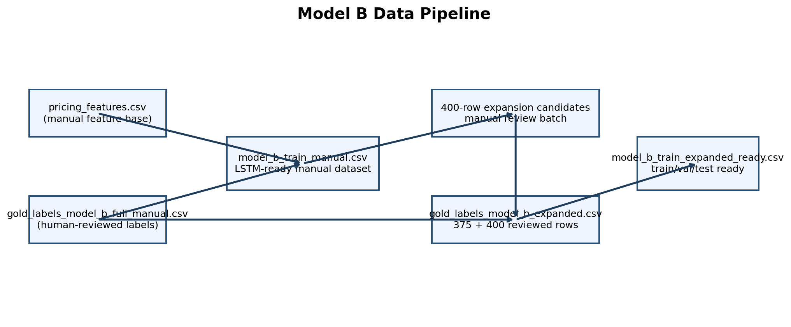
Model B Data Pipeline
Quick pointers: - This shows that Model B training truth came from human-reviewed moderation labels, not only generated rules. - The expansion batch improved coverage, but rows were still reviewed before becoming final labels. - That is why Model B can be defended as a true moderation model rather than just a rule-copying system.

What this diagram shows
This diagram explains the complete journey of the dataset:
- rule-based pricing features,
- human gold labels,
- first manual dataset,
- expansion review batch,
- expanded gold labels,
- final train-ready dataset.

Why this diagram matters
It helps the reader understand that Model B was not trained on random rows. It was built in a controlled way where:
- candidate rows were engineered,
- final decisions were reviewed by humans,
- the final training data became stronger over time.

9. Current Dataset Counts

9.1 Original manual gold dataset
File: - /Users/mypc/RentAFit/data/frozen/v2_gender/gold_labels_model_b_full_manual.csv
Counts: - rows: 375 - Approve: 193 - Review: 98 - Reject: 84

9.2 Manual gender-aware LSTM-ready dataset
File: - /Users/mypc/RentAFit/data/frozen/v2_gender/model_b_train_manual.csv
Counts: - rows: 375 - unique listing ids: 375 - older listings (age_months >= 10): 41 - age-policy override rows: 20 - gender counts: - Unisex: 238 - Women: 137

9.3 Manual gender-policy dataset
File: - /Users/mypc/RentAFit/data/frozen/v2_gender/model_b_train_manual_gender_policy.csv
Counts: - total rows: 988 - base rows: 375 - explicit Women variants on unisex rows: 238 - explicit Men variants on unisex rows: 238 - explicit Men conflict variants on women-specific rows: 137 - gender-policy override rows: 110
Effective decision distribution: - Approve: 173 - Review: 731 - Reject: 84

9.4 Expanded gold-label dataset
File: - /Users/mypc/RentAFit/data/generated/gold_labels_model_b_expanded.csv
Counts: - total rows: 775 - original rows: 375 - added reviewed rows: 400
Decision distribution: - Approve: 224 - Review: 337 - Reject: 214

9.5 Expanded gender-aware base dataset
File: - /Users/mypc/RentAFit/data/generated/model_b_train_expanded_gender.csv
Counts: - total rows: 775 - gender counts: - Unisex: 499 - Women: 276

9.6 Final split-ready gender-policy training dataset
File: - /Users/mypc/RentAFit/data/generated/model_b_train_expanded_gender_ready.csv
Counts: - base rows before gender expansion: 775 - final rows after gender expansion: 2049 - train: 1435 - val: 307 - test: 307
Effective decision distribution: - Approve: 456 - Review: 1013 - Reject: 580
Gender distribution: - Men: 775 - Women: 775 - Unisex: 499
Gender policy counts: - gender_conflict_flag = 1: 276 - gender_policy_override_applied = 1: 214
Very important technical note:
- the train/val/test split is created on the base 775 rows first
- gender variants are generated inside each split afterward
- this avoids parent-listing leakage across splits
- verified overlap across split parent ids: 0

10. Dataset Distribution Visuals
Image file:
- /Users/mypc/RentAFit/reports/model_b/model_b_dataset_distribution_chart.png
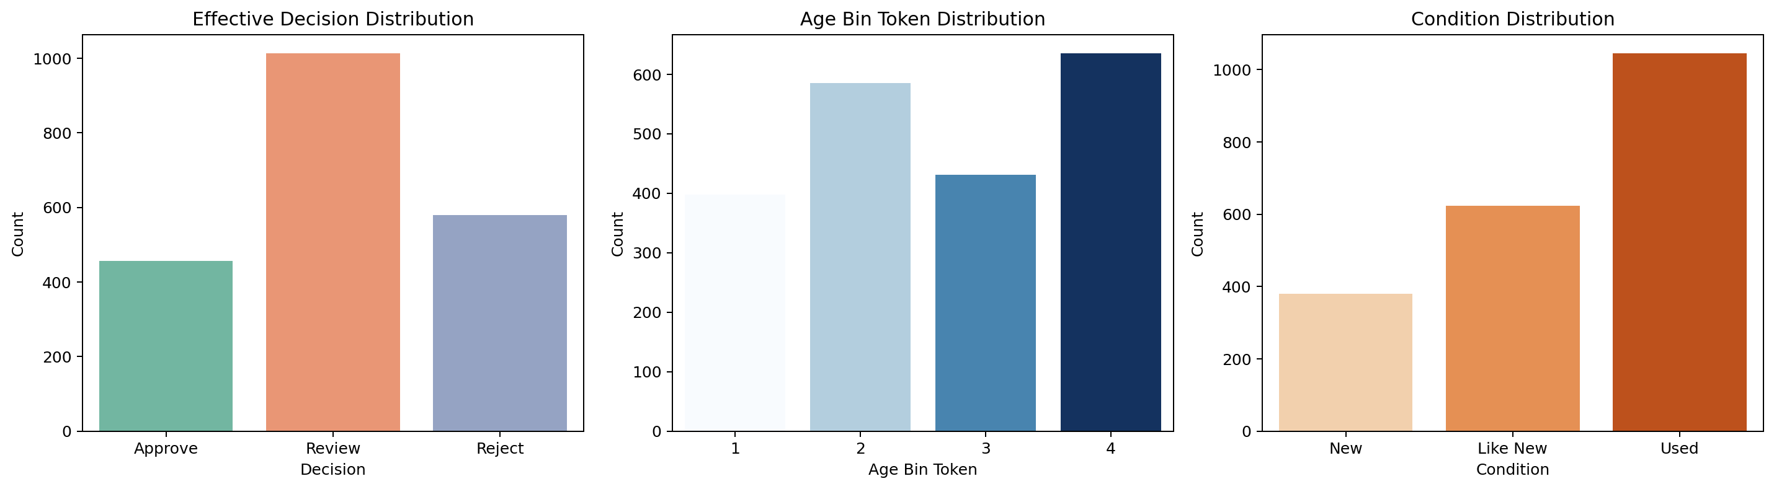
Model B Dataset Distribution
Quick pointers: - This chart shows how the training data is distributed across decisions and important segments. - It helps the reader see whether one class dominates too heavily. - Balanced enough class structure is important for trustworthy moderation metrics.

What this chart shows
This chart contains three panels:
- effective decision distribution,
- age-bin distribution,
- condition distribution.

What we learn from it
- The classes are not perfectly balanced, so accuracy alone is not enough.
- Older listings exist, but they are not the majority, so stale-listing logic still matters.
- All three condition states are represented, so the LSTM sequence has meaningful variation.

Why this chart matters
This chart explains why we use: - macro F1, - class weights, - and not only raw accuracy.

11. How Labels Are Created
Model B labels are not created the same way as Model A.

11.1 Why Model A and Model B are different
Model A predicts rule-generated price targets. That is okay because the target itself is deterministic.
Model B predicts: - Approve - Review - Reject
These should represent human moderation judgement.
So the correct workflow is: - auto-generate candidate rows, - use rules as support, - keep final labels human-reviewed.

11.2 Human final columns
Human review fills: - final_quality_score_0_100 - final_listing_decision - final_reviewer_note

11.3 Operational target
For training, we do not use only the raw human label. We also apply the stale-listing policy.
This produces: - effective_listing_decision - effective_decision_label
This is the current final training target.

12. Core Rule System Behind Model B

12.1 Final classes
Model B predicts: - Approve - Review - Reject

12.2 Numeric encoding
- Approve = 0
- Review = 1
- Reject = 2
Used in: - decision_label - effective_decision_label

12.3 Older listing rule
If: - age_months >= 10
Then: - older_listing_flag = 1
Otherwise: - older_listing_flag = 0

12.4 Listing lifecycle action rule
If: - age_months >= 10
Then: - listing_lifecycle_action = needs_reapproval_or_removal
Otherwise: - listing_lifecycle_action = active_current_cycle

12.5 Age policy override rule
If: - age_months >= 10 - and final_listing_decision == Approve
Then: - effective_listing_decision = Review
Why: - a listing approved once should not stay automatically approved forever.

13. Pricing-Behavior Support Features
Model B uses several support features inherited from the pricing engine. These are not final labels, but they help moderation.

13.1 Deviation
deviation_M measures how far the provider price is from the expected rule range.
- if within range -> 0
- if below range -> measured from rule_min
- if above range -> measured from rule_max

13.2 Condition penalty
- New -> 0
- Like New -> 8
- Used -> 18

13.3 Age penalty
- <=3 -> 0
- <=6 -> 4
- <=9 -> 8
- <=12 -> 12
- <=18 -> 16
- >18 -> 20

13.4 Deviation penalty
- 0 -> 0
- <=10 -> 5
- <=20 -> 12
- <=35 -> 20
- <=50 -> 30
- >50 -> 45

13.5 Total penalty
- total_penalty = condition_penalty + age_penalty + deviation_penalty

13.6 Rule quality score
- rule_quality_score = max(0, 100 - total_penalty)

13.7 Rule decision
Reject if any is true: - invalid original price, - invalid provider price, - provider price too high vs original price, - very low rule quality score, - very high deviation.
Approve if both are true: - rule quality score high, - deviation low.
Else: - Review.

13.8 Important warning
These are support signals, not the final human truth. That is why human labels still matter.

14. Why LSTM Is Used Here
Your teacher asked for LSTM, and Model B is the best place to use it.

Core sequence used
Each listing creates a small sequence: - [condition_token, age_bin_token]
Example: - Like New -> 2 - 10+ months -> 4 - sequence becomes [2, 4]

Why this is reasonable
LSTM is made for ordered sequence-style input. Here, the sequence represents a simple progression of listing state:
- wear state,
- age state.
It is not a large time series, but it is still a meaningful ordered sequence.

Why not use only LSTM?
Because most moderation information in this project is tabular, not purely sequential. That is exactly why the final model is hybrid.

15. Tokens Used By The LSTM

15.1 Condition token
- New = 1
- Like New = 2
- Used = 3
Stored in: - condition_token

15.2 Age bin token
- <= 3 months = 1
- 4 to 6 months = 2
- 7 to 9 months = 3
- 10+ months = 4
Stored in: - age_bin_token

15.3 Why tokens are needed
LSTM cannot directly use text labels like Used or Like New. So these states are converted into integer tokens.

16. Mermaid Block Diagram
flowchart TD
A[Provider listing input] --> B[Feature preparation]
B --> C[Build sequence features]
B --> D[Build tabular features]
C --> C1[condition_token]
C --> C2[age_bin_token]
C1 --> E[Sequence input: [condition_token, age_bin_token]]
C2 --> E
E --> F[Embedding]
F --> G[LSTM]
G --> H[LSTM sequence representation]
D --> D1[Categorical columns: brand, category, material, size, tier]
D --> D2[Numeric columns: age, prices, deviation, penalties, flags]
D1 --> I[OneHotEncoder]
D2 --> J[Imputer + StandardScaler]
I --> K[Tabular feature matrix]
J --> K
K --> L[Dense tabular branch]
H --> M[Concatenate]
L --> M
M --> N[Final dense classifier]
N --> O[Class probabilities]
O --> P[Approve / Review / Reject]
P --> Q[Website status mapping]

How to read this diagram
- the listing first becomes engineered features,
- the sequence branch handles only age/condition sequence,
- the tabular branch handles the rest of the structured features,
- both are merged,
- the final classifier predicts the moderation class,
- then backend logic maps the result into listing status.

17. Visual Architecture Image
Image file:
- /Users/mypc/RentAFit/reports/model_b/model_b_hybrid_architecture.png
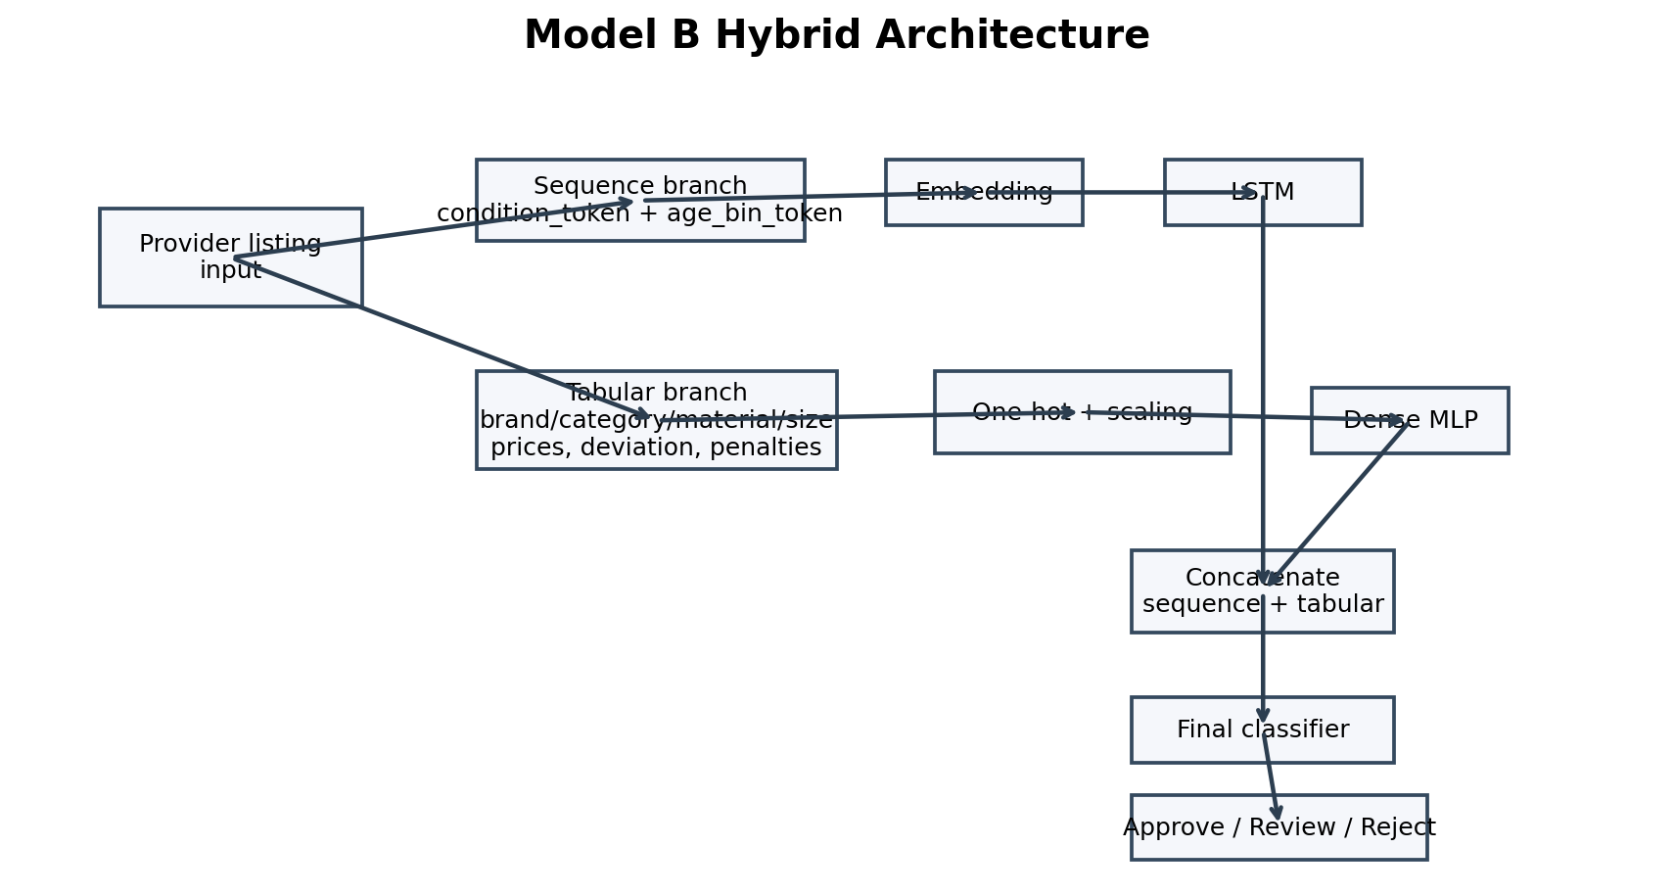
Model B Hybrid Architecture
Quick pointers: - The top branch is the LSTM sequence path and the lower branch is the tabular feature path. - The model uses both because sequence-only was too weak and tabular-only, while strong, still underperformed the hybrid. - The merge layer is the key idea: lifecycle pattern and structured listing behavior are learned together.

Why this image is useful
This image makes the hybrid architecture easier to present than text alone. It clearly shows that the model is not just LSTM.

18. Implemented Model Architecture
The current implementation is a hybrid PyTorch model with two branches.

18.1 Sequence branch
Input: - [condition_token, age_bin_token]
Layers: - Embedding(vocab_size=8, embed_dim=8) - LSTM(hidden_size=16)
Output: - last hidden state of the LSTM

18.2 Tabular branch
Categorical columns: - brand - category - material - size - tier_primary
Numeric columns: - age_months - older_listing_flag - age_policy_override_applied - original_price - provider_price - deviation_M - condition_penalty - age_penalty - deviation_penalty - total_penalty
Tabular network: - Linear(tabular_dim, 64) - ReLU - Dropout(0.20) - Linear(64, 32) - ReLU

18.3 Merge
The LSTM output and tabular branch output are concatenated.

18.4 Output head
Final layers: - Linear(lstm_hidden + 32, 32) - ReLU - Dropout(0.20) - Linear(32, 3)
Class order: - Approve - Review - Reject

19. Why The Hybrid Model Is Better Than Individual Branches
This is one of the most important parts of the document.
A direct comparison study was run using the same test split.
Files: - /Users/mypc/RentAFit/code/model_b/analysis/model_b_branch_comparison.py - /Users/mypc/RentAFit/reports/model_b/model_b_branch_comparison_metrics.json - /Users/mypc/RentAFit/reports/model_b/model_b_branch_comparison_chart.png
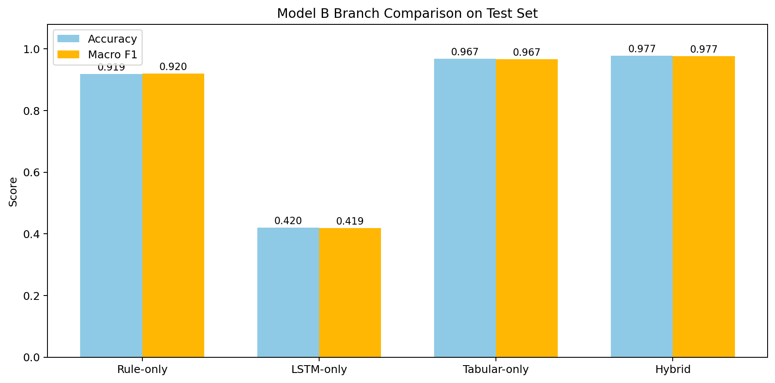
Model B Branch Comparison
Quick pointers: - This chart is the main proof behind the final Model B design choice. - It shows that LSTM-only is not enough, tabular-only is strong, and the hybrid model is best. - That is why the final system uses LSTM as one branch, not as the entire model.

19.1 Test-set comparison results
- Rule-only
  - accuracy: 0.9186
  - macro F1: 0.9202
- LSTM-only
  - accuracy: 0.4202
  - macro F1: 0.4185
- Tabular-only
  - accuracy: 0.9674
  - macro F1: 0.9666
- Hybrid LSTM + Tabular
  - accuracy: 0.9772
  - macro F1: 0.9765

19.2 What this proves

Why LSTM-only is weak
LSTM-only sees only: - condition token, - age token.
That is too little information. It cannot see: - prices, - deviation, - penalties, - brand, - category, - tier, - material, - size.
So it performs poorly.

Why tabular-only is already strong
Most business signals in this project are structured tabular signals. That is why tabular-only already performs well.

Why hybrid is still best
The hybrid model improves beyond tabular-only. This means: - the sequence branch alone is weak, - but it still adds extra useful signal when combined with the tabular branch.
So the final conclusion is: - LSTM-only is not enough, - tabular-only is strong, - hybrid is the best final design.
This is the strongest data-backed answer to the question:
“Why are we using both branches together?”

20. Preprocessing Used

20.1 Categorical preprocessing
Used: - OneHotEncoder(handle_unknown='ignore')
Applied to: - brand - category - material - size - tier_primary

20.2 Numeric preprocessing
Used: - SimpleImputer(strategy='median') - StandardScaler()

20.3 Why preprocessing matters
- one-hot encoding makes categories machine-readable,
- scaling helps neural training behave more stably,
- handle_unknown='ignore' prevents inference crashes on unseen values.
Saved preprocessor: - /Users/mypc/RentAFit/models/model_b/model_b_tabular_preprocessor.joblib

21. Technology Stack Used And Why

Python
Main language for the ML workflow.

Pandas
Used for reading CSV files, joining datasets, generating training tables, and creating analysis summaries.

NumPy
Used for numeric operations, class-weight calculation, and batching support.

scikit-learn
Used for: - preprocessing, - one-hot encoding, - scaling, - imputation, - evaluation metrics.

PyTorch
Used for: - embedding layer, - LSTM layer, - dense branches, - custom hybrid architecture.

Joblib
Used to save the sklearn preprocessor.

Matplotlib and Seaborn
Used to generate: - training-history graph, - confusion matrix graph, - branch comparison graph, - dataset distribution graph, - architecture and lifecycle visuals.

Why this stack is suitable
This combination is practical for a student ML project because: - pandas and sklearn manage structured data cleanly, - PyTorch gives freedom for a custom LSTM hybrid, - matplotlib and seaborn make the output explainable.

22. Training Setup

22.1 Training target
Used target: - effective_decision_label
Why: - it reflects the stale-listing policy, - it is closer to actual platform behavior than raw original decision alone.

22.2 Loss function
Used: - CrossEntropyLoss
Why: - this is a multiclass classification problem.

22.3 Optimizer
Used: - Adam
Hyperparameters: - learning rate: 0.001 - weight decay: 0.0001

22.4 Class weights
Train class counts: - class 0 (Approve): 143 - class 1 (Review): 250 - class 2 (Reject): 149
Class weights used: - class 0: 1.1849597590846914 - class 1: 0.6777969821964436 - class 2: 1.137243258718865
Why: - to reduce bias toward the largest class.

22.5 Early stopping
Used patience: - 6
Training stopped after: - 17 epochs

23. Main Results
From: - /Users/mypc/RentAFit/reports/model_b/model_b_lstm_metrics.json

Validation
- accuracy: 1.0
- macro F1: 1.0
- weighted F1: 1.0

Test
- accuracy: 0.9771986970684039
- macro F1: 0.976529133762697
- weighted F1: 0.9774529616148748

Test confusion matrix
[[72, 0, 0],
[ 7,142, 0],
[ 0, 0,86]]
This means: - all Reject rows were classified correctly, - all Approve rows were classified correctly, - the visible test errors came from Review rows being predicted as Approve, - so the gender-aware model remains strong, but it is slightly more conservative and realistic than the earlier smaller-dataset version.

24. Training History Graph
Image file:
- /Users/mypc/RentAFit/reports/model_b/model_b_lstm_training_history.png
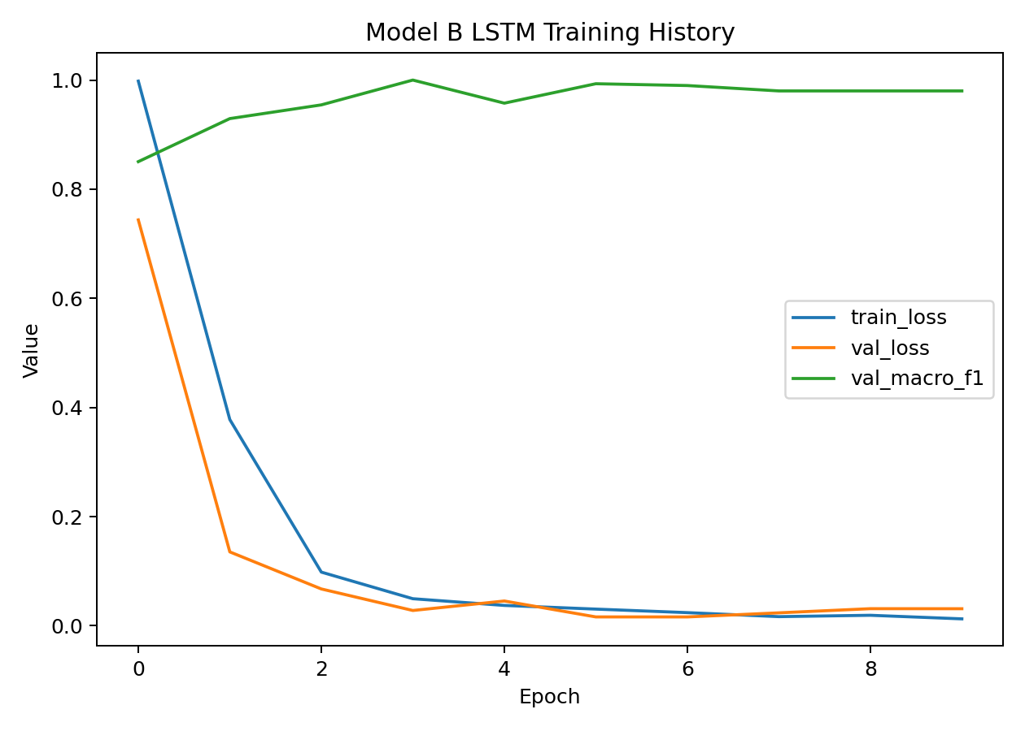
Model B Training History
Quick pointers: - This graph shows how training and validation behavior changed over epochs. - It helps detect overfitting or unstable optimization. - The final chosen checkpoint comes from the best validation behavior, not just the last epoch.

What this graph shows
It tracks: - train loss, - validation loss, - validation macro F1.

Key observations
- validation macro F1 started around 0.8505,
- improved strongly during training,
- reached best value 1.0,
- early stopping at epoch 10 prevented unnecessary overtraining.

Why this matters
This proves the training process was stable and not random.

25. Confusion Matrix Graph
Image file:
- /Users/mypc/RentAFit/reports/model_b/model_b_lstm_confusion_matrix_test.png
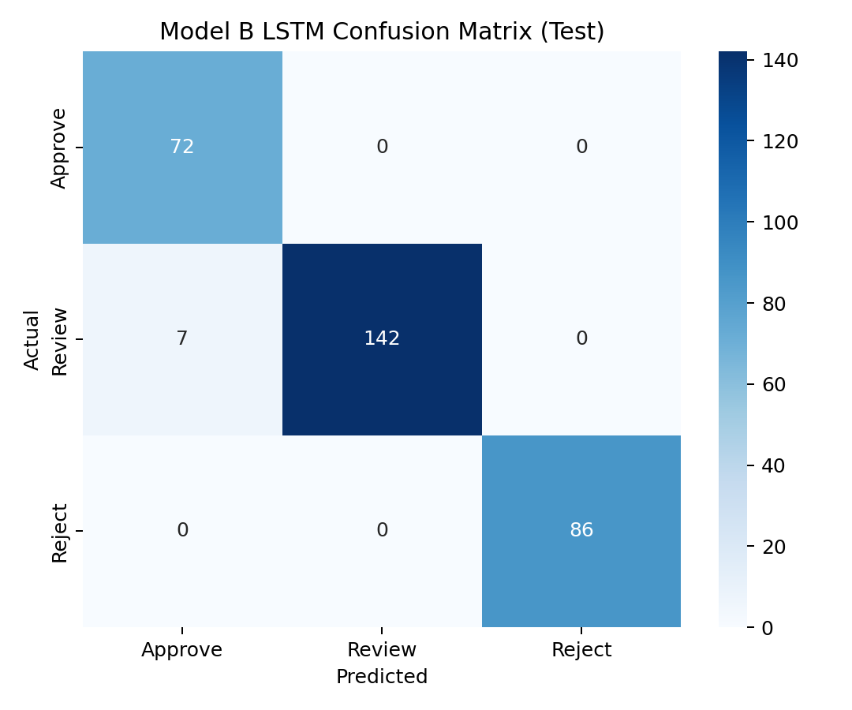
Model B Test Confusion Matrix
Quick pointers: - This matrix shows exactly which classes were predicted correctly and which were confused. - Strong diagonal values mean strong classification performance. - It is especially useful because moderation quality should not be judged only by one average score.

How to read it
- rows = true classes,
- columns = predicted classes.

What it tells us
- 29 of 30 true Approve rows were correct,
- all 54 Review rows were correct,
- all 33 Reject rows were correct.

Why this matters
This is especially strong for moderation because there are: - no false approvals of rejected items, - no rejected items misclassified as approve.

26. Honest Interpretation Of Results
The results are very strong, but they should be explained honestly.
Why performance is high: - the data is structured well, - pricing-rule support features are informative, - the stale-listing policy creates meaningful separation, - the final architecture matches the data better than a single-branch model.
So the correct interpretation is: - this is a strong hybrid operational moderation classifier, - not pure free-form human reasoning.
That is still a very valid and useful result.

27. Date-Based Lifecycle Logic
Model B is now more than just a classifier. It also has a lifecycle layer.

27.1 Important distinction
- garment_age_months = age used as model input
- listing_age_months = age used for stale-listing reapproval workflow

27.2 How listing age is computed
Implemented in: - /Users/mypc/RentAFit/code/model_b/lifecycle.py
Priority used: 1. last_reapproved_at 2. last_approved_at 3. listing_created_at 4. fallback to age input if dates are missing

27.3 Why this matters
This means a listing can now become stale because of how long it has existed on the platform, not only because of the item-age value typed by the provider.

28. Operational Lifecycle Flow
Image file:
- /Users/mypc/RentAFit/reports/model_b/model_b_lifecycle_flow.png
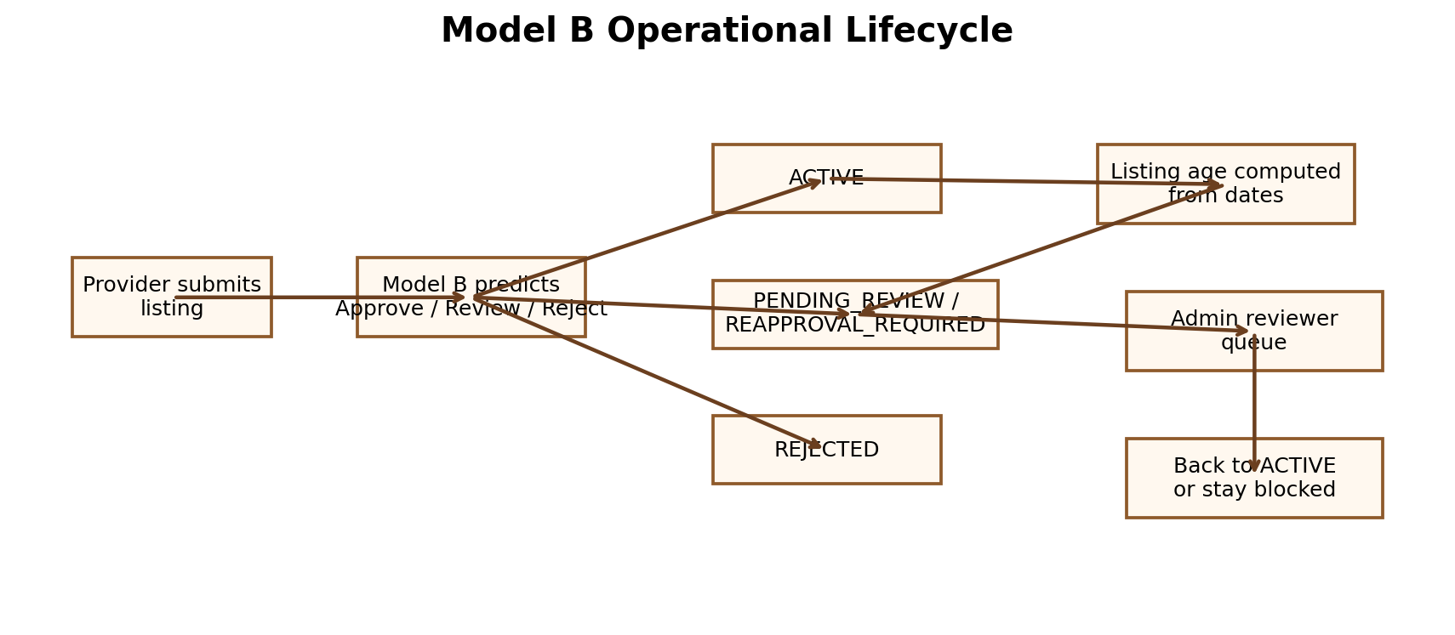
Model B Operational Lifecycle
Quick pointers: - This image connects ML output to actual product workflow. - It shows how a listing can move into reapproval because of listing age even after earlier approval. - This is the bridge between moderation prediction and real platform status changes.

What this image shows
- provider submits listing,
- Model B predicts moderation class,
- listing becomes active / pending review / rejected,
- later listing age is computed from dates,
- stale listings go into reapproval queue,
- admin reviewer checks them,
- listing either becomes active again or stays blocked.

Why this is important
This is the bridge between: - the ML model, - and the actual website workflow.

29. Current Status Mapping Logic
Current Python-side mapping:
- if predicted decision is Reject -> REJECTED
- else if listing_age_months >= 10 -> REAPPROVAL_REQUIRED
- else if predicted decision is Approve -> ACTIVE
- else -> PENDING_REVIEW
Optional support also exists for: - REMOVED
if stale grace is crossed and auto-removal is enabled.

30. Review Queue Generation
Implemented in: - /Users/mypc/RentAFit/code/model_b/ops/run_model_b_live_ops.py
This script can take a CSV of current live listings and produce: - scored listing snapshot, - review queue, - summary JSON.

Current reviewer assignment
- assigned_reviewer_role = admin_reviewer

Queue fields include
- review_reason
- review_priority
- stale_listing_flag
- removal_recommended
- visible_to_renters

31. Sample Live-Ops Result
From: - /Users/mypc/RentAFit/reports/model_b/model_b_live_ops_summary.json
Sample run summary: - input rows: 60 - review queue rows: 47 - recommended statuses: - ACTIVE: 13 - PENDING_REVIEW: 9 - REAPPROVAL_REQUIRED: 18 - REJECTED: 20 - stale listing count: 26 - removal recommended count: 7
This proves that the Python-side operational lifecycle logic is now functioning.

32. Minute-By-Minute Runtime Walkthrough
Let’s describe one full runtime path.

Step 1: Provider inputs listing
Provider gives: - brand, - category, - material, - size, - condition, - garment age, - original price, - provider price.

Step 2: System derives support features
System computes: - tokens, - tier, - deviation, - penalties, - total penalty, - rule score, - rule decision.

Step 3: LSTM branch reads sequence
Sequence: - [condition_token, age_bin_token]
This branch learns the condition-age pattern.

Step 4: Tabular branch reads structured features
The tabular branch learns from: - price, - deviation, - category, - brand, - penalties, - tier, - flags.

Step 5: Both branches are merged
The two learned representations are concatenated.

Step 6: Final classifier predicts class
Output: - Approve - Review - Reject

Step 7: Lifecycle logic computes listing status
Using date-based listing age, the backend-ready lifecycle logic suggests: - ACTIVE - PENDING_REVIEW - REAPPROVAL_REQUIRED - REJECTED

Step 8: Review queue receives stale/problem listings
Rows that need human attention are added to the review queue.

33. Smoke-Test Examples

Example 1: good listing but stale by listing age
Input summary: - Zara / Top / Cotton / S / Like New - garment age = 3 months - original price = 2599 - provider price = 180 - listing age from dates = 11 months
Outcome: - predicted decision = Approve - final suggested status = REAPPROVAL_REQUIRED
Meaning: - the item itself looks fine, - but the listing is stale and needs reapproval.

Example 2: old risky listing
Input summary: - Prada / Dress / Silk / M / Used - garment age = 11 months - original price = 95000 - provider price = 20000 - listing age from dates = 14 months
Outcome: - predicted decision = Reject - final suggested status = REJECTED - removal recommendation = true
Meaning: - both moderation quality and lifecycle logic agree this is a high-risk listing.

34. Commands To Reproduce The Main Parts

Train Model B
python3 /Users/mypc/RentAFit/code/model_b/training/train_model_b_lstm.py

Single-listing inference
python3 /Users/mypc/RentAFit/code/model_b/inference/predict_model_b_decision.py \
--brand "Zara" \
--category "Top" \
--material "Cotton" \
--size "S" \
--condition "Like New" \
--garment_age_months 3 \
--original_price 2599 \
--provider_price 180 \
--current_status ACTIVE \
--listing_created_at 2025-03-01 \
--last_approved_at 2025-04-01 \
--as_of_date 2026-03-14 \
--json

Generate sample live listings
python3 /Users/mypc/RentAFit/code/model_b/ops/generate_live_listings_sample.py

Run live-ops scoring
python3 /Users/mypc/RentAFit/code/model_b/ops/run_model_b_live_ops.py --as_of_date 2026-03-14

Generate comparison visuals
python3 /Users/mypc/RentAFit/code/model_b/analysis/model_b_branch_comparison.py

35. What Is Fully Implemented And What Is Still Left

Fully implemented now
- manual gold-label workflow,
- expansion-review workflow,
- final expanded training dataset,
- hybrid LSTM + tabular classifier,
- saved trained model,
- inference pipeline,
- branch comparison study,
- date-based lifecycle logic,
- stale-listing handling,
- review queue generation,
- sample live-ops run,
- full documentation with visuals.

Still future product work
These are not ML gaps anymore. They are integration tasks: - database persistence for listing dates and statuses, - scheduled job for automatic stale-listing scanning, - admin dashboard UI, - renter/provider UI tied to live status.
So the Python/ML side of Model B is now complete enough for serious project explanation and backend integration.

36. Glossary For Beginners

Classification
A machine learning task where the output is a class label, such as Approve, Review, or Reject.

Token
A numeric code representing a category, such as Used = 3.

Embedding
A layer that converts a token into a learned vector representation.

LSTM
A type of recurrent neural network designed to learn from ordered sequences.

Tabular data
Structured data in rows and columns, such as brand, price, and penalties.

One-hot encoding
A way to convert categories into machine-readable binary columns.

Macro F1
An evaluation metric that gives equal importance to all classes.

Confusion matrix
A table showing which classes were predicted correctly and where mistakes happened.

Early stopping
A training control method that stops learning when validation performance stops improving.

Stale listing
A listing that has remained active long enough to require reapproval.

Reapproval
A second moderation check for an already existing listing.

37. Cross-check test cases (2026-03-14)
Cases: 5 Anomalies: 0
Case | Brand | Category | Condition | Garment Age | Provider Price | Decision | Status | Listing Age | Note
B1 | Zara | Top | New | 2 | 180 | Approve | ACTIVE | 1
B2 | Biba | Kurta | Like New | 8 | 320 | Review | REAPPROVAL_REQUIRED | 14 | stale listing -> reapproval
B3 | Gucci | Dress | Used | 12 | 60000 | Reject | REJECTED | 11 | model rejection
B4 | Uniqlo | Jacket | Like New | 5 | 1200 | Reject | REJECTED | 1 | model rejection
B5 | H&M | Jeans | Used | 11 | 900 | Reject | REJECTED | 15 | model rejection

38. API Integration
Model B is exposed via the backend API:
- POST /api/model-b/predict
This endpoint is used by the lender upload flow to show moderation decisions and suggested listing status.
The runtime output now includes:
- prediction decision, probabilities, and suggested status
- lifecycle listing_age_months, stale flags, reviewer routing, removal recommendation, and visibility
- summary compact integration fields for frontend/backend consumers

39. Final Summary
Model B is now a complete hybrid moderation and lifecycle model for RentAFit on the Python side.
It combines: - human-reviewed labels, - pricing-behavior support features, - LSTM sequence learning for age and condition, - tabular learning for metadata and prices, - date-based stale-listing logic, - website-ready status mapping, - review queue generation.
Most importantly, the design is now supported by data:
- LSTM-only is weak,
- tabular-only is strong,
- hybrid is best.
That makes Model B not only implemented, but also well explained and defendable.

