RentAFit Model C Handbook

1. Purpose Of This Document
This handbook explains the final Model C recommendation system used in RentAFit. It is written to be detailed enough for project defense, but clear enough that a student can learn how the recommender works from start to finish.
Model C is the renter-side model. Its job is to recommend relevant clothes from the live catalog in a way that is:
- explainable,
- policy-aware,
- safe,
- size-conscious,
- gender-aware,
- and practical without real renter click history.

2. What Model C Does
Model C recommends clothes in two ways:
- Viewed item -> similar items
- Liked items -> profile-based recommendations
So if a renter opens one item, Model C finds similar catalog items. If a renter likes multiple items, Model C builds a simple preference profile and recommends based on that combined preference.
The current v1 system is a content-based recommender.
That means it recommends using item features such as:
- category,
- gender,
- size,
- material,
- brand,
- tier,
- condition,
- price,
- quality,
- freshness.
It does not depend on real renter behavior logs yet.

3. Why A Content-Based Recommender Was Chosen
This was the right starting point because RentAFit currently has:
- a structured clothing catalog,
- pricing and quality features,
- moderation signals from Model B,
- but no real renter click / like / order history at scale.
If we tried to build collaborative filtering first, we would need real user-item interaction logs. That data does not exist yet in a trustworthy form.
So the practical and honest v1 choice is:
- build recommendations from the content of the items themselves
- keep the logic explainable
- support a clean upgrade path later when real renter history exists
That is why Model C is content-based first, while still leaving room for:
- liked-item profile recommendations later,
- hybrid recommendation later,
- collaborative filtering later.

4. Final Policy Decisions For Model C
These are the final rules chosen for Model C.

4.1 Main recommendation goal
- recommend similar clothes from a selected item
- support liked-item based recommendations later

4.2 Core modeling approach
- content-based recommender using catalog metadata and quality context

4.3 Gender rule
- gender is a hard compatibility filter
- Women query can see Women and Unisex
- Men query can see Men and Unisex
- Unisex query sees only Unisex

4.4 Category rule
- same category only in v1

4.5 Size rule
- exact same size first
- nearest size next
- extended size can still appear if the pool is too small

4.6 Safety rule
- primary recommendations come from safe approved items
- up to 2 Review items may be used only as fallback if otherwise strong matches exist

4.7 Budget rule
- if renter gives explicit budget, use that
- otherwise use category-average provider price as the default budget reference

4.8 Output rule
- top 5 recommendations
- include reason tags explaining why each item was selected

4.9 Evaluation rule
- use proxy metrics
- because real renter interaction logs do not exist yet

5. What “Freshness” Means
Freshness was not a manually typed raw dataset field.
It is a derived feature built from age_months.
The intuition is simple:
- newer item -> higher freshness
- older item -> lower freshness
Current derived feature: - item_freshness_score
This helps Model C prefer items that feel more current and rental-ready.
So freshness is basically: - a normalized “how recent / less old is this item?” signal

6. Data Used By Model C
Primary source file: - /Users/mypc/RentAFit/data/frozen/v2_gender/pricing_features_augmented_1500.csv
Generated catalog files: - /Users/mypc/RentAFit/data/generated/model_c_catalog.csv - /Users/mypc/RentAFit/data/generated/model_c_catalog_recommendable.csv
Saved training artifacts: - /Users/mypc/RentAFit/models/model_c/content_based/model_c_preprocessor.joblib - /Users/mypc/RentAFit/models/model_c/content_based/model_c_nearest_neighbors.joblib - /Users/mypc/RentAFit/models/model_c/content_based/model_c_feature_matrix.joblib - /Users/mypc/RentAFit/models/model_c/content_based/model_c_catalog_recommendable.csv - /Users/mypc/RentAFit/models/model_c/content_based/model_c_metadata.json
Current dataset counts: - source rows: 1500 - full catalog rows: 1500 - recommendable rows: 932 - filtered out rows: 568 - recommendable rate: 0.6213
Current pool counts: - PRIMARY_APPROVE: 529 - REVIEW_FALLBACK: 403 - FILTERED_OUT: 568
Current recommendable gender counts: - Unisex: 575 - Women: 357
Current recommendable size counts: - M: 357 - S: 243 - L: 215 - XS: 60 - XL: 57

7. Why Model B Is Part Of Model C
Model C does not recommend items blindly.
Before an item becomes recommendable, Model C uses Model B moderation output to help decide whether the item belongs in:
- the main safe pool,
- the review fallback pool,
- or the filtered-out pool.
Columns added during catalog preparation: - model_b_predicted_decision - model_b_approve_probability - model_b_review_probability - model_b_reject_probability - recommendation_pool_status - recommendable_flag - review_fallback_eligible
This is important because recommendation quality is not just “find similar items”. It is also:
- avoid weak items,
- avoid risky items,
- keep the renter-facing catalog safer.
So Model C is not isolated from the rest of the ML system. It is deliberately linked with Model B.

8. Recommendation Pool Rule
Model C first builds a catalog and then classifies items into recommendation pools.

8.1 Primary recommendation pool
An item goes into PRIMARY_APPROVE when:
- Model B predicts Approve
- and rule_quality_score >= 55

8.2 Review fallback pool
An item goes into REVIEW_FALLBACK when:
- Model B predicts Review
- and rule_quality_score >= 60
- and deviation_M <= 40

8.3 Filtered out pool
An item becomes FILTERED_OUT when:
- provider_price <= 0
- or original_price <= 0
- or it fails the pool rules above
This policy means:
- approved and strong items come first,
- review items are available only as a controlled fallback,
- clearly weak items are excluded entirely.

9. Data Pipeline Diagram
Image file: - /Users/mypc/RentAFit/reports/model_c/model_c_data_pipeline.png
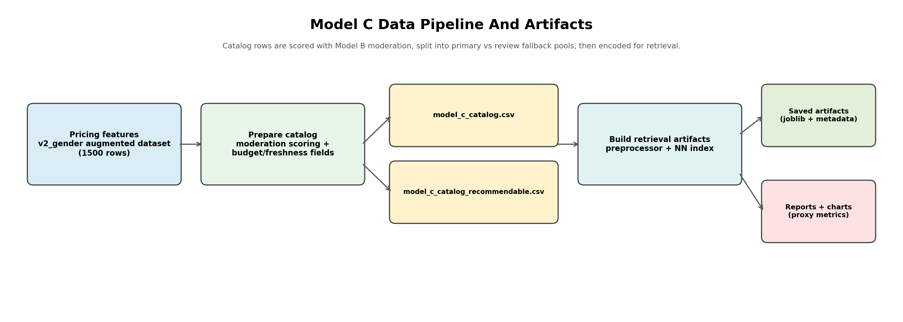
Model C Data Pipeline
Quick pointers: - the v2 gender-aware pricing dataset is the starting point - Model B moderation is used during catalog preparation - the output is split into full catalog vs recommendable catalog - training artifacts are then built from the recommendable pool - charts and reports are generated after the artifacts are ready
Why this matters: - it shows that Model C is a full pipeline, not just one ranking script

10. Feature Engineering Used In Model C

10.1 Categorical features
- brand
- category
- gender
- material
- size
- condition
- tier_primary
These are one-hot encoded.

10.2 Numeric features
- age_months
- original_price
- provider_price
- rule_mid
- rule_quality_score
- quality_score_norm
- item_freshness_score
- provider_price_pct_of_original
- category_avg_provider_price
- price_vs_category_avg_ratio
- catalog_priority_score
- model_b_approve_probability
- model_b_review_probability
These are median-imputed and standardized.

10.3 Derived recommendation features
These are not all used inside the preprocessor, but they are important during policy and re-ranking:
- budget_alignment_score
- gender_match_label
- size_match_label
- recommendation_pool_status

10.4 Why these features make sense
This feature set helps the recommender understand:
- what the item is,
- how premium it is,
- whether it is safe enough to recommend,
- whether it is fresh or stale,
- whether it fits expected price behavior,
- whether it belongs near the renter’s size and budget zone.

11. Architecture Diagram
Image file: - /Users/mypc/RentAFit/reports/model_c/model_c_architecture.png
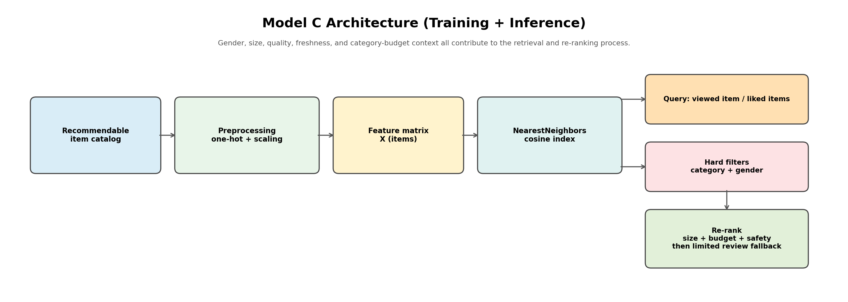
Model C Architecture
Quick pointers: - the recommendable catalog is encoded into vectors - a cosine nearest-neighbor index retrieves similar items - hard policy filters are applied after retrieval - re-ranking then uses size, budget, and safety signals - limited review fallback is applied only at the end
Why this matters: - it shows that Model C is not only nearest-neighbor retrieval - it is a retrieval + policy + re-ranking system

12. Recommendation Flow Diagram
Image file: - /Users/mypc/RentAFit/reports/model_c/model_c_similarity_flow.png
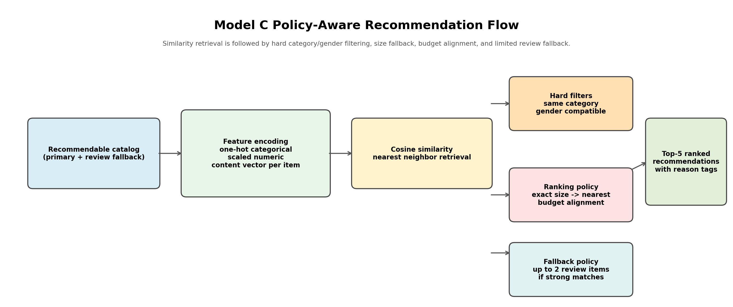
Model C Recommendation Flow
Quick pointers: - similarity retrieval gives a candidate set first - category and gender are enforced as hard filters - exact size is preferred before nearest size - budget and safety then reshape the ranking - review fallback is capped at 2 items
Why this matters: - it makes the runtime policy easy to understand step by step

13. How Training Works In Model C
Model C does not train a deep neural network.
Instead, it builds reusable recommender artifacts:
- fit the preprocessor on the recommendable catalog
- transform the catalog into an item feature matrix
- fit a cosine NearestNeighbors model
- save artifacts for runtime retrieval
Main scripts: - /Users/mypc/RentAFit/code/model_c/prepare_model_c_catalog.py - /Users/mypc/RentAFit/code/model_c/training/train_model_c_content_based.py
Saved metadata currently says: - model type: content_based_cosine_similarity - catalog rows: 932 - neighbors fit: 150

14. Recommendation Scoring Logic
Model C is a two-stage recommender:
- retrieve candidates by cosine similarity
- re-rank candidates using policy-aware signals
Current re-ranking weights: - base similarity weight: 0.55 - quality weight: 0.15 - freshness weight: 0.08 - budget alignment weight: 0.10 - size match weight: 0.07 - safety weight: 0.05

Why these weights make sense
- similarity remains the most important signal
- quality matters because renters should see better items first
- freshness matters because newer items are usually more attractive
- budget alignment matters because recommendations should stay realistic
- size matters because fit matters
- safety matters because primary approved items should outrank fallback review items

Important clarification about budget
When the renter does not provide an explicit budget, Model C uses:
- category_average_budget
This is a soft ranking signal, not a hard removal rule.
That means: - a luxury item can still rank well if similarity, size, quality, and tier are strong - but price distance from the category average will reduce its budget alignment score
This behavior is intentional.

15. Query Modes

15.1 Item-to-item recommendation
Example:
python3 /Users/mypc/RentAFit/code/model_c/inference/recommend_model_c_items.py \
--seed_item_id L0015 --top_k 5 --json

15.2 Profile-from-liked-items recommendation
Example:
python3 /Users/mypc/RentAFit/code/model_c/inference/recommend_model_c_items.py \
--liked_item_ids L0015,L0021,L0100 --top_k 5 --json
In profile mode, Model C builds a small preference summary from the liked items, such as:
- dominant category,
- dominant gender,
- dominant material,
- dominant size,
- dominant brand,
- dominant tier,
- average provider price.

16. Runtime Policy Rules In Plain Language
At runtime, Model C follows this logic:
- find candidate items using similarity
- keep only same-category items
- enforce gender compatibility
- prefer exact size matches
- then allow nearest sizes
- use category-average or explicit budget for budget alignment
- rank primary approved items first
- allow up to 2 review fallback items if needed
- return top 5 items with reason tags
This is exactly why the system feels safer and more intentional than a plain nearest-neighbor list.

17. Evaluation Method
Real renter interaction logs do not yet exist. So Model C is evaluated using policy-aware proxy metrics.
That means we check whether recommended items are:
- same category,
- gender compatible,
- size compatible,
- materially similar,
- tier aligned,
- budget aligned,
- high enough quality,
- retrieved with strong similarity.
We also compare against a policy-aware random baseline.
This is important: - the random baseline uses the same hard filters - so metrics forced by policy may become identical by design - the more meaningful comparison is on ranking-sensitive metrics such as: - material match - tier match - similarity - budget alignment - final score - average quality

18. Current Metrics
From: - /Users/mypc/RentAFit/reports/model_c/model_c_proxy_metrics.json
Current Model C proxy metrics: - fill_rate_at_5 = 0.9350 - same_category_at_5 = 1.0000 - gender_compatible_at_5 = 1.0000 - exact_size_at_5 = 0.6560 - size_compatible_at_5 = 0.8881 - same_material_at_5 = 0.8531 - same_tier_at_5 = 0.5563 - avg_rule_quality_score_top5 = 84.1663 - avg_similarity_score_top5 = 0.6731 - avg_budget_alignment_top5 = 0.6900 - avg_final_score_top5 = 0.7331 - review_fallback_rate_top5 = 0.1296
From: - /Users/mypc/RentAFit/reports/model_c/model_c_proxy_vs_random_metrics.json
Policy-aware random baseline: - fill_rate_at_5 = 0.9350 - same_category_at_5 = 1.0000 - gender_compatible_at_5 = 1.0000 - exact_size_at_5 = 0.6560 - size_compatible_at_5 = 0.8881 - same_material_at_5 = 0.8069 - same_tier_at_5 = 0.5313 - avg_rule_quality_score_top5 = 83.5606 - avg_similarity_score_top5 = 0.6247 - avg_budget_alignment_top5 = 0.6727 - avg_final_score_top5 = 0.7023 - review_fallback_rate_top5 = 0.1296

What these numbers mean
Some metrics are identical because:
- category is a hard filter
- gender is a hard filter
- size behavior is heavily shaped by policy before ranking
So the real evidence that Model C is better than random is:
- better material alignment
- better tier alignment
- higher average quality
- higher average similarity
- better budget alignment
- higher final ranking score
That is exactly what we want from a ranking model.

19. Proxy Metrics Chart
Image file: - /Users/mypc/RentAFit/reports/model_c/model_c_proxy_metrics_chart.png
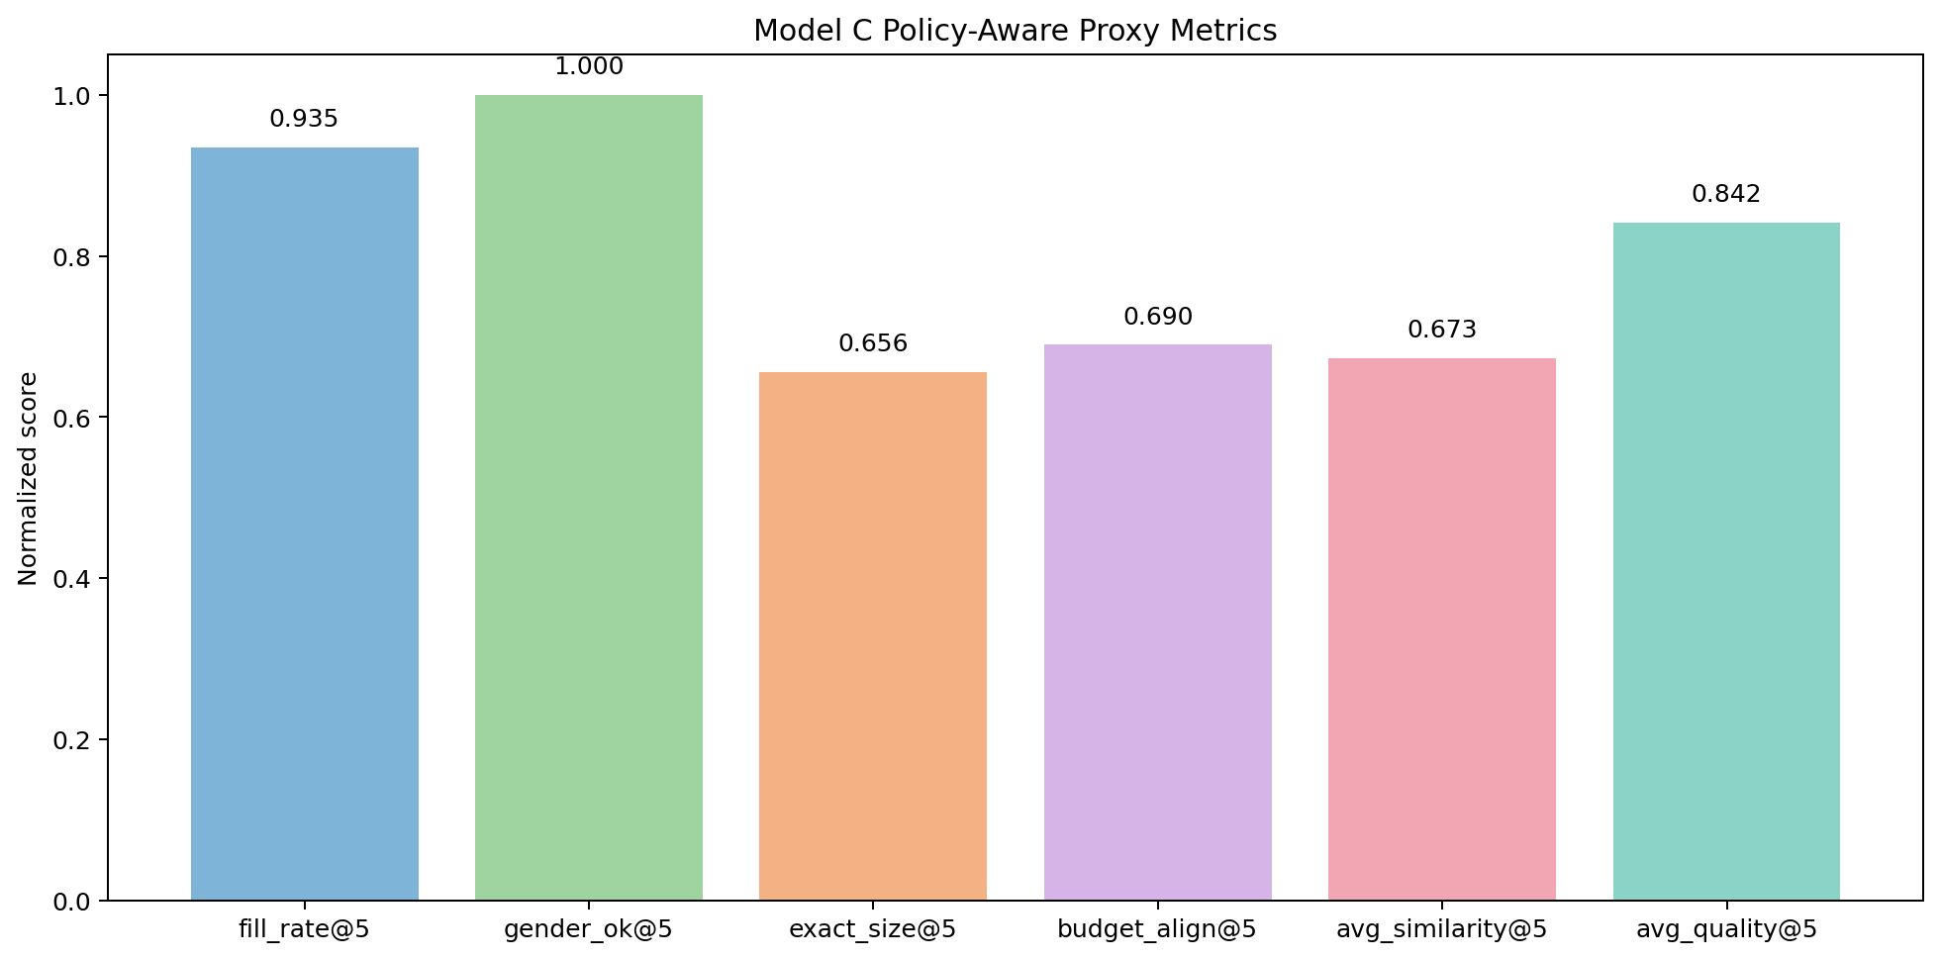
Model C Proxy Metrics
Quick pointers: - fill rate shows how often the model can fill the top 5 list - gender compatibility stays perfect because of hard policy filtering - exact size is lower than total size compatibility because nearest size fallback is allowed - budget alignment and similarity are both reasonably strong - average quality stays high, meaning recommendations are not low-grade items

20. Model C vs Random Baseline Chart
Image file: - /Users/mypc/RentAFit/reports/model_c/model_c_proxy_vs_random_chart.png
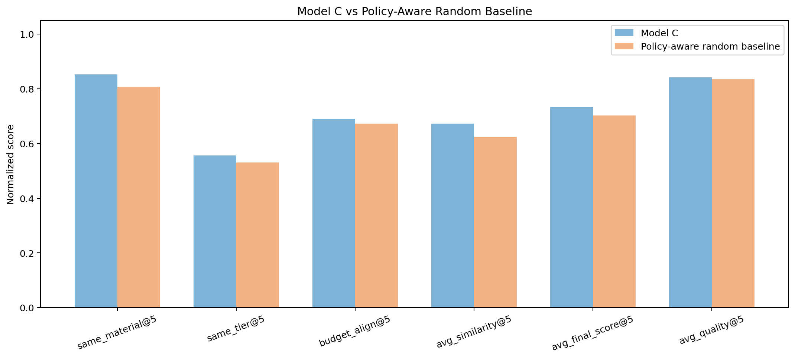
Model C vs Random Baseline
Quick pointers: - comparison focuses on ranking-sensitive metrics - the gain over random is strongest where real ranking matters - Model C beats the random baseline on: - material similarity - tier similarity - budget alignment - average similarity - average final score - average quality
Why this matters: - it proves the recommender is doing more than policy filtering - it is actually ranking better candidates higher

21. Catalog Distribution Chart
Image file: - /Users/mypc/RentAFit/reports/model_c/model_c_catalog_distribution_chart.png
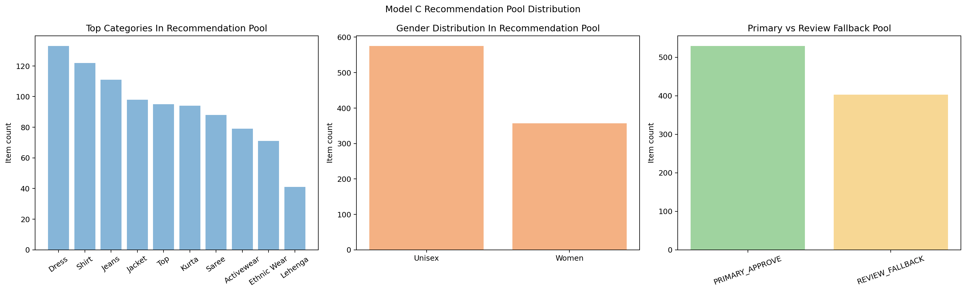
Model C Catalog Distribution
Quick pointers: - the chart shows the top categories in the recommendable pool - it also shows gender balance in the pool - it visualizes how many items are primary vs review fallback
Why this matters: - it helps explain the actual recommendation search space before ranking happens

22. Real Smoke-Test Examples

22.1 Women-item query
Command used:
python3 /Users/mypc/RentAFit/code/model_c/inference/recommend_model_c_items.py --seed_item_id L0015 --top_k 5 --json
Observed behavior: - category stayed Dress - gender stayed Women - exact size matches were preferred - no review fallback was needed

22.2 Unisex-item query
Command used:
python3 /Users/mypc/RentAFit/code/model_c/inference/recommend_model_c_items.py --seed_item_id L0037 --top_k 5 --json
Observed behavior: - category stayed Shirt - gender stayed Unisex - exact size matches appeared first when available - extended sizes appeared only when the pool needed them

22.3 Profile query
Command used:
python3 /Users/mypc/RentAFit/code/model_c/inference/recommend_model_c_items.py --liked_item_ids L0015,L0021,L0100 --top_k 5 --json
Observed behavior: - the profile summarized into Dress, Women, Silk, L, Tier 5 - the recommender respected category and gender - exact size and extended size both appeared depending on availability

22.4 Review fallback edge case
Command used:
python3 /Users/mypc/RentAFit/code/model_c/inference/recommend_model_c_items.py --seed_item_id L0080 --top_k 5 --json
Observed behavior: - only 2 results were returned - both were REVIEW_FALLBACK - policy_summary.review_items_used = 2
This proves: - the review fallback cap is respected - the system does not fill the list with weak items just to reach 5 results

23. Main Code Files

Preparation
- /Users/mypc/RentAFit/code/model_c/prepare_model_c_catalog.py

Policy helpers
- /Users/mypc/RentAFit/code/model_c/policy.py

Training / artifact building
- /Users/mypc/RentAFit/code/model_c/training/train_model_c_content_based.py

Runtime
- /Users/mypc/RentAFit/code/model_c/runtime.py

Inference
- /Users/mypc/RentAFit/code/model_c/inference/recommend_model_c_items.py

Analysis
- /Users/mypc/RentAFit/code/model_c/analysis/model_c_report.py

24. Why Model C Is Strong For This Stage
Model C is strong for the current stage of the project because it is:
- explainable,
- policy-aware,
- connected with Model B moderation,
- gender-aware,
- size-aware,
- budget-aware,
- and already able to serve both item and profile queries.
It is not pretending to be something it is not.
It is honestly a well-engineered content-based recommender, which is exactly the right v1 choice for the available data.

25. Honest Limitations
Model C still has important limitations:
- it does not yet use real renter click / like / booking logs
- proxy metrics are not the same as true production precision@K
- budget defaults use category averages, which can underrepresent luxury seed preferences
- the system is currently metadata-driven, not image-driven
- broader cross-category styling recommendations are intentionally disabled in v1
These are acceptable limitations for a student project baseline.

26. Best Future Upgrades
Natural future upgrades are:
- add real renter interaction logs
- move to a hybrid recommender
- personalize with renter style history
- allow related-category recommendations
- use image embeddings later for style similarity
- integrate explicit budget and occasion filters in the frontend

27. Final Summary
Model C is the renter-side recommendation model for RentAFit.
It:
- builds a moderated and filtered recommendation pool,
- represents items using content features,
- retrieves candidates by cosine similarity,
- applies hard category and gender rules,
- prioritizes exact size then nearest size,
- uses category-average or explicit budget alignment,
- allows at most 2 review fallback items,
- and returns top 5 explainable recommendations.
That makes it a complete, defensible, and practical v1 recommender for the current project.

