END-TO-END MLOps
HEART DISEASE PREDICTION
Assignment 01 | MLOps AIMLCZG523

Student Name | Anmol Sinha
BITS ID | 2025AE05129
Project | UCI Heart Disease — Binary Classification API
Technology Stack | GitHub Actions • MLflow • Docker • Minikube • kubectl • Helm • Prometheus • Grafana • ngrok

Repository and demonstration links
Main GitHub repository: https://github.com/anmol-sinha-coder/BITS-MLOps-AIMLZG523_Assignment-1
MP4 screen recording: https://github.com/anmol-sinha-coder/BITS-MLOps-AIMLZG523_Assignment-1/blob/main/2025AE05129__AnmolSinha__MLOps_Assignment-1.mp4

Prepared against the Assignment 01 requirements. Screenshots in this report are taken from the supplied screenshot archive; runtime values and availability should be rechecked at final submission.

1. Executive Summary
This project implements an end-to-end machine-learning workflow for binary heart-disease classification using the UCI Heart Disease (Cleveland) dataset. The engineering lifecycle includes data acquisition and cleaning, exploratory data analysis (EDA), feature transformation, model comparison, MLflow experiment tracking, automated tests and CI, Docker-based API packaging, Kubernetes deployment options, and operational monitoring.
The goal is reproducibility and operational visibility—not only a trained estimator. Preprocessing is packaged with the model to reduce training-serving skew. GitHub Actions automates quality gates; Docker makes the API portable; Minikube, kubectl and Helm support Kubernetes deployment; Prometheus and Grafana expose operational signals; ngrok can provide temporary public access to the locally hosted API.

Assignment rubric mapping
Requirement | Project implementation / evidence
Data acquisition & EDA — 5 marks | UCI acquisition/fallback, cleaning, class balance, missingness, histograms, boxplots and correlation plot.
Feature engineering & modelling — 8 marks | Numeric/categorical preprocessing; Logistic Regression and Random Forest; stratified CV and tuning.
Experiment tracking — 5 marks | MLflow parameters, metrics, artifacts, evaluation plots and model files.
Packaging & reproducibility — 7 marks | Serialized full pipeline, separate serving dependencies and repeatable commands.
CI/CD and tests — 8 marks | GitHub Actions workflow for lint, pytest, data/training checks, Docker build and smoke test.
Containerization — 5 marks | FastAPI API image with health endpoint and sample prediction test.
Production deployment — 7 marks | Kubernetes manifests/Helm chart, Minikube rollout and service exposure.
Monitoring & logging — 3 marks | API logs, Prometheus `/metrics`, Grafana data source/dashboard.
Documentation — 2 marks | Architecture, setup, evidence screenshots, repository and video links.
The active ngrok URL was not supplied in the request, so a clearly marked placeholder is used rather than inventing a public address.

2. Architecture and End-to-End Flow
UCI CSV → Download / validate / clean → EDA outputs
↓
Preprocessing + Logistic Regression / Random Forest
↓
Cross-validation + model selection + MLflow
↓
Serialized pipeline → FastAPI prediction service
↓
GitHub Actions → tests → Docker build → smoke test
↓
Minikube Kubernetes Deployment / Service
↓
ngrok HTTPS tunnel for demo access
↓
Prometheus scrape → Grafana dashboard

Technology roles
Technology | Role in this project
GitHub repository | Versioned source, scripts, tests, workflows, deployment files, screenshots and video.
GitHub Actions | Automates linting, tests, training/build checks and logs workflow results.
MLflow | Tracks model experiments, parameters, metrics and artifacts through a web UI.
Docker | Packages FastAPI and runtime dependencies into a portable image.
Minikube | Runs a local Kubernetes cluster for deployment practice.
kubectl | Applies resources and inspects pods, services, rollout and logs.
Helm | Templates and versions Kubernetes application resources through values and releases.
Prometheus | Scrapes numeric metrics from the API and makes them queryable.
Grafana | Visualizes Prometheus time-series data in dashboards.
ngrok | Creates a temporary HTTPS tunnel to a local API port; it does not host the model.

Prediction request path
- A client sends a JSON payload containing the model's input features to `POST /predict`.
- FastAPI validates the request and invokes the saved preprocessing-plus-classifier pipeline.
- The API returns the binary prediction and probability/confidence fields.
- API telemetry is exposed at `/metrics`; Prometheus scrapes it and Grafana visualizes it.

3. Data Acquisition, Preprocessing and EDA

Dataset and target
The assignment identifies the UCI Heart Disease dataset and asks for a binary prediction of disease presence/absence. The Cleveland subset commonly contains 303 records and 13 predictors, plus an original target field `num`. The implementation maps `num > 0` to class 1 and `num = 0` to class 0.
Predictors include age, sex, chest-pain type (`cp`), resting blood pressure (`trestbps`), cholesterol (`chol`), fasting blood sugar (`fbs`), resting ECG (`restecg`), maximum heart rate (`thalach`), exercise-induced angina (`exang`), ST depression (`oldpeak`), slope, major vessels (`ca`) and thalassemia category (`thal`).

Data acquisition and cleaning
- Download module retrieves the dataset and supports local fallback for offline execution.
- Raw and cleaned data are stored separately to preserve source provenance.
- Feature values are converted to numeric where appropriate; missing feature values are retained for pipeline imputation.
- The target is converted into a binary label for the classifier.
- Suggested commands: `python -m src.download_data` followed by `python -m src.eda`.

EDA results and interpretation
The supplied EDA screenshots document the original target-label distribution, the binarized class distribution, missing-value counts, class-wise numeric distributions, class-wise boxplots, categorical feature distributions and a feature-correlation matrix.
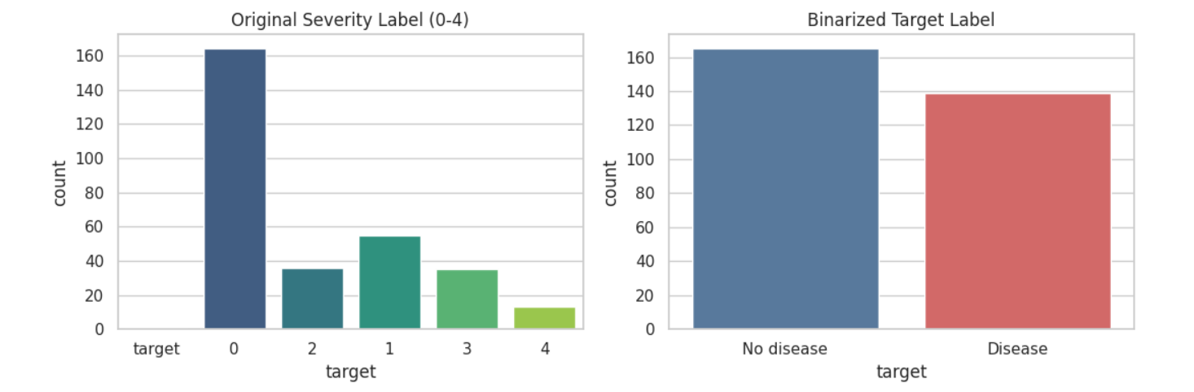
Figure 1. Original target-label distribution before binarization.
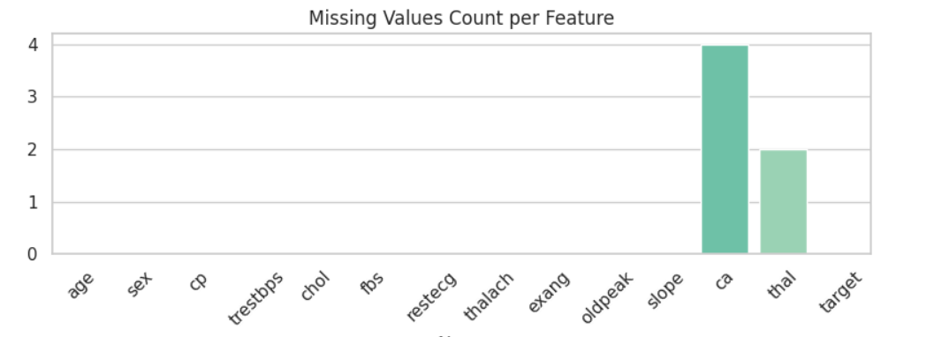
Figure 2. Binary class balance after target conversion.

3.1 EDA Evidence — Missingness and Feature Distributions
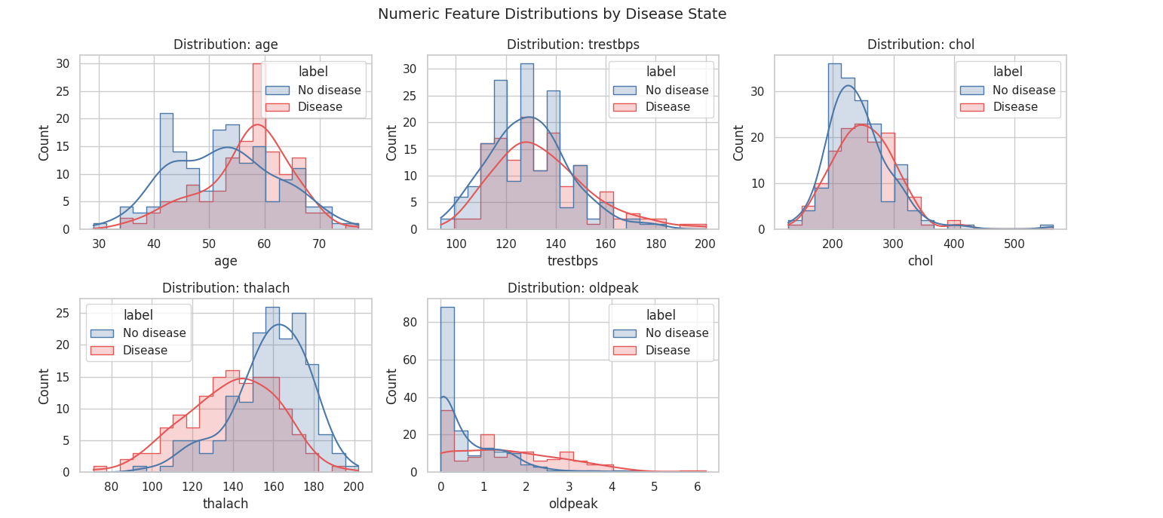
Figure 3. Numeric feature distributions split by disease class.
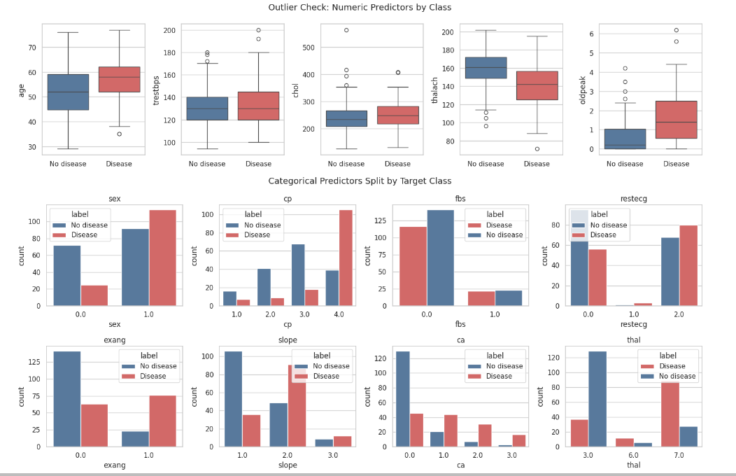
Figure 4. Numeric boxplots and categorical distributions by class.
The missing-value plot in the supplied EDA output shows missingness concentrated in `ca` and `thal` (four and two values respectively in the inspected dataset). Imputation is preferable to dropping all such rows for this small dataset, provided the imputation statistics are learned only from the training folds.

3.2 EDA Evidence — Correlation
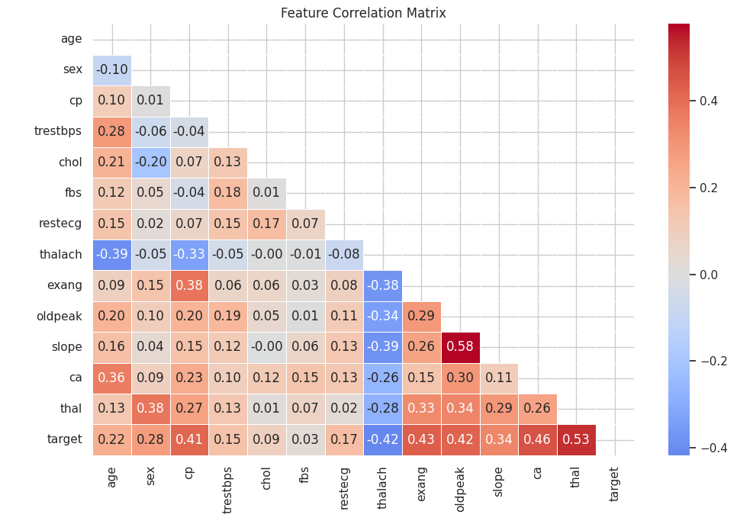
Figure 5. Feature-correlation matrix generated by the EDA script.
The heatmap is a useful exploratory overview, but Pearson correlation assumes numeric meaning. Integer-coded nominal categories such as `cp` and `thal` do not necessarily have a linear ordering. Interpret these coefficients cautiously; contingency tables or Cramér’s V are more appropriate complementary analyses for categorical associations.
EDA is descriptive, not causal. Potential outliers should be investigated rather than removed automatically, and visual patterns should be described in the report using the actual plots and model results.

4. Feature Engineering and Model Development

Preprocessing pipeline
The model pipeline separates numeric and categorical inputs with a column transformer. Numeric columns use median imputation and standard scaling; categorical columns use most-frequent imputation and one-hot encoding. The transformer and classifier are saved together, so inference applies the same transformations learned during training.
- Imputation and scaling are fitted inside each training fold, limiting cross-validation leakage.
- Scaling supports Logistic Regression optimization where features have different units.
- One-hot encoding avoids treating nominal categories as continuous measurements.
- The full pipeline is persisted to reduce training-serving skew.

Models compared
Model | Purpose | Tuning approach
Logistic Regression | Interpretable linear baseline; regularized decision boundary. | Grid search over regularization strength (`C`) with sufficient iterations.
Random Forest | Tree ensemble that can capture non-linear patterns and interactions. | Grid search over estimator count, maximum depth and minimum leaf size.
Stratified cross-validation preserves class proportions across folds. ROC-AUC is used as the model-selection metric, while accuracy, precision, recall and ROC-AUC are reported for evaluation. The enhanced implementation selects the champion using cross-validated ROC-AUC and reserves the held-out test set for final evaluation. This is preferable to selecting a model based on test-set performance.
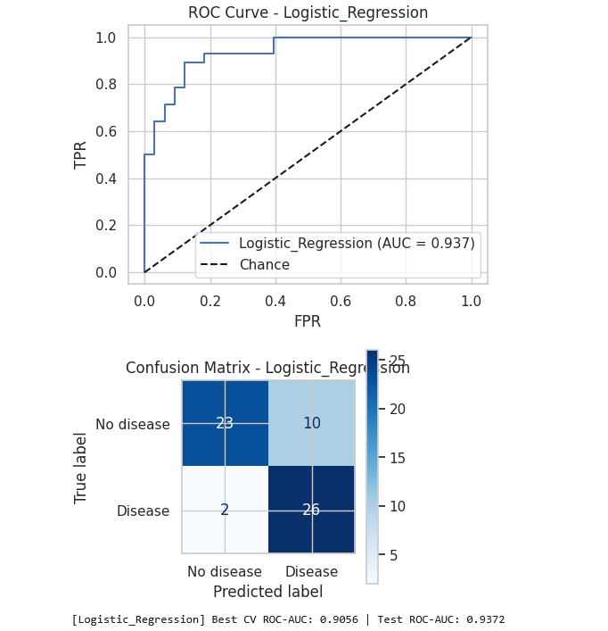
Figure 6. Logistic Regression ROC and confusion-matrix output.
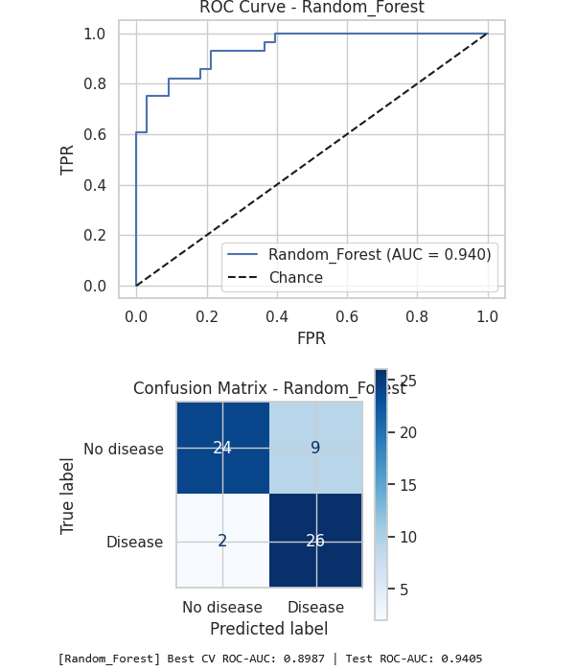
Figure 7. Random Forest ROC and confusion-matrix output.
The supplied figures show example evaluation outputs. Use the final MLflow run values for any numeric claims; do not transcribe metrics from an older run if the model or data changed.

5. Experiment Tracking with MLflow
MLflow Tracking records training runs in an experiment so model candidates can be compared and results can be reproduced. The training workflow logs model parameters, cross-validation and hold-out metrics, plots and serialized model artifacts.
Tracked item | Purpose
Parameters | Classifier family and selected hyperparameters.
Cross-validation ROC-AUC | Selection criterion for champion model.
Hold-out metrics | Accuracy, precision, recall and ROC-AUC for final evaluation.
Artifacts | ROC curves, confusion matrices, serialized pipeline and supporting files.
Run metadata | Run name, experiment grouping and training context.

Tracking server
The local Docker Compose configuration provides an MLflow service on port 5000 backed by SQLite and a persistent artifact directory. With the server running, the training process can use `MLFLOW_TRACKING_URI=http://localhost:5000`; the MLflow UI is then available at `http://localhost:5000`. When no remote tracking URI is configured, a local file-based tracking store can be used for development.
- Start MLflow with `docker compose up -d mlflow`.
- Check service health and open the UI at `http://localhost:5000`.
- Train with `MLFLOW_TRACKING_URI=http://localhost:5000 python -m src.train`.
- Compare candidate runs and inspect parameters, metrics and artifacts in the UI.
Persistent storage is important: routine deployment commands should not remove volumes containing MLflow database/artifact history. Any destructive cleanup command should be used only when intentionally resetting the development environment.

6. CI/CD with GitHub Actions
The GitHub Actions workflow automates quality checks so code changes are evaluated consistently. The repository workflow is intended to cover linting, automated tests, data/EDA execution, training checks, deployment configuration validation, Docker image build and API smoke testing. The Actions page is the authoritative evidence of actual job status for a specific commit.
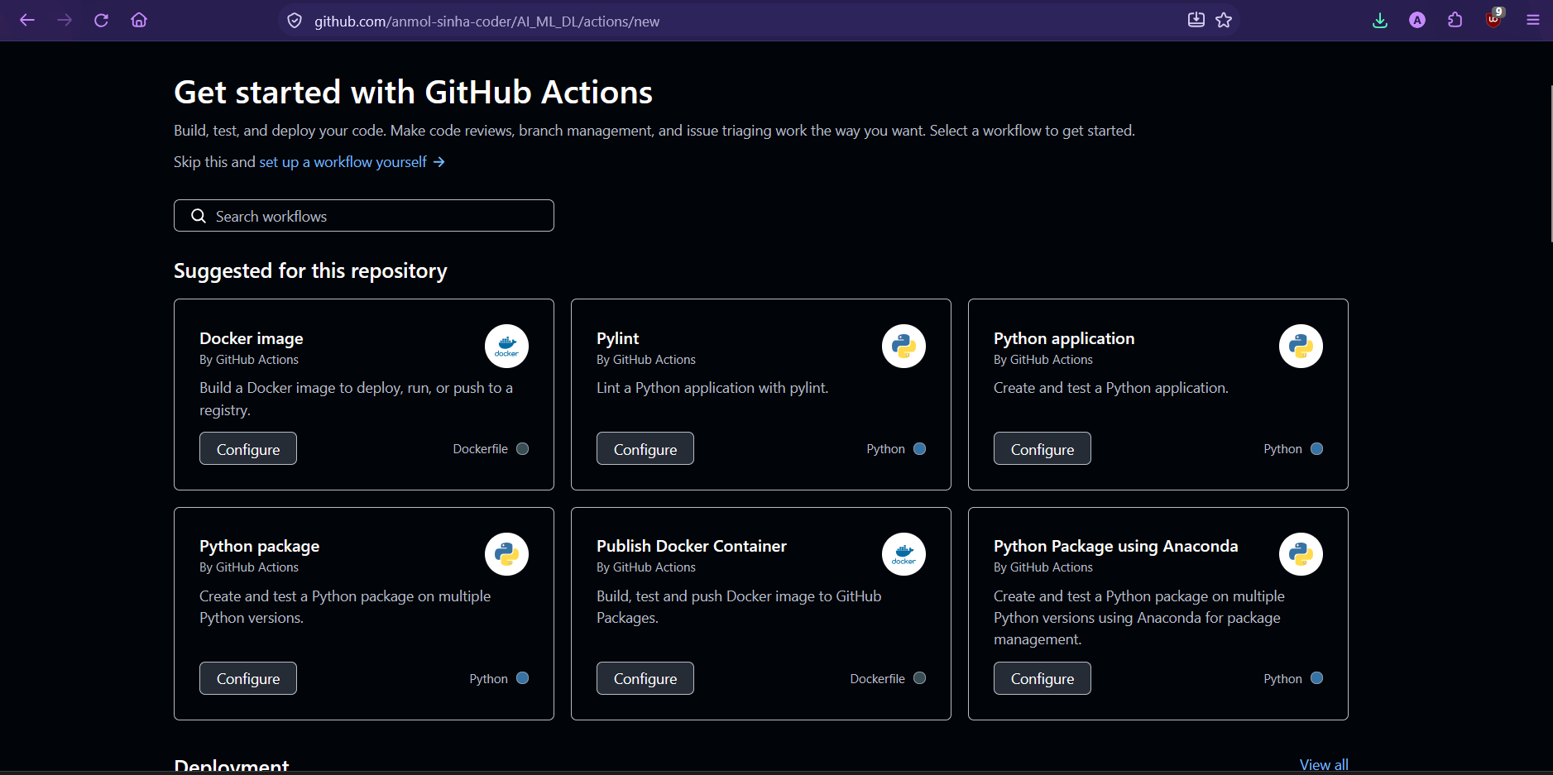
Figure 8. GitHub Actions entry point for workflow runs.
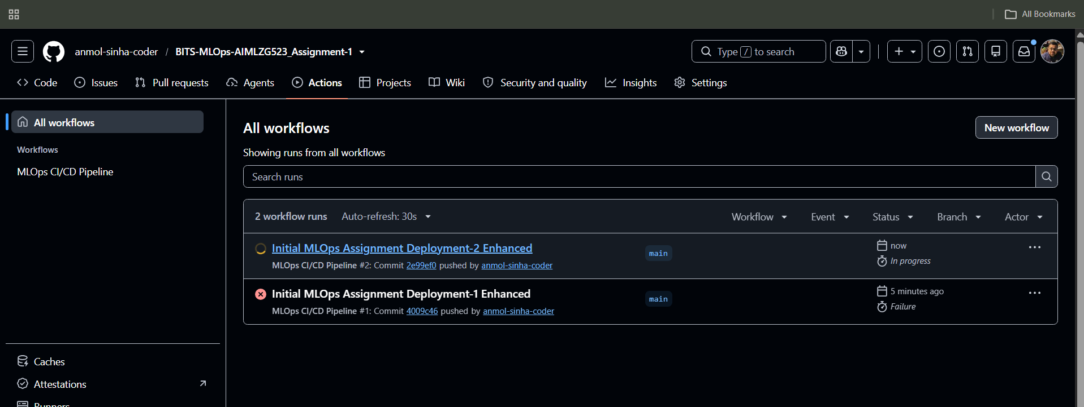
Figure 9. Workflow run listing and pipeline execution evidence.

6.1 CI/CD Evidence and Interpretation
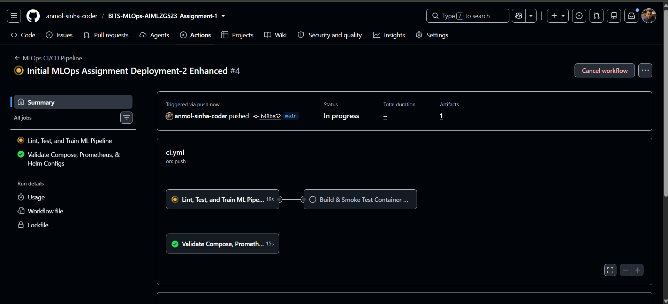
Figure 10. Workflow progress / job status captured from GitHub Actions.
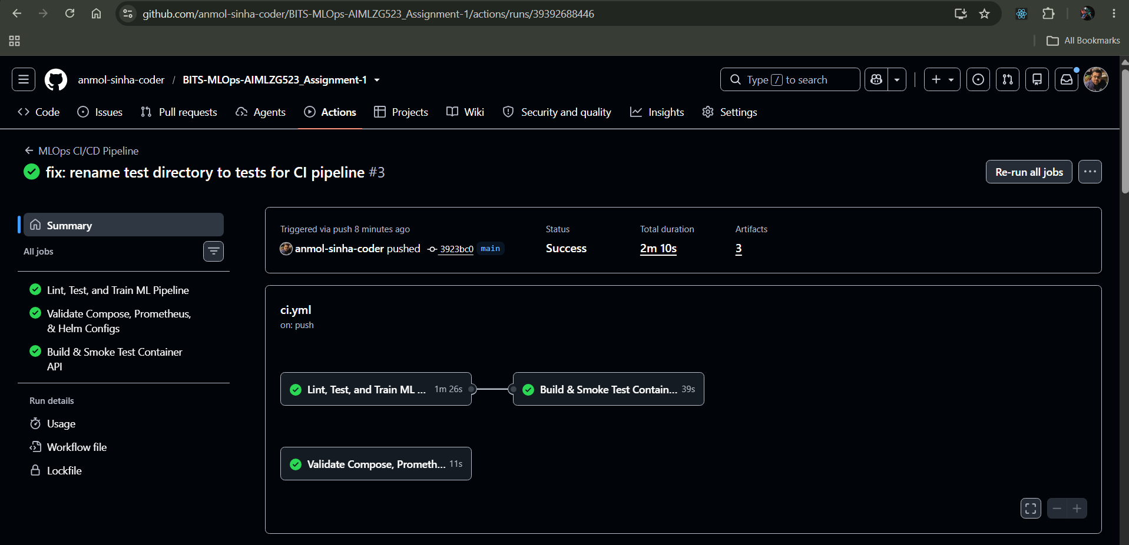
Figure 11. Captured completed workflow/deployment run.

Expected CI stages
Stage | What it verifies
Lint | Flags style and common code-quality issues.
Pytest | Checks data cleaning, preprocessing and API/model behavior.
Training | Exercises the training workflow and experiment logging.
Docker build | Verifies the serving image can be built.
Smoke test | Checks health and prediction endpoints against a running container.
Artifacts/logs | Preserves useful diagnostics for reviewing failed or successful runs.
A passing Actions run proves the jobs passed at the displayed commit; it does not by itself prove that the Kubernetes deployment or ngrok tunnel is currently live. Include the final workflow URL and commit SHA in the final submission evidence.

7. Docker, FastAPI and Model Packaging
The model-serving API is implemented with FastAPI and packaged into a Docker image. FastAPI provides typed request validation and automatic OpenAPI documentation; Docker isolates the runtime and dependencies so the service behaves consistently across local execution and Kubernetes.

API endpoints
Endpoint | Function
`GET /health` | Health response used by container and Kubernetes probes.
`POST /predict` | Accepts feature JSON and returns the prediction and probability/confidence.
`GET /model-info` | Exposes model metadata for traceability.
`GET /metrics` | Exports metrics for Prometheus scraping.
`GET /docs` | Interactive OpenAPI page for manual testing.

Container design
- Python slim base image and a separate serving requirements file reduce runtime footprint.
- The container runs as a non-root user and exposes port 8000.
- A health check tests the API health endpoint.
- The model pipeline must exist before the image is built.

Local build and smoke test
- Train or obtain the final model artifact.
- Build: `docker build -t heart-disease-api:v1 .`.
- Run the container with port 8000 mapped to the host.
- Call `/health`, `/docs`, `/metrics` and `POST /predict` with the documented sample input.
- Run the repository smoke-test script and retain terminal output as evidence.
The endpoint is an educational demonstration and must not be used as a medical diagnostic or treatment tool. Avoid logging full health-feature payloads or submitting real patient data to a public tunnel.

8. Environment Setup and Deployment Evidence
The supplied screenshots record Python installation, virtual-environment preparation and the terminal-based deployment sequence. These establish the steps used in the working environment; for clean reproducibility, the same commands should also be tested from a fresh checkout.
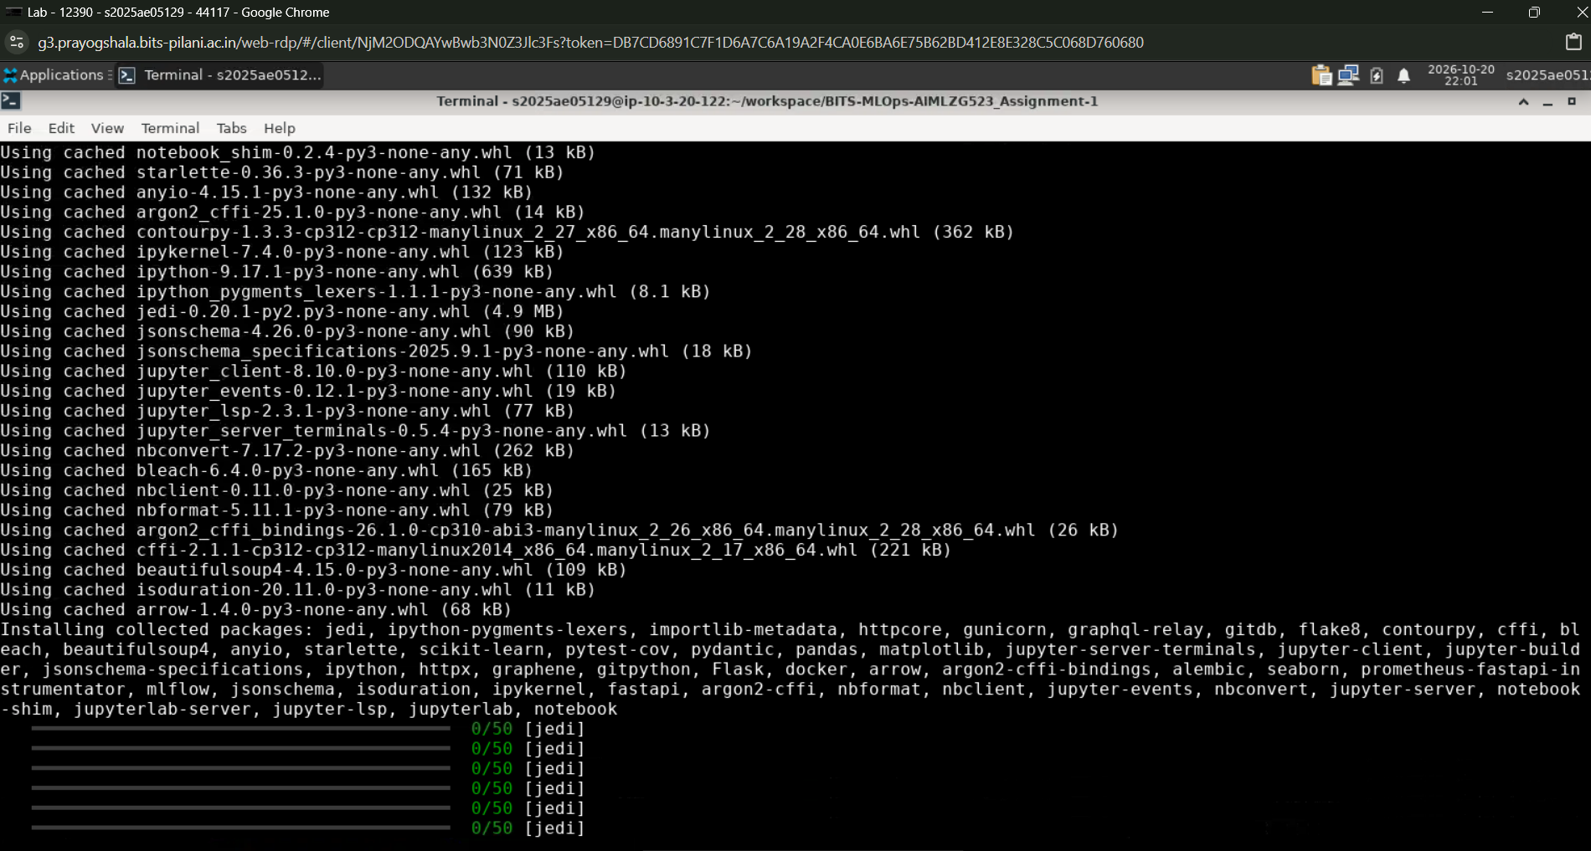
Figure 12. Python and package setup terminal evidence.
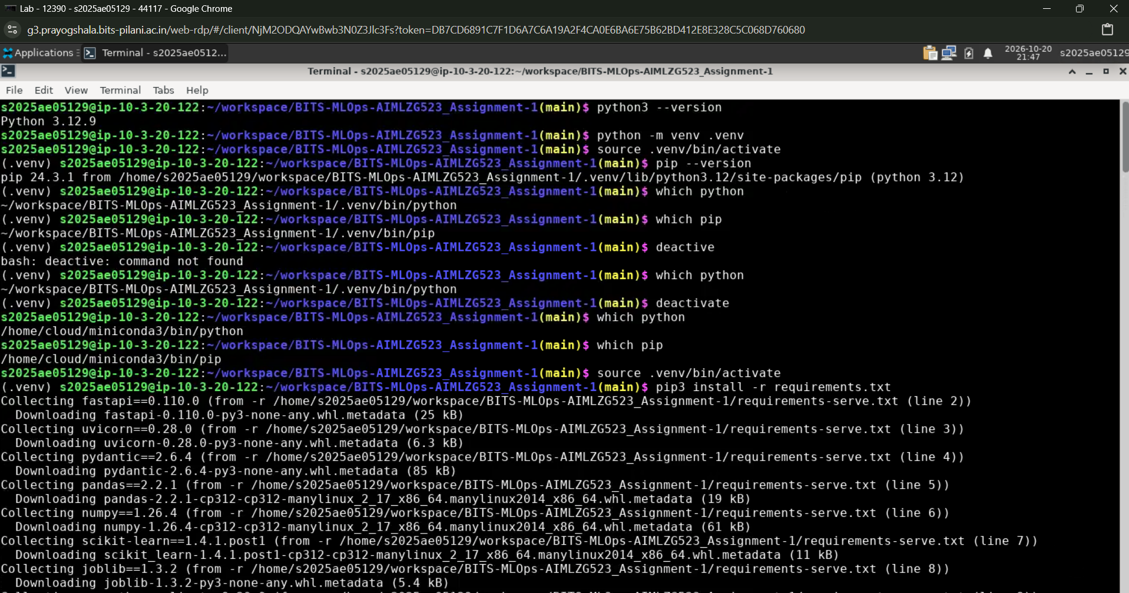
Figure 13. Virtual environment and dependency setup evidence.

8.1 Kubernetes Deployment with Minikube, kubectl and Helm
Minikube provides a local Kubernetes cluster. `kubectl` applies and inspects Kubernetes resources, while Helm templates the deployment and exposes configurable values such as image, replica count, resources, probes and optional ingress/autoscaling.

Stepwise deployment
- Start cluster: `minikube start --driver=docker`.
- Build image: `docker build -t heart-disease-api:v1 .`.
- Load image into Minikube: `minikube image load heart-disease-api:v1`.
- Deploy with manifests or `helm upgrade --install heart-disease-api helm/heart-disease-app`.
- Wait for rollout: `kubectl rollout status deployment/heart-disease-api`.
- Inspect resources: `kubectl get pods,svc` and review logs/events if readiness fails.
- Expose service with the configured Service, Minikube service URL or `kubectl port-forward`.
- Run smoke tests against the reachable service endpoint.
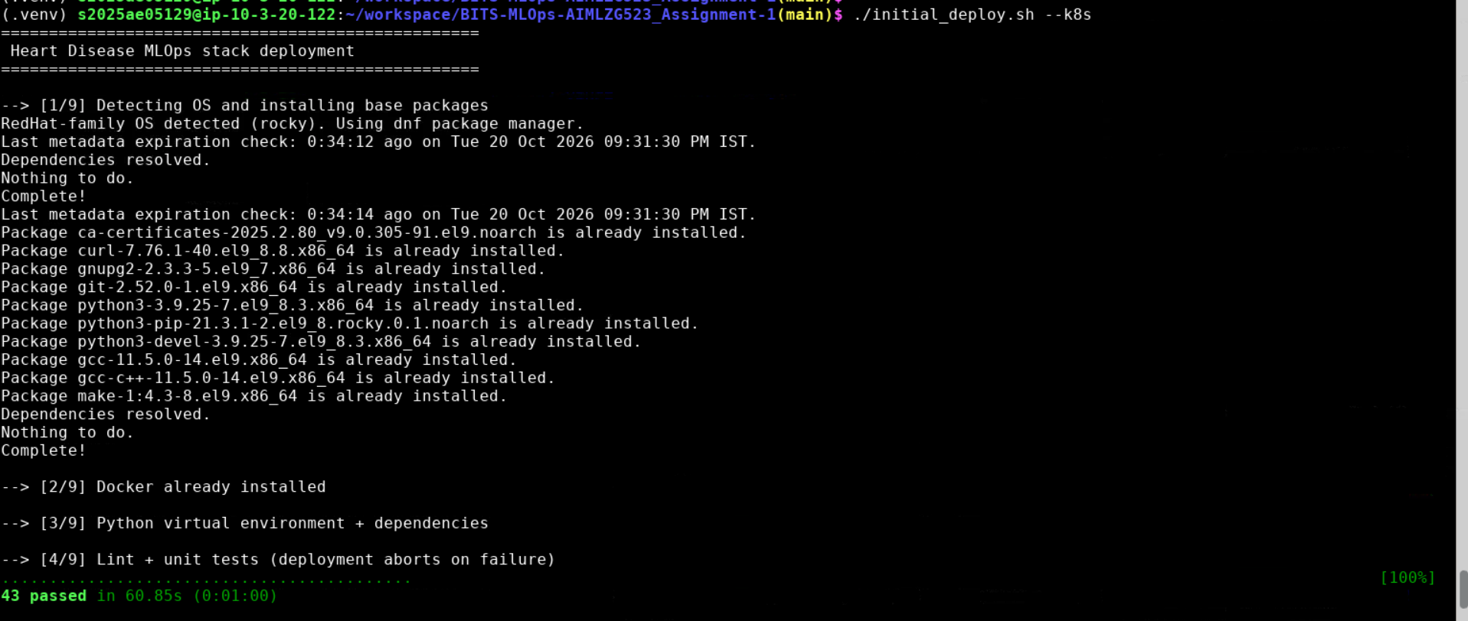
Figure 14. Deployment steps 1–4 from the supplied terminal capture.

8.2 Kubernetes Deployment — Continued
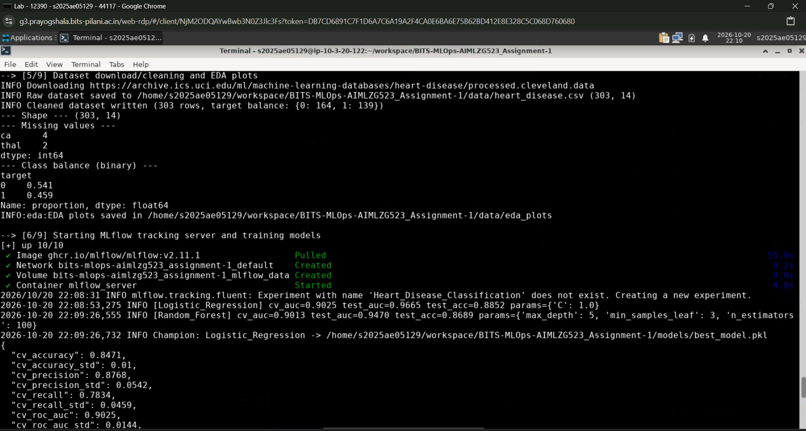
Figure 15. Deployment steps 5–6.
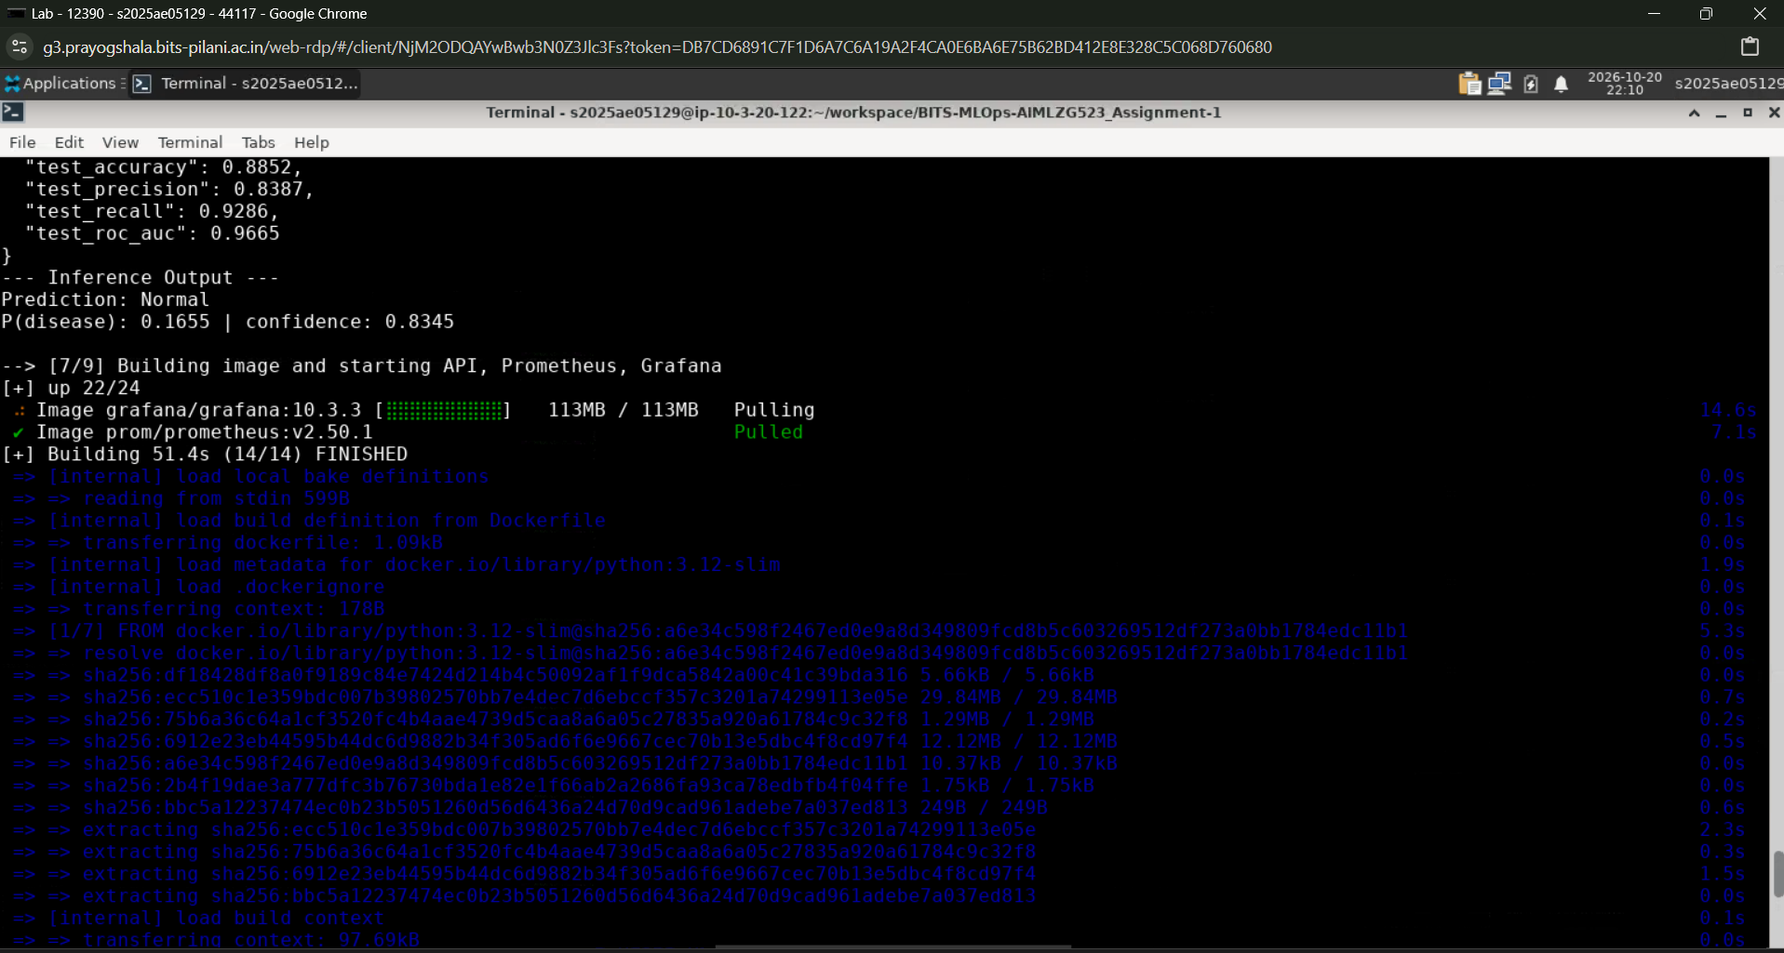
Figure 16. Deployment steps 6–7.

8.3 Kubernetes Deployment — Rollout and Service Checks
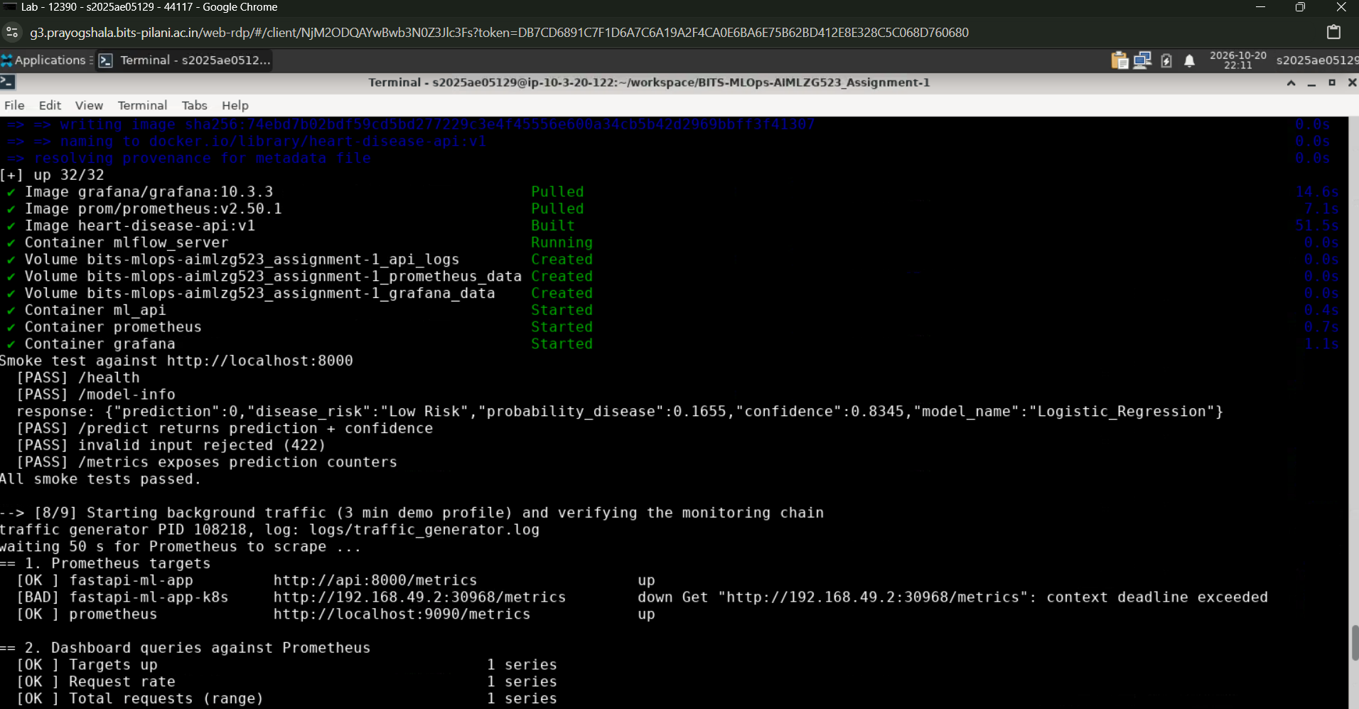
Figure 17. Deployment steps 7–8.
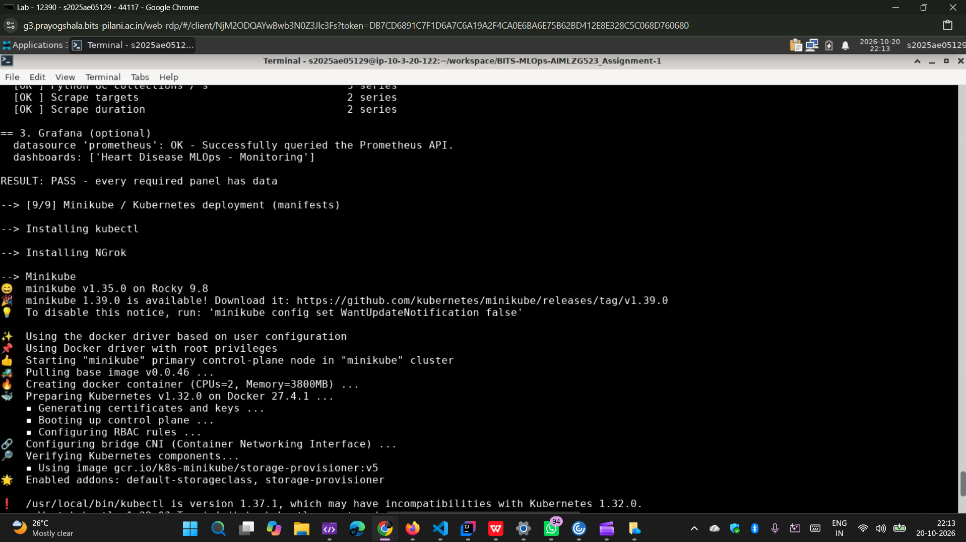
Figure 18. Deployment steps 8–9.
After rollout, confirm the desired replicas are ready, inspect the Service/endpoint and test the API. A healthy pod is necessary but not sufficient: a successful prediction request and correct Prometheus scrape are also required.

9. Monitoring and Logging: Prometheus + Grafana
Prometheus collects time-series metrics from the API’s `/metrics` endpoint. Grafana connects to Prometheus as a data source and visualizes request counts, latency, error behavior and other exposed metrics. The screenshot evidence below documents the dashboard views captured during the project.

Monitoring verification
- Confirm the API `/metrics` endpoint responds.
- Open Prometheus Targets and confirm the API target is UP.
- Generate a limited number of sample API requests to create visible telemetry.
- Confirm Grafana panels update and the data source reports healthy.
- Inspect API logs for request and error details; avoid logging sensitive input values.
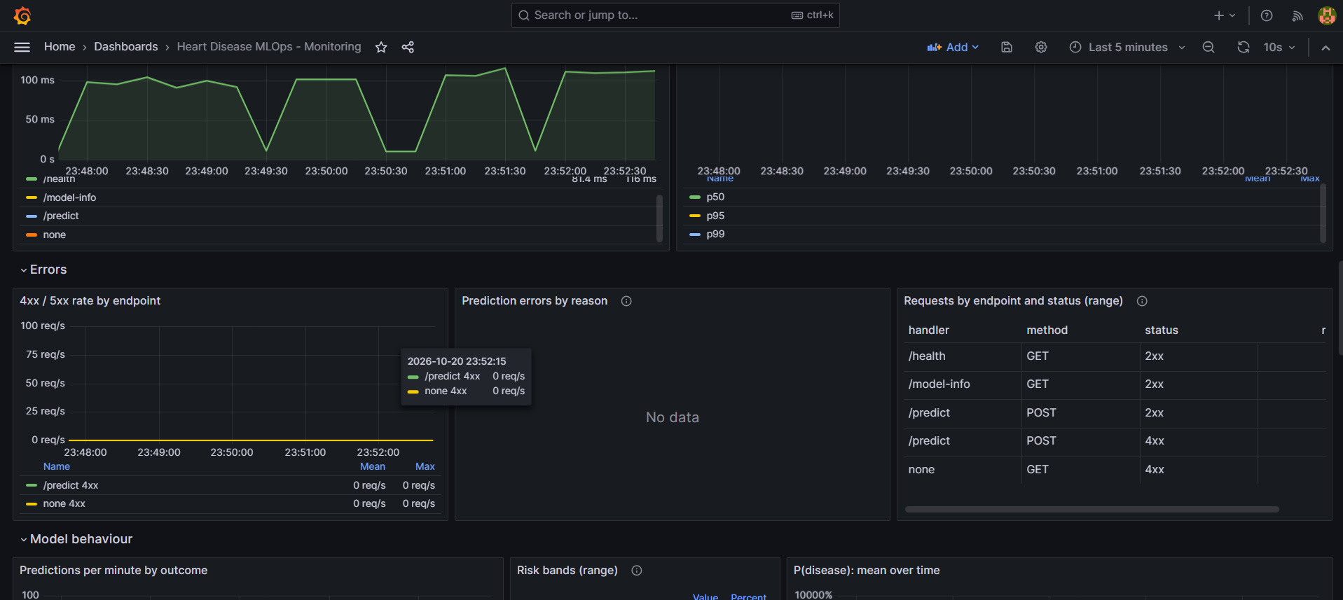
Figure 19. Monitoring interface / dashboard evidence supplied for the project.

9.1 Grafana Dashboard Evidence
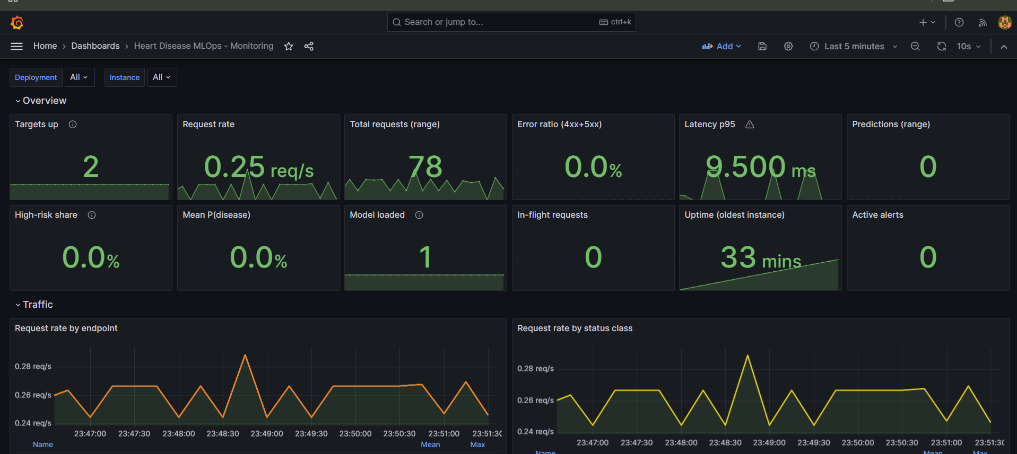
Figure 20. Grafana dashboard overview.
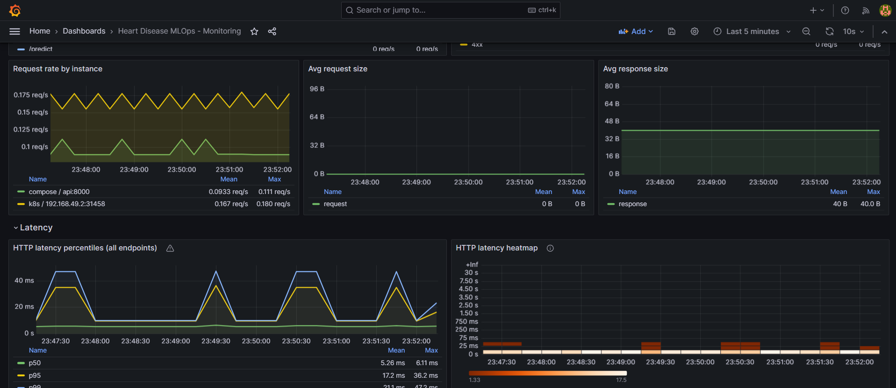
Figure 21. Grafana panels showing API/operational time series.

9.2 Additional Monitoring View
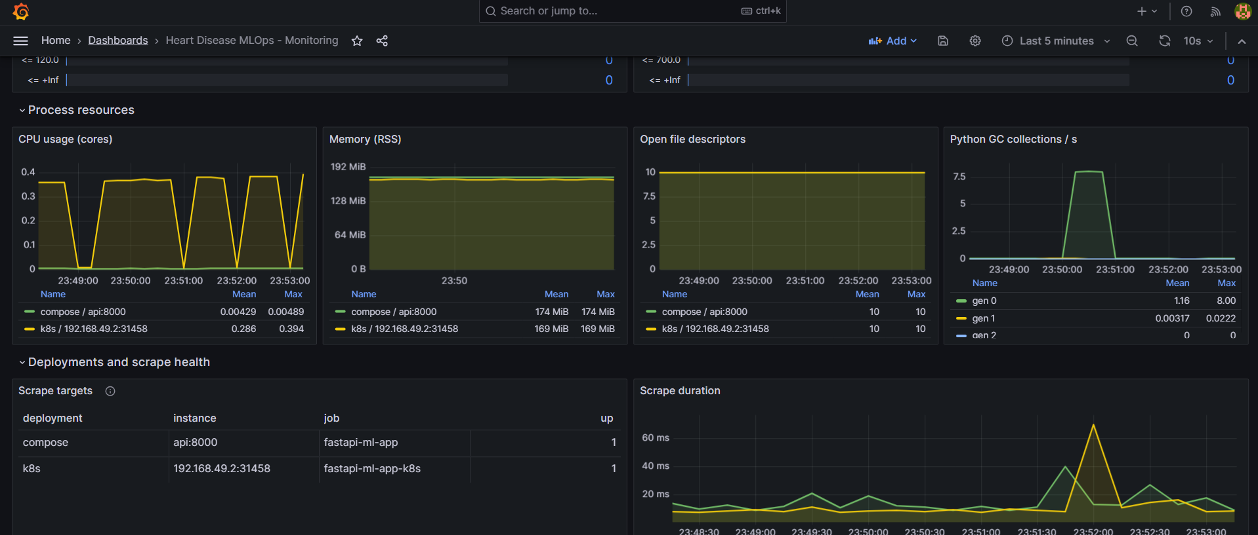
Figure 22. Additional Grafana dashboard panels.
Dashboards should be interpreted in context: flat or empty charts may indicate no recent traffic, an incorrect Prometheus target, or a query/time-range mismatch. Screenshots are point-in-time evidence; rerun the checks at submission and include timestamps or URLs where possible.

Security considerations
- Change default Grafana credentials before any non-local exposure.
- Do not expose MLflow, Prometheus or Grafana publicly without authentication and access controls.
- Treat the ngrok API URL as public and temporary; stop the tunnel when no longer required.

10. Public API Access with ngrok and Runbook
ngrok creates a public HTTPS tunnel to a local port where the API is listening. It does not make Minikube itself a managed cloud cluster; the host machine, cluster, port-forward/service route and ngrok process must remain active for the URL to work.

Recommended sequence
- Verify the API locally with `/health` and `/docs`.
- Expose the Kubernetes service locally, commonly through `kubectl port-forward` to port 8000, or use the actual reachable local service port.
- Start ngrok against that port (for example, `ngrok http 8000` if the API is reachable on local port 8000).
- Copy the exact HTTPS forwarding URL shown by ngrok.
- Test the public `/health` and `/docs` endpoints from a separate browser/network.
- Test `POST /predict` using a synthetic example payload, then record the URL and timestamp in this report.
Public API URL: [INSERT ACTIVE HTTPS NGROK URL HERE]. The exact live URL is not present in the supplied request or screenshot archive; this field must be replaced with the verified URL from the final running session.

Clean setup runbook
- Clone the main repository and enter its directory.
- Create a Python 3.12 virtual environment and install `requirements.txt`.
- Run `flake8 .` and `pytest`.
- Run data acquisition and EDA scripts.
- Start MLflow, train and verify metrics/artifacts in the UI.
- Build and smoke-test the Docker API image.
- Deploy with Kubernetes manifests or Helm and verify readiness.
- Confirm Prometheus target status and Grafana dashboard data.
- Start ngrok, verify the public API, capture screenshots and stop the tunnel after the demonstration.

11. Reproducibility, Limitations and Final Checklist

Limitations
- The dataset is small and historical; metrics do not establish clinical validity.
- The binary label collapses original disease severity levels 1–4 into one positive class.
- Correlation analysis on integer-coded nominal categories must be interpreted cautiously.
- Input-domain validation should reject invalid target values before binarization and validate expected feature ranges/categories.
- Local MLflow storage and Minikube are suitable for an assignment demonstration but do not provide production-grade high availability.
- A public ngrok URL can change between sessions and should be reported only after a live check.

Submission evidence checklist
- ☐ Repository contains source, data download instructions, cleaned dataset, EDA scripts/outputs, training and inference code.
- ☐ Tests pass and final GitHub Actions workflow URL/commit SHA is recorded.
- ☐ MLflow shows the final experiment, parameters, metrics and artifacts.
- ☐ Docker image builds and passes the smoke test in isolation.
- ☐ Minikube rollout is ready and the API is reachable.
- ☐ Prometheus target is UP and Grafana panels show data after test requests.
- ☐ Screenshots included in this report correspond to actual project runs.
- ☐ Active ngrok HTTPS URL is inserted and externally verified.
- ☐ MP4 video link is accessible from the repository.
- ☐ Report has been reviewed for correct final metrics and deployment state.

Project links
Main GitHub repository: https://github.com/anmol-sinha-coder/BITS-MLOps-AIMLZG523_Assignment-1
MP4 screen recording: https://github.com/anmol-sinha-coder/BITS-MLOps-AIMLZG523_Assignment-1/blob/main/2025AE05129__AnmolSinha__MLOps_Assignment-1.mp4
Conclusion: the project combines data preparation, model development, experiment tracking, CI checks, containerized inference, Kubernetes deployment and monitoring into one reproducible workflow. The strongest submission will link each claim to a real artifact, successful workflow run, MLflow run, API test or screenshot. Confirm all final runtime details immediately before submission.

