

FEB 2022

CLOUD COUNSELAGE

CTRL_ALT_DEFINE

Version: 1

Team Captain: Anmol Jain

Created On: 26th Feb 2022

Team Members:

Tirth Patel

Sahil Agarwal

Jyotsna Bhatia

**INDEX**

1.Introduction 2

2.Overview 3

3. Software Requirements 4

4. Hardware Requirements 4

5. Constraints, Assumptions, Dependencies 4

6. Design/ User Flow/ Wireframes 5

7. Methodology 6

# 1.Introduction

**What it is:** App pharmacy services

**How it works:** The [Medicine](https://www.medisafeapp.com/) Reminder medication reminder app is a straightforward smartphone app. You’ll record when you take your medications and receive medication reminders. You can use [Medicine](https://www.medisafeapp.com/) Reminder to track your prescriptions and reminds you when it’s time for a refill.

If you miss a dosage (and don’t respond to several alerts), your [Medicine](https://www.medisafeapp.com/) Reminder will also receive push notifications. In future, caregivers will also receive an email, text alert, or phone call if a dose is missed. Weekly summary reports will be available soon.

All you must do is pay attention to the time and date printed on each individual package. The display will automatically show the current time and day of the week. This helps you know when you last took your medication.

**Additional features include:**

* A timer option, which alerts you to take your medics on time.
* Individual pill compartments can be locked until a medication needs to be taken.
* The app also allows to add the description of the medicine including name of the medicine, expiry date, option to add alarm and other features also.
* Light and dark theme-based UI app

# 2.Overview

The emphasis grows more on elderly age group who tend to forget to take medicines. Staying healthy and getting your medications exactly when your body needs them is vital, but sometimes you just forget.

In a 2017 high level study involving 1,198 adults, they were found to have medication delays [80–85 percent](https://www.sciencedirect.com/science/article/abs/pii/S016926071630579X) of the time and to have forgotten medication [44–46 percent](https://www.sciencedirect.com/science/article/abs/pii/S016926071630579X) of the time.

If general forgetfulness is the reason, you have problems adhering to your med timetable, you may want to try this timer from [Medical](https://tabtime.com/) Reminder.

# We’ve built the app which focuses on reminding many medical patients to take their medications on time. Use of [Medical](https://tabtime.com/) Reminder is free. You’re only responsible for the costs associated with your medications. This app is also useful to add any upcoming doctor appointments which can be an additional feature in the future.

# 3. Software Requirements

Android and IOS device. The software required for the app to run is ANDROID VERSION-9.0 and IOS 9.0.

# 4. Hardware Requirements

Android and IOS device with minimum 2 GB RAM with decent processor and free disk space of 25 MB.

# 5. Constraints, Assumptions, Dependencies

For the prototype, we used Flutter language. For the app icon we used FLAT ICON.

The main constraints are memory, battery life, ability to adapt to different screen sizes and orientations, security, and network bandwidth

The dependencies used are FLUTTER SDK, FLUTTER date_picker_timeline, dev_dependencies, Cupertino_icons.

# 6. Design/ User Flow/ Wireframes

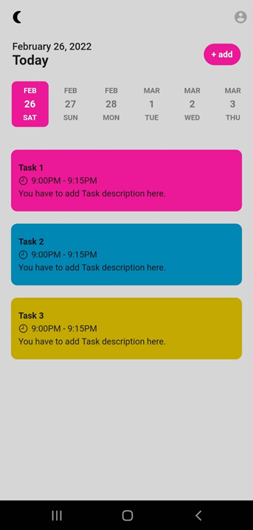

# 7. Methodology

Youtube link. - https://youtu.be/5fyNAa4sSmo