Assignment-1 St id:u2888226
SimpleCalculatorApp
Addition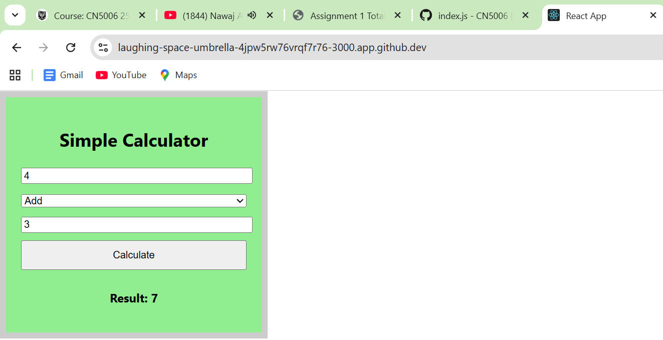

Subtraction
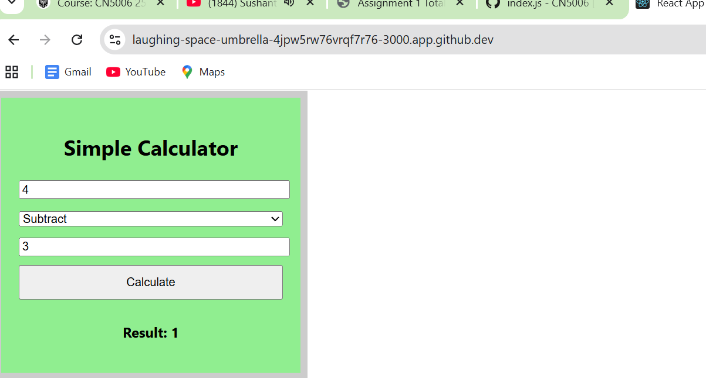
Multiplication
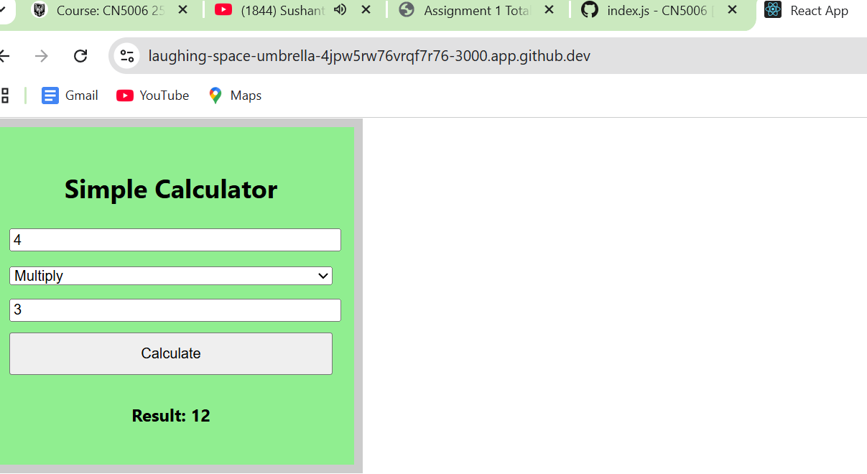

Division
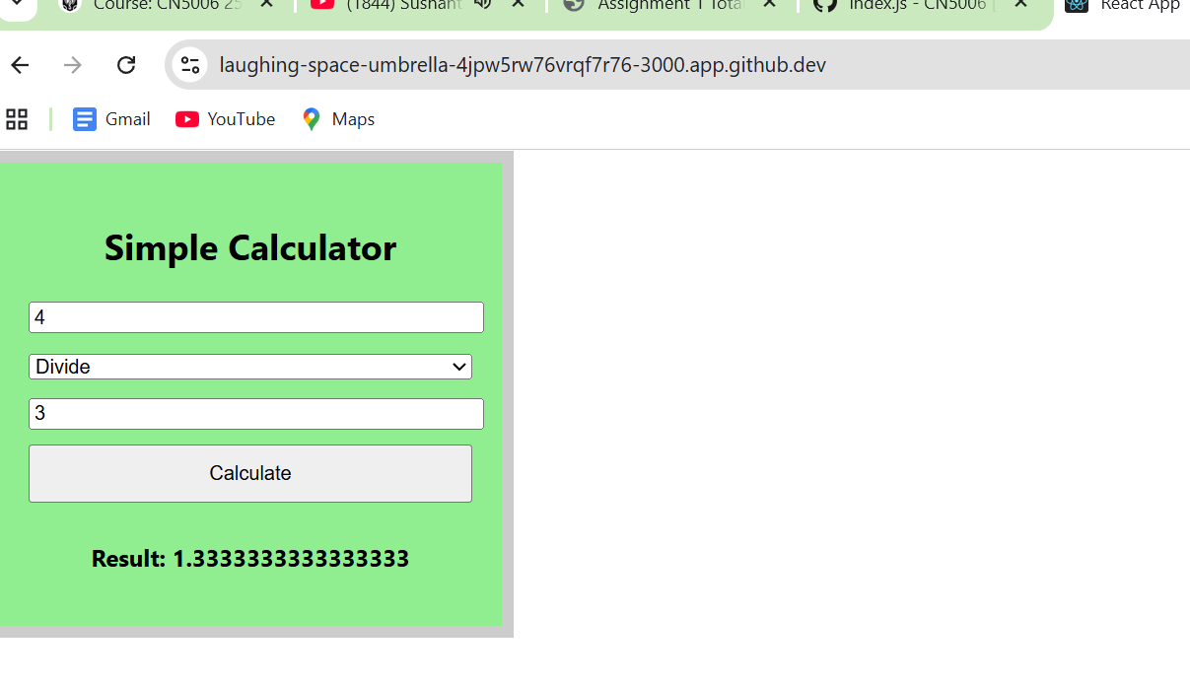

Explanation of how code works,
The Calculator app is developed using a functional component called Calculator in a file called SimpleCalculator.js. It provides a simplistic interface for the user to input two numbers, select an arithmetic operation, and then click on a Calculate button to show the result. Upon button press, the calculate function reads the values of the input and the operator chosen, then performs the calculation and shows the result on the page. After that, index.js executes the component by importing Calculator and rendering it with ReactDOM.createRoot, which will make the calculator appear and work properly in the browser.
Name=Anmol Adhikari
Student id=u2888226
Group=30

