**Project Name: ShareTheMeal**

**Project Members:**

|  |  |
| --- | --- |
| **PRN No.** | **Name** |
| **0095** | **Satyajeet Yadav** |
| **0013** | **Anmol Jadhav** |
| **0069** | **Shrikant Patange** |
| **0012** | **Aniket Patil** |

**Introduction of Project:**

Food wastage is a massive problem and one of the most overlooked things in today’s world.

One third of all food produced in the world goes to waste

Some restaurants/cafés have a policy to not serve food from previous day, despite being perfectly edible. This is all thrown away as “waste”, at the end of day.

At the same time, worldwide most of people do not have enough to eat. That means one in nine people are suffering from hunger. Also many street animals haven`t get food minimum one time in a day.

**Objective and Scope of Project:**

Our project provides a way to bridge the gap between the wastage and deficit, by letting restaurants donate this food to needy like food community, animal care organizations, Food processing units etc.

**Modification and improvement over the existing Implementation:**

Present State:

Now a day there are some websites and applications are available to collect wastage food and provide it for NGO.

After implementation of project:

In our project a food collected by restaurants will be available for food community and it will be also available for animal care organizations, animal communities and food processing units.

**Project Plan:**

* **Users-**

1] Restaurant login.

2] Login for everyone who need waste food.

**Modules** –

1] A restaurant/café worker creates a collection request for excess food, which is then sent across to all the NGOs within the network

2] A needy person viewing the enterprises’ inventory can raise a shortage request

**Technology:**

Frontend-React

Backend-spring boot/express

Database-mysql

Others –

**Roles and Responsibilities:**

|  |  |  |
| --- | --- | --- |
| **Roles And Responsibilities** | | |
| 1 | Role | Front-End, Back-End Developing, Database Design |
| Member Name | Satyajeet Yadav |
| PRN No | 0095 |
| Description |  |
| 2 | Role | Front-End, Back-End Developing, Database Design |
| Member Name | Anmol Jadhav |
| PRN No | 0013 |
| Description |  |
| 3 | Role | Front-End,Back-End Developing, Database Design |
| Member Name | Shrikant Patange |
| PRN No | 0069 |
| Description |  |
| 4 | Role | Front-En ,Back-End Developing, Database Design |
| Member Name | Aniket Patil |
| PRN No | 0012 |
| Description |  |

**Data Flow Diagram (DFD):**

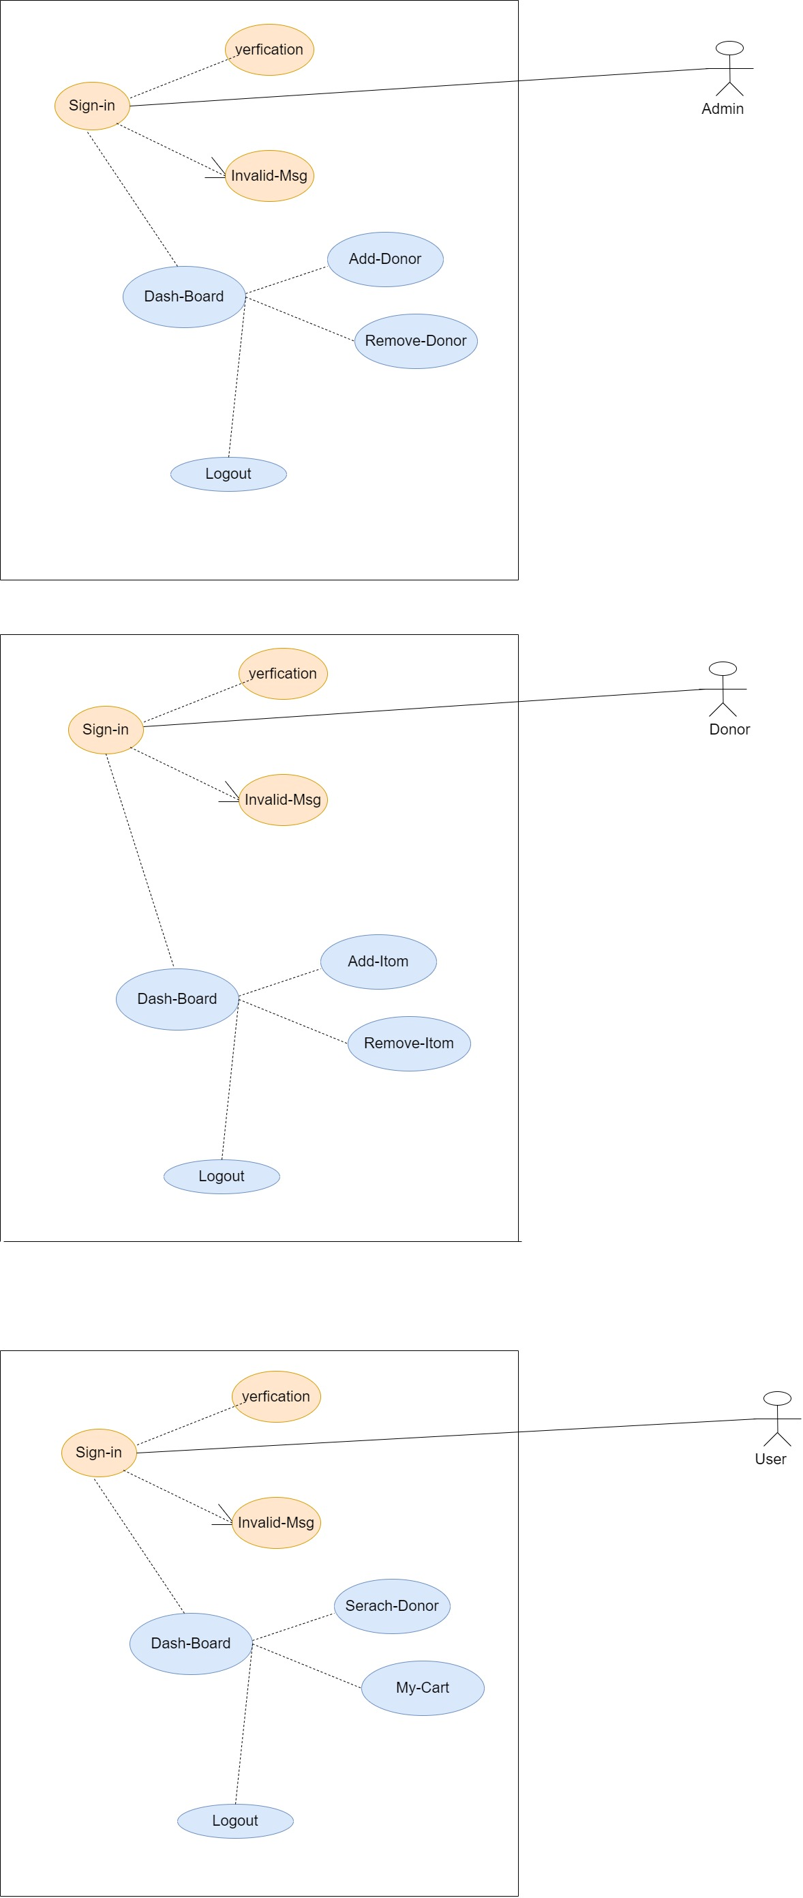

**U-I Diagram::**

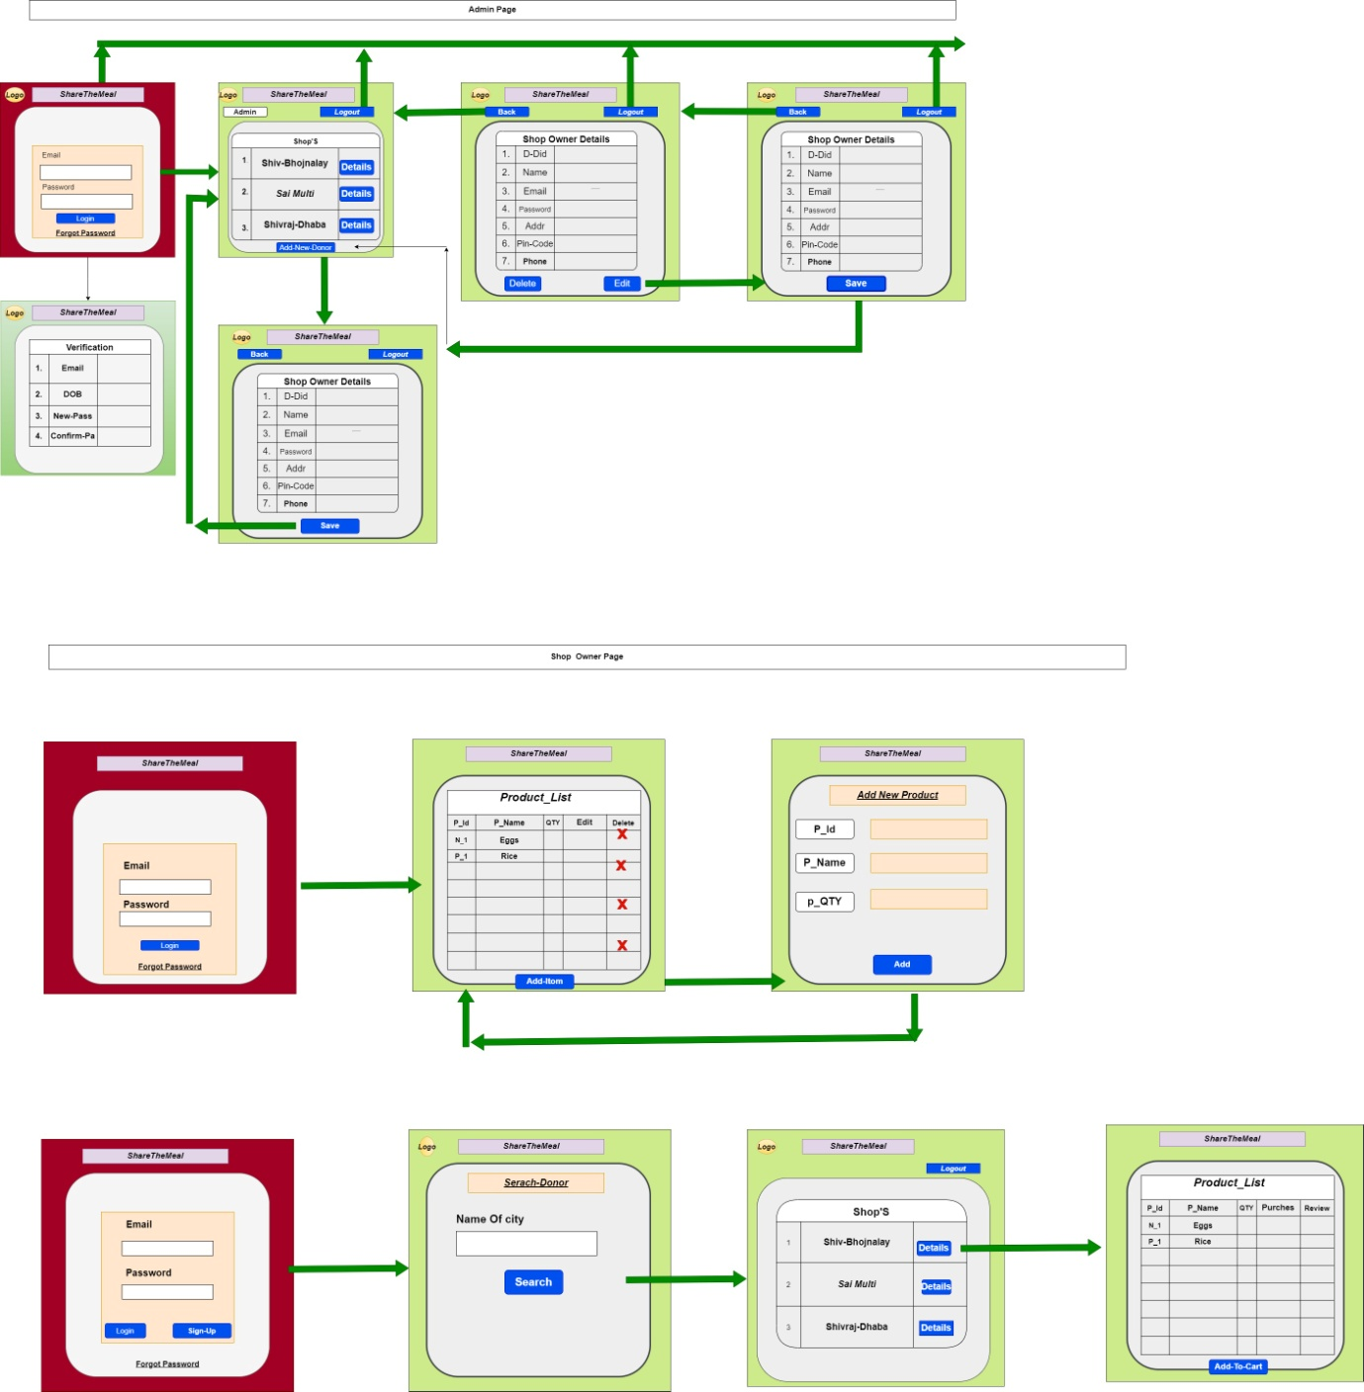

**ERD / Database Tables:**

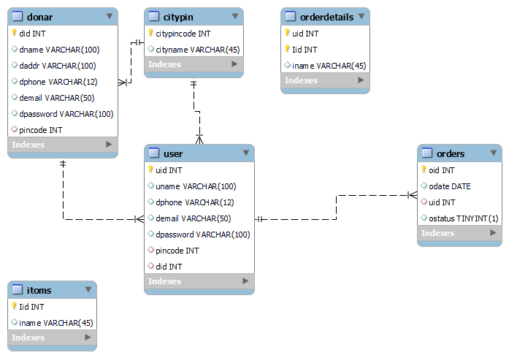

**Future Scope:**

Instead of just restaurants/cafés we can also have people register themselves to donate leftovers from home.

**Project n-tier**

