**SYSTEM-ANALYSIS**

***Logs:-***

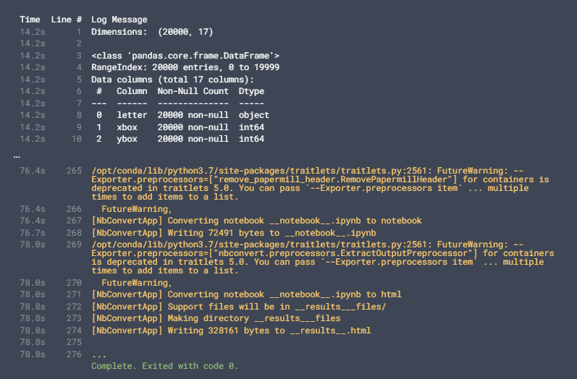

***Execution:-***

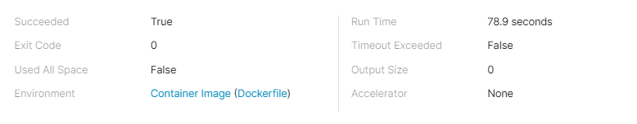

***How do various attributes vary with the letters:-***

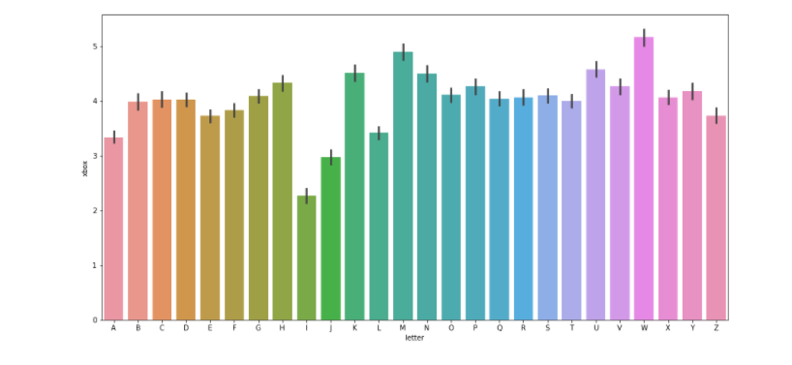

***Accuracy of Different Models:-***

