COMMAND : SBT CLEAN COVERAGE TEST

OUTPUT :

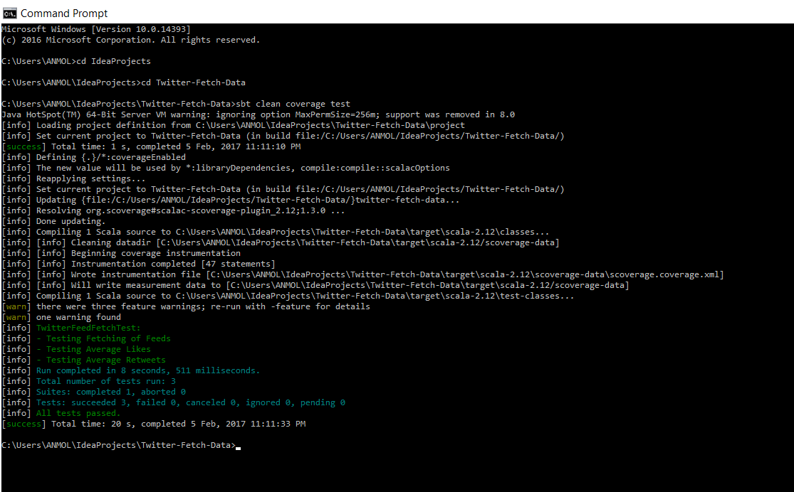

COMMAND : SBT COVERAGE REPORT

OUTPUT:

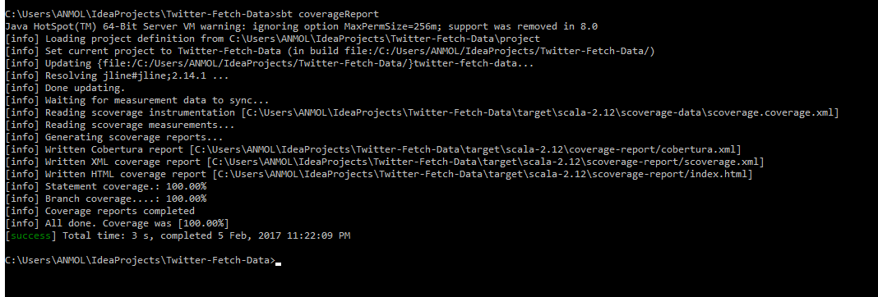

COMMAND : SBT SCALASTYLE

OUTPUT :

