**Help Manual for NIC email Id creation**

For creation of NIC Email Id, it is required to have a VPN connection which can be obtained by applying online at <https://vpn.nic.in>. After obtaining VPN connection, A network need to be established to NIC server through the software named as **CISCO Any Connect Secure Mobility Client** as shown below:

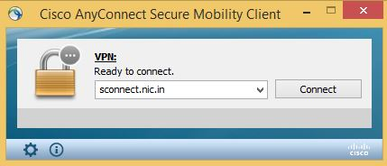

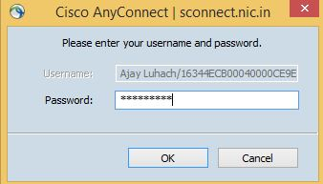

After establishing a connection through CISCO ANY Connect Secure Mobility Client software, it is required to go to the URL [**https://mailadmin.nic.in**](https://mailadmin.nic.in) wherein some login credentials are required to be entered and an OTP will be sent to the concerned mobile number in whose name the VPN connection has been obtained as shown below:

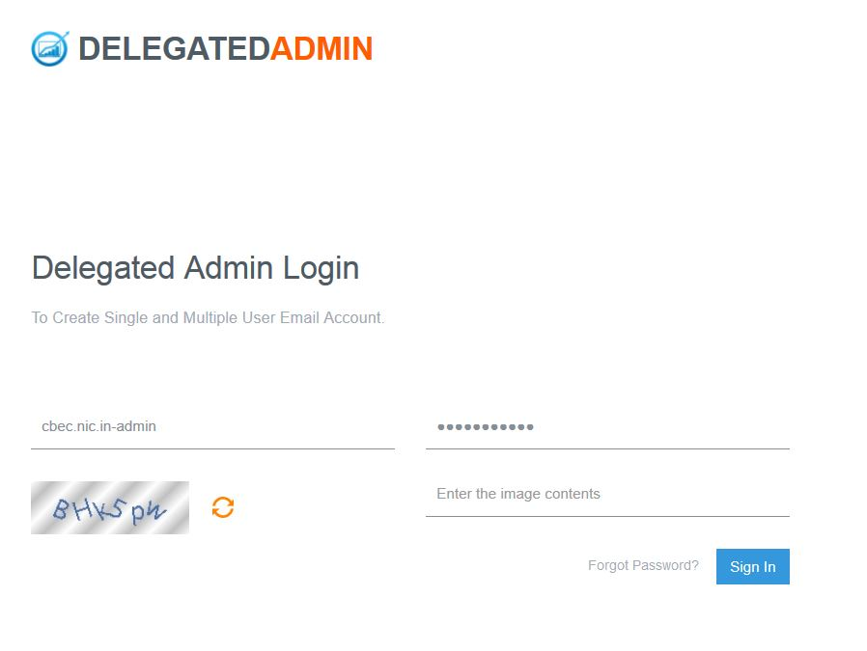

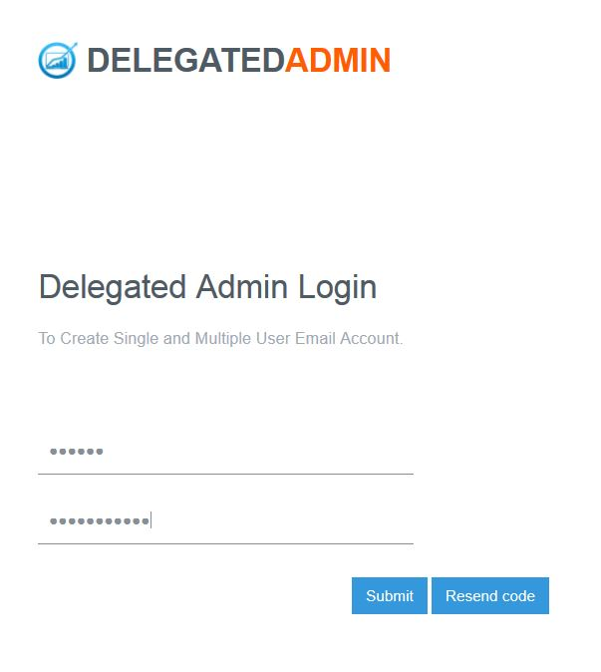

After successful login at [**https://mailadmin.nic.in**](https://mailadmin.nic.in) , several links under the title DELEGATED ADMIN can be found as shown below:

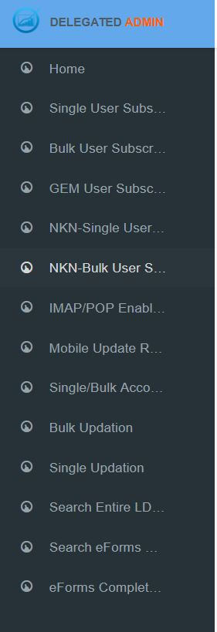

* NIC Email Ids are created on the requests of the user which are submitted through either ways as

1. Submitting the duly filled details as shown below in Annexure A (Ms-Excel file) to the delegated admin coordinator NIC Email Id.



1. Submitting the online request through <https://eforms.nic.in>.

If the request is received on Admin coordinator email id then the Excel file with all the details send by the user in the desired format only as present in Annexure A need to be uploaded using **Single/Bulk Account Creation** link by selecting the desired Mail Id type and free quota as shown below:

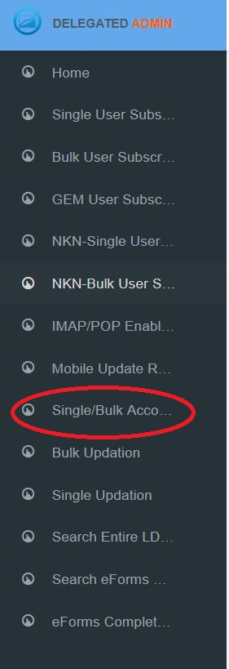

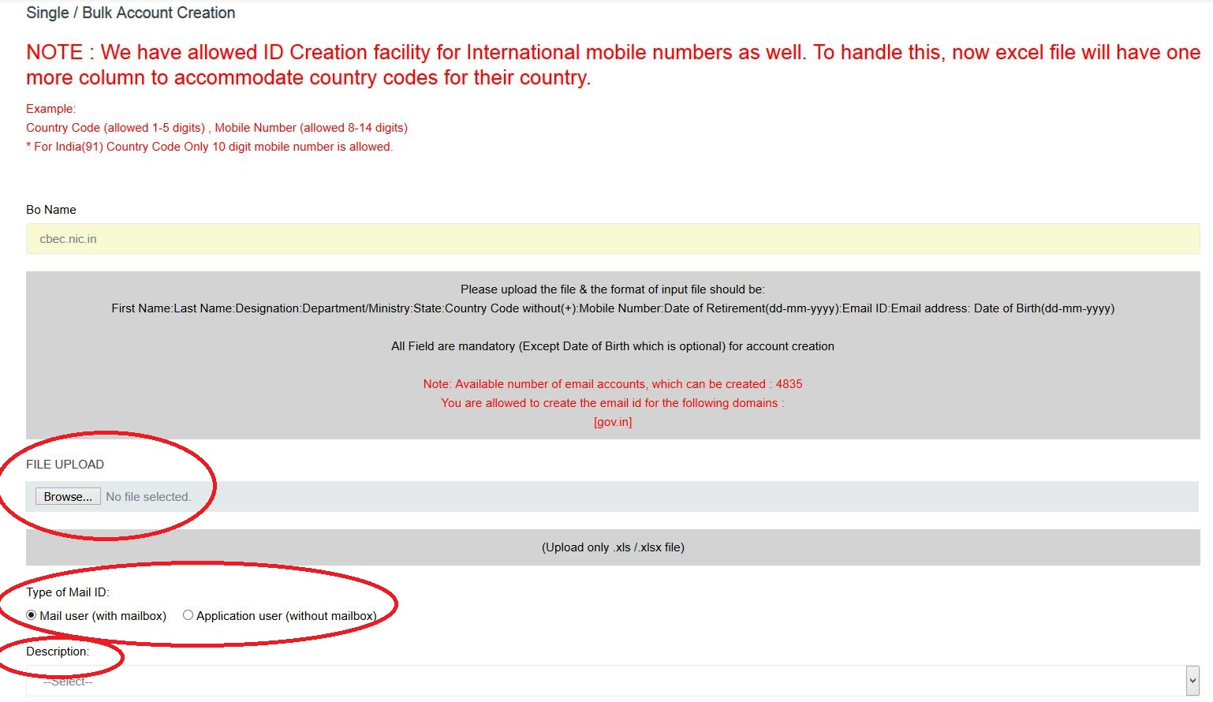

But If the request submitted through online e forms is received then same can be completed using **Single User Subscription Request** or **Bulk user Subscription Request** link as shown below:

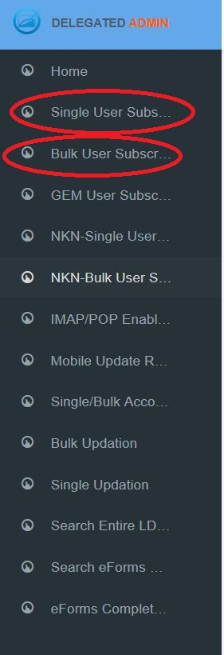

Single User Subscription Requests can be completed by using the button Create ID and selecting the check boxes against individual rows as shown below:

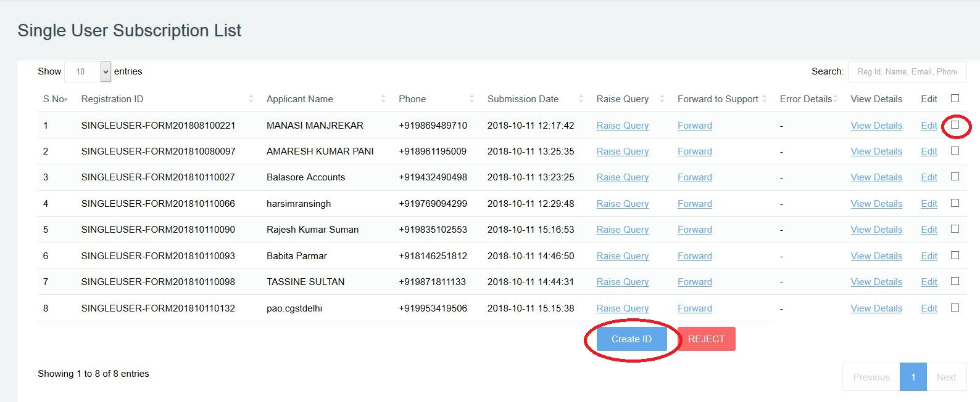

Whereas the Bulk user Subscription Requests can also be completed by using the above shown procedure, although the View Users link against individuals rows of bulk user requests need to clicked prior to it as shown below:

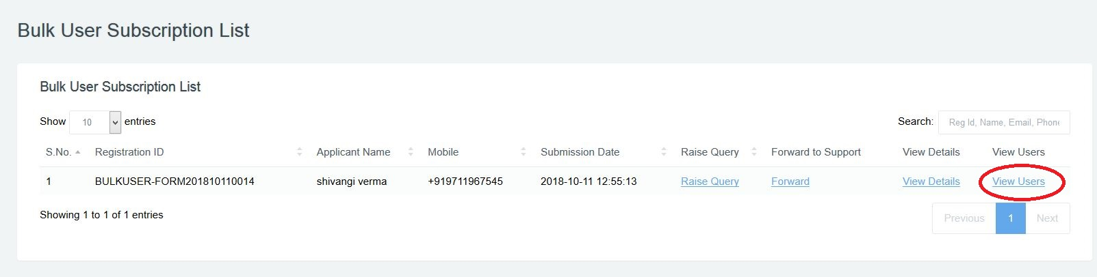

While creating the NIC Email Ids some errors may occur due to incorrect details or incorrect format in Annexure A. So all the details need to be uploaded accordingly.