**Step by step guide for the role of PAR Manager.**

1. Open the url**https://sparrow-irs.eoffice.gov.in** in Mozilla browser. The software runs smoothly on Mozilla browser and thus it is recommended to install Mozilla browser.

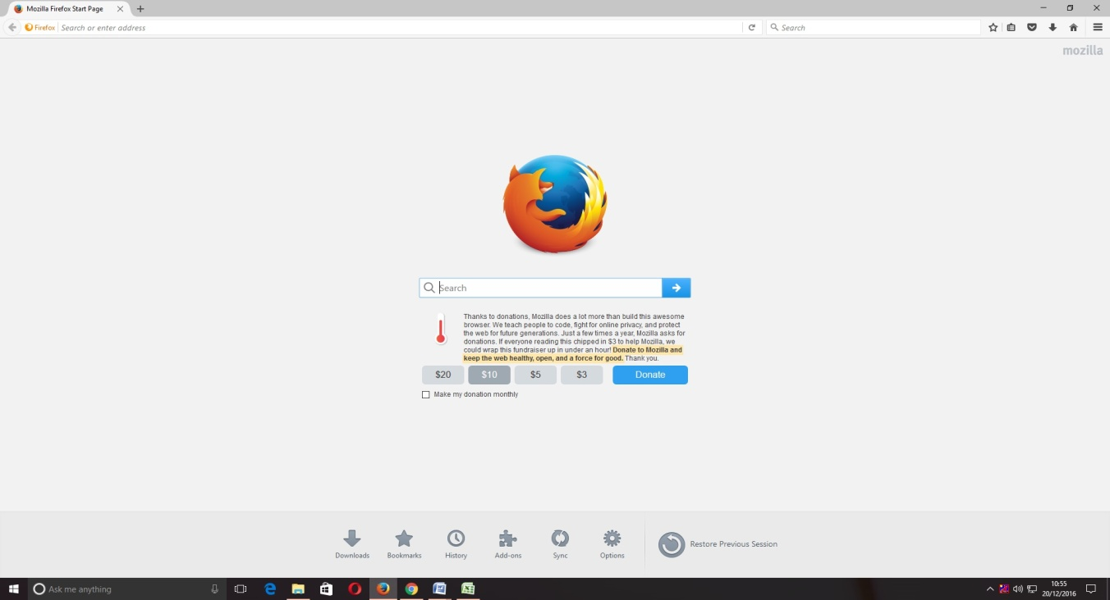

On opening the url, the "**SPARROW - Read Me**" window (given below) will open which shows the information about the e-signing facility in the SPARROW.

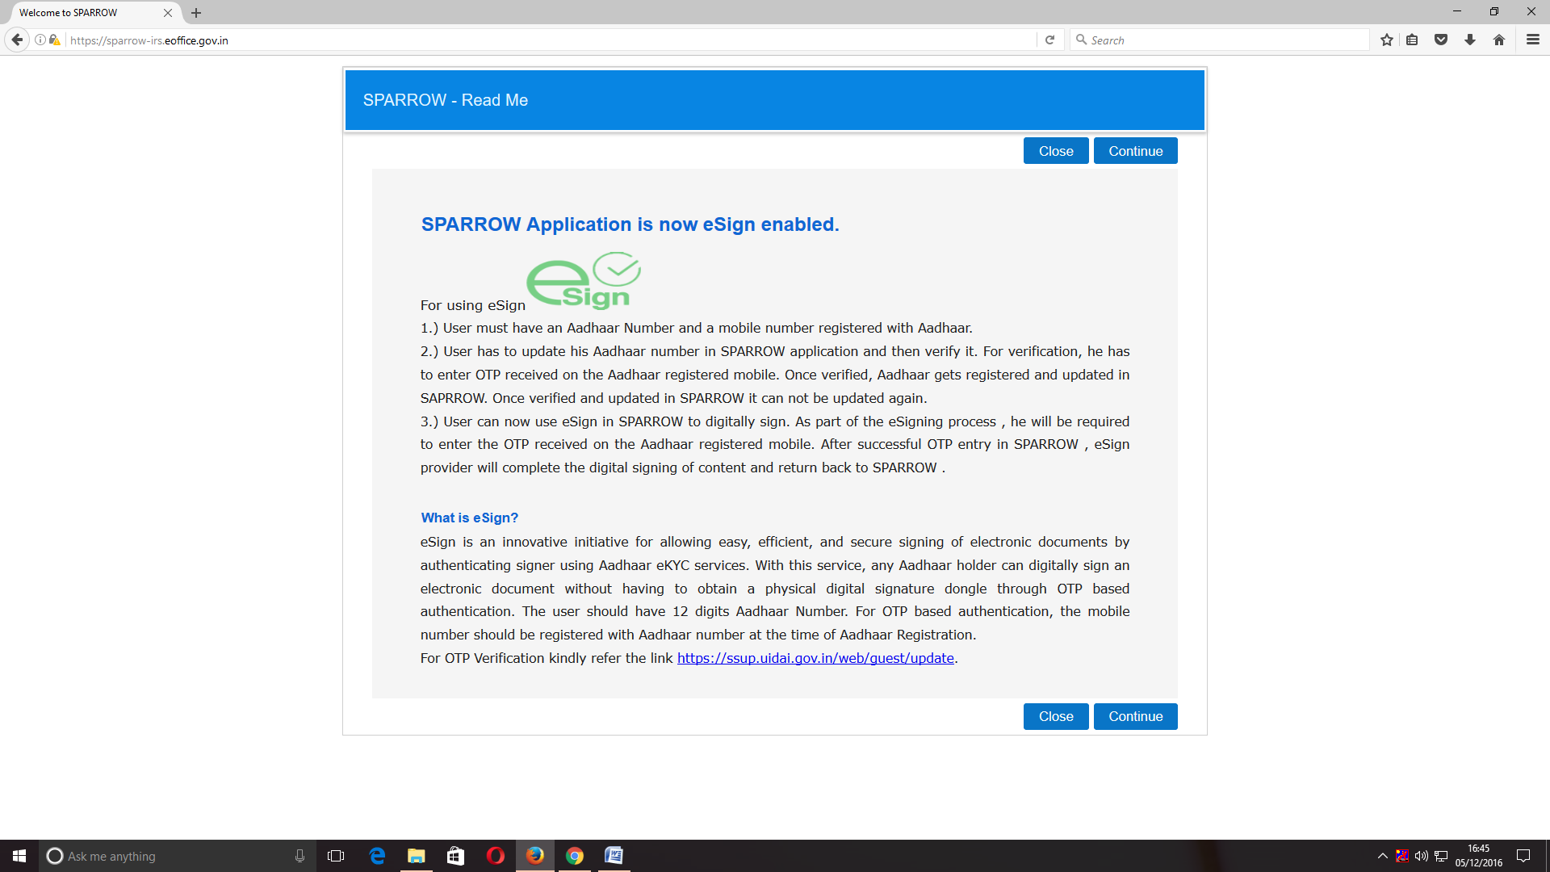

2. The read me window will have two buttons namely Close and Continue marked in blue, you can click any of the two buttons they will be doing the same function. On clicking any of the above two buttons, the user will be directed to the login screen of the SPARROW.

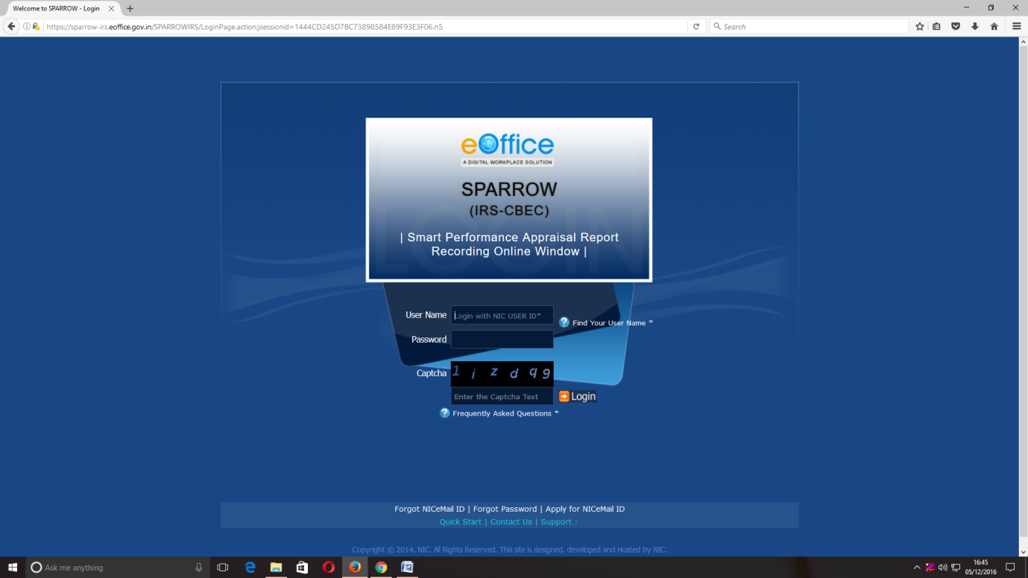

3. The "**Smart Performance Appraisal Report Recording Online Window**" screen will open up which is essentially a login screen for SPARROW. The screen will have three fields "**Username**", "**Password**" and "**Captcha**".

The username will be the NIC email id and only the name before **"@"** should be entered. For example if your NIC email is anish.upadhay@nic.in or anish.upadhay@gov.in, then, the user id will be anish.upadhyay.

The password for the application will be same as your NIC email ID password.

4. The Captcha as given in the box should be entered then click the "**Login**" button. It would open a POP UP Window to verify and update the Adhaar number.

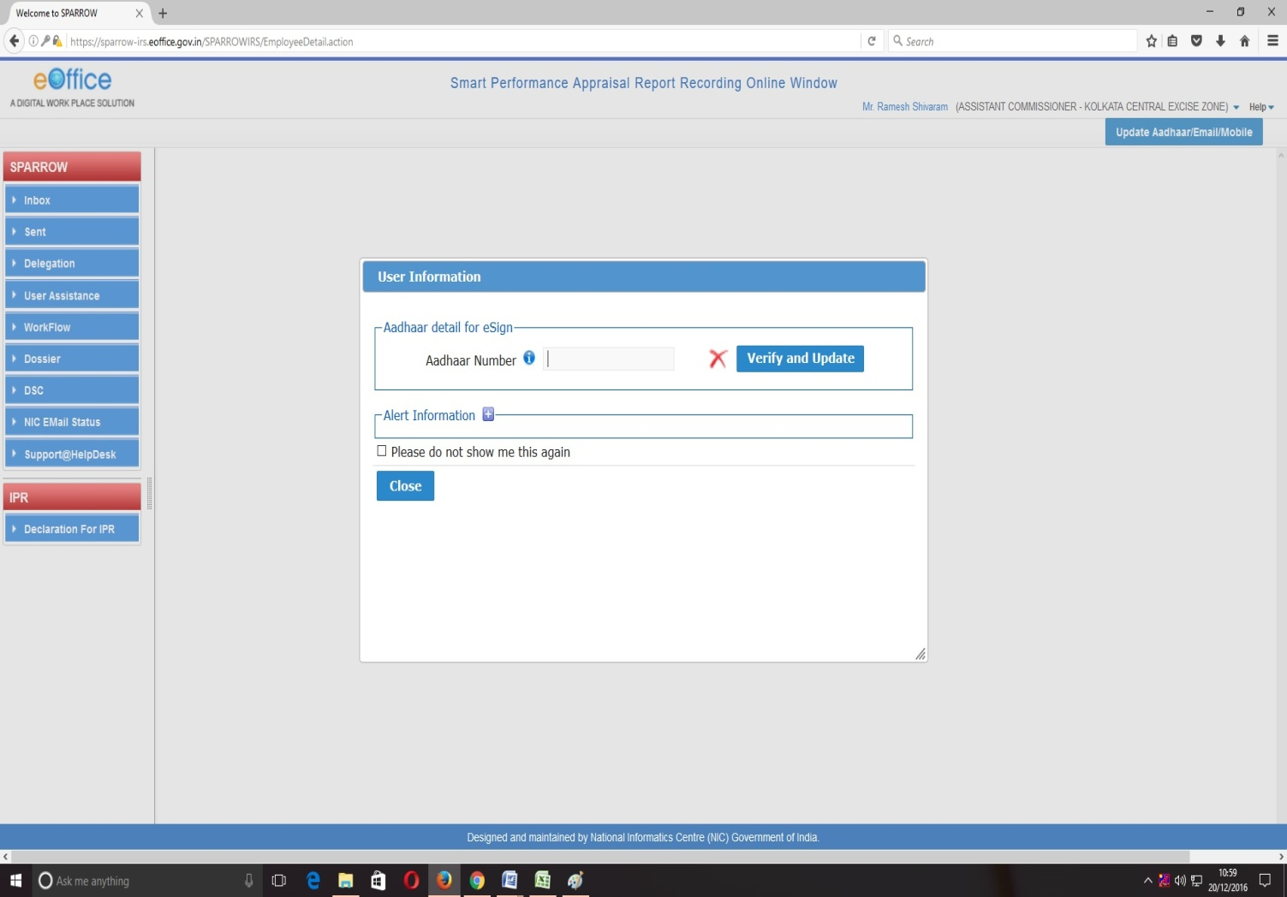

5. The officer has to enter Adhaar number and press Verify and update button. On pressing, an OTP number will be generated and sent to the registered mobile. Once this OTP number is fed, the Adhaar number will get verified and a green colour tick mark will come where red cross is there. This Adhaar verification window will not pop-up, once the Adhaar has been verified.

After verifying the Adhaar, the software would automatically move to next screen. By default, the SPARROW window will open up as shown in the next page.

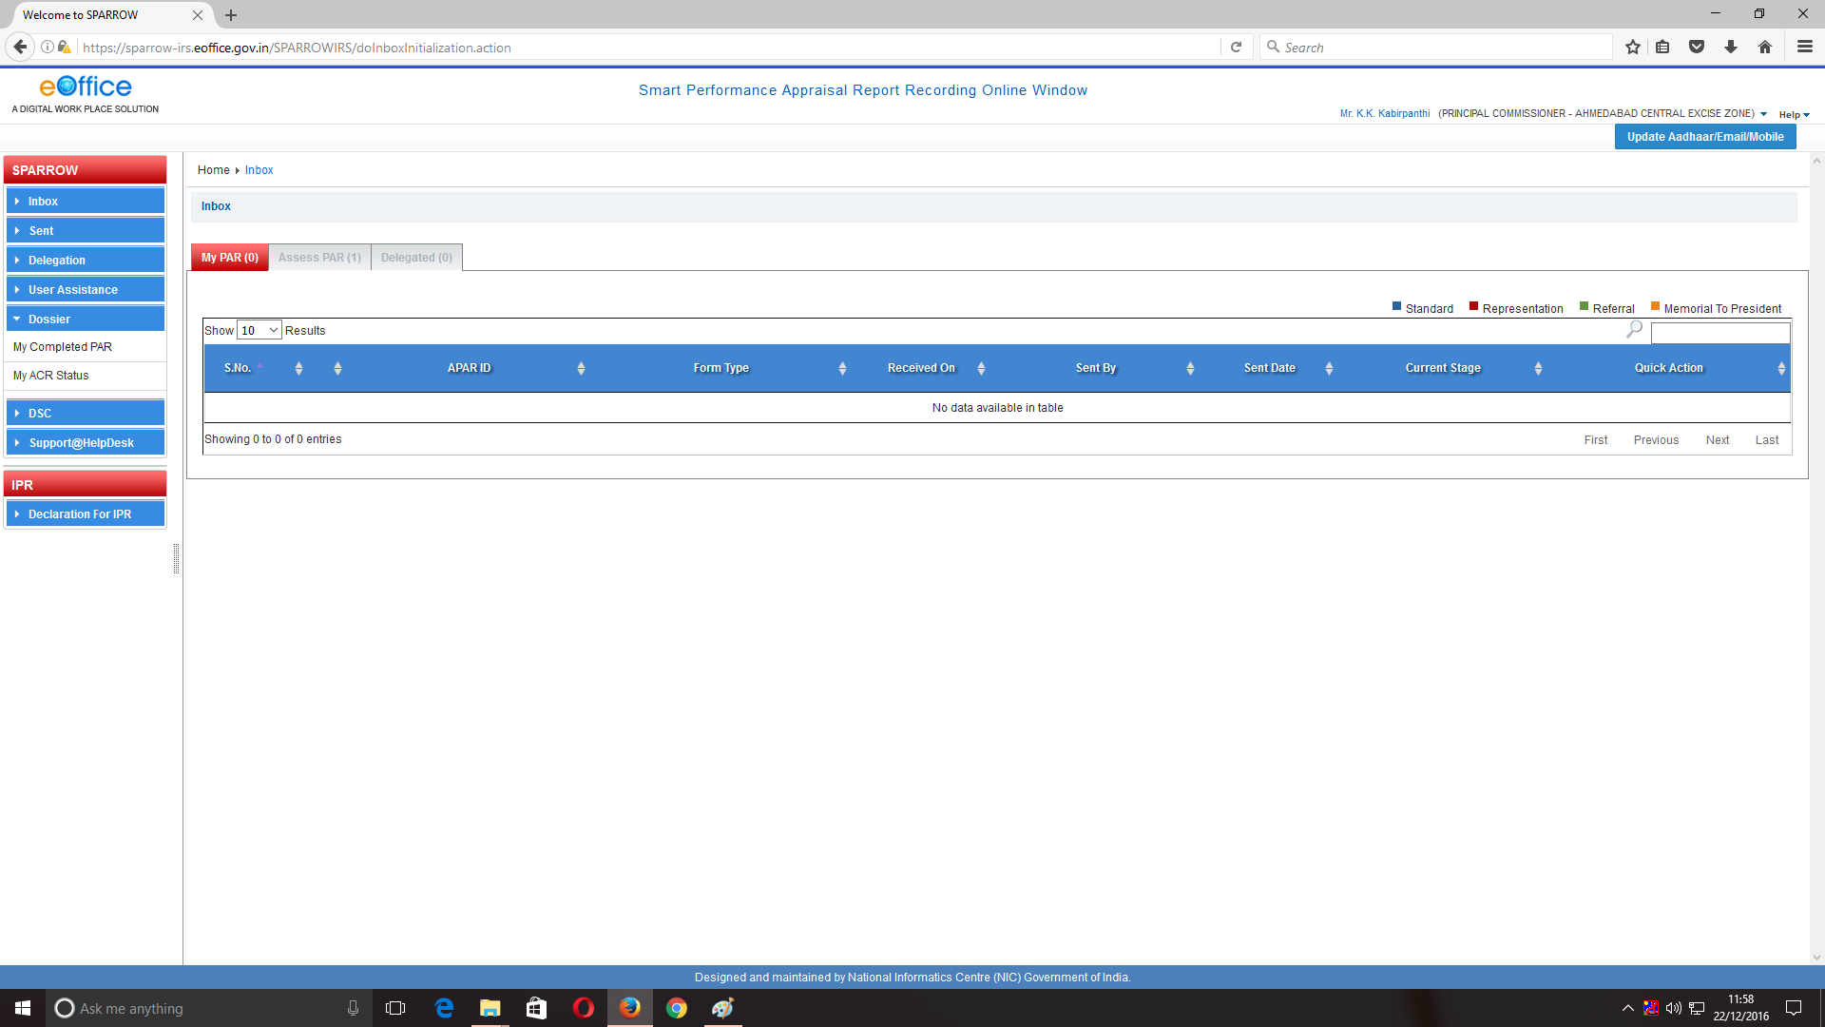

6. After successful login, the above window will open up. This page will have some tabs in the left side depending upon the role assigned to the officer. The Reviewing officer must click over the Inbox to check the APAR received to assess after the Custodian has completed the Section I and the officer reported upon has completed Section II and Reporting has completed Section III.

A screen would appear with 3 options **MyPAR(0), Assess PAR(0) and Delegated(0)**.

1. The **MyPARtab**allows the officer to write his own APAR in the role of Officer Reported Upon**.**
2. The**Assess PAR tab**would allow the officer to review the APAR of all subordinates. Details of all subordinates whose APAR has to be reviewed would appear in different rows. The officer can go to any APAR by clicking on Blue number under APAR-ID. The image below shows the details.

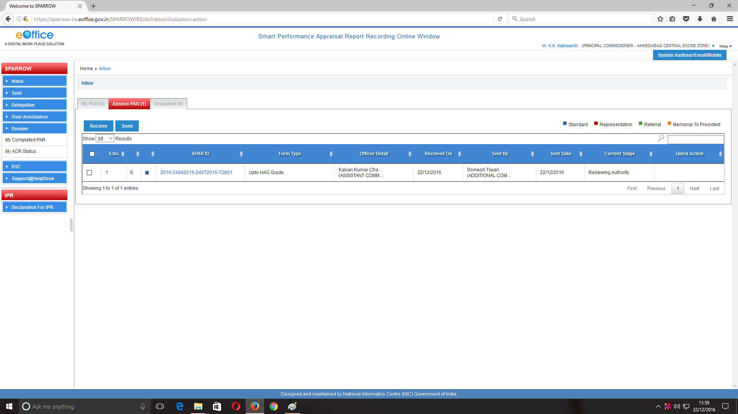

Go to this option to access APAR as Reviewing Officer

Click here to select the APAR to be reviewed

8. Once the officer clicks on Blue coloured number under APAR-ID, the screen containing Section-I, Section-II, Section-III as filled by Custodian, Officer Reported Upon, Reporting Authority would appear. The Reviewing officer can review the APAR by clicking on **Section IV** tab as shown in the image below.

Reviewing Officer has to choose the option whether he/she agrees with the gradings of Reporting officer or not and hence can select Yes/No option. The officer has to further mention the reasons for the same in the next text box.

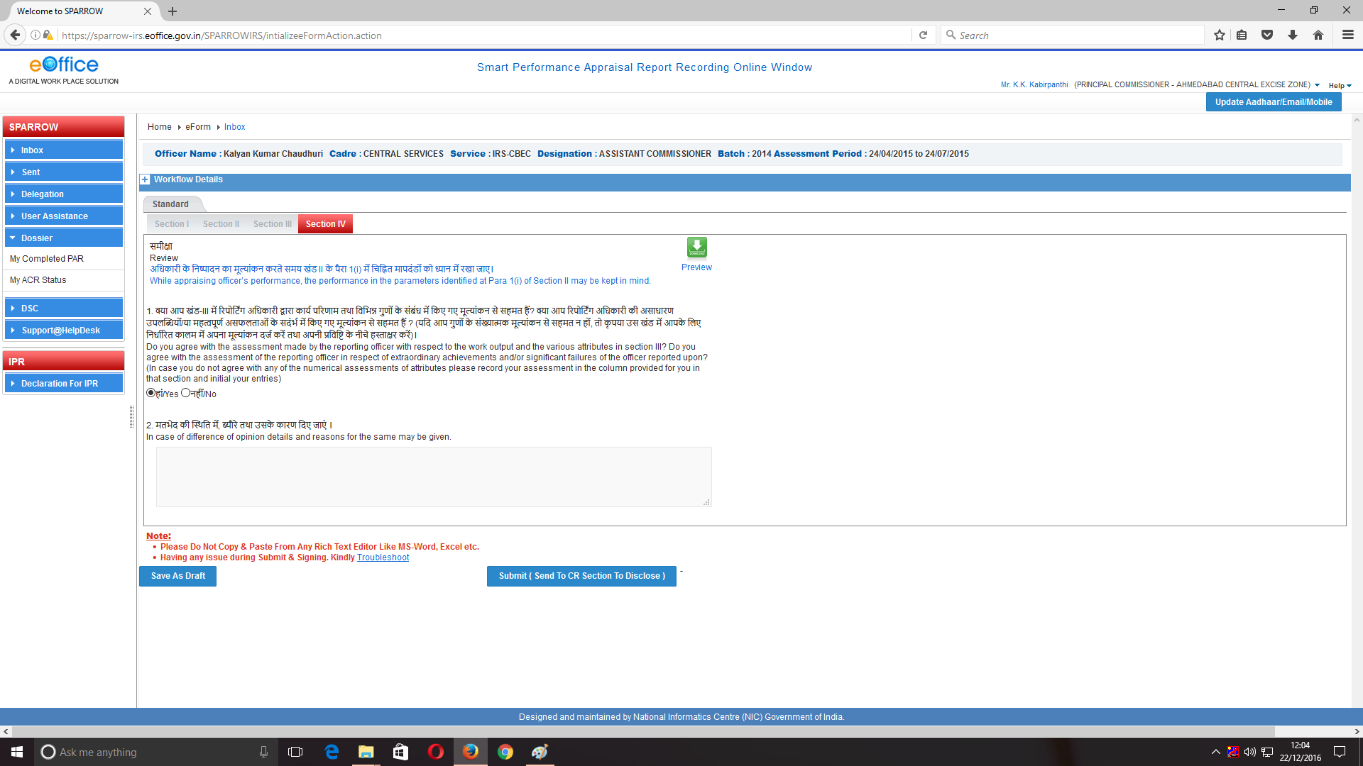

9. The **Reviewing Officer** has to then write the Pen Picture of the **Officer Reported Upon.**Further he can agree or disagree with the domain assignment recommended by the Reporting Officerby pressing Yes/No option and can suggest his own preferences. Screenshots mentioned below shows details to be filled by Reviewing Officer.

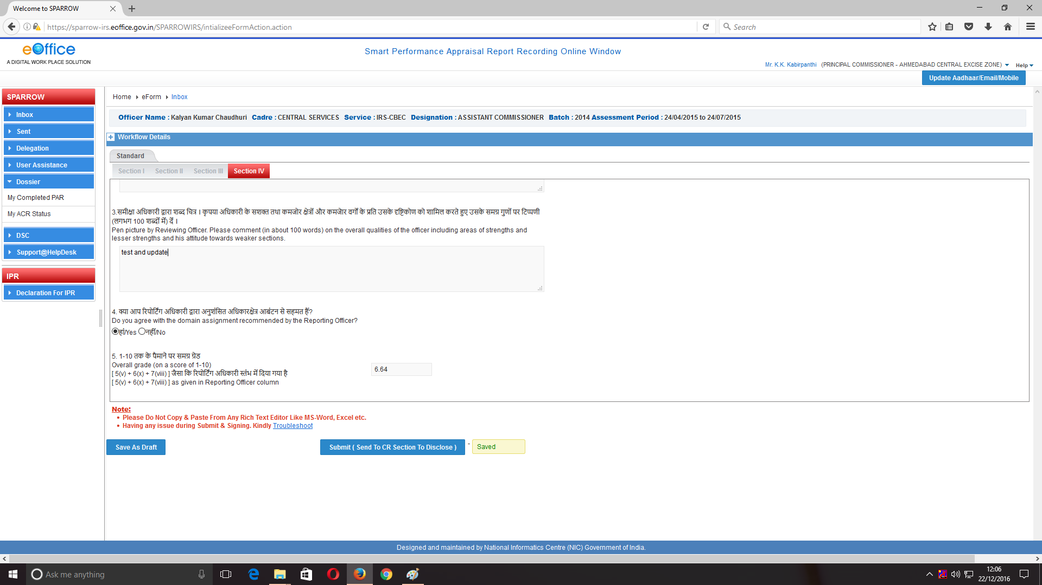

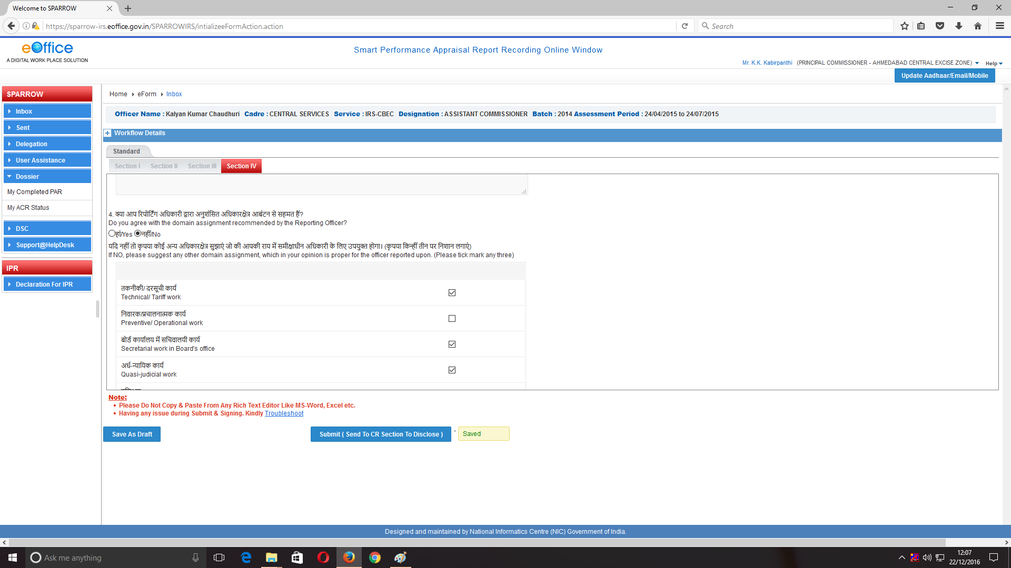

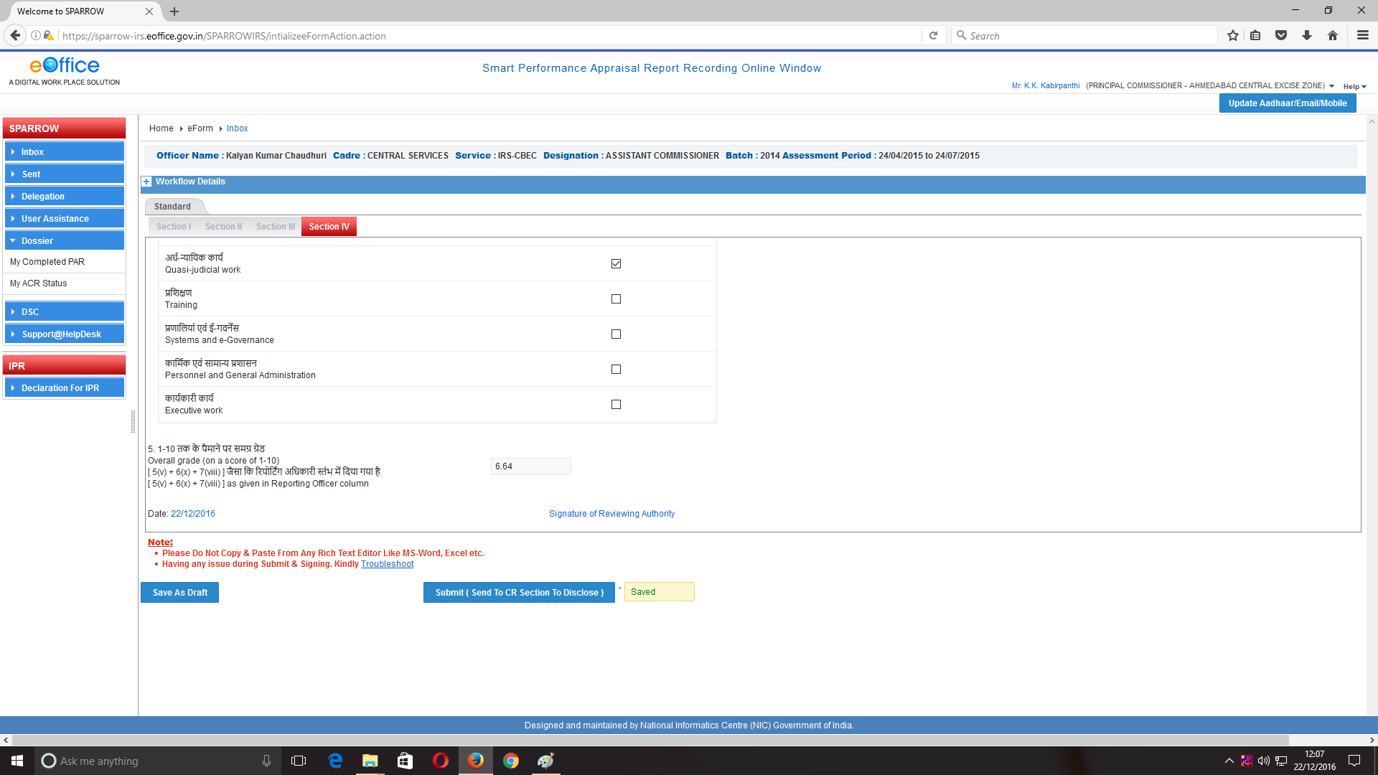

10. Now to give the grading to the Officer Reported Upon, the **Reviewing Officer** needs to click on the **Section III tab** to fill the assessment/ Grading of the **Officer Reported Upon.**

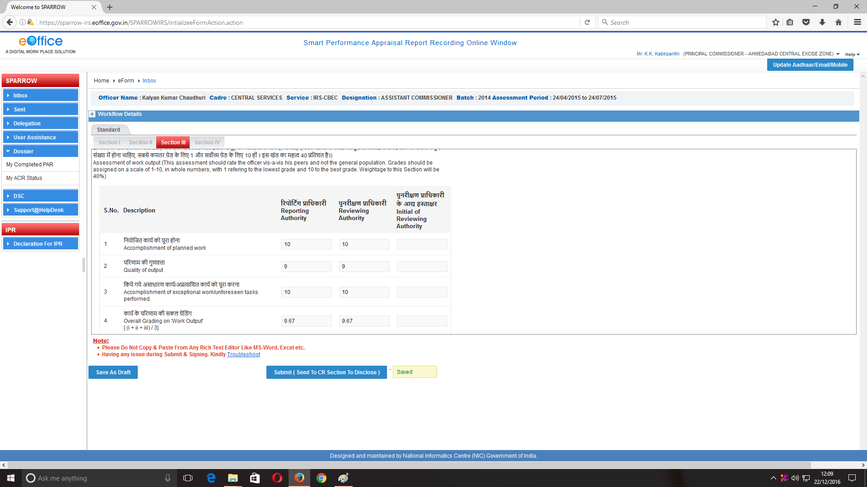

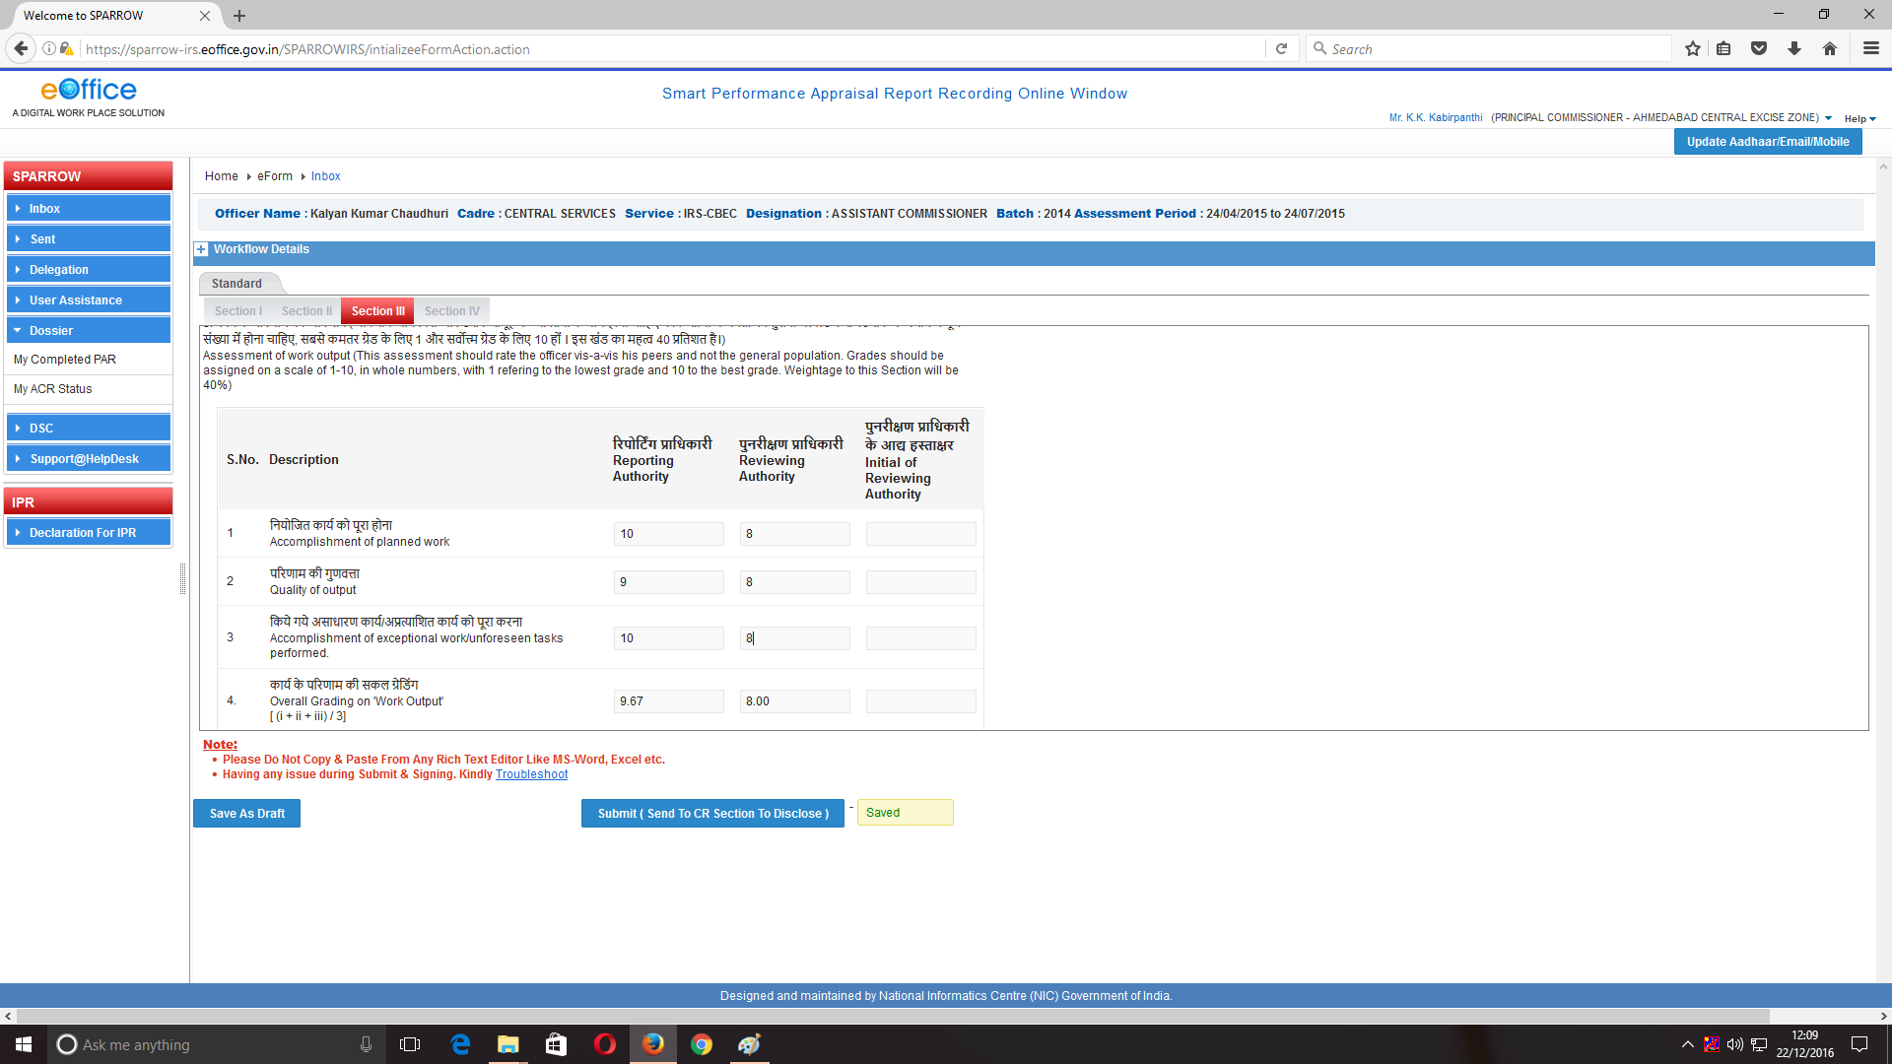

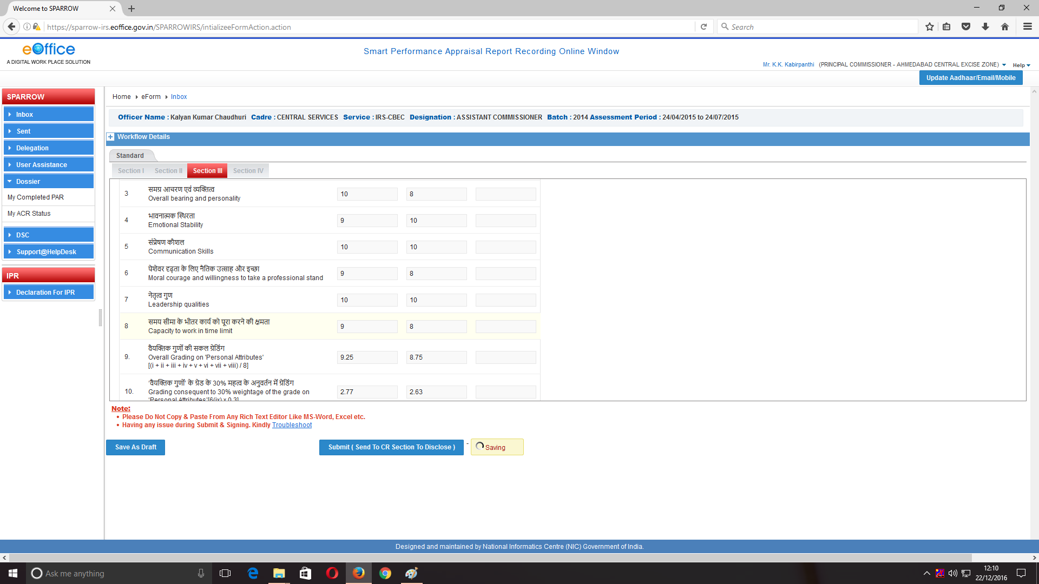

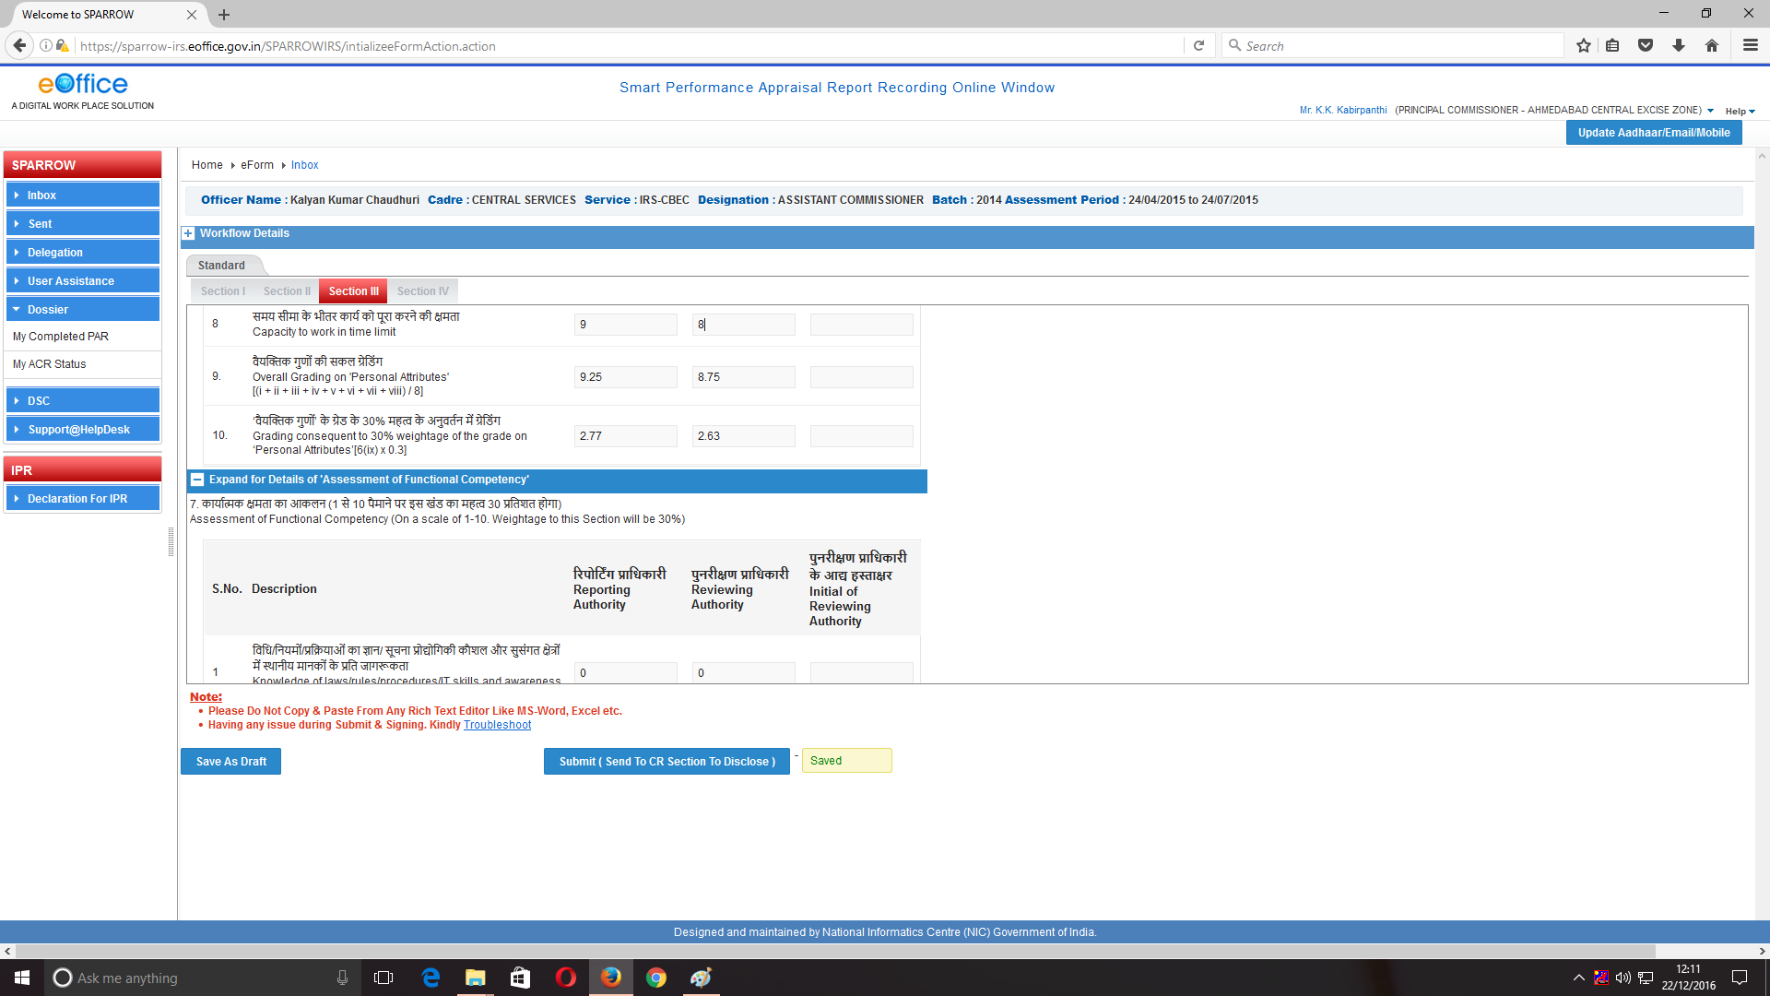

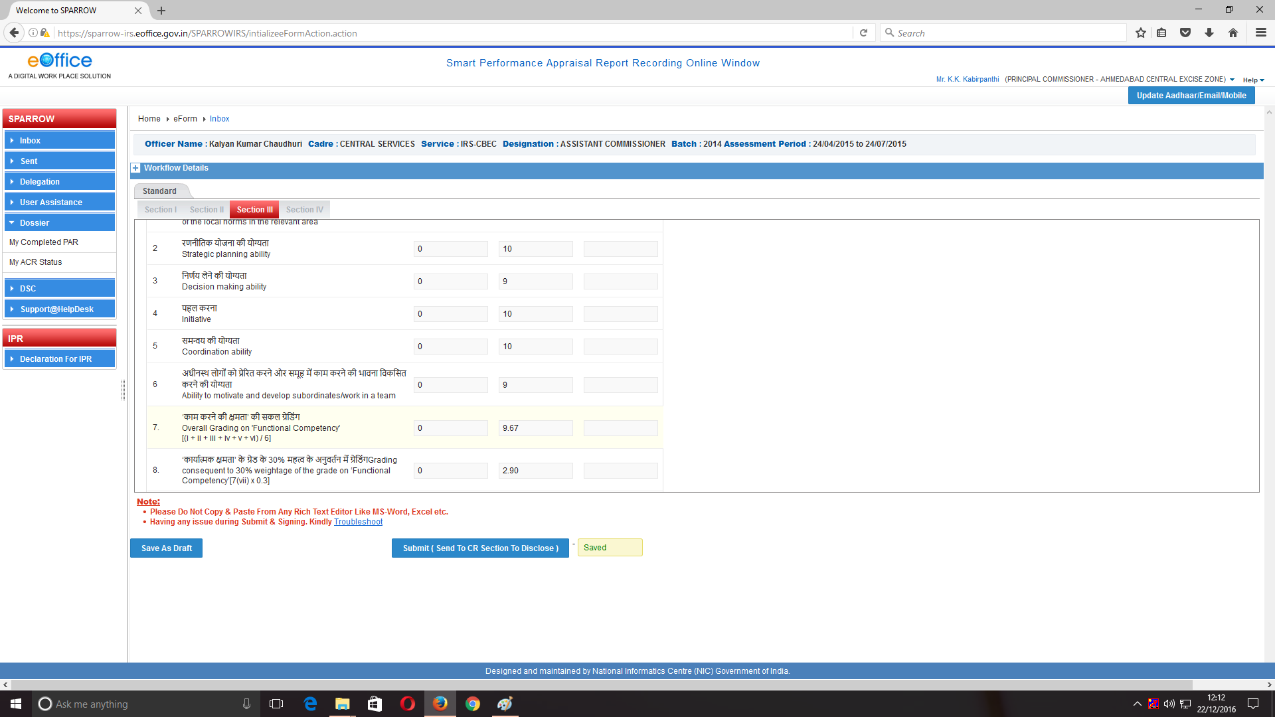

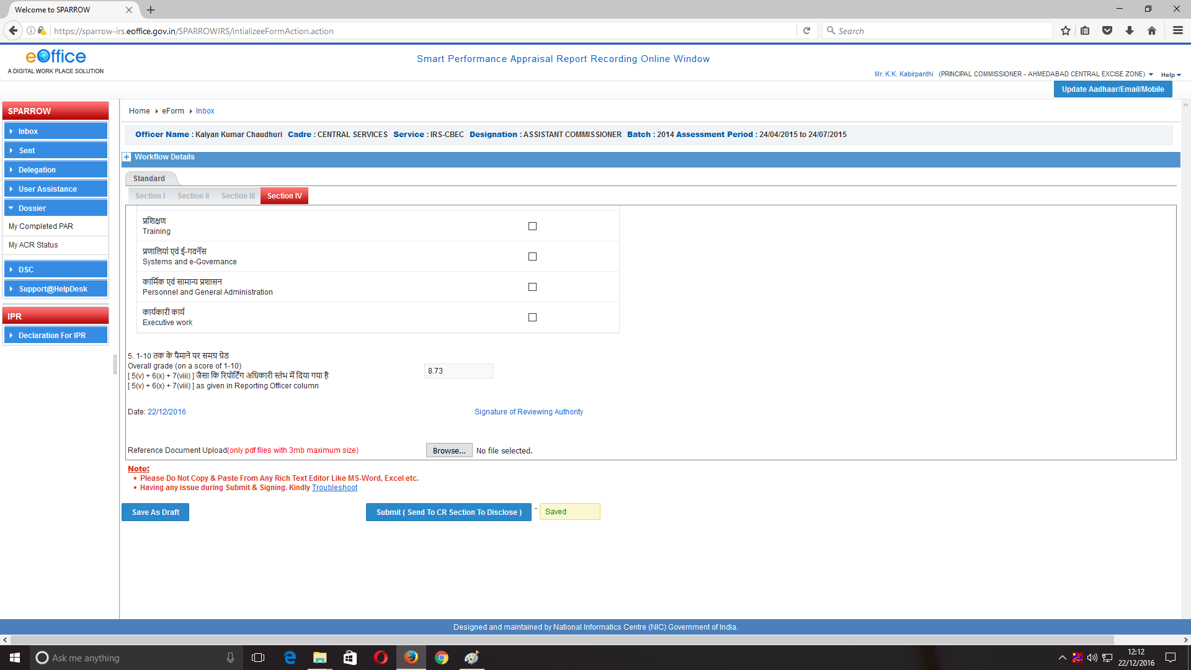

11. After giving his gradings, the Reviewing Officer would press on **Submit (Send to CR Section to Disclose)** to send the APAR to Custodian. The Custodian would then disclose the APAR to the Officer Reported Upon. After pressing Submit button a message would appear –“**Once form is submitted data will not be changed. Are you sure you want to submit”.**The officer needs to press OK to continue submitting the graded APAR.

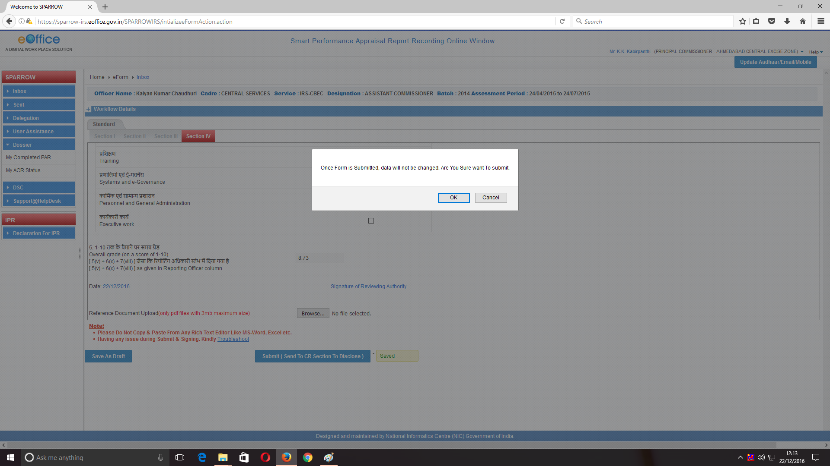

12. This completes the process of Reviewing by Reviewing Authority.

