**ERROR DOCUMENT HELP MANUAL**

**INDEX**

|  |  |  |
| --- | --- | --- |
| **Sr. No.** | **Topic** | **Page no.** |
| 1 | How To Reset The Nic Email Password | 2 |
| 2 | Step by step guide for Aadhaar verification in SPARROW. | 4 |

**How To Reset The Nic Email Password**

1. Open url https://mail.gov.in/

Click here

2. Login page will open as below:

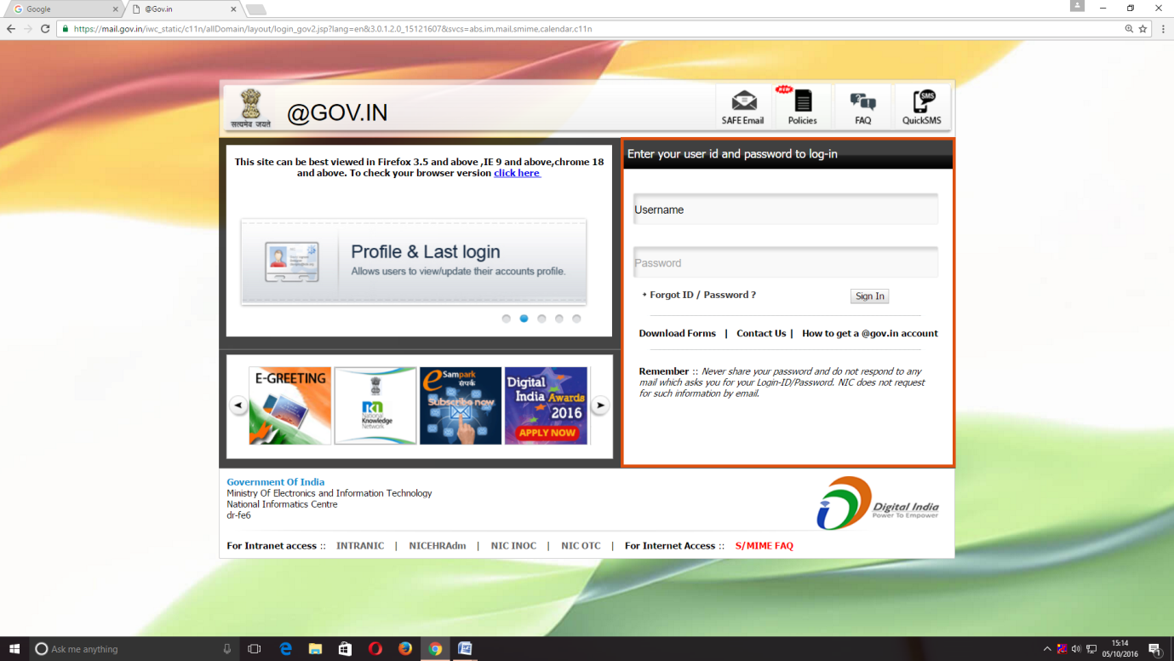

3.Click over "[**Forgot ID / Password ?**](https://mail.gov.in/iwc_static/c11n/allDomain/layout/forgot.html)" in the login page and a new window will open as below:

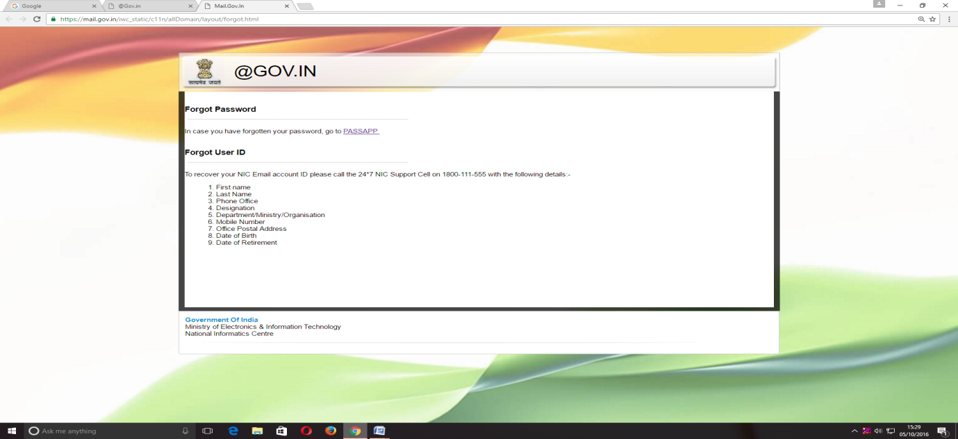

Click here

4.In this window click the a link for resetting the password with a title "[PASSAPP](https://passapp.emailgov.in/)".

5.On clicking the PASSAPP link, following window shall open: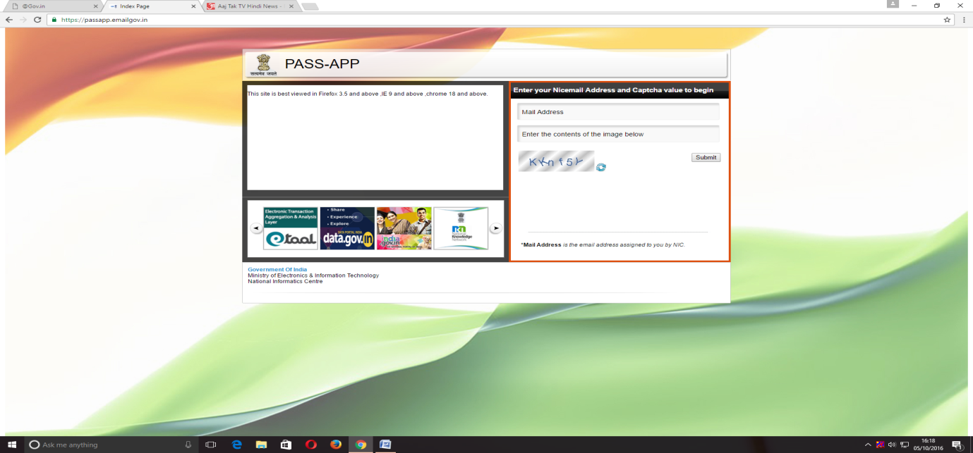

6.The user has to give email id for which password has to be reset and then he has to enter the captcha (alphabet/numerals given in image shown below).

7.The password will be generated and will be sent to the registered mobile no. of the user.

8.The user can log on through the password received in SMS in https://mail.gov.in/ .

*****

**Step by step guide for Aadhaar verification in SPARROW.**

1. Open the url **https://sparrow-irs.eoffice.gov.in/** in Mozilla browser. The software runs smoothly on Mozilla browser and thus it is recommended to install Mozilla browser.

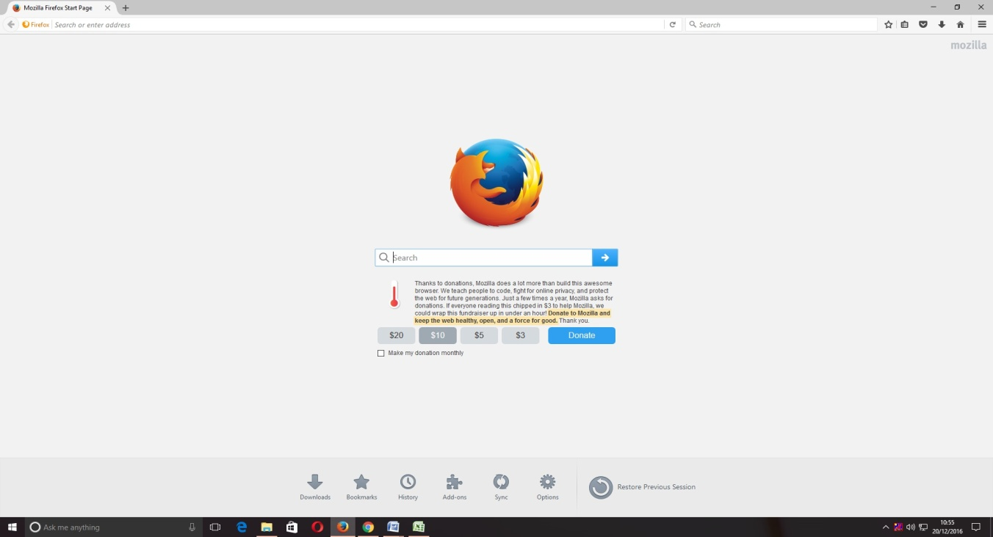

On opening the url, the "**SPARROW - Read Me**" window (given below) will open which shows the information about the e-signing facility in the SPARROW.

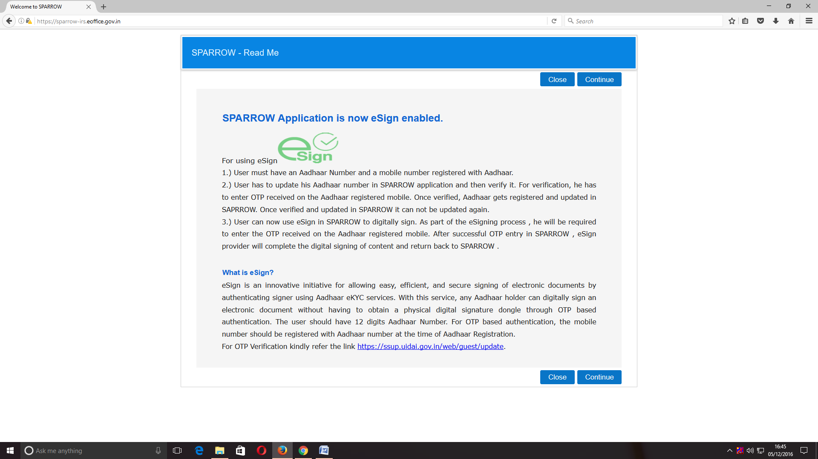

2. The read me window will have two buttons namely Close and Continue marked in blue, you can click any of the two buttons they will be doing the same function. On clicking any of the above two buttons, the user will be directed to the login screen of the SPARROW.

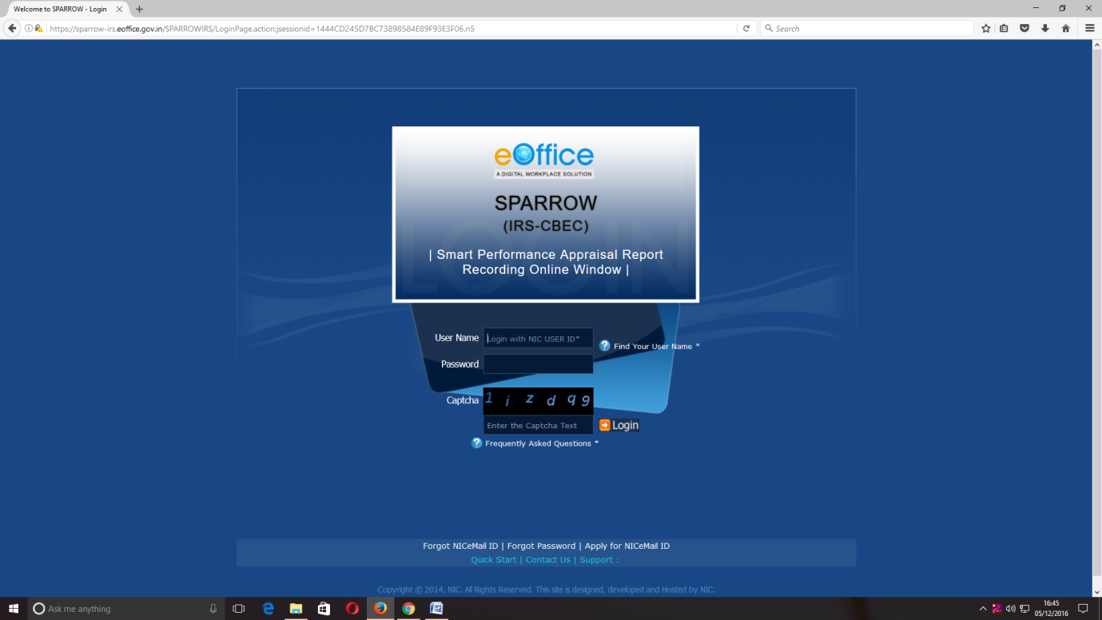

3. The "**Smart Performance Appraisal Report Recording Online Window**" screen will open up which is essentially a login screen for SPARROW. The screen will have three fields "**Username**", "**Password**" and "**Captcha**".

The username will be the NIC email id and only the name before **"@"** should be entered. For example if your NIC email is anish.upadhay@nic.in or anish.upadhay@gov.in, then, the user id will be anish.upadhyay.

The password for the application will be same as your NIC email ID password.

(Note: For practice environment, till software is launched, the default password for logging into the system is kept as "**sparrow_irs**" for all the users.)

4. The Captcha as given in the box should be entered then click the "**Login**" button. It would open a POP UP Window to verify and update the Aadhaar number as shown in the screen below.

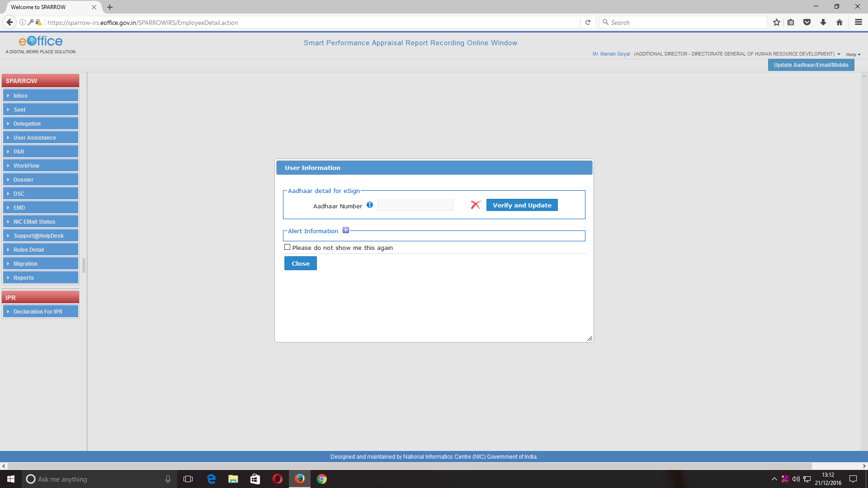

5. The officer has to enter Aadhaar number and click **Verify and Update** button.

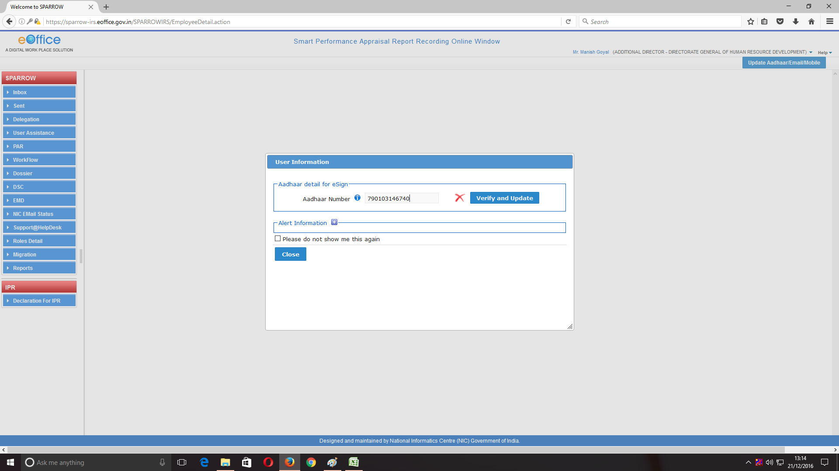

6. On clicking Verify and Update the following confirmation window will appear wherein your consent will be asked for providing the Aadhaar no.

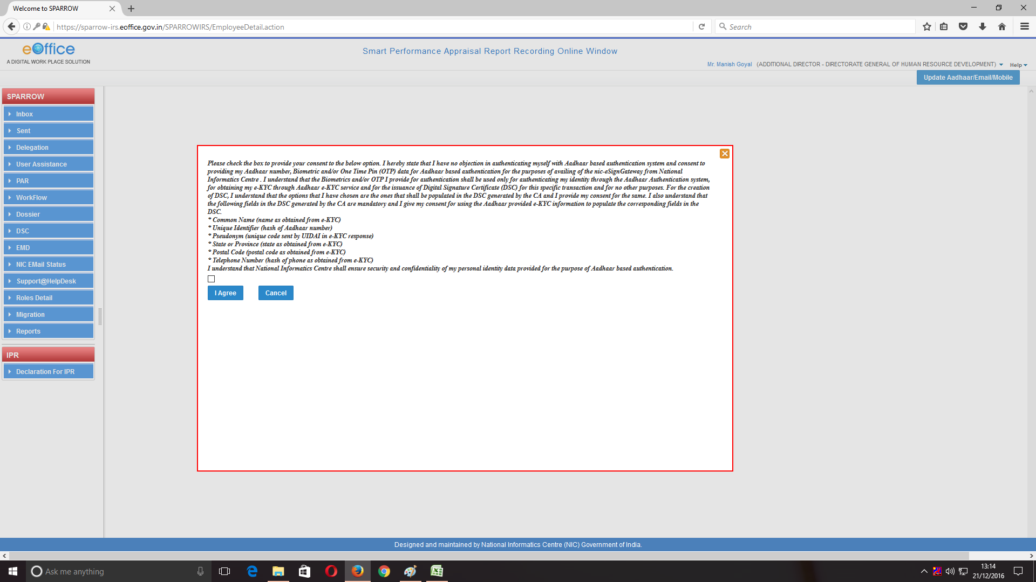

7. Click on the check box provided at the bottom just above I Agree tab as shown in the screen below. Click I Agree tab

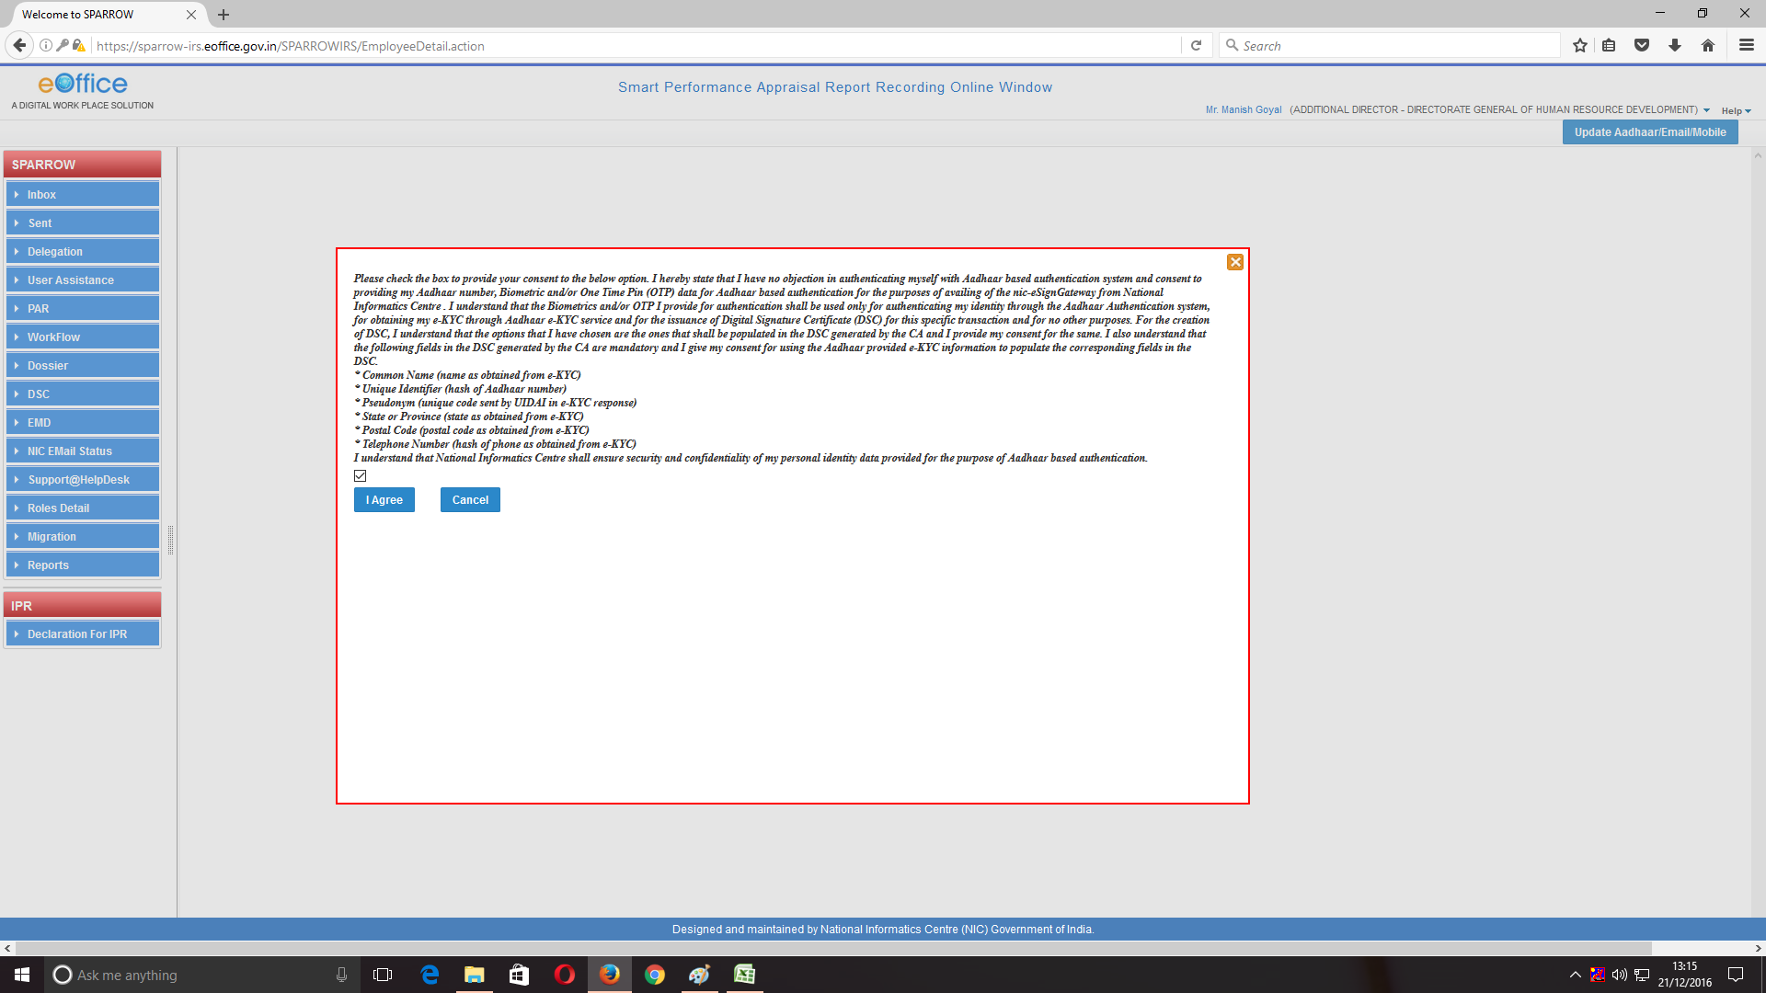

8. On clicking I Agree, an OTP number will be generated and sent to the registered mobile. Thus, it is mandatory to get the mobile linked with the Aadhaar. Once this OTP number is fed, the Aadhaar number will get verified and a green coloured tick mark will come where red coloured cross is there. This completes the Aadhaar verification process. This is a one-time activity as this Aadhaar verification window will not pop-up, once the Aadhaar has been verified.

*****