MAZE SOLVING

ROBOT

USING MSP

430

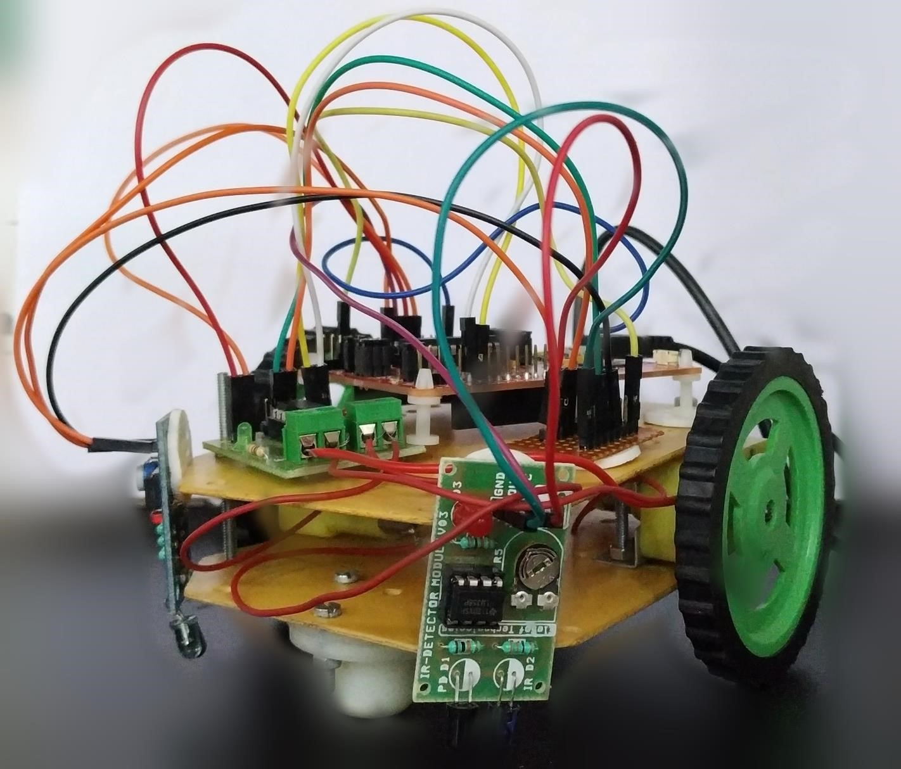

COMPONENTS USED

•

MSP430G2

LaunchPad

from

Texas Instruments

•

The L293D motor driver module

•

Connecting wires

•

IR sensors

•

Chasis

, wheel

•

Caster wheel

•

Energia

IDE

•

Power supply (3.3v) and 5v

-

12

v

•

BO motors

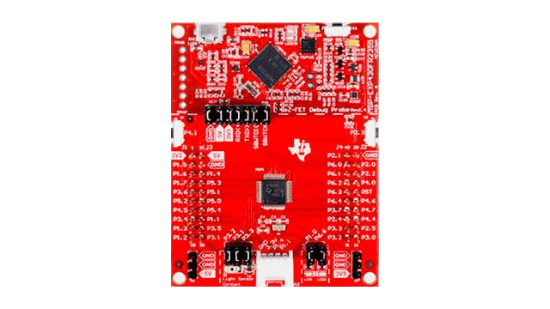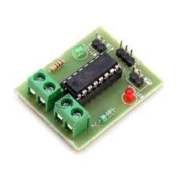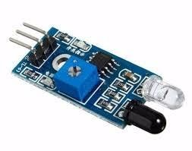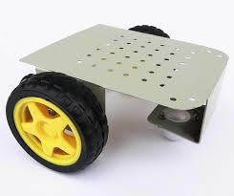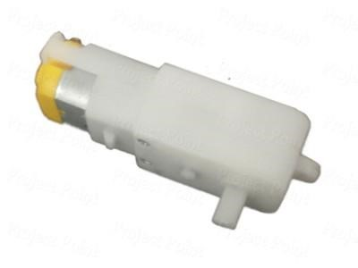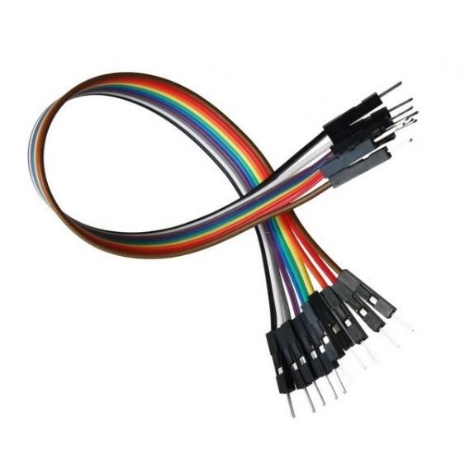

# BLOCK DIAGRAM

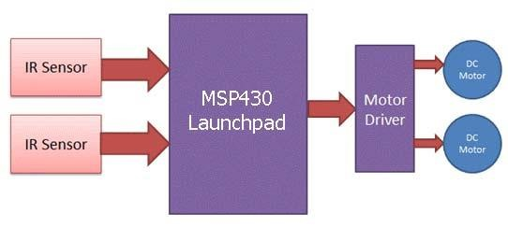

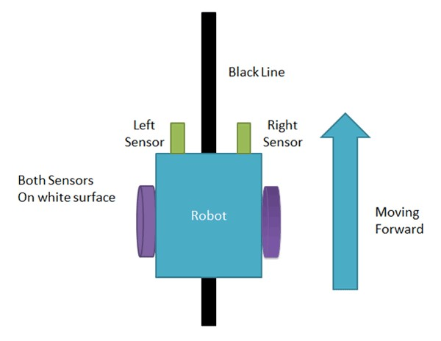

When both left and right sensor senses white then robot move forward

Working of Maze Solver

Robot using MSP430

•

Working of line follower is very

interesting. Line follower robot

senses black line by using sensor

and then sends the signal to

MSP430 Launchpad. Then MSP430

Launchpad drives the motor

according to sensors'

output.

If Left sensor comes on back line then robot turns left side

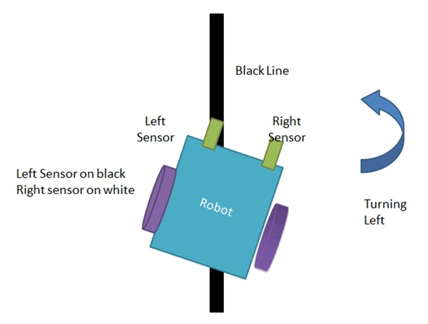If right sensor sense black line then robot turn right side until both sensor comes at white surface. When white surface comes robot starts moving on forward again

If both sensors comes on black line, robot stops

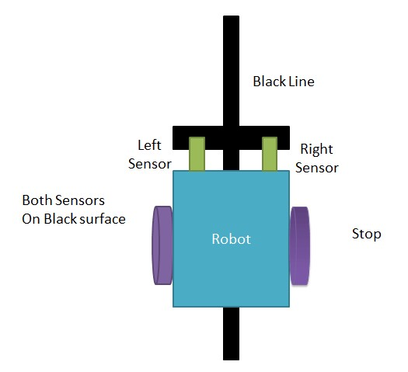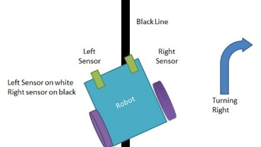

SOFTWARE USED



Energia

is an

[ope](https://github.com/energia/energia)

[n](https://github.com/energia/energia)

[-](https://github.com/energia/energia)

[sourc](https://github.com/energia/energia)

[e](https://github.com/energia/energia)

electronics prototyping

platform started by Robert Wessels in January of 2012

with the goal to bring the Wiring and Arduino framework

to the Texas Instruments MSP430 based

LaunchPad

. The

Energia

IDE is cross platform and supported on Mac OS,

Windows, and Linux.

Energia

uses the

[mspgc](http://mspgcc.sourceforge.net/original.html)

[c](http://mspgcc.sourceforge.net/original.html)

compiler

by

[Peter Bigo](http://sourceforge.net/users/pabigot)

[t](http://sourceforge.net/users/pabigot)

and is based on

the

[Wirin](http://wiring.org.co/)

[g](http://wiring.org.co/)

and

[Arduin](http://arduino.cc/)

[o](http://arduino.cc/)

framework.

Energia

includes an

integrated development environment (IDE) that has it’s

foundation in the

[Processin](http://www.processing.org/)

[g](http://www.processing.org/)

[I](http://www.processing.org/)

DE

(

Processing→Wiring→Arduino→Energia

)

.

Energia

is also a

portable framework/abstraction layer that can be used in

other popular IDEs

# ALGORITHM

void setup() {

pinMode(P1_2,OUTPUT);// left motor clockwise

void loop() {

pinMode(P1_3,OUTPUT);// left motor if ((digitalRead(P1_4)==HIGH)&&(digitalRead(P1_5)==HIGH)) pinMode(P2_4,OUTPUT);//right motor clockwise {

digitalWrite(P1_2,HIGH);//FORWARD

pinMode(P2_5,OUTPUT);//right digitalWrite(P1_3,LOW);

digitalWrite(P2_4,HIGH);

pinMode(P1_4,INPUT);//LEFT SENSOR digitalWrite(P2_5,LOW); pinMode(P1_5,INPUT);//RIGHT SENSOR }

}

if ((digitalRead(P1_4)==LOW)&&(digitalRead(P1_5)==LOW))

|  |  |
| --- | --- |
| {  digitalWrite(P1_2,HIGH);//STOP  digitalWrite(P1_3,LOW); digitalWrite(P2_4,LOW);  digitalWrite(P2_5,LOW);  }  if ((digitalRead(P1_4)==HIGH)&&(digitalRead(P1_5)==LOW)) | if  ((digitalRead(P1_4)==LOW)&&(digitalRead(P1_5)==  HIGH))  {  digitalWrite(P1_2,LOW);//FORWARD  digitalWrite(P1_3,HIGH); digitalWrite(P2_4,HIGH);  digitalWrite(P2_5,LOW);  } |

{

digitalWrite(P1_2,HIGH);//FORWARD

digitalWrite(P1_3,LOW);

digitalWrite(P2_4,LOW);

digitalWrite(P2_5,HIGH);

}

}

# WORKING VIDEO

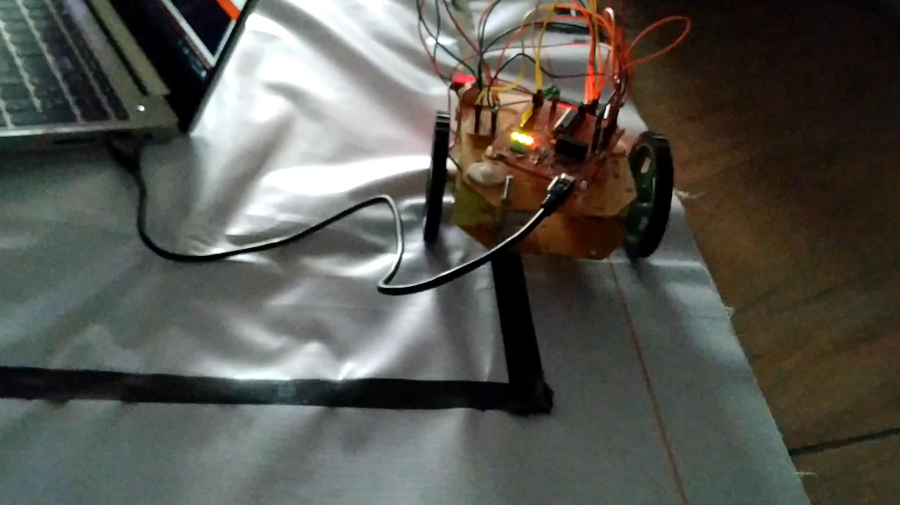

# APPLICATIONS

• Applications of such autonomous vehicles range from simple tasks like robots employed in industries to carry goods through factories, office buildings and other workspaces to dangerous or difficult to reach areas like bomb sniffing, finding humans in wreckage, etc.

## • Search and Rescue operations • Navigation problems • Medical attention

