MEDICAL DIAGNOSTIC SYSTEM

SET OF INSTRUCTIONS

REQUIREMENTS :- DOS BOX & TURBO PROLOG PREINSTALLED

* Double click on dos box
* TYPE “mount c c:”
* TYPE “c:\”
* TYPE “c:\prolog\prolog.exe”
* PRESS “Enter”

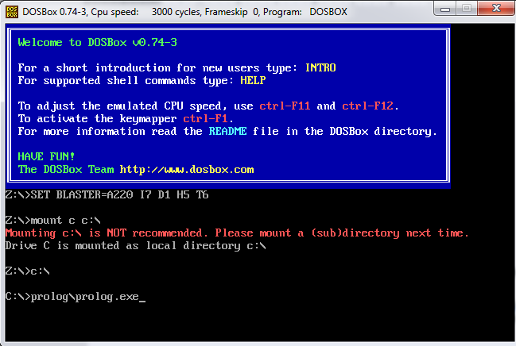

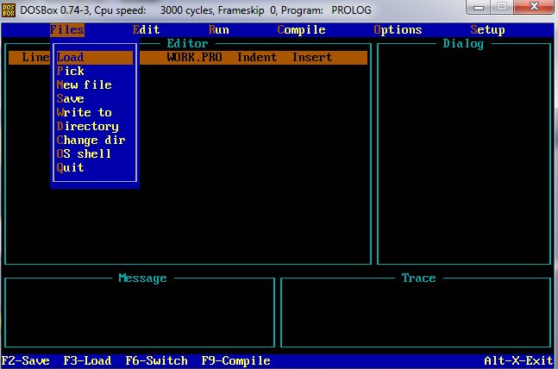

1. Load the program in the editor.
2. Go to Run to run the program, it will compile on its own.

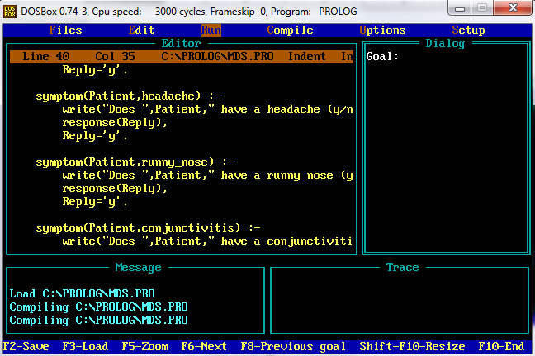

1. Then in the Dialog section type “mds” in front of “Goal:-” to start the Medical Diagnostic System. [ Goal:- mds ]
2. It will ask you name of the patient.

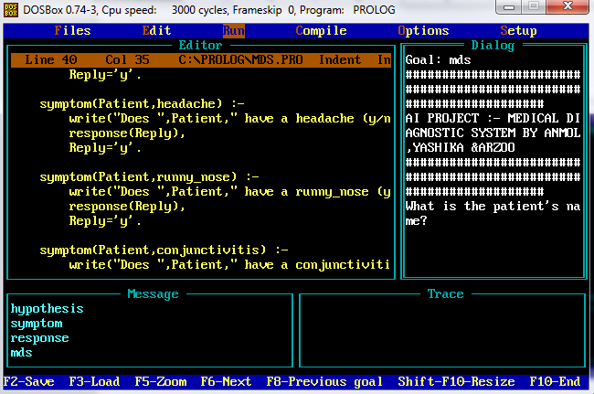

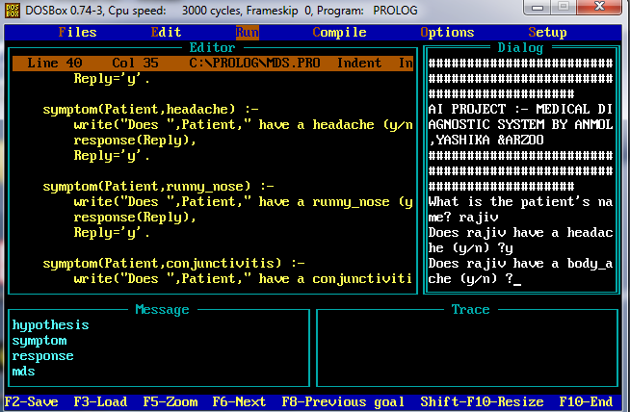

1. It will keep asking questions which have to be responded with a “ y ” for YES if the specified symptom exists and “ n ” for NO if the specified symptom does not exist .
2. In the end it will terminate by giving name of the disease which will just be an assumption based on symptoms you said “Yes” for or it will say “Sorry, I don’t seem to be able to diagnose the disease” if the system is unable to diagnose the disease.

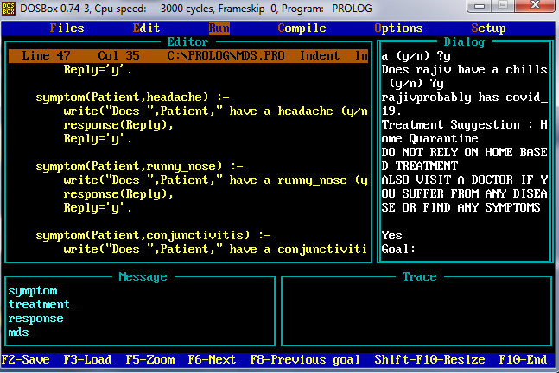

POSITIVE RESULT :- SYSYTEM IS ABLE TO DIAGNOSE THE DISEASE ALSO SUGGESTING TREATMENT

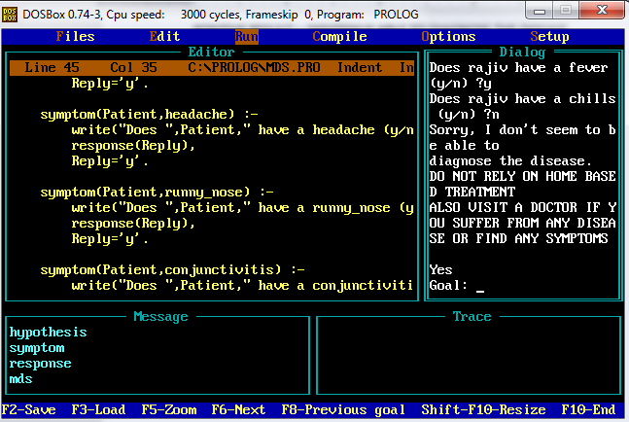

NEGATIVE RESULT :- SYSYTEM IS NOT ABLE TO DIAGNOSE THE DISEASE