DBMS PROJECT-Restaurant Database

MySQL Database-

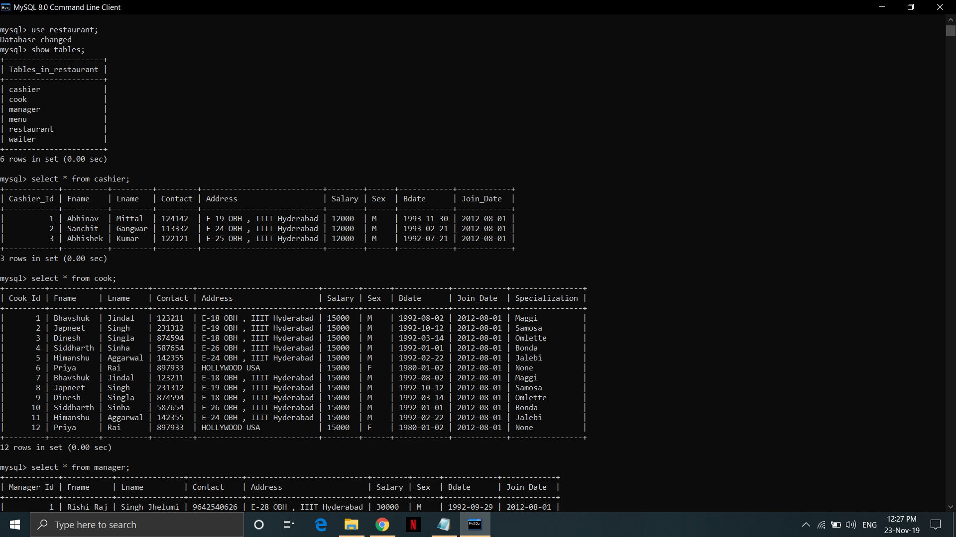

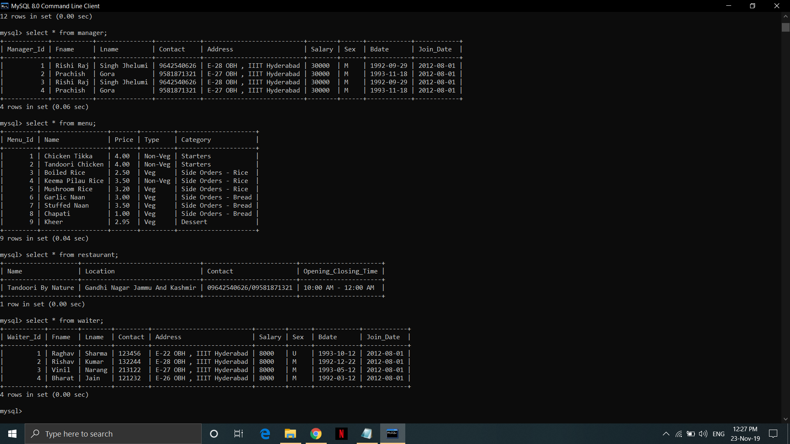

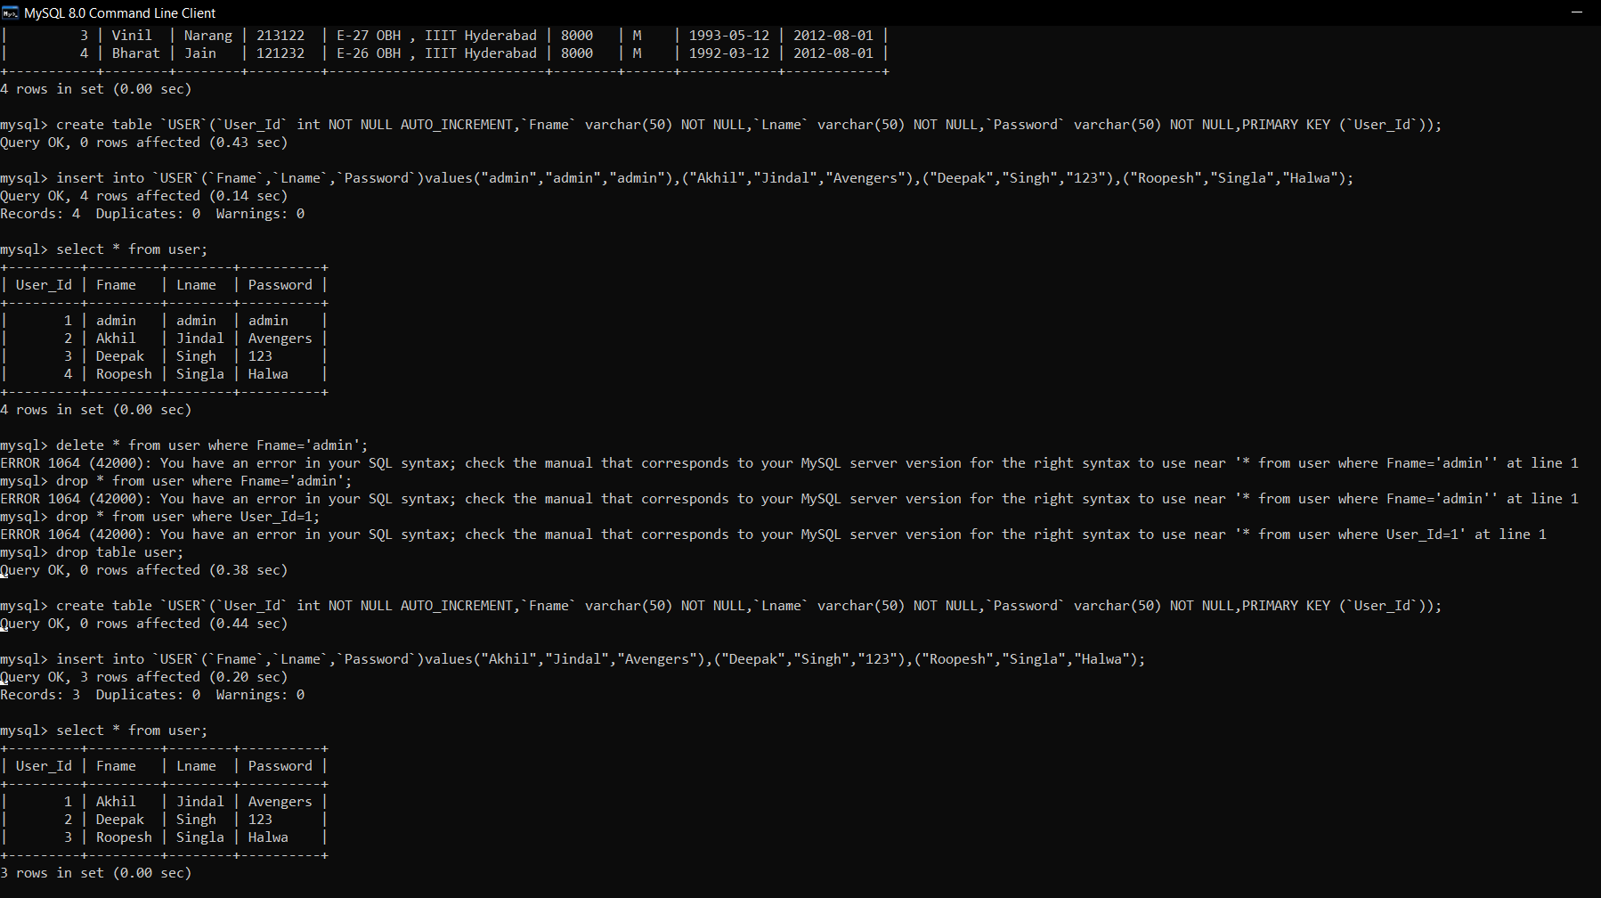
Code-

create database `restaurant`;
use `restaurant`;

drop table if exists `USER`;
create table `USER`(
`User_Id` int NOT NULL AUTO_INCREMENT,
`Fname` varchar(50) NOT NULL,
`Lname` varchar(50) NOT NULL,
`Password` varchar(50) NOT NULL,
PRIMARY KEY (`User_Id`)
)

create table `RESTAURANT`(
`Name` varchar(100) NOT NULL,
`Location` varchar(100) NOT NULL,
`Contact` varchar(100) NOT NULL,
`Opening_Closing_Time` varchar(100) NOT NULL,
PRIMARY KEY (`Name`)
)

create table `MANAGER`(
`Manager_Id` int NOT NULL AUTO_INCREMENT,
`Fname` varchar(15) NOT NULL,
`Lname` varchar(15) NOT NULL,
`Contact` varchar(20) NOT NULL,
`Address` varchar(30) DEFAULT NULL,
`Salary` varchar(30) DEFAULT NULL,
`Sex` char(1) DEFAULT NULL,
`Bdate` date DEFAULT NULL,
`Join_Date` date NOT NULL,
PRIMARY KEY (`Manager_Id`)
)

create table `WAITER`(
`Waiter_Id` int NOT NULL AUTO_INCREMENT,
`Fname` varchar(15) NOT NULL,
`Lname` varchar(15) NOT NULL,
`Contact` varchar(20) NOT NULL,
`Address` varchar(30) DEFAULT NULL,
`Salary` varchar(30) DEFAULT NULL,
`Sex` char(1) DEFAULT NULL,
`Bdate` date DEFAULT NULL,
`Join_Date` date NOT NULL,
PRIMARY KEY (`Waiter_Id`)
)

create table `CASHIER`(
`Cashier_Id` int NOT NULL AUTO_INCREMENT,
`Fname` varchar(15) NOT NULL,
`Lname` varchar(15) NOT NULL,
`Contact` varchar(20) NOT NULL,
`Address` varchar(30) DEFAULT NULL,
`Salary` varchar(30) DEFAULT NULL,
`Sex` char(1) DEFAULT NULL,
`Bdate` date DEFAULT NULL,
`Join_Date` date NOT NULL,
PRIMARY KEY (`Cashier_Id`)
)

create table `COOK`(
`Cook_Id` int NOT NULL AUTO_INCREMENT,
`Fname` varchar(15) NOT NULL,
`Lname` varchar(15) NOT NULL,
`Contact` varchar(20) NOT NULL,
`Address` varchar(30) DEFAULT NULL,
`Salary` varchar(30) DEFAULT NULL,
`Sex` char(1) DEFAULT NULL,
`Bdate` date DEFAULT NULL,
`Join_Date` date NOT NULL,
`Specialization` varchar(50) DEFAULT NULL,
PRIMARY KEY (`Cook_Id`)
)

create table `MENU`(
`Menu_Id` int NOT NULL AUTO_INCREMENT,
`Name` varchar(100) NOT NULL,
`Price` varchar(20) NOT NULL,
`Type` varchar(20) DEFAULT NULL,
`Category` varchar(30) NOT NULL,
PRIMARY KEY(`Menu_Id`,`Name`)
)

insert into `RESTAURANT`(`Name`,`Location`,`Contact`,`Opening_Closing_Time`,`Details`)
values
("Tandoori By Nature","Gandhi Nagar Jammu And Kashmir","09642540626/09581871321","10:00 AM - 12:00 AM","None");

insert into `MANAGER`(`Fname`,`Lname`,`Contact`,`Address`,`Salary`,`Sex`,`Bdate`,`Join_Date`)
values
("Rishi Raj","Singh Jhelumi","9642540626","E-28 OBH , IIIT Hyderabad","30000","M","1992-09-29","2012-08-01"),
("Prachish","Gora","9581871321","E-27 OBH , IIIT Hyderabad","30000","M","1993-11-18","2012-08-01");

insert into `WAITER`(`Fname`,`Lname`,`Contact`,`Address`,`Salary`,`Sex`,`Bdate`,`Join_Date`)
values
("Raghav","Sharma","123456","E-22 OBH , IIIT Hyderabad","8000","U","1993-10-12","2012-08-01"),
("Rishav","Kumar","132244","E-28 OBH , IIIT Hyderabad","8000","M","1992-12-22","2012-08-01"),
("Vinil","Narang","213122","E-27 OBH , IIIT Hyderabad","8000","M","1993-05-12","2012-08-01"),
("Bharat","Jain","121232","E-26 OBH , IIIT Hyderabad","8000","M","1992-03-12","2012-08-01"),

insert into `CASHIER`(`Fname`,`Lname`,`Contact`,`Address`,`Salary`,`Sex`,`Bdate`,`Join_Date`)
values
("Abhinav","Mittal","124142","E-19 OBH , IIIT Hyderabad","12000","M","1993-11-30","2012-08-01"),
("Sanchit","Gangwar","113332","E-24 OBH , IIIT Hyderabad","12000","M","1993-02-21","2012-08-01"),
("Abhishek","Kumar","122121","E-25 OBH , IIIT Hyderabad","12000","M","1992-07-21","2012-08-01");

insert into `COOK`(`Fname`,`Lname`,`Contact`,`Address`,`Salary`,`Sex`,`Specialization`,`Bdate`,`Join_Date`)
values
("Bhavshuk","Jindal","123211","E-18 OBH , IIIT Hyderabad","15000","M","Maggi","1992-08-02","2012-08-01"),
("Japneet","Singh","231312","E-19 OBH , IIIT Hyderabad","15000","M","Samosa","1992-10-12","2012-08-01"),
("Dinesh","Singla","874594","E-18 OBH , IIIT Hyderabad","15000","M","Omlette","1992-03-14","2012-08-01"),
("Siddharth","Sinha","587654","E-26 OBH , IIIT Hyderabad","15000","M","Bonda","1992-01-01","2012-08-01"),
("Himanshu","Aggarwal","142355","E-24 OBH , IIIT Hyderabad","15000","M","Jalebi","1992-02-22","2012-08-01"),
("Priya","Rai","897933","HOLLYWOOD USA","15000","F","None","1980-01-02","2012-08-01");

insert into `MENU`(`Name`,`Price`,`Type`,`Category`)
values
("Chicken Tikka","4.00","Non-Veg","Starters"),
("Tandoori Chicken","4.00","Non-Veg","Starters"),

("Boiled Rice","2.50","Veg","Side Orders - Rice"),
("Keema Pilau Rice","3.50","Non-Veg","Side Orders - Rice"),
("Mushroom Rice","3.20","Veg","Side Orders - Rice"),
("Garlic Naan","3.00","Veg","Side Orders - Bread"),
("Stuffed Naan","3.50","Veg","Side Orders - Bread"),
("Chapati","1.00","Veg","Side Orders - Bread"),
("Kheer","2.95","Veg","Dessert");

insert into `USER`(`Fname`,`Lname`,`Password`)
values
("Akhil","Jindal","Avengers"),
("Deepak","Singh","123"),
("Roopesh","Singla","Halwa");

ER Diagram of Project

Name
Name
Restaurant
Location
Contact
Owner
User
Id
have
Manager
manages
Id
Name
Contact
Waiter
Serves
Id
Name
Contact
Menu
Id
Type
have
1
N
1
1

