README
Command to run:
make N=some_number t=num_threads

For example:
make N=100000 t=5

Programs in src:
In src directory there are four programs namely 1.c, 2.c, graph.c and main.c.
1.c contains baseline implementation based on naive approach.
2.c containes load balanced implementation.
graph.c is used to plot the graph.
main.c is used compile and launch other three programs (1.c,2.c and graph.c) and it also takes the input from command line arguments and passes to 1.c and 2.c.

Output Directory:
Output is located in output directory with files file1.txt, file2.txt and plot.png.
file1.txt, created from 1.c, contains thread number and corresponding computation time of the thread.
file2.txt, created from 2.c, contains thread number and corresponding computation of the thread like in file.txt.
plot.png contains plot of the time taken by each thread. In the plot, strategy1 corresponds to plot for baseline implementation and strategy2 corresponds to plot for load balanced implementation.

Console Output:
In the console I have outputted four things, i.e.,
1. The total time taken by whole program 1.c (baseline).
2. The total time taken by whole program 2.c (load balanced).
3. Prime Numbers
4. Number of prime numbers found.

Observation from the Graph:
There was not much difference between the two plots for both the implementations for small value of N and t. But when N and t was larger, then the load balanced implementation had equal number of time taken by each thread. But in baseline implementation, the curve have different values for each thread.

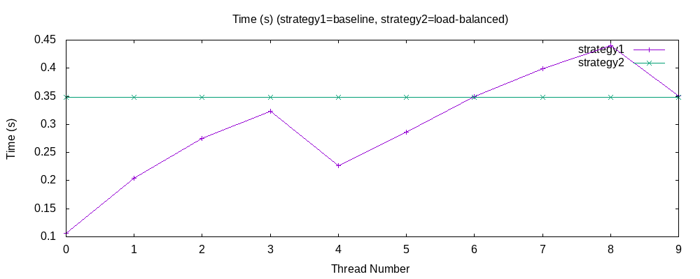

Observation on Total Time taken:
In my case, for larger value of N and t, load-balanced approach (2.c) executed the program faster compared to baseline approach. (1.c)

Chunk Size
I also tried different chunk sizes given to each thread, I noticed that for smaller chunk size, the load balancing was present among the threads. But when chunk size was increased, the load balancing was not fully present, as can be seen below for N=10^6, t=10:
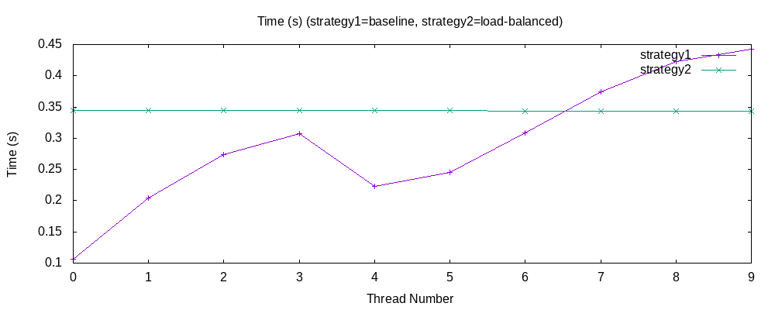
Chunk size=1

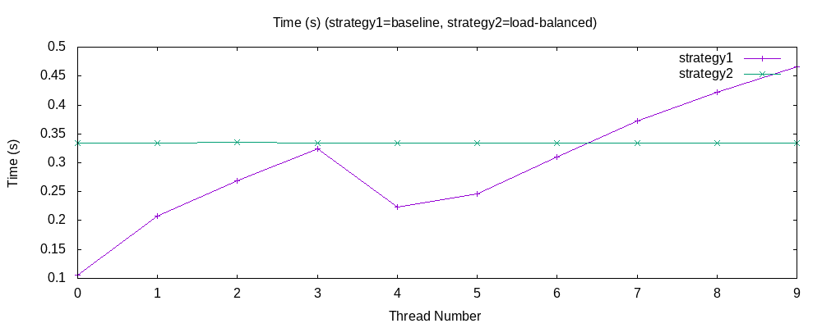
Chunk size=100

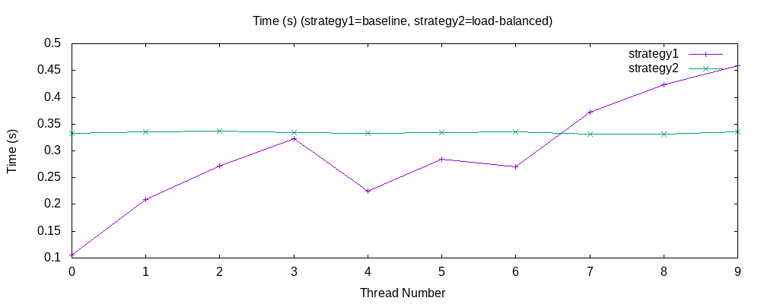
Chunk Size=1000

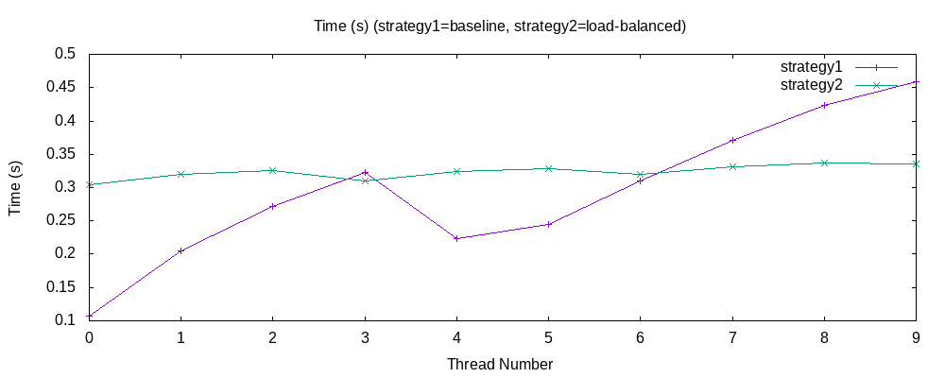
Chunk Size=10000

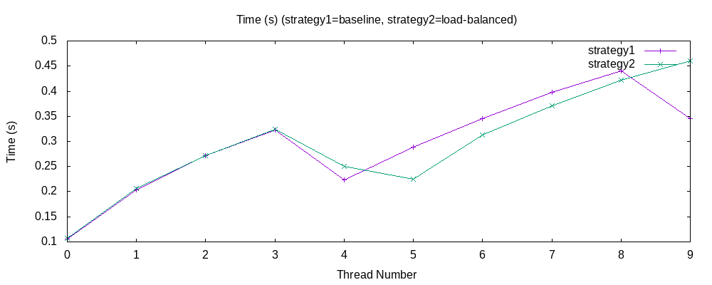
Chunk Size = 100000

Chunk size can be changed in line 106 of file 2.c in src directory.
I have set it to 1 by default.

