DESIGN AND MANUFACTURING
OF A RECTANGULAR RC AIRCRAFT WING
S1210 Airfoil | 1.00 m Span | 0.20 m Chord
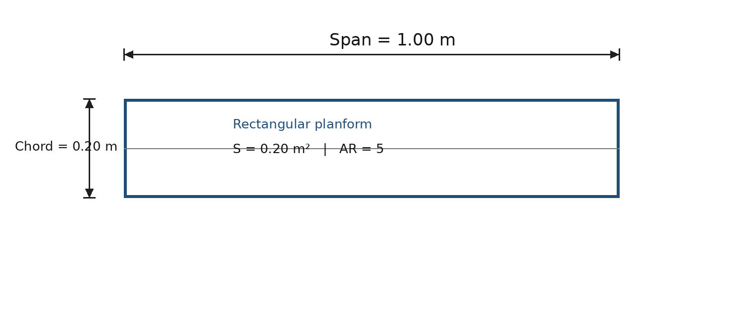
Figure 1. Final wing planform used for the design study (rectangular, unswept).
Prepared from the supplied wing dimensions and the attached low-Reynolds-number airfoil polar comparison. The report documents the design basis, airfoil selection, geometry, aerodynamic interpretation, manufacturing workflow, quality checks, and the remaining verification items required before flight testing.
Item | Status
Wing planform | Defined: 1.00 m span × 0.20 m chord
Planform area | 0.20 m²
Aspect ratio | 5.0
Airfoil | S1210, 12% thickness variant (as labelled in supplied plot)
Manufacturing status | Manufactured (per project description)
Aerodynamic comparison | Supplied polars at Re = 100,000, M = 0, Ncrit = 9
Full-aircraft validation | Pending mass, CG, flight-speed, tail-volume and structural data

1. Executive Summary
A rectangular wing with a span of 1.00 m and a chord of 0.20 m was designed and manufactured for an RC aircraft using the S1210 12% airfoil. The resulting wing has a planform area of 0.20 m², an aspect ratio of 5.0, a taper ratio of 1.0, and a mean aerodynamic chord of 0.20 m. The supplied airfoil comparison was conducted at a common low-Reynolds-number condition of Re = 100,000, with M = 0 and Ncrit = 9.
Within the supplied polar set, the S1210 curve shows strong lift capability and a high lift-to-drag ratio over the useful positive angle-of-attack range. Its Cl curve reaches the highest level among the compared airfoils in the supplied figure, while the Cl/Cd curve also reaches the upper end of the comparison. These characteristics support its selection for a low-speed RC wing where high lift and aerodynamic efficiency are important.
Because the supplied graphs are two-dimensional airfoil polars, they should not be interpreted as direct predictions of the complete finite-wing performance. The finished wing has a moderate aspect ratio of 5, so induced drag, tip effects, surface finish, manufacturing accuracy, and any control-surface discontinuities will reduce the full-wing lift-to-drag ratio relative to the 2-D polar. The wing should therefore be validated with finite-wing analysis and flight testing before the design is treated as fully flight-validated.

2. Design Basis and Requirements
The known design inputs are limited to the wing dimensions, airfoil choice, and the supplied polar comparison. The following requirements are therefore separated into fixed project data and items that must be confirmed from the aircraft-level design.
Parameter | Value / status | Design implication
Span, b | 1.00 m | Sets total lifting span and bending lever arm
Chord, c | 0.20 m | Sets reference chord and Reynolds number for a given speed
Planform | Rectangular, unswept | Uniform chord; simple construction and predictable geometry
Airfoil | S1210, 12% | Moderate thickness with the aerodynamic behaviour shown in the supplied polar
Reference polar Re | 100,000 | Low-Reynolds-number condition appropriate to small RC aircraft studies
Flight mass | Not supplied | Required for wing loading, stall speed and structural sizing
Cruise / stall speed | Not supplied | Required to check whether Re = 100,000 represents the actual operating range
Spar / skin material | Not supplied | Required for structural strength and stiffness verification
Aileron geometry | Not supplied | Required for control effectiveness and structural cut-out checks

3. Wing Geometry and Design Calculations

3.1 Planform area
For a rectangular wing:
S = b c = (1.00)(0.20) = 0.20 m²
Therefore the wing provides 0.20 square metres of lifting planform area.

3.2 Aspect ratio
Aspect ratio is defined as:
AR = b² / S = (1.00)² / 0.20 = 5.0
An aspect ratio of 5 is a moderate value for an RC aircraft wing. It is compatible with a compact 1 m span, while still providing more aerodynamic efficiency than a very short, broad wing. The final induced-drag performance depends on the actual lift coefficient and span efficiency.

3.3 Taper ratio, sweep and mean aerodynamic chord
Quantity | Result
Taper ratio, λ = ct/cr | 1.0 (rectangular wing)
Quarter-chord sweep | 0° (assuming the supplied geometry is unswept)
Mean aerodynamic chord, MAC | 0.20 m
Wing thickness for 12% airfoil | ≈ 0.12 × 0.20 = 0.024 m = 24 mm

3.4 Reynolds-number check
The supplied polar plot is labelled Re = 0.100M, i.e. approximately 100,000. Reynolds number is Re = Vc/ν. Taking c = 0.20 m and a representative air kinematic viscosity ν ≈ 1.5 × 10⁻⁵ m²/s gives:
V ≈ Re ν / c ≈ (100,000)(1.5 × 10⁻⁵)/0.20 ≈ 7.5 m/s ≈ 27 km/h
This is an approximate operating-speed equivalence, not a flight-speed requirement. The actual aircraft speed should be used to calculate the real Reynolds number. The calculation does, however, show that the supplied Re = 100,000 polar is representative of a low-speed model aircraft rather than a high-speed aircraft.

4. Airfoil Selection Study
The supplied figure compares four airfoils: AG25 Bubble Dancer DLG, NACA 2412, S1210 12%, and S1223 RTL. All four are shown under the same nominal polar conditions, which makes the comparison internally consistent. The plotted variables are Cl–α, Cl–Cd, Cm–α, Cl/Cd–α, and Cd–α.
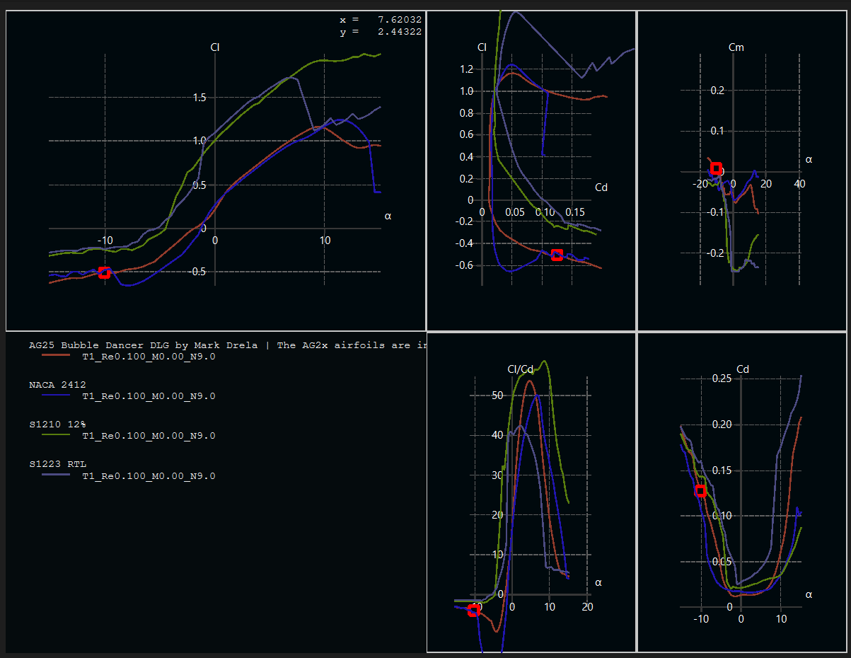
Figure 2. Supplied airfoil polar comparison used for the S1210 selection. The plotted condition is labelled Re = 0.100M, M = 0, N9.0.

4.1 Interpretation of the supplied curves
Polar | Observed behaviour of S1210 in the supplied figure | Design significance
Cl vs α | The S1210 curve reaches the highest lift levels in the positive-α range and maintains high lift before the curve changes behaviour near the upper-angle region. | Supports low-speed lift generation and provides a useful lift margin for take-off / landing design.
Cd vs α | Profile drag is low around the low-to-moderate α region and increases as α becomes large. | Indicates that operation near the middle of the lift curve is preferable to sustained high-α operation.
Cl/Cd vs α | S1210 reaches the highest/near-highest peak in the supplied comparison, in the mid positive-α range. | Indicates favourable 2-D aerodynamic efficiency at the tested Reynolds number.
Cl vs Cd | The S1210 polar extends to high Cl while retaining a comparatively favourable drag trend. | Shows that useful lift can be produced without immediately entering the highest-drag region.
Cm vs α | The S1210 curve is predominantly negative over the plotted operating range. | Indicates a pitching-moment contribution that must be balanced by aircraft trim and tail sizing.

The selection decision is therefore technically consistent with a model-aircraft objective that values high lift and good low-Reynolds-number aerodynamic efficiency. The comparison is meaningful because the airfoils were evaluated under the same plotted conditions; however, the analysis remains 2-D and should be followed by finite-wing analysis.

4.2 Approximate graphical readings
The screenshot does not provide machine-readable data points, so numerical values read from the curves should be treated as approximate. The S1210 curve appears to achieve Cl,max on the order of roughly 1.8–2.0 and a peak Cl/Cd in the mid-to-high 50s. These are graphical estimates from the supplied plot, not a substitute for the original polar data file.

5. Aerodynamic Design Analysis

5.1 Lift generation
The wing lift is estimated from: L = ½ ρ V² S CL. With S = 0.20 m², the lift-producing area is fixed by the chosen planform. For aircraft-level sizing, the required coefficient is therefore:
CL,req = W / (½ ρ V² S)
This expression should be used with the actual aircraft weight and expected flight speed. It is particularly important because the S1210 polar was generated at Re = 100,000, and CL,stall can vary with Reynolds number and surface quality.

5.2 Example at the polar reference condition
Using the approximate speed corresponding to Re = 100,000 (7.5 m/s) and sea-level density ρ ≈ 1.225 kg/m³ gives q ≈ 34.5 Pa and qS ≈ 6.9 N. At CL = 1.5, the idealized 2-D-based lift level would be about 10.3 N (approximately 1.05 kgf); at CL = 1.8, it would be about 12.4 N (approximately 1.26 kgf). These figures are useful only as a scale check; a real aircraft will have 3-D effects, fuselage drag, tail forces, surface imperfections and possibly different operating Reynolds number.

5.3 Stall-speed relation
Once aircraft mass m and an appropriate finite-wing maximum lift coefficient CL,max are known, stall speed can be estimated from:
Vstall = √[2W / (ρ S CL,max)] = √[2mg / (ρ S CL,max)]
This equation should use a conservative finite-wing CL,max rather than the raw 2-D airfoil value from the screenshot.

5.4 Induced drag and aspect-ratio effect
The finite wing generates induced drag according to the approximate relation:
CD,i = CL² / (π e AR)
where e is the span-efficiency factor. For AR = 5, even a reasonably efficient wing with e = 0.8 has CD,i ≈ CL²/12.57. Thus, at CL = 1.0, induced drag alone is approximately 0.080. This illustrates why the 2-D airfoil Cl/Cd peak in the mid-to-high 50s should not be interpreted as the complete aircraft or finite-wing L/D. At the model-aircraft level, induced drag and parasite drag must be combined with the profile drag.

6. Structural Design Considerations
The wing geometry defines the external load-carrying shape, but structural adequacy cannot be demonstrated from the supplied information alone. The spar system, skin/rib material, wing mass, aircraft mass, design load factor, landing loads and control-surface cut-outs are needed for a defensible structural calculation.

6.1 Primary structural load path
- The main spar should carry the dominant bending load generated by lift. Its location should be close to the airfoil region that gives a favourable balance between bending stiffness and skin/rib construction.
- The leading edge and skin contribute to torsional stiffness. A closed or well-braced leading-edge structure is beneficial because the S1210 airfoil has camber and a relatively deep nose region.
- The control-surface region should retain adequate trailing-edge stiffness. Material removed for ailerons or hinges should not interrupt the primary load path or excessively reduce torsional rigidity.
- The wing-to-fuselage attachment should be checked separately for bending, shear, local crushing and pull-out loads.

6.2 Preliminary bending-load relation
For a simple preliminary calculation, if the total lift W is approximated as uniformly distributed over the span, the root bending moment is Mroot ≈ Wb/8. With b = 1 m this becomes Mroot ≈ W/8 in SI units. This is only a preliminary idealization; the real spanwise lift distribution is not uniform, and gust, manoeuvre and landing loads can be higher than steady 1g lift.

7. Manufacturing Process
Because the exact manufacturing material and shop process were not specified in the project brief, the following sequence is written as a general manufacturing record for a 1.0 m × 0.20 m S1210 wing. It can be edited to match the actual construction method (balsa, foam, composite, or mixed construction).
1. Prepare the S1210 airfoil template at the final 200 mm chord. Verify the upper and lower surfaces and identify the datum/chord line before cutting templates.
2. Mark the 1.00 m span and establish the wing centreline, root reference, and tip reference. Because the planform is rectangular, the chord remains 200 mm from root to tip.
3. Prepare ribs or wing stations. Maintain the same chord and airfoil section at each station unless washout or another geometric modification was intentionally incorporated.
4. Position the primary spar(s) consistently along the span. Check that the spar locations remain compatible with the internal airfoil geometry and provide a continuous load path.
5. Assemble the wing from root to tip on a flat jig or verified reference surface. During assembly, monitor chord, incidence, straightness, and symmetry to prevent built-in twist.
6. Install the leading-edge and trailing-edge structure. Maintain the correct S1210 contour and avoid flattening the lower or upper surface during joining.
7. Provide the aileron/control-surface cut-out only after the main wing geometry is fixed. Preserve adequate trailing-edge structure and ensure the hinge line is straight.
8. Finish the surface to a smooth contour. Fill steps, gaps, abrupt joints and leading-edge imperfections because, at low Reynolds number, relatively small surface disturbances can affect boundary-layer behaviour.
9. Balance and inspect the completed wing. Verify total mass, left-right symmetry, spar alignment, control-surface freedom, and the final wing incidence relative to the fuselage reference.

8. Manufacturing Quality-Control Checklist
Check | Suggested acceptance criterion | Purpose
Span | 1000 mm nominal; maintain project tolerance consistently | Ensures planned aspect ratio
Chord | 200 mm nominal at root and tip | Preserves the intended Reynolds/chord geometry
Left-right geometry | Matched within the chosen build tolerance | Prevents unwanted roll/yaw bias
Dihedral / incidence | Same on both sides; measured rather than assumed | Avoids trim and stability problems
Washout | Zero unless intentionally designed; otherwise document exact value | Prevents unknown stall asymmetry
Airfoil contour | Continuous S1210 profile; no sharp steps on lifting surfaces | Reduces avoidable separation / drag
Trailing edge | Straight and adequately supported | Improves control-surface effectiveness and finish
Spar continuity | No unreinforced interruptions in the primary load path | Protects bending strength
Control surfaces | Full free movement, no binding, adequate clearance | Ensures commanded control response
Mass and balance | Measure and record after finishing | Supports aircraft CG and wing-loading calculations

9. Verification and Flight-Test Plan
Before flight testing, the design should be verified progressively. The following sequence keeps aerodynamic, structural and control uncertainties separated.
1. Dimensional inspection: verify span, chord, planform symmetry, incidence and any dihedral/washout values.
2. Static structural test: apply a controlled load representative of the intended test envelope, with suitable margin and without exceeding the wing material limits.
3. Control test: verify aileron free movement, neutral position, direction, servo endpoints and absence of binding at full deflection.
4. Low-risk initial flight: use conservative control throws and an operating condition with adequate altitude for trim correction.
5. Record behaviour: trim angle, stall onset, roll response, pitch trim and any visible aeroelastic deformation should be recorded.
6. Update the aircraft model using measured mass and flight observations. If performance differs substantially from the 2-D prediction, investigate Reynolds number, surface finish, wing incidence, CG and 3-D induced-drag effects before changing the airfoil.

10. Limitations and Required Additional Data
The current report is sufficient to document the wing geometry and the airfoil-selection rationale from the supplied evidence, but it is not a complete aircraft-level sizing report. The following data are required to close the remaining calculations:
- Complete aircraft mass and target take-off mass.
- Target cruise speed, expected minimum speed, and intended operating envelope.
- Wing incidence, dihedral, sweep, and any washout actually manufactured.
- Spar number, spar location, spar dimensions, material, rib spacing and skin material.
- Aileron span, chord, hinge position and maximum deflection.
- Aircraft centre of gravity range and tail geometry.
- Actual airfoil polar data (CSV or XFOIL/XFLR5 export) if precise numerical performance plots are required.

11. Conclusion
The final wing is a 1.00 m span, 0.20 m chord rectangular wing with 0.20 m² planform area and aspect ratio 5.0, using the S1210 12% airfoil. The supplied low-Reynolds-number polar comparison supports the airfoil choice because S1210 provides strong lift and favourable 2-D aerodynamic efficiency within the tested range. The 200 mm chord and 100,000 Reynolds-number analysis correspond approximately to a 7.5 m/s airspeed under standard-air assumptions, making the selected polar relevant to low-speed RC operation.
The manufacturing design is straightforward for a rectangular wing, but structural and aircraft-level performance cannot be confirmed from the available information alone. In particular, the finite-wing induced-drag penalty, actual wing loading, stall speed, structural margins and control-surface effectiveness must be calculated from the completed aircraft data. The recommended next step is therefore a finite-wing analysis followed by static load testing and a controlled flight-test programme.

References and Technical Sources
- Abbott, I. H., and von Doenhoff, A. E., Theory of Wing Sections, Dover Publications, 1959.
- Anderson, J. D., Fundamentals of Aerodynamics, McGraw-Hill, standard editions.
- Drela, M., XFOIL: An Analysis and Design System for Low-Reynolds-Number Airfoils, in Low Reynolds Number Aerodynamics, Springer, 1989.
- Supplied project material: airfoil polar comparison screenshot provided with the wing design brief; plotted condition labelled Re = 0.100M, M = 0, N9.0.
Document note: Values explicitly calculated in this report are based on the supplied 1.00 m × 0.20 m geometry. Values read visually from the provided polar screenshot are identified as approximate.

