**Brand Name:**

**Restro-pedia**

**Business Functions & Transcations:**

* To find the Best Rated Thai Restaurant around the University of Maryland.
* To find the Indian Restaurant with the best Value for money and having Free Wifi in College Park
* To list all the Restaurants near the University of Maryland that are open 24/7 and also have outdoor seating.
* To find all the Multi-cuisine Restaurants having door delivery or at a distance less than 5 miles from the Robert H. Smith School of Business.
* To find the Restaurant in College Park which is providing the Best Service and also has car parking.
* To find the Chinese Restaurant near the University of Maryland with the most number of customer reviews.
* To find the Mexican Restaurant in College Park having the Best ambience and providing any offer.
* To find the Best Rated American Restaurant near the University that is offering 10% or more off and has car parking available.

**ER Schema:**

Entities, Attributes and Primary Keys

Restaurant (**restaurantID**, name, phoneNo, address, distance, doorDelivery, carParking,

outdoorSeating, freeWifi, openingHours, -weekDays, - weekends)

Customer (**customerID**, customerName, -firstName, -middleName, -lastName, location,

gender)

Offers (**offerID**, description)

Cuisine (**cuisineID**, cuisineName)

Relationships, Attributes, Degrees, Participating Entities and Constraints

Provides(validity) : binary relationship

1 Restaurant to 0 or more Offers

1 Offer to 0 or more Restaurants

Reviews (ambience, foodQuality, service, valueForMoney, =overallRating, comments) :

binary relationship

1 Customer to 0 or more Restaurants

1 Restaurant to 0 or more Customers

Sells : binary relationship

1 Cuisine to 0 or more Restaurants

1 Restaurant to 1 or more Cuisines

**E-R Diagram:**

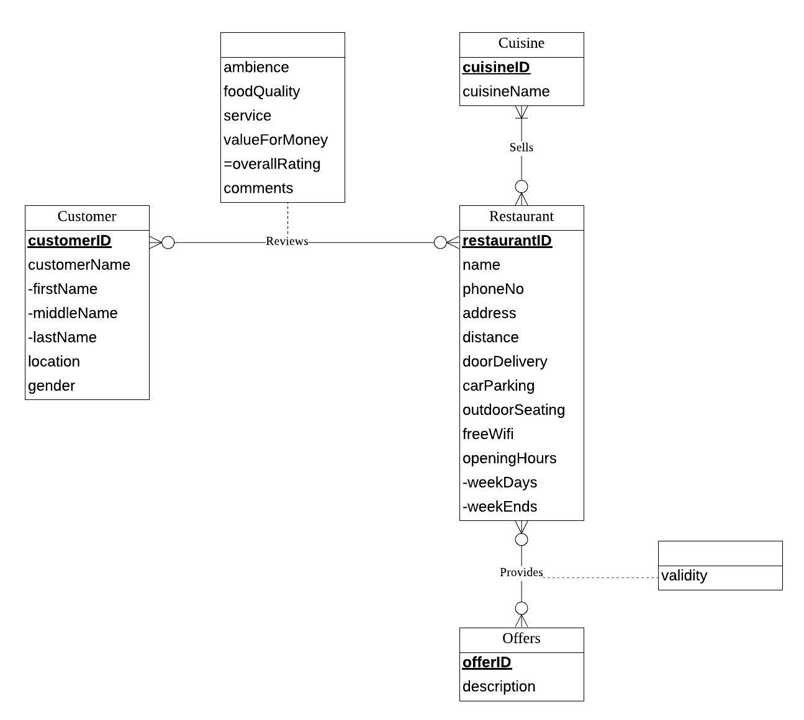

**Mission Statement:**

To provide a perfect online platform for people to find the best restaurant of their choice near the University of Maryland, based on the facilities available, offers provided and customer reviews.

**Mission Objectives:**

* The system shall assist the users in restaurant search near the University based on the cuisines available in each restaurant.
* The system shall help the users filter their restaurant search by parameters like distance from the Smith School, location, opening hours and availability of facilities like car parking, free wifi, outdoor seating and door delivery.
* The system shall provide a review section where the users can check the overall rating/comments and individual ratings for ambience, value for money, quality of food and service which would greatly help customers choose a particular restaurant.
* The system shall provide users information on various offers provided by each restaurant along with their validity.

**Relations:**

Restaurant (**restaurantID**, name, phoneNo, address, distance, doorDelivery,

carParking, outdoorSeating, freeWifi, openingHoursWeekdays,

openingHoursWeekends)

Customer (**customerID**, customerFirstName, customerMiddleName,

customerLastName, location, gender)

Offers (**offerID**, description)

Cuisine (**cuisineID**, cuisineName)

Provides (***restaurantID***, ***offerID***, validity)

Sells (***restaurantID***, ***cuisineID***)

Reviews (***restaurantID***, ***customerID***, ambience, foodQuality, service,

valueForMoney, comments)

**Functional Dependency:**

restaurantID 🡪 name, phoneNo, address, distance, doorDelivery, carParking,

outdoorSeating, freeWifi, openingHoursWeekdays,

openingHoursWeekends

customerID 🡪 customerFirstName, customerMiddleName,

customerLastName, location, gender

offerID 🡪 description

cuisineID 🡪 cuisineName

restaurantID, offerID 🡪 validity

restaurantID, cuisineID 🡪

restaurantID, customerID 🡪 ambience, foodQuality, service, valueForMoney,

comments

**Normalizaton:**

Restaurant (**restaurantID**, name, phoneNo, address, distance, doorDelivery,

carParking, outdoorSeating, freeWifi, openingHoursWeekdays,

openingHoursWeekends) = 3NF

Customer (**customerID**, customerFirstName, customerMiddleName,

customerLastName, location, gender) = 3NF

Offers (**offerID**, description) = 3NF

Cuisine (**cuisineID**, cuisineName) = 3NF

Provides (***restaurantID***, ***offerID***, validity) = 3NF

Sells (***restaurantID***, ***cuisineID***) = 3NF

Reviews (***restaurantID***, ***customerID***, ambience, foodQuality, service,

valueForMoney, comments) = 3NF

**Business rules:**

1. When a restaurant is deleted from the database, the corresponding offers provided information should be deleted from the database.
2. When the information on a restaurant is changed in the database, the corresponding offers provided information should be changed accordingly.
3. When an offer is no longer available in the database, the corresponding offers provided information should be deleted from the database.
4. When an offer information is changed in the database, the corresponding offers provided information should be changed accordingly.
5. When a restaurant is deleted from the database, the corresponding sells cuisines information should be deleted from the database.
6. When the information on a restaurant is changed in the database, the corresponding sells cuisines information should be changed accordingly.
7. When a cuisine is no longer available in the database, the corresponding sells cuisines information should be deleted from the database.
8. When the information on a cuisine is changed in the database, the corresponding sells cuisines information should be changed accordingly.
9. When a restaurant is deleted from the database, the corresponding reviews information should be deleted from the database.

[R10] When a restaurant information is changed in the database, corresponding

reviews information should be changed too.

[R11] When a customer is deleted from the database, corresponding

reviews information should be deleted from the database.

[R12] When a customer information is changed in the database, corresponding

reviews information should be changed too.

**Referential integrity:**

|  |  |  |  |  |  |  |  |
| --- | --- | --- | --- | --- | --- | --- | --- |
| Relation | Foreign Key | Base Relation | Primary Key | Business Rule | Constraint: ON DELETE | Business Rule | Constraint: ON UPDATE |
| Provides | restaurantID | Restaurant | restaurantID | R1 | CASCADE | R2 | CASCADE |
| Provides | offerID | Offers | offerID | R3 | CASCADE | R4 | CASCADE |
| Sells | restaurantID | Restaurant | restaurantID | R5 | CASCADE | R6 | CASCADE |
| Sells | cuisineID | Cuisine | cuisineID | R7 | CASCADE | R8 | CASCADE |
| Reviews | restaurantID | Restaurant | restaurantID | R9 | CASCADE | R10 | CASCADE |
| Reviews | customerID | Customer | customerID | R11 | CASCADE | R12 | CASCADE |

**Sample Data:**

Restaurant (**restaurantID (1001)**, name (Krazi Kebob), phoneNo (3018645150),

address (4427, Lehigh Rd), Distance (0.6 miles), doorDelivery (Y),

carParking (Y), outdoorSeating (N), freeWifi (Y),

openingHoursWeekdays (11am - 10pm),

openingHoursWeekends (11am – 10pm))

Customer (**customerID (10001)**, customerFirstName (Mark),

customerMiddleName (Null), customerLastName (Thomas),

location (Laurel), gender (Male))

Offers (**offerID (101)**, description (20% cash back))

Cuisine (**cuisineID (01, 02, 03)**, cuisineName (Mexican, Indian, Pakistani))

Provides (***restaurantID (1001)***, ***offerID (101)***, validity (12-31-2018))

Sells (***restaurantID (1001, 1001, 1001)***, ***cuisineID (01, 02, 03)***)

Reviews (***restaurantID (1001)***, ***customerID (10001)***, ambience (4), foodQuality

(5), service (5), valueForMoney (5), comments (Food is good and fresh.

The service is quick))