**Read-me File**

* Our **Data Sources** include individual instances from **Yelp, Trip Advisor and RetailMeNot.**
* **Sheet 1** answers the Business Transaction **‘Which is the Best Rated Thai Restaurant around the University of Maryland ?’**

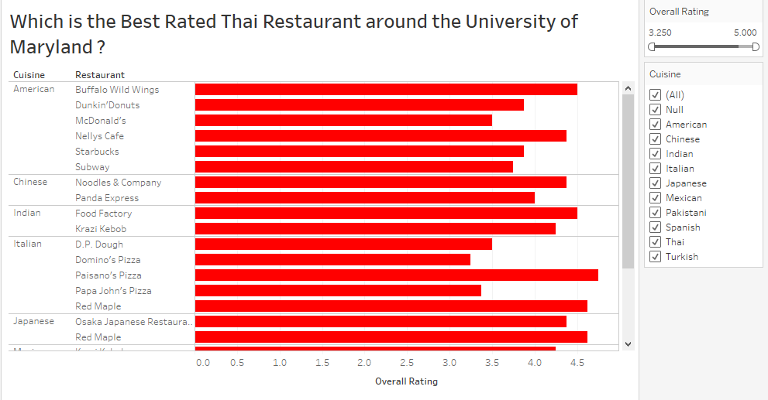

**After selecting ‘Mexican’ Cuisine from the Cuisine filter and increasing the value in the ‘Overall Rating’ scroll bar, we get the result of our Business Transcation as shown below.**

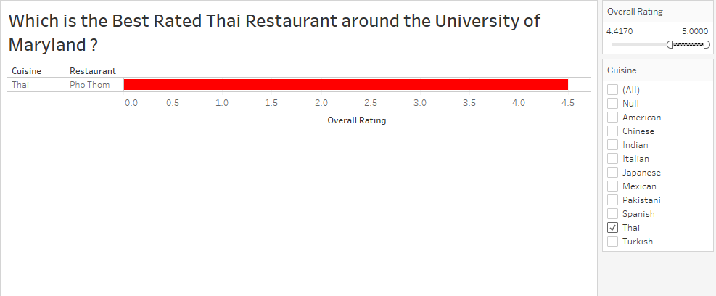

* **Sheet 2** answers the Business Transaction **‘Which Indian Restaurant in College Park has the Best Value for Money and also has free wifi ?’**

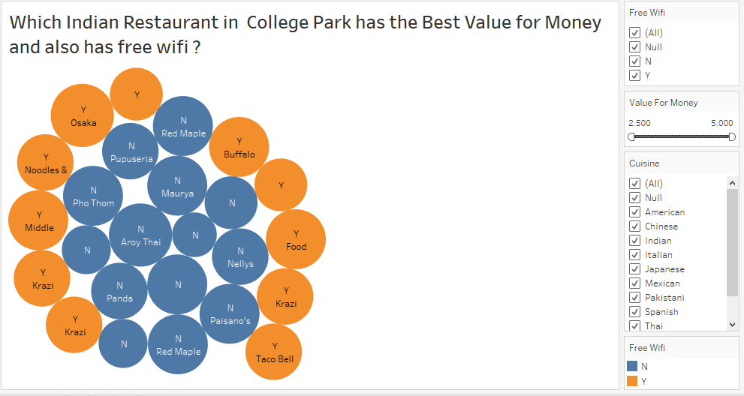

**After selecting ‘Indian’ Cuisine from the Cuisine filter, ‘Y’ from the Free Wifi filter and increasing the value in the ‘Value For Money’ scroll bar, we get the result of our Business Transcation as shown below.**

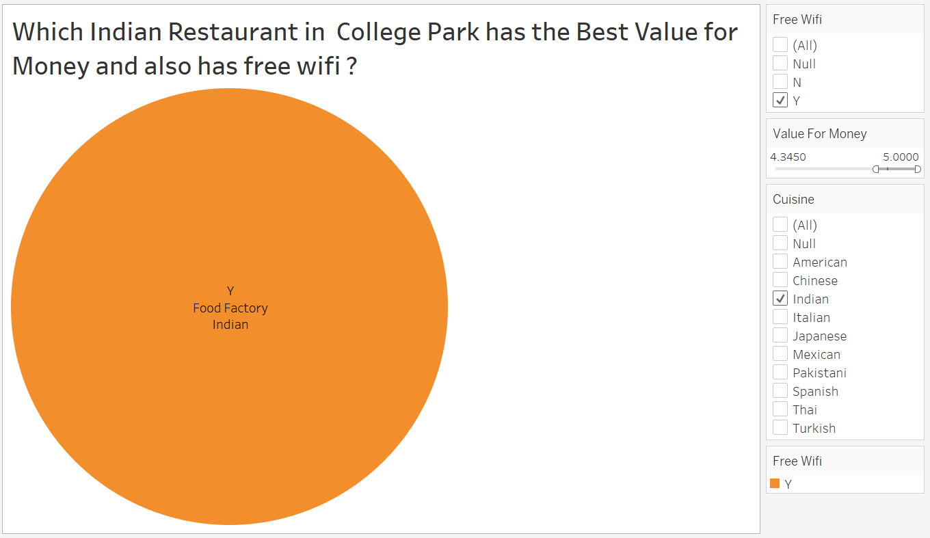

* **Sheet 3** answers the Business Transaction **‘Which Restaurant in College Park provides the Best Service and also has the facility of Car parking ?’**

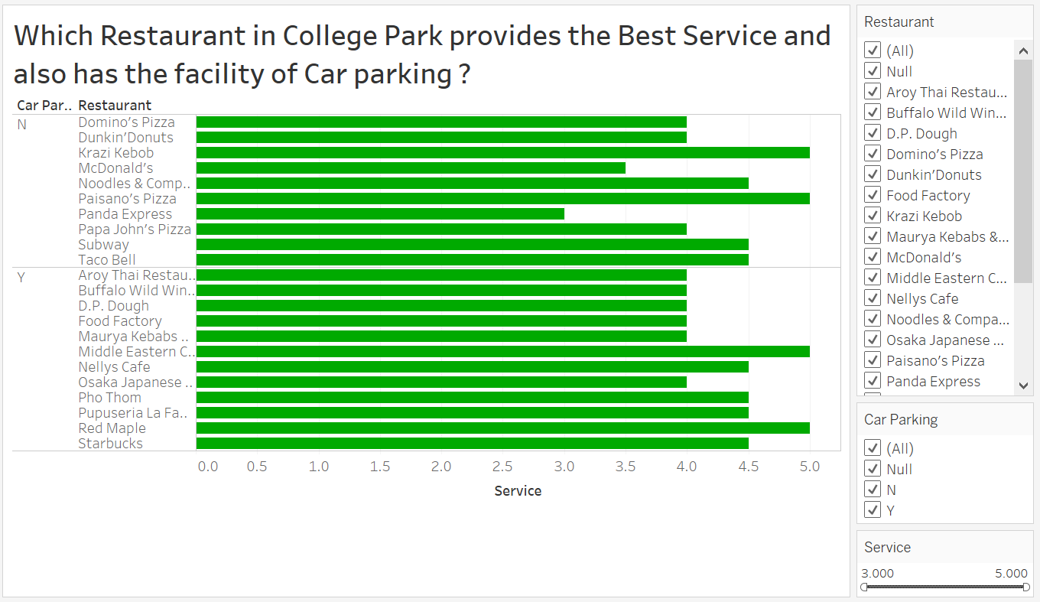

**After selecting ‘Y’ from the Car Parking filter and increasing the value in the ‘Service’ scroll bar, we get the result of our Business Transcation as shown below.**

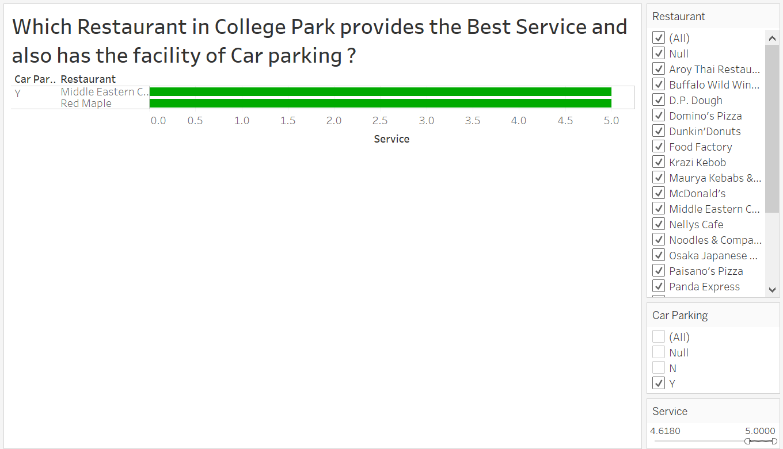

* **Sheet 4** answers the Business Transaction **‘Which Mexican Restaurant has the Best Ambience and is Providing any Offer ?’**

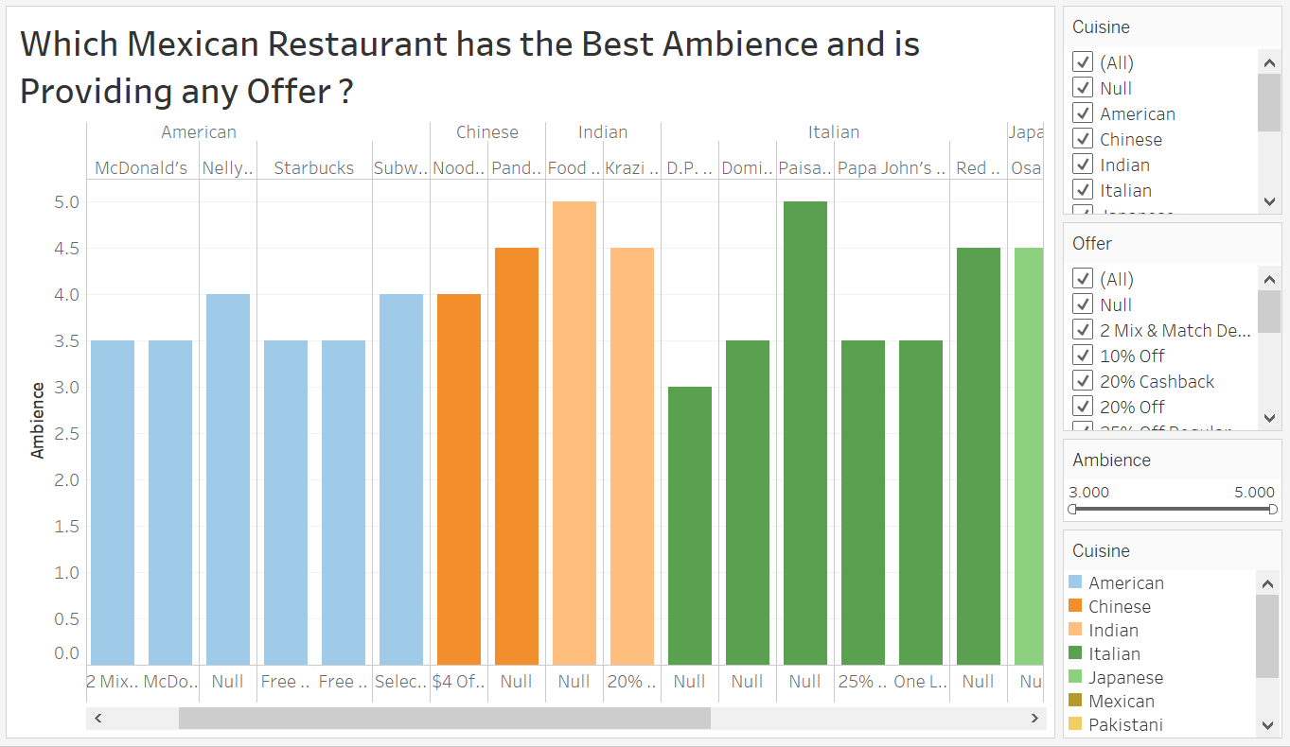

**After selecting ‘Mexican’ Cuisine from the Cuisine filter, de-selecting ‘Null’ from the Offer filter and increasing the value in the ‘Ambience’ scroll bar, we get the result of our Business Transcation as shown below.**

