SUMMER TRAINING/INTERNSHIP

PROJECT REPORT
(Term June-July 2025)

(Telco Customer Churn Prediction)

Submitted by

Anmol Chadgal, Md Farhan Ahmad, Prashant Singh
Registration Number: 12313347, 12317236, 12322155

Course Code: PETV79

Under the Guidance of

Mahipal Singh
Uid: 32137

(Name of mentor with designation)

School of Computer Science and Engineering

CERTIFICATE

This is to certify that the project report titled “Telco Customer Churn Prediction”has been successfully completed under supervision of Mahipal Singh in partial fulfilment of the requirements for summer training/internship by Anmol Chadgal, Md Farhan Ahmad, Prashant Singh.
Supervisor
Mahipal Singh
Name: Anmol Chadgal, Md Farhan Ahmad, Prashant Singh.
Designation: B.Tech CSE

ACKNOWLEDGEMENT

I Anmol Chadgal, Md Farhan Ahmad, Prashant Singh, would like to express my heartfelt gratitude to my project guide, Mahipal Singh, Professor, for their consistent guidance, encouragement, and feedback during this internship. I also thank the School of Computer Science and Engineering at Lovely Professional University for providing the platform and environment for learning and innovation.

TABLE OF CONTENTS
- CHAPTER 1: INTRODUCTION
  - Company profile
  - Overview of training domain
  - Objective of the project
- CHAPTER 2: TRAINING OVERVIEW
  - Tools & technologies used
  - Areas covered during training
  - Daily/weekly work summary
- CHAPTER 3: PROJECT DETAILS
  - Title of the project
  - Problem definition
  - Scope and objectives
  - System Requirements
  - Architecture Diagram (if any)
  - Data flow / UML Diagrams
- CHAPTER 4: IMPLEMENTATION
  - Tools used
  - Methodology
  - Modules / Screenshots
  - Code snippets (if needed)
- CHAPTER 5: RESULTS AND DISCUSSION
  - Output / Report
  - Challenges faced
  - Learnings
- CHAPTER 6: CONCLUSION
  - Summary

CHAPTER 1: INTRODUCTION

🔹 Company Profile
This is an academic project undertaken during the summer internship period under the supervision of faculty Mahipal Singh from the School of Computer Science and Engineering, Lovely Professional University. No external corporate entity was involved; the focus was on self-driven learning and practical implementation of machine learning techniques on a real-world dataset.

🔹 Overview of Training Domain

The domain of this training was machine learning and data science, particularly in the context of customer retention and business analytics. The training included understanding data, performing preprocessing, visualizing insights, and building models for prediction. The project was executed using tools such as Python, pandas, seaborn, scikit-learn, and Streamlit.

🔹 Objective of the Project
The objective of the project is to develop a predictive system that can forecast whether a telecom customer is likely to churn. Early identification of at-risk customers allows businesses to take preemptive measures to retain them. The solution includes data visualization, model development, hyperparameter tuning, evaluation, and deployment.

CHAPTER 2: TRAINING OVERVIEW

🔹 Tools & Technologies Used
- Programming Language: Python 3.x
- Libraries: pandas, numpy, seaborn, matplotlib, scikit-learn
- Deployment: Streamlit
- IDE: Jupyter Notebook, Visual Studio Code

🔹 Areas Covered During Training
- Data acquisition and cleansing
- Exploratory Data Analysis (EDA)
- Label Encoding and Feature Engineering
- Machine learning model building
- Model evaluation and optimization
- Deployment of ML model using Streamlit

🔹 Weekly Work Summary

Activities
Dataset exploration, cleaning, label encoding
EDA, visualization, feature correlation
Model building and evaluation
Hyperparameter tuning and Streamlit app creation

CHAPTER 3: PROJECT DETAILS

🔹 Title of the Project

Telco Customer Churn Prediction

🔹 Problem Definition
Customer churn is one of the biggest challenges in the telecom industry. The aim of this project is to build a machine learning model that can accurately predict whether a customer is likely to discontinue service based on their usage patterns and account data.

🔹 Scope and Objectives
- Analyze telecom data for patterns of churn
- Train and evaluate ML models
- Deploy a user-friendly prediction app

🔹 System Requirements
- Python 3.x
- Jupyter Notebook or IDE
- Libraries: pandas, scikit-learn, matplotlib, seaborn, Streamlit

🔹 Architecture Diagram (Conceptual)

┌──────────────┐
│ User Inputs │
└────┬───── ───┘
↓
┌──────────────┐
│ Data Preproc │
└────┬───── ──┘
↓
┌───────────────────┐
│ ML Model (Trained). │
└────┬────────── ───┘
↓
┌─────────────┐
│ Prediction │
└─────────────┘

User Input → Preprocessing → Trained Model → Prediction Output (Streamlit)

Data Flow Diagram
Customer Data → Feature Engineering → Model Inference → Output Prediction

CHAPTER 4: IMPLEMENTATION

🔹 Tools Used
- Jupyter Notebook
- Python
- Streamlit

🔹 Methodology
- Load and clean dataset
- Encode categorical variables
- Visualize key insights
- Train models
- Optimize using GridSearchCV
- Save the best model
- Build UI with Streamlit

🔹 Modules / Screenshots
- Screenshot 1: Data Visualization (Churn vs Tenure, Internet Service vs Churn, etc.)
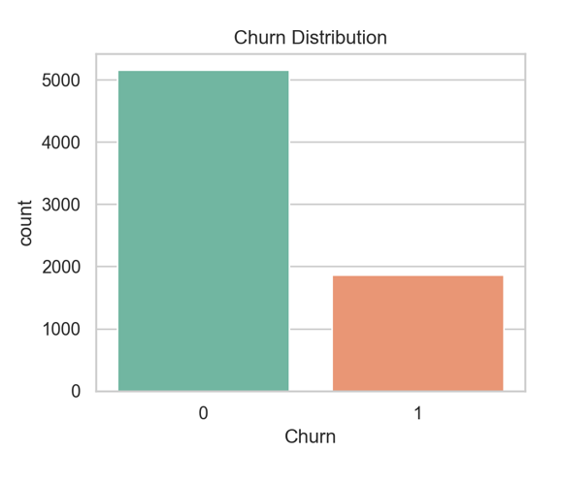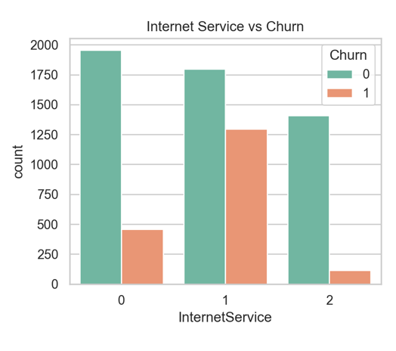
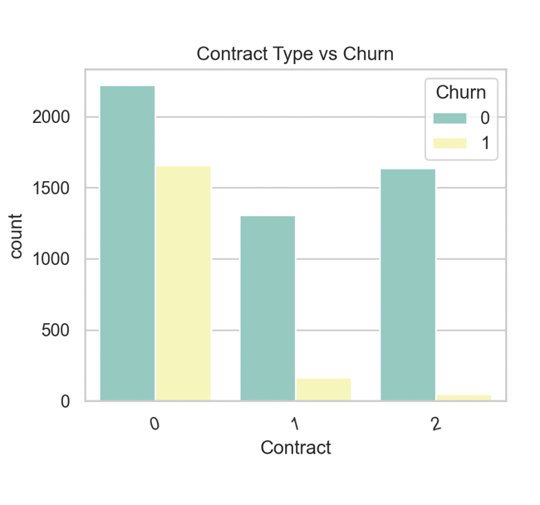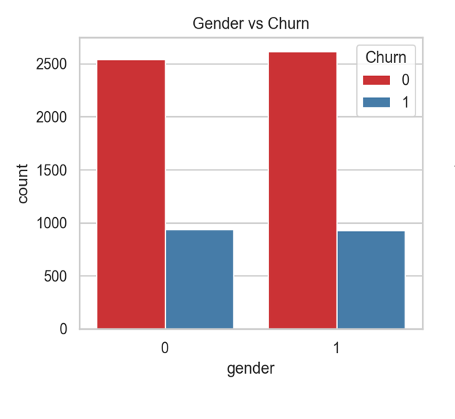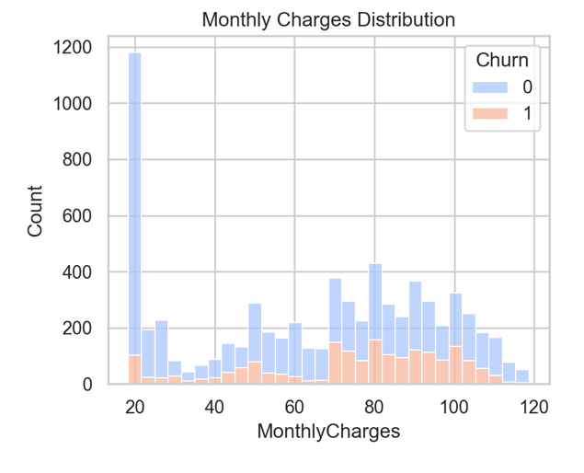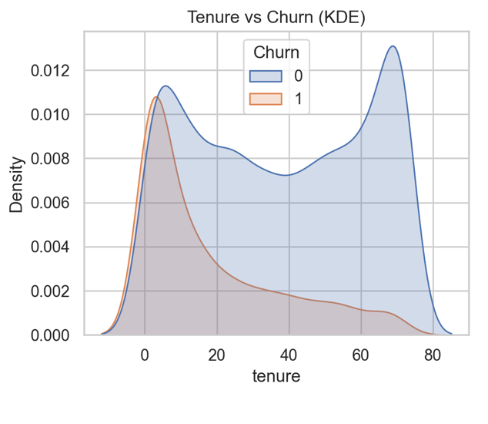
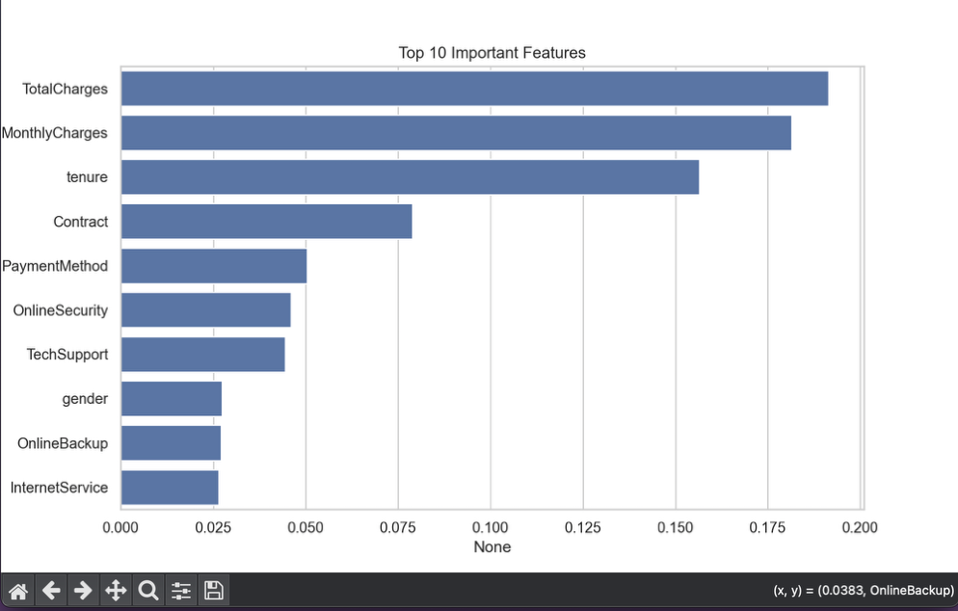

- Screenshot 2: Streamlit UI interface
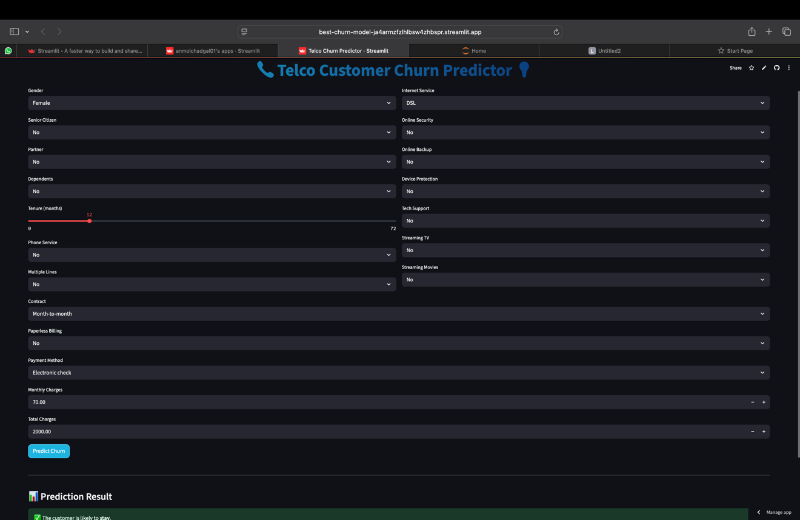
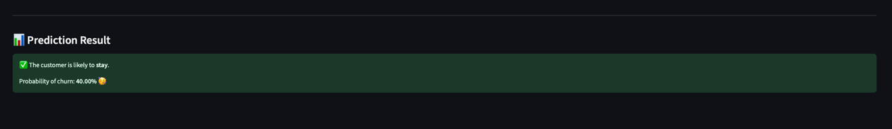

CHAPTER 5: RESULTS AND DISCUSSION

🔹 Output / Report
- Accuracy:
  - Logistic Regression: ~80%
  - Random Forest: ~83%
  - SVM: ~81%
- Best Model: Random Forest with tuned hyperparameters

🔹 Challenges Faced
- Class imbalance in churn distribution
- Convergence warnings in Logistic Regression
- Handling missing or corrupt Total Charges entries

🔹 Learnings
- Full machine learning pipeline development
- Practical feature encoding
- Streamlit app deployment
- Importance of data cleaning and tuning

CHAPTER 6: CONCLUSION

🔹 Summary
The Telco Customer Churn Prediction project successfully achieved its goal of designing and deploying a machine learning model to predict the likelihood of customer churn in a telecom company. Throughout the training period, various aspects of data science were explored — from data preprocessing, visualization, and feature engineering, to training multiple machine learning algorithms and deploying the final model using a user-friendly Streamlit web interface.
This end-to-end project enabled a deeper understanding of how predictive modeling can be applied in real-world scenarios, especially in industries such as telecommunications where customer retention is crucial.

🔹 Key Accomplishments
- Developed a complete ML pipeline using Python and scikit-learn.
- Analyzed telecom data using data visualization techniques.
- Identified relevant features impacting customer churn through feature correlation.
- Trained and evaluated multiple models (Logistic Regression, Random Forest, SVM).
- Tuned hyperparameters using GridSearchCV for optimal performance.
- Deployed the final model using Streamlit for real-time predictions.

🔹 Future Scope
The current model can be further enhanced by:
- Incorporating advanced models like XGBoost or Neural Networks.
- Using time-based features or customer behavioral data (e.g., usage logs).
- Implementing alerts or integration into a CRM system for retention actions.
- Adding automated retraining and continuous deployment (MLOps concepts).

