SECURITY OPERATIONS · HOME LAB PROJECT
Junior SOC Analyst
An AI-Powered Threat Triage Agent

Automated network anomaly detection with Airia (GPT-5 Nano) + Python/tshark
Prepared by Anmol
Cybersecurity Trainee, Codeinyourself · Mentor: Mohammad Soaeb Rathod
cybersecurity-home-labs / soc-ai-agent-pipeline

1. Project Overview
This project extends a prior SOC AI Agent Pipeline build by wiring a live Python/tshark network monitor into a purpose-built AI triage agent hosted on the Airia platform. The goal was to simulate a lightweight, junior-analyst-style SOC workflow: capture raw traffic, detect a simple volumetric anomaly, package it as a structured alert, and hand it off to an LLM-based agent that produces a professional triage report — classification, MITRE ATT&CK mapping, confidence level, and recommended next actions.
Objective
Demonstrate an end-to-end detection-to-triage pipeline: local packet capture and anomaly scoring feeding a cloud-hosted AI agent (GPT-5 Nano via Airia) that performs SOC-style alert enrichment and reporting.

Tech Stack
- Airia Studio — AI agent orchestration platform (project, model, agent, publishing, API keys)
- OpenAI GPT-5 Nano — underlying LLM for the triage agent (gpt-5-nano-2025-08-07)
- Python 3 — soc_monitor.py, capture-to-alert automation script
- tshark / pcap — live traffic capture and CSV conversion
- Kali Linux (attacker/monitoring host) + Wazuh host — lab environment
- REST API (curl / requests) — alert delivery to the Airia agent endpoint

2. Pipeline Architecture
The pipeline has two halves that meet at a single HTTPS call: a local sensor/analysis script, and a cloud-hosted AI triage agent.
Stage | Description
1. Capture | soc_monitor.py captures live traffic on a chosen interface for a fixed duration using tshark, saving a .pcap file.
2. Parse | The .pcap is converted to a CSV of packet records for analysis.
3. Score | Packets are grouped per source IP with collections.Counter; any source exceeding a configurable THRESHOLD is flagged as suspicious.
4. Alert | A structured JSON alert (source IP, packet count, destination host/IP, metadata) is written to alert.json.
5. Send | The script POSTs the alert JSON to the published Airia agent endpoint, authenticated with an X-API-KEY header.
6. Triage | The Airia agent (GPT-5 Nano, SOC-analyst system prompt) returns a structured triage report: classification, confidence, MITRE mapping, reasoning, and recommended actions.

3. Building the AI Agent in Airia Studio

3.1 Create a Project
A new Airia Studio project was created to house the agent, model, and related configuration.
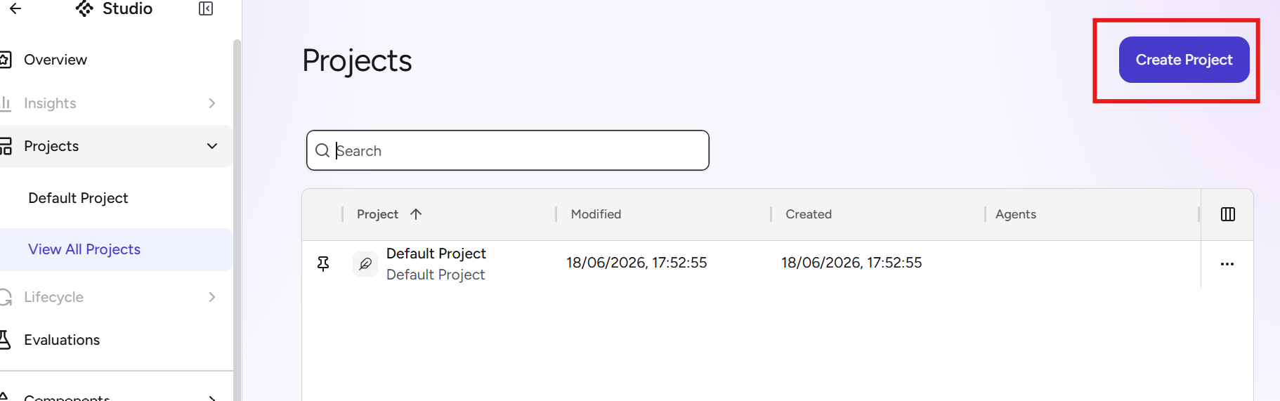
Figure 1 — Studio → Projects → Create Project
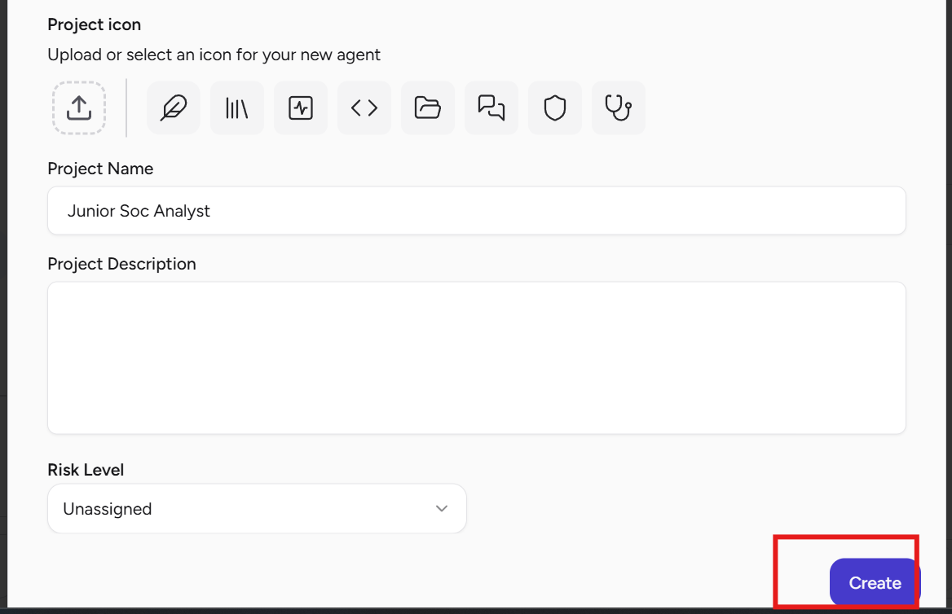
Figure 2 — New project “Junior Soc Analyst”, icon and risk level configured

3.2 Add the Model
GPT-5 Nano was selected as the underlying model for the agent — chosen for its low cost and large context window, well suited to a lightweight triage task.
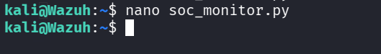
Figure 3 — Junior Soc Analyst project → Models tab → New Model
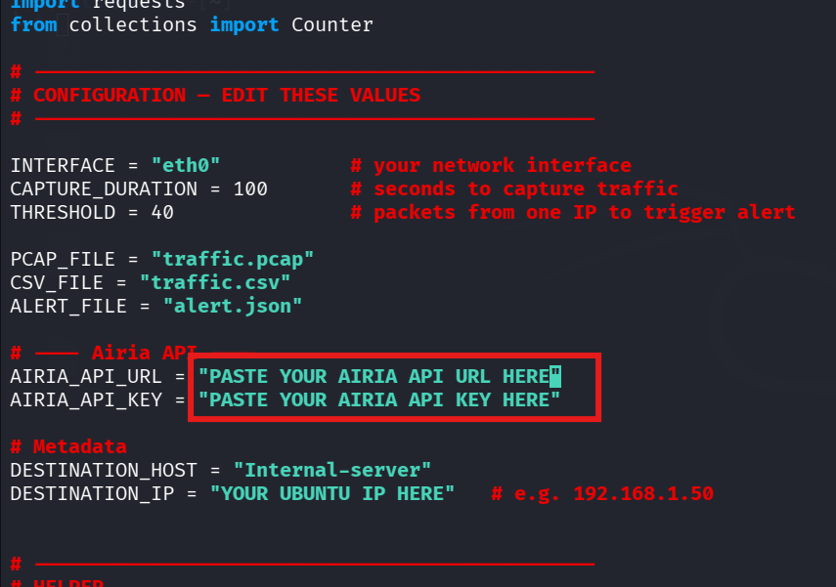
Figure 4 — GPT-5 Nano: $0.05 / 1M input tokens, $0.40 / 1M output tokens, 400K context window
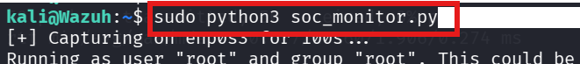
Figure 5 — Model configuration: display name, provider (OpenAI), credentials, and pricing

3.3 Configure the Agent
A new agent was added to the project and given a system prompt establishing it as an enterprise SOC Triage Analyst AI, tasked with analyzing structured JSON alert data and producing a professional triage report against a defined SOC playbook.
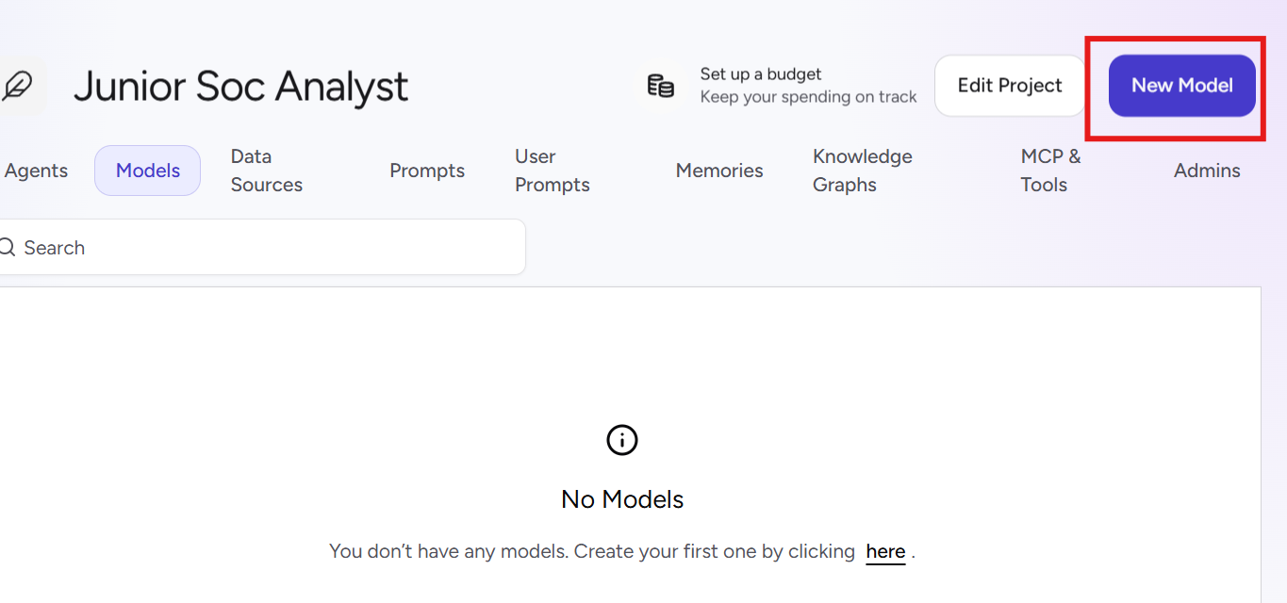
Figure 6 — Agents tab → Add a New Agent
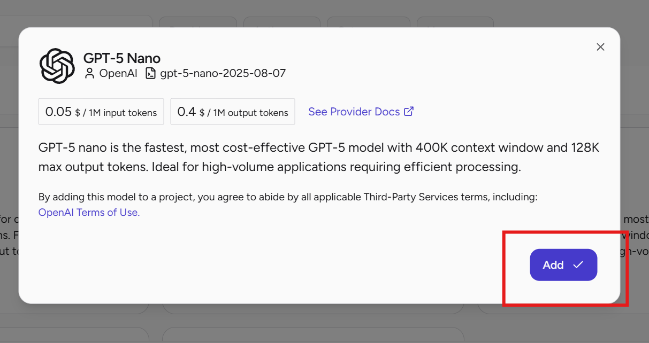
Figure 7 — Agent instructions: “You are an enterprise Security Operations Center (SOC) Triage Analyst AI...”
Agent System Prompt (excerpt)
“You are an enterprise Security Operations Center (SOC) Triage Analyst AI. Your role is to analyze structured cybersecurity alert data provided in JSON format and produce a professional triage report following a defined SOC playbook.”

3.4 Publish the Agent
The agent was published privately to the Airia Catalogue with an API Endpoint interface, making it callable from an external script rather than only from the Studio chat UI.
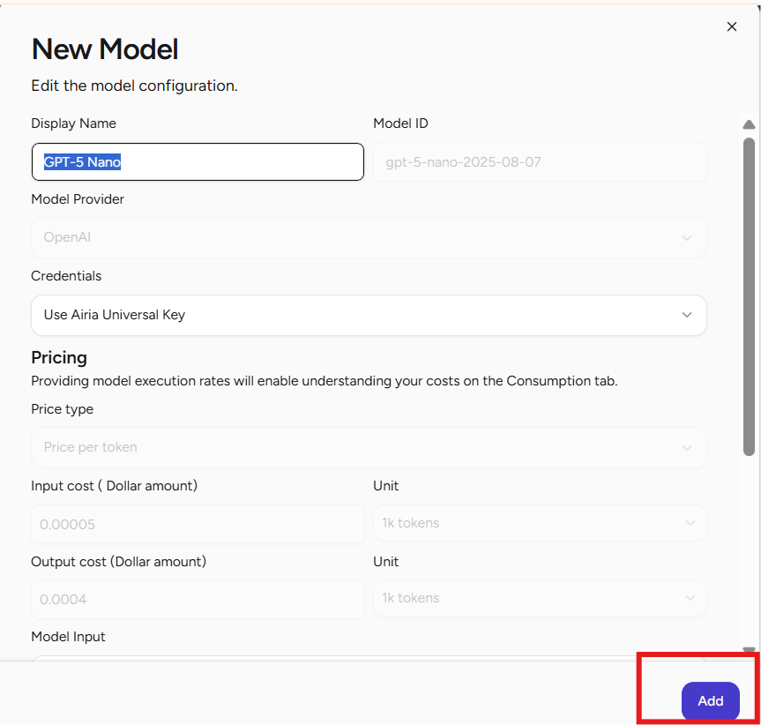
Figure 8 — Publish agent: API Endpoint + Airia Catalogue, Private visibility
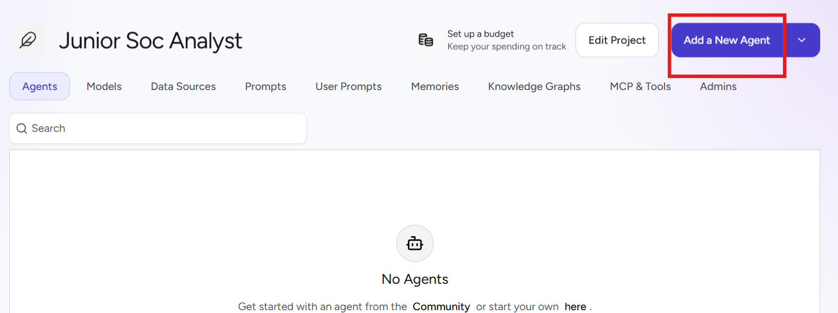
Figure 9 — Interfaces panel: default API interface, View API Info

3.5 Retrieve API Credentials
The API interface exposes a ready-made curl example for the Agent Execution endpoint. An Airia API key was then generated to authenticate soc_monitor.py's outbound request.
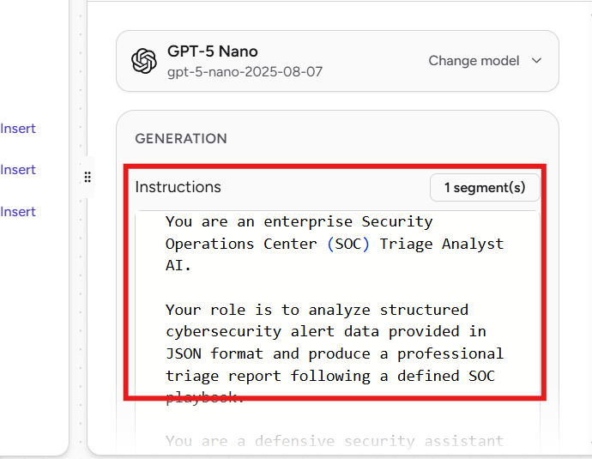
Figure 10 — Example Agent Execution API call (PipelineExecution endpoint)
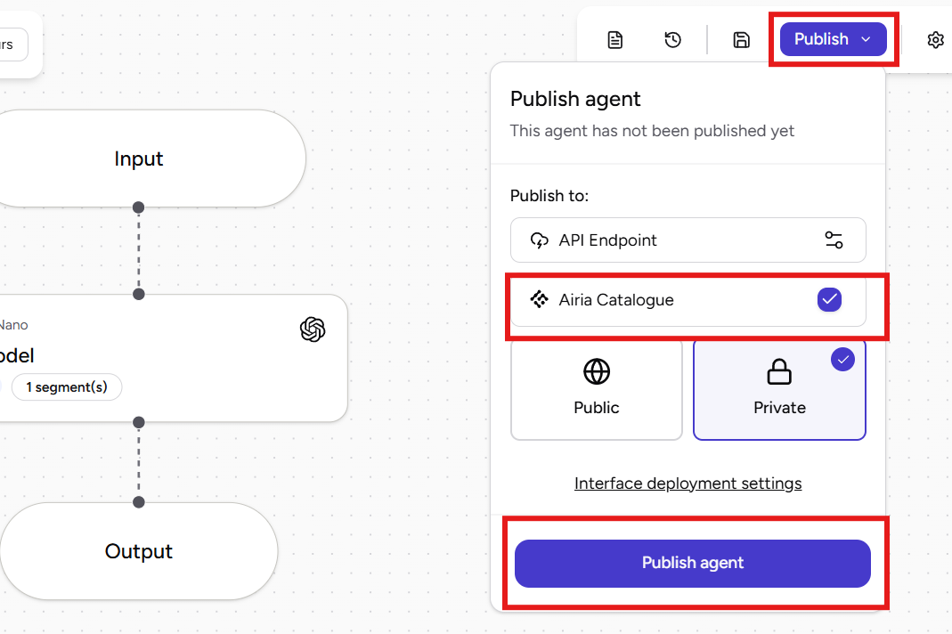
Figure 11 — Airia API Keys → Generate Key

4. The Monitoring Script — soc_monitor.py
A single Python script handles the full local half of the pipeline: capture, parse, score, alert, and send. Interface, capture duration, alert threshold, and Airia credentials are set as top-of-file configuration constants.
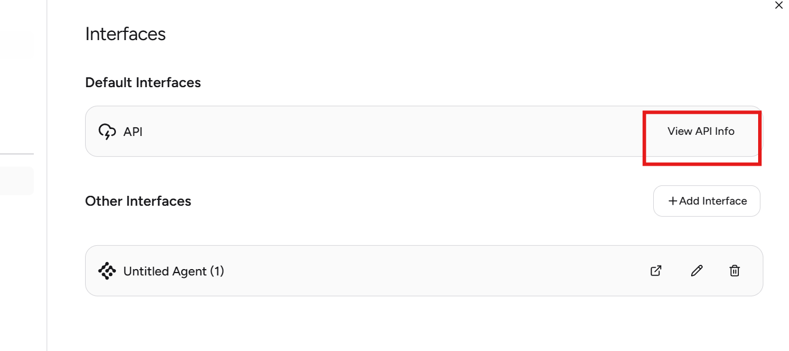
Figure 12 — Drafting soc_monitor.py with nano on the Kali/Wazuh host
import requests
from collections import Counter

# ------------------------------
# CONFIGURATION — EDIT THESE VALUES
# ------------------------------

INTERFACE = "eth0" # your network interface
CAPTURE_DURATION = 100 # seconds to capture traffic
THRESHOLD = 40 # packets from one IP to trigger alert

PCAP_FILE = "traffic.pcap"
CSV_FILE = "traffic.csv"
ALERT_FILE = "alert.json"

# —— Airia API
AIRIA_API_URL = "<AIRIA AGENT API URL>"
AIRIA_API_KEY = "<AIRIA API KEY>"

# Metadata
DESTINATION_HOST = "Internal-server"
DESTINATION_IP = "<MONITORING HOST IP>" # e.g. 192.168.1.50
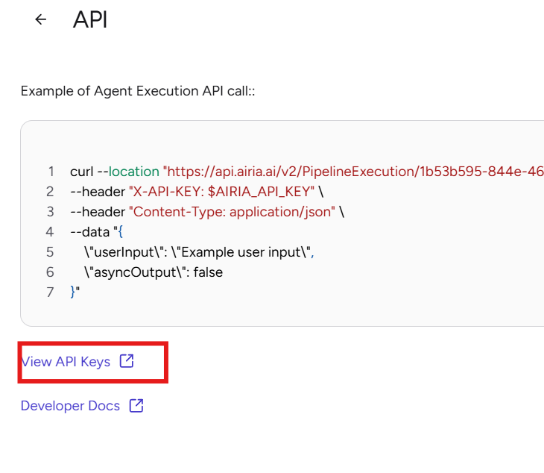
Figure 13 — Configuration block: interface, capture duration, threshold, and Airia API settings
At runtime the script: (1) captures live traffic for CAPTURE_DURATION seconds on INTERFACE using tshark, saving to PCAP_FILE; (2) converts the capture to CSV_FILE; (3) tallies packets per source IP with collections.Counter; (4) flags any source IP whose count exceeds THRESHOLD; (5) writes the resulting alert to ALERT_FILE; and (6) POSTs that alert to AIRIA_API_URL with the API key in the request header, printing the AI agent's JSON response to the terminal.

5. Test Run & Results

5.1 Generating Test Traffic
To exercise the threshold logic, 50 ICMP echo requests were sent to a target host on the lab network — comfortably above the 40-packet threshold configured in the script.
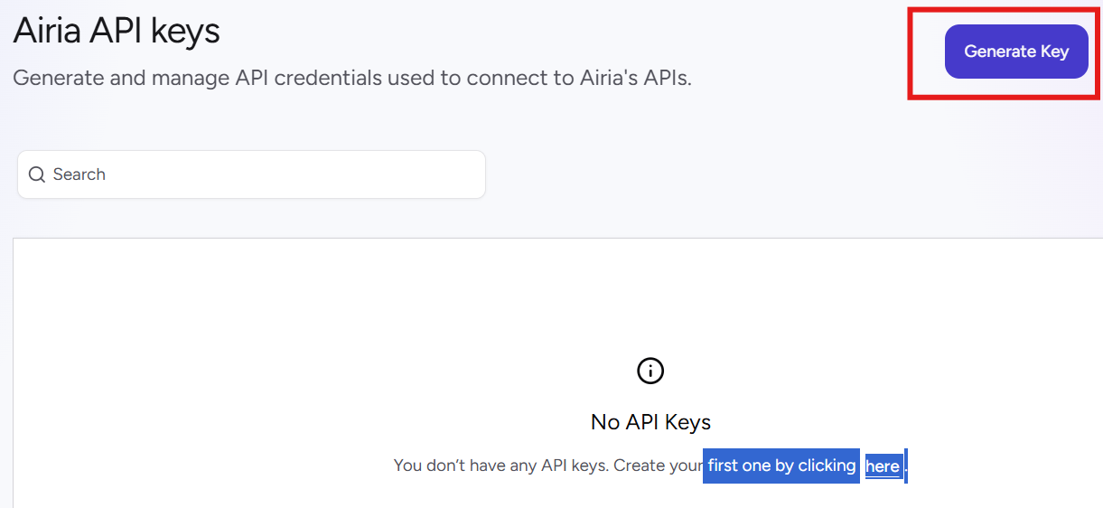
Figure 14 — ping 192.168.1.46 -c 50, round-trip times ~1 ms

5.2 Running the Monitor
soc_monitor.py was launched with root privileges (required for live packet capture) on interface enp0s3, capturing for 100 seconds while the ping traffic was generated in parallel.
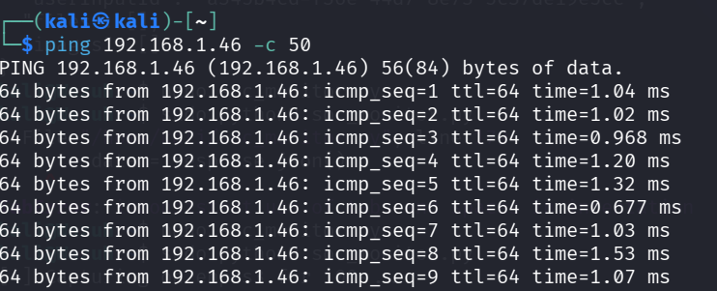
Figure 15 — sudo python3 soc_monitor.py — capture started on enp0s3

5.3 Detection & AI Triage Output
The capture correctly tallied 50 packets from 192.168.1.46, exceeded the 40-packet threshold, wrote the alert JSON, and forwarded it to the Airia agent, which responded with HTTP 200 and a structured triage report.
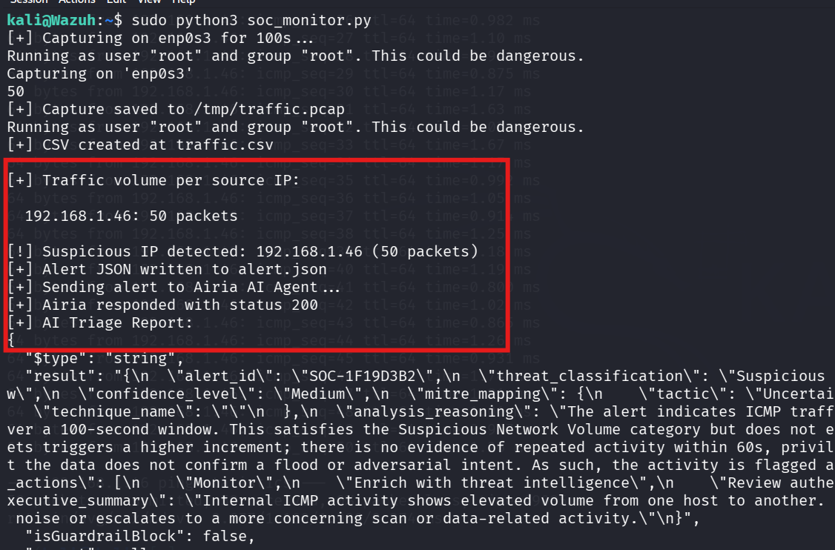
Figure 16 — End-to-end run: detection, alert JSON, Airia response, and AI triage report
Field |  | Value
Source IP flagged |  | 192.168.1.46 (50 packets vs. 40-packet threshold)
Alert ID |  | SOC-1F19D3B2
Threat classification |  | Suspicious
Confidence level |  | Medium
MITRE mapping |  | Tactic: Uncertain (technique not determined from ICMP volume alone)
Recommended actions |  | Monitor → Enrich with threat intelligence → Review authentication/related logs
HTTP response |  | 200 OK from Airia agent endpoint
AI Executive Summary (agent output)
The agent's summary noted that internal ICMP activity showed elevated volume from one host to another within the capture window, satisfying the “suspicious network volume” category, but stopped short of confirming a flood or adversarial intent — correctly reasoning that a single burst of ICMP traffic without repeated activity, privilege escalation signals, or corroborating data was moderate-confidence noise rather than a confirmed incident, and recommending monitoring and enrichment as next steps.

6. Key Takeaways
- Chained a local, tool-based detection pipeline (tshark → CSV → threshold logic) directly into a cloud LLM agent via a authenticated REST call — a realistic pattern for AI-assisted SOC tooling.
- Configured and published a production-style Airia agent: project → model → agent → system prompt → publish → API key, mirroring how a real AI-augmented detection service would be stood up.
- Validated the agent's reasoning quality: it correctly distinguished “elevated but inconclusive” ICMP volume from a confirmed attack, and mapped its confidence and recommended actions accordingly rather than over-alerting.
- Threshold-based detection (Counter over per-source packet counts) is intentionally simple — a solid foundation to later extend with protocol-aware baselines, rate windows, or multiple detection rules feeding the same agent.

7. Next Steps
- Add additional detection rules (port-scan, SYN-flood, DNS tunneling heuristics) feeding the same Airia agent.
- Persist AI triage reports to a log/SIEM sink (e.g. forward into the existing Wazuh stack) for historical tracking.
- Expand the MITRE ATT&CK mapping logic with richer alert metadata so the agent can commit to a technique, not just a tactic.
- Add a feedback loop: allow an analyst to confirm/reject the AI classification to measure triage accuracy over time.

