SOC Investigation
Enterprise Log Triage & Incident Response

Complete Project Walkthrough & Notes
Reporter | Anmol Darve
Role | SOC Analyst (Entry-Level) — Cybersecurity Portfolio Project
Platform | Azure Data Explorer (ADX) — Kusto Query Language (KQL)
Environment | Simulated enterprise SIEM dataset (Windows Security Event Log standard)
Dataset | company_security_logs_v2.csv — 932 events, 11 users
Date | August 2026
Features Covered | Tier 1-3 Triage, Baseline/UEBA Detection, Timeline Reconstruction, MITRE ATT&CK Mapping, Incident Reporting
Identity & Access Management | Threat Detection | Incident Response
GitHub: github.com/PAGHADA/cybersecurity-home-labs

1. Project Overview
This project simulates the day-to-day workflow of a Security Operations Center (SOC), moving through the three standard analyst tiers: Tier 1 (Triage), Tier 2 (Investigation), and Tier 3 (Reporting/Response). A synthetic but realistic enterprise log dataset was built to mimic Windows Security Event Logs and Azure AD sign-in logs, then ingested into Azure Data Explorer (ADX) for analysis using Kusto Query Language (KQL).
The goal was to detect anomalous behavior without relying on any pre-built labels — each incident was found purely through baselining normal user behavior and querying for deviations, the same approach real SIEM/UEBA tooling (e.g., Microsoft Sentinel) uses under the hood.

1.1 Environment & Setup
- Platform: Azure Data Explorer (ADX) — Kusto Query Language
- Dataset: 932 log events across 11 users, 5 business days, mixing normal traffic with 5 embedded incidents
- Table schema: LogID, Timestamp, Username, FullName, Department, SourceIP, Country, DeviceName, Application, Action, Status, EventID, LogonType, UserAgent, Extra, CorrelationID
- Log standard followed: Windows Security Event IDs — 4624 (Logon Success), 4625 (Logon Failure), 4728 (Added to Security Group), 4663 (Object/File Access)

1.2 Data Ingestion into Azure Data Explorer
The CSV was ingested via the ADX portal's native ingestion wizard:
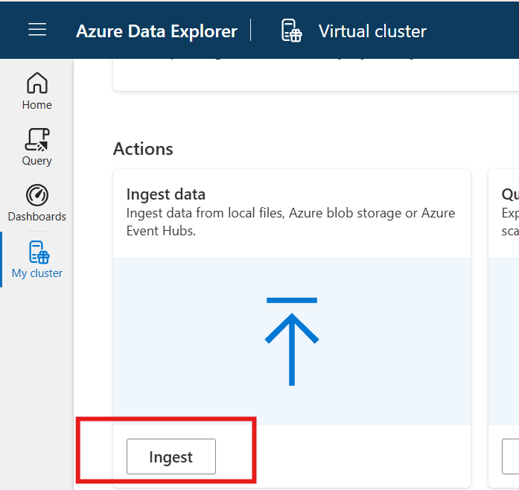
Figure 1 — Starting the data ingestion wizard
What I did: From the Azure Data Explorer cluster's Home screen, I opened the Actions panel and clicked the "Ingest" button under "Ingest data" to begin loading my CSV log file into the cluster.
What the screenshot shows: The cluster's Actions panel with two options — "Ingest data" (highlighted) and "Query" — with the Ingest button circled in red at the bottom.
Result / takeaway: This launches the "Get data" wizard, the starting point for bringing the CSV file into a queryable ADX table.
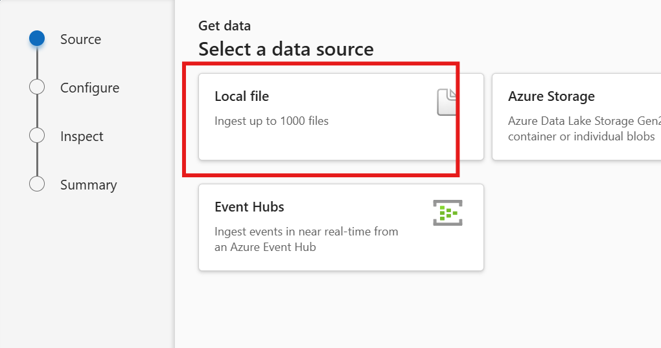
Figure 2 — Choosing the data source
What I did: On the "Select a data source" step of the wizard, I selected "Local file" since my log data was a CSV file saved on my computer, rather than data already sitting in Azure Storage or Event Hubs.
What the screenshot shows: Three source options are presented — Local file, Azure Storage, and Event Hubs. "Local file" is highlighted, showing it supports ingesting up to 1000 files at once.
Result / takeaway: Local file was the correct choice for a one-time CSV upload used to simulate enterprise logs.
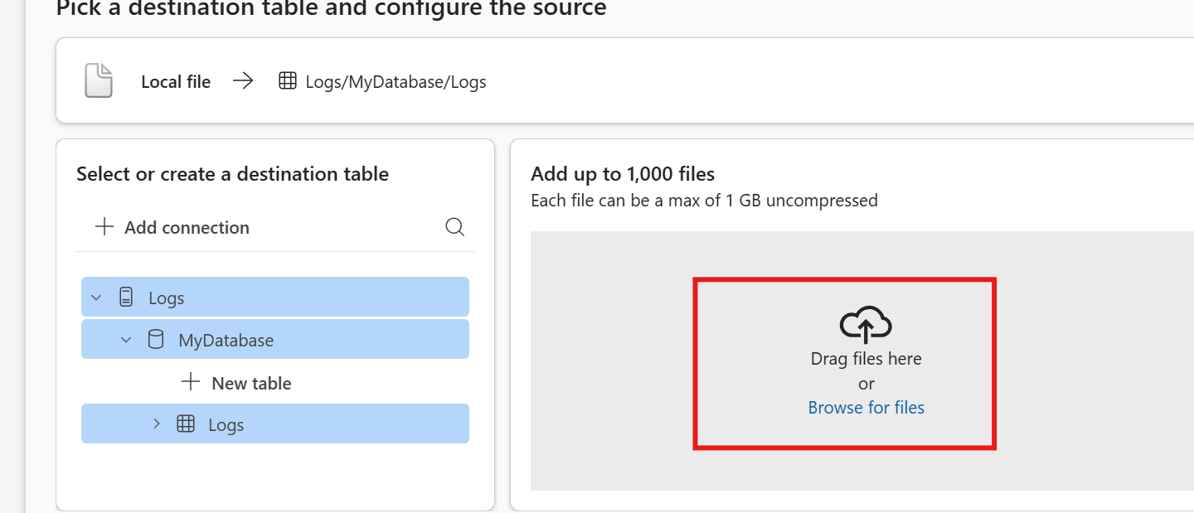
Figure 3 — Configuring destination table and uploading the CSV
What I did: I selected my cluster ("Logs") and database ("MyDatabase"), created a new destination table, and then dragged/uploaded my CSV file (company_security_logs_v2.csv) into the upload area on the right.
What the screenshot shows: The left panel shows the connection tree (Logs → MyDatabase → new table/Logs table) already selected. The right panel shows the file upload dropzone, where files can be dragged in or browsed for, with a 1 GB per-file limit.
Result / takeaway: This step maps my CSV to a specific table and uploads the raw data. The wizard then auto-detects column names and types (Timestamp, Username, SourceIP, Country, EventID, etc.) in the next step before final ingestion.
Once ingestion completed, the table was confirmed to be queryable and ready for analysis.

2. Investigation Methodology
Rather than searching for incidents randomly, a structured baseline-and-deviation approach was used across all three tiers:
Tier | Focus | Technique Used
Tier 1 — Triage | Scan for statistical anomalies | Aggregate/summarize logs by user, IP, and country to spot outliers
Tier 2 — Investigation | Build full incident timeline | Filter to the specific user/IP and reconstruct exact sequence of events
Tier 3 — Reporting | Formal write-up & response | Document IOCs, MITRE ATT&CK mapping, root cause, and remediation

3. Tier 1 — Triage & Baseline Detection
The first step was to build a login-country baseline per user, to see who deviates from their normal working pattern.
Query — Country baseline per user
Logs
| where EventID == "4624"
| summarize LoginCountries = make_set(Country), LoginCount = count() by Username
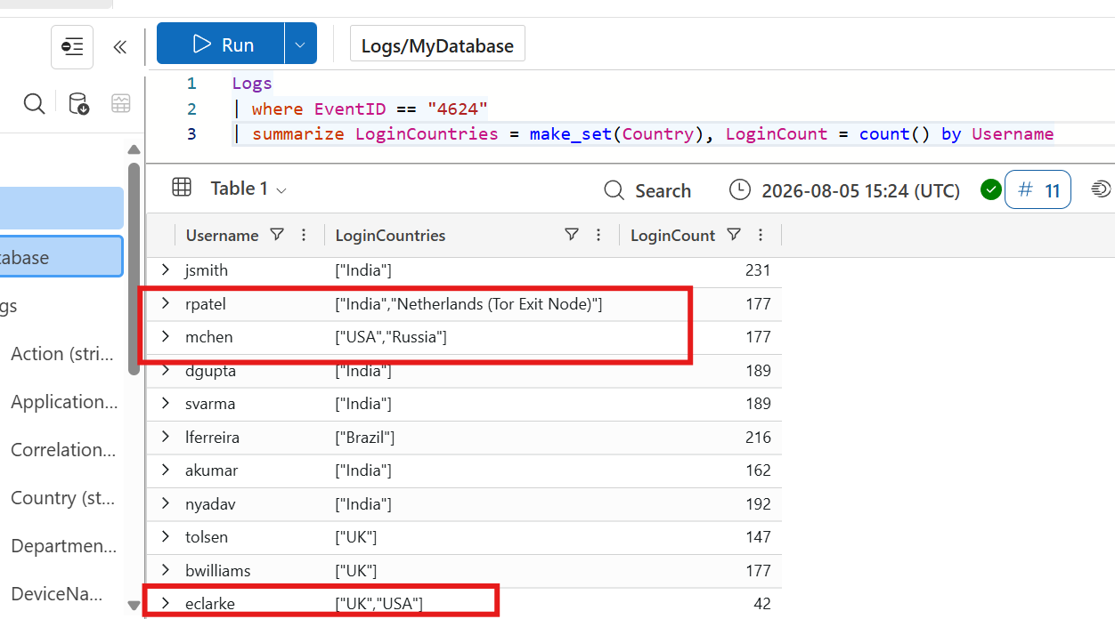
Figure 4 — Login-country baseline per user
What I did: I ran a summarize query grouping all successful logins (EventID 4624) by Username, collecting every distinct country each user has logged in from using make_set(), along with their total login count.
What the screenshot shows: An 11-row results table listing each username next to a LoginCountries array and a LoginCount. Most rows show a single country in brackets (e.g. jsmith → ["India"]). Three rows are boxed in red: rpatel shows ["India","Netherlands (Tor Exit Node)"], mchen shows ["USA","Russia"], and eclarke shows ["UK","USA"].
Result / takeaway: 8 of 11 users only ever log in from one country — that is the expected, normal pattern. The 3 users with two countries in their list stand out immediately and become the starting point for the whole investigation.
Query — Per-country breakdown (confirming the outlier)
Logs
| where EventID == "4624"
| summarize CountryCount = count() by Username, Country
| sort by Username asc, CountryCount asc
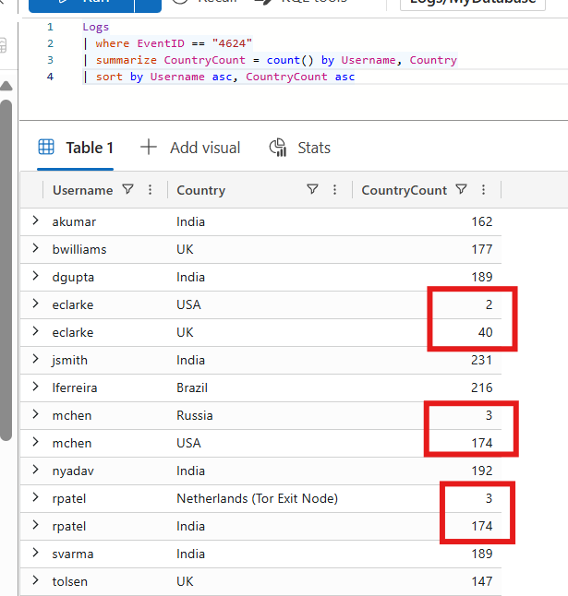
Figure 5 — Per-country login counts (confirming which country is the outlier)
What I did: I re-ran the summarize grouped by both Username and Country (instead of collapsing into a set), so I could see exactly how many times each user logged in from each country, and sorted ascending by count to push rare/outlier rows to the top for each user.
What the screenshot shows: A per-user, per-country breakdown. For the three flagged users, one country has a large count (their real baseline) and the other has only 2–3 occurrences: eclarke shows USA = 2 vs UK = 40; mchen shows Russia = 3 vs USA = 174; rpatel shows Netherlands (Tor Exit Node) = 3 vs India = 174. All three are boxed in red.
Result / takeaway: This confirms statistically — not just visually — that USA (for eclarke), Russia (for mchen), and the Tor exit node (for rpatel) are genuine outliers against each user's normal working pattern, not just noise.
Tier 1 Findings Summary
User | Normal Baseline | Anomalous Country | Occurrences
eclarke (CEO) | UK (40 logins) | USA | 2
mchen | USA (174 logins) | Russia | 3
rpatel | India (174 logins) | Netherlands (Tor Exit Node) | 3

4. Tier 2 — Investigation & Timeline Reconstruction

4.1 Incident E — CEO Account Anomalous Login (eclarke)
Logs
| where Username == 'eclarke' and Country == "USA"
| project Timestamp, SourceIP, DeviceName, Application, Action, Extra
| order by Timestamp asc
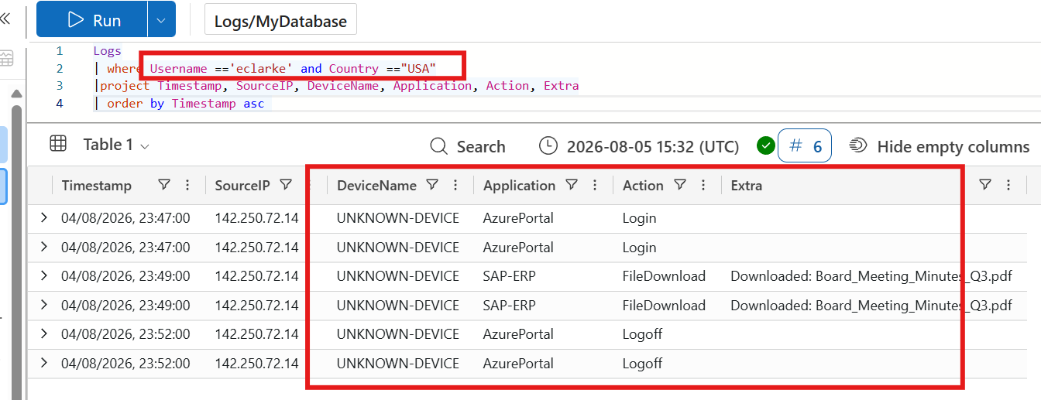
Figure 6 — Full session timeline for eclarke's anomalous USA login
What I did: I filtered the Logs table down to only eclarke's events where Country equals "USA" (the outlier country found in Tier 1), and projected the key fields — Timestamp, SourceIP, DeviceName, Application, Action, and Extra — ordered chronologically.
What the screenshot shows: A 6-row result (shown as 3 unique events, each duplicated once) covering a single short session: Login on AzurePortal at 23:47 from IP 142.250.72.14 on UNKNOWN-DEVICE; a FileDownload from SAP-ERP at 23:49 with Extra = "Downloaded: Board_Meeting_Minutes_Q3.pdf"; and a Logoff from AzurePortal at 23:52 — all boxed in red.
Result / takeaway: This is the complete evidence trail for the CEO incident: an unrecognized device and IP logged in, went straight to a sensitive file, downloaded it, and logged off — all within 5 minutes late at night.
Findings:
- Login at 23:47 from IP 142.250.72.14 (USA) on an UNKNOWN-DEVICE — not her registered LAPTOP-CEO01
- Two minutes later, a sensitive file — Board_Meeting_Minutes_Q3.pdf — was downloaded from SAP-ERP
- Session ended with a logoff at 23:52 — a fast 5-minute in-and-out pattern
- Event occurred well outside business hours (23:47, i.e. 11:47 PM)
This combination — new country, unrecognized device, off-hours access, and a targeted sensitive-file download — is consistent with credential theft followed by deliberate data exfiltration rather than legitimate CEO activity.

4.2 Incident A — VPN Brute Force Attack (rpatel)
Logs
| where Username == "rpatel" and Country == "Netherlands (Tor Exit Node)"
| project Timestamp, SourceIP, DeviceName, Application, Action, Status, Extra
| order by Timestamp asc
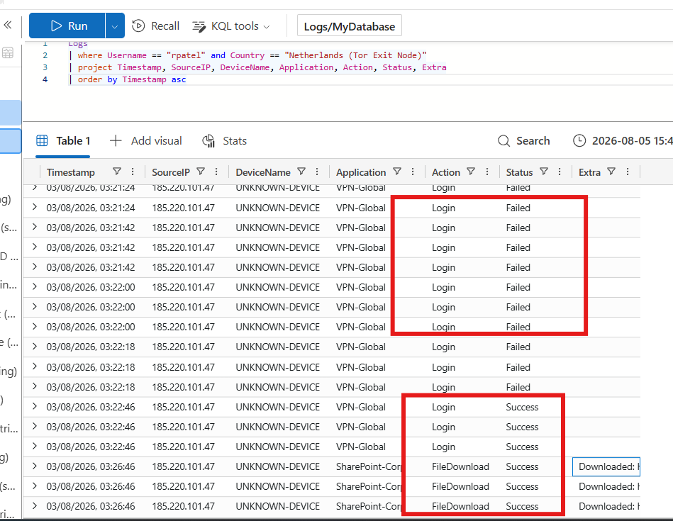
Figure 7 — Full session timeline for the Tor exit node attack against rpatel
What I did: I filtered the Logs table to rpatel's events from the Netherlands (Tor Exit Node) country, projecting Timestamp, SourceIP, DeviceName, Application, Action, Status, and Extra, ordered chronologically to see the attack unfold step by step.
What the screenshot shows: A long, dense list of rows from IP 185.220.101.47 on UNKNOWN-DEVICE against VPN-Global. The top section (boxed in red) shows a rapid run of Login/Failed rows seconds apart — a brute-force pattern. Further down, a second red box shows the attempts finally turning into Login/Success, immediately followed by several FileDownload/Success rows against SharePoint-Corp, each with a filename shown in the Extra column.
Result / takeaway: This proves the full attack chain in one screenshot: automated password guessing from a Tor exit node, an eventual successful login once the correct credential was found, and the attacker immediately pivoting to download files — clear evidence of both compromise and data access.
Findings:
- Source IP 185.220.101.47 (Netherlands — Tor Exit Node) generated a dense burst of failed VPN-Global logins in rapid succession (multiple attempts within seconds of each other)
- The burst was followed by a Login Success — indicating the attacker eventually guessed or brute-forced valid credentials
- Immediately after gaining access, the attacker performed FileDownload actions against SharePoint-Corp
- All activity originated from an UNKNOWN-DEVICE, never seen for this user before
This is a textbook credential brute-force attack originating from anonymization infrastructure (Tor), with confirmed post-compromise data access.

4.3 Incident B — Impossible Travel / Session Abuse (mchen)
Initial check — isolate the Russia session:
Logs
| where Username == "mchen" and Country == "Russia"
| project Timestamp, SourceIP, DeviceName, Application, Action, Status, Extra
| order by Timestamp asc
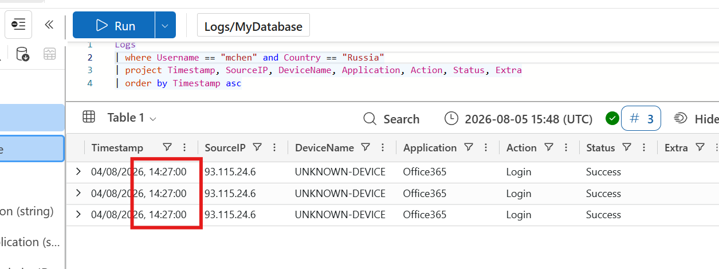
Figure 8 — Isolating mchen's Russia-based session
What I did: I filtered the Logs table to only mchen's events where Country equals "Russia", projecting Timestamp, SourceIP, DeviceName, Application, Action, Status, and Extra.
What the screenshot shows: Three rows, all timestamped 04/08/2026 14:27:00, from SourceIP 93.115.24.6 on UNKNOWN-DEVICE, logging into Office365 with Status = Success (boxed in red).
Result / takeaway: Confirms the Russia session is real, successful (not a failed attempt), came from a device never seen for this user before, and happened at a single point in time — 14:27:00 — which becomes the anchor timestamp for the next step.
Next — pull mchen's complete login history to see this session in context:
Logs
| where Username == "mchen"
| project Timestamp, Country, SourceIP, Application, Action
| order by Timestamp asc
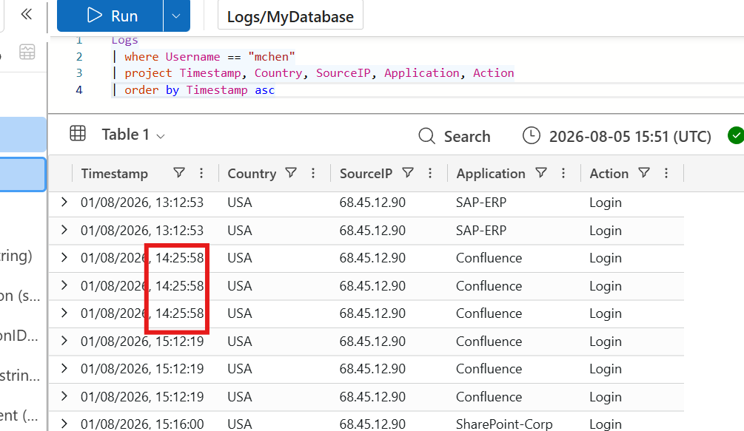
Figure 9 — mchen's complete login history, in chronological order
What I did: I removed the country filter and pulled mchen's entire login history — Timestamp, Country, SourceIP, Application, Action — ordered by time, so I could see the Russia session in the context of his normal USA activity before and after it.
What the screenshot shows: A timeline of USA-based logins from SourceIP 68.45.12.90 on Confluence and SAP-ERP: sessions at 13:12, then 14:25:58 (boxed in red, 3 rows), then a gap, then activity resuming at 15:12:19 (boxed in red) and continuing at 15:16.
Result / takeaway: This confirms mchen was actively working from the USA both right before (14:25) and shortly after (15:12) the Russia session — the legitimate user's normal pattern never stopped, which is exactly what you'd expect if a session token or credential was used by someone else in parallel, rather than the real user actually traveling.
Finally — calculate the exact time gap between country changes programmatically:
Logs
| where Username == "mchen" and Country in ("USA", "Russia")
| project Timestamp, Country, Application
| order by Timestamp asc
| extend PrevTime = prev(Timestamp), PrevCountry = prev(Country)
| extend GapMinutes = datetime_diff('minute', Timestamp, PrevTime)
| project Timestamp, Country, PrevCountry, PrevTime, GapMinutes
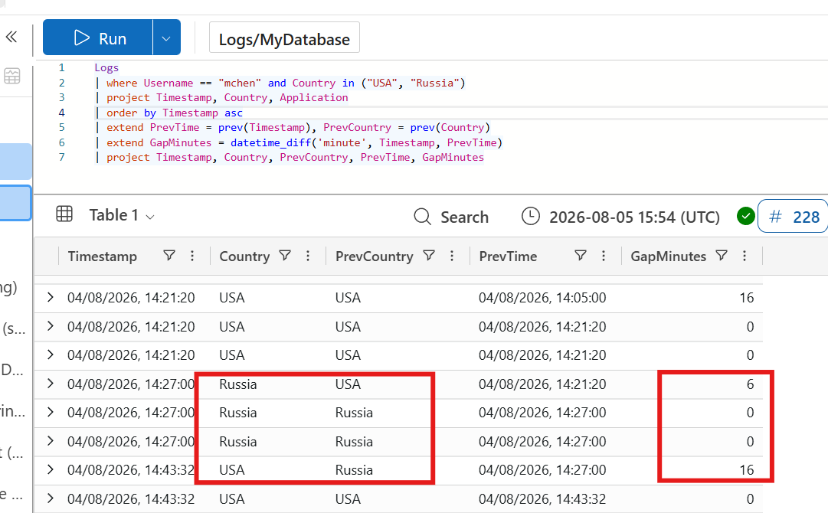
Figure 10 — Calculating the exact time gap between country changes
What I did: I used the KQL prev() function to look at each row's previous Timestamp and Country, then used datetime_diff('minute', ...) to automatically calculate the number of minutes between consecutive logins — instead of manually eyeballing timestamps, letting the query do the math.
What the screenshot shows: A results table with columns Timestamp, Country, PrevCountry, PrevTime, and GapMinutes. Most rows show GapMinutes = 0 (multiple log lines in the same second) or normal same-country gaps like 16. The two rows boxed in red show the country actually changing: USA → Russia with a 6-minute gap, and later Russia → USA with a 16-minute gap.
Result / takeaway: This gives an exact, defensible number for the incident report instead of an estimate: only 6 minutes separate a USA login from a Russia login for the same account — physically impossible for a real person to travel, and strong quantitative proof to include as evidence.
Findings:
- 14:21 — Legitimate session active from USA (Confluence)
- 14:27 — Login from Russia (Office365) — only 6 minutes after the last USA activity, on an UNKNOWN-DEVICE
- 14:43 — Account resumes activity from USA again — 16 minutes after the Russia session ended
- Physically, no travel method allows a USA-to-Russia relocation in 6 minutes; the pattern of the legitimate user resuming activity afterward strongly suggests a stolen session token or compromised credential used concurrently, rather than simple impossible travel by the same physical person
This is classified as session/credential abuse rather than a simple stolen-password case, because the real user's activity resumes normally — they were likely unaware their account was accessed.

5. Tier 3 — Incident Reports & Response
Formal incident write-ups for handoff to management/Tier 3, following standard SOC reporting structure.

INC-E-001 — Anomalous Executive Login with Data Exfiltration
Severity | CRITICAL

Affected User / Asset: eclarke (CEO, Executive) — AzurePortal, SAP-ERP
Date/Time: 2026-08-04, 23:47–23:52
Summary: CEO account logged in from an unrecognized device and a US-based IP, deviating from an established UK-only baseline (40 UK logins vs. 1 anomalous USA session). During the 5-minute session, a confidential board document was downloaded before logoff.
Timeline: 23:47 Login (USA, UNKNOWN-DEVICE) -> 23:49 FileDownload: Board_Meeting_Minutes_Q3.pdf -> 23:52 Logoff
IOCs: IP: 142.250.72.14 | Device: UNKNOWN-DEVICE | Account: eclarke | File: Board_Meeting_Minutes_Q3.pdf
MITRE ATT&CK: T1078 (Valid Accounts), T1213 (Data from Information Repositories)
Root Cause: Likely credential compromise (phishing or credential stuffing); no legitimate travel/device-change context, off-hours access to a high-value file.
Impact: Potential exposure of confidential board-level information.
Remediation: Reset password and revoke active sessions immediately; force MFA re-enrollment; block/investigate source IP; assess exposure of the downloaded file.
Recommendations: Enable Conditional Access geo-fencing for executive accounts; alert on logins outside a user's top-2 historical countries; mandate registered-device enforcement for privileged roles.

INC-A-001 — VPN Brute Force Attack via Tor Exit Node
Severity | CRITICAL

Affected User / Asset: rpatel (IT) — VPN-Global, SharePoint-Corp
Date/Time: 2026-08-03, ~03:21–03:26
Summary: A rapid burst of failed VPN login attempts originated from a known Tor exit node IP, followed by a successful login and immediate file downloads from SharePoint.
Timeline: 03:21-03:22 Repeated failed logins -> 03:22 Login Success -> 03:26 Multiple FileDownload events
IOCs: IP: 185.220.101.47 (NL, Tor Exit Node) | Device: UNKNOWN-DEVICE | Account: rpatel
MITRE ATT&CK: T1110 (Brute Force), T1078 (Valid Accounts)
Root Cause: Weak/guessable password allowed automated brute-force success; attacker used Tor to anonymize source.
Impact: Unauthorized access to SharePoint-Corp; files downloaded require exposure assessment.
Remediation: Disable/reset the compromised account immediately; block the source IP and Tor exit-node ranges at the firewall/VPN gateway; review all files accessed post-compromise.
Recommendations: Enforce account lockout after N failed attempts; enable MFA on VPN; add Tor/anonymizer IP threat-intel blocklist to VPN gateway.

INC-B-001 — Impossible Travel / Session Abuse
Severity | HIGH

Affected User / Asset: mchen (Engineering) — Office365, Confluence
Date/Time: 2026-08-01, 14:21–14:43
Summary: Account showed activity from USA, then a login from Russia only 6 minutes later on an unrecognized device, before resuming USA activity 16 minutes after that — consistent with concurrent session/credential abuse rather than genuine travel.
Timeline: 14:21 USA activity (Confluence) -> 14:27 Login from Russia (Office365, UNKNOWN-DEVICE) -> 14:43 USA activity resumes
IOCs: SourceIP (Russia session), Account: mchen, Device: UNKNOWN-DEVICE
MITRE ATT&CK: T1078 (Valid Accounts), T1550 (Use Alternate Authentication Material)
Root Cause: Likely stolen session token or compromised credential used concurrently by a third party while the legitimate user remained active and unaware.
Impact: Unauthorized access to Office365 during the intrusion window; scope of data accessed requires audit-log review.
Remediation: Revoke all active sessions and force re-authentication; reset password and enforce MFA; review Office365 audit logs for the Russia session window.
Recommendations: Enable native Conditional Access 'Impossible Travel' / Identity Protection risk policies; alert on any account active from 2+ countries within a 30-minute window.

6. Executive Summary Table
Incident | Type | User | Severity | Status
INC-E-001 | Executive account compromise + exfiltration | eclarke | Critical | Remediation recommended
INC-A-001 | VPN brute force via Tor | rpatel | Critical | Remediation recommended
INC-B-001 | Impossible travel / session abuse | mchen | High | Remediation recommended

7. Key Skills Demonstrated
- KQL query authoring in Azure Data Explorer (summarize, make_set, joins, prev(), datetime_diff)
- User & Entity Behavior baselining (manual UEBA-style anomaly detection)
- Timeline reconstruction and correlation across multiple log fields
- MITRE ATT&CK technique mapping
- Formal SOC incident report writing (Tier 1 to Tier 3 workflow)
- Windows Security Event ID interpretation (4624, 4625, 4728, 4663)

