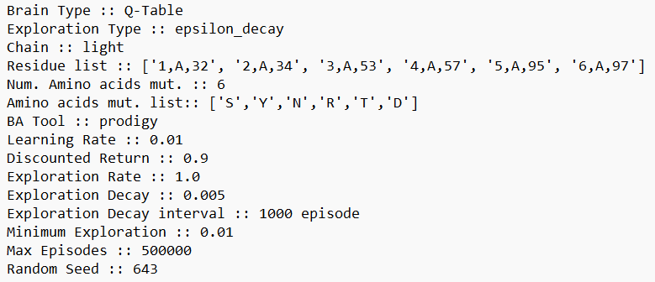 blue

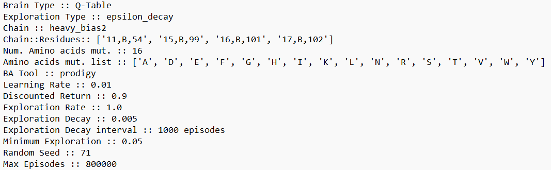orange

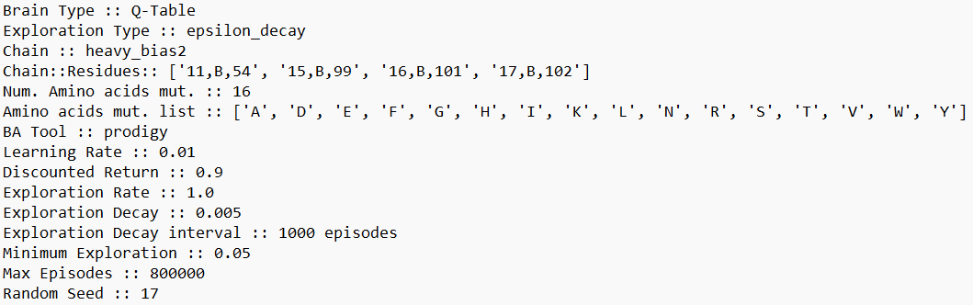green

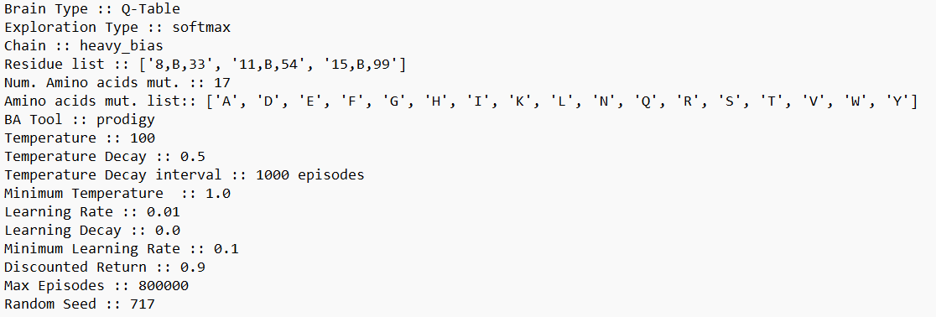 red

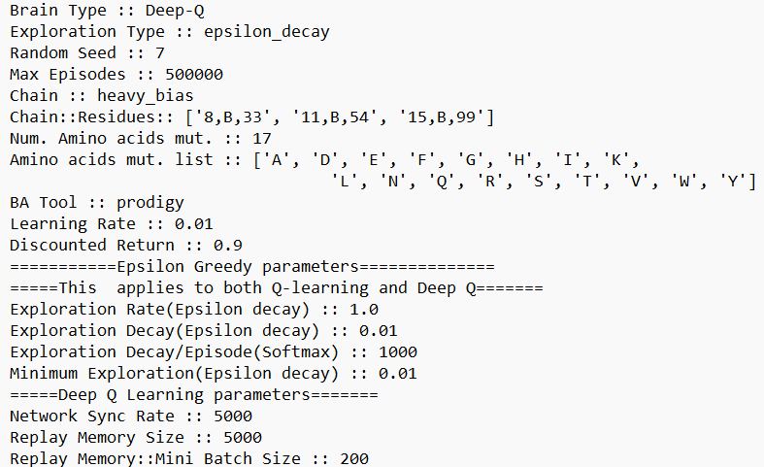 yellow

|  |  |  |  |  |  |  |  |  |  |  |  |  |  |
| --- | --- | --- | --- | --- | --- | --- | --- | --- | --- | --- | --- | --- | --- |
| Q-Learning | | | | | | | | | | | | | |
| Soft-max | | | | | | | | | | | | | |
| Chain | Residues position | No. of Mutation a.a. | Mutations Residues | Temperature | Temperature decay | Temperature decay interval | Minimum Temperature | Learning rate | Discount factor | | | Random Seed | |
| Heavy |  |  |  |  |  |  |  |  |  | | |  | |
| Epsilon Decay | | | | | | | | | | | | | |
| Chain | Residues position | No. of Mutation a.a. | Mutations Residues | Temperature | Temperature decay | Temperature decay interval | Minimum Temperature | Learning rate | Discount factor | | | Random Seed | |
|  |  |  |  |  |  |  |  |  |  | | |  | |
|  |  |  |  |  |  |  |  |  |  | | |  | |
|  |  |  |  |  |  |  |  |  |  | | |  | |
| Deep Q Learning | | | | | | | | | | | | | |
| Chain | Residues position | No. of Mutation a.a. | Mutations Residues | Temperature | Temperature decay | Temperature decay interval | Minimum Temperature | Learning rate | Discount factor |  |  |  | Random Seed |
|  |  |  |  |  |  |  |  |  |  |  |  |  |  |
|  |  |  |  |  |  |  |  |  |  |  |  |  |  |

|  |  |  |
| --- | --- | --- |
| Score | Binding Affinity (kcal/mole) | Reward |
| >=3 | < -12.6 | 10 |
| >=3 | >= -12.6 | 5 |
| 3>score>-1 | < -12.6 | 1 |
| 3 > score > -1 | > -12.6 | -1 |
| -1>= score > -10 | - | -1 |
| < -10 | - | -10 |