Internals Systems Biology: M.Sc. Semester 4 (Batch 12)
Name: Anmol Singh; Roll. no. 225HSBB004; Date: 09-03-2024

Problem 1.
Code:
#Q1: dN/dt= rN*(1-(N/K))
## solution: Nt_b=(Nt[1]*exp(r*t))/(1+(Nt[1]/K)*(exp(r*t)-1)
library(deSolve)
# parameters
r<-0.0312
K<-198.6
## a. plot time versus population in a graph
# data for the US census
t<-c(0,10,20,30,50,60,70,80,90,100,110,120,130,140,150,160,170,180,190,200,210,220,230)
Nt<-c(3.9,5.3,7.2,9.6,12.9,17.8,23.2,31.4,38.5,50.2,62.9,76.2,92.2,
106.2,123.2,132.2,151.3,179.3,203.3,226.5,248.7,281.42,308.7)
plot(t,Nt,xlab="Time(in years)", ylab="Population(Nt)in millions",
main="Time vs Population(in Millions)", col="red", type='p',)
## b. For the values r = 0.0312 and K = 198.6, compute N(t) as a function of t using above
#solution formula. Plot this curve on the same plot along with data points. Upto which year, the fit
#is good? Is the logistic equation is good model for this population growth data?. Comment.
Nt_b<- (Nt[1]*exp(r*t))/(1+(Nt[1]/K)*(exp(r*t)-1))
lines(t,Nt_b, col="blue")

a. plot time vs population:
b . For the values r = 0.0312 and K = 198.6, compute N(t) as a function of t using above
solution formula. Plot this curve on the same plot along with data points. Upto which year, the fit
is good? Is the logistic equation is good model for this population growth data?. Comment.
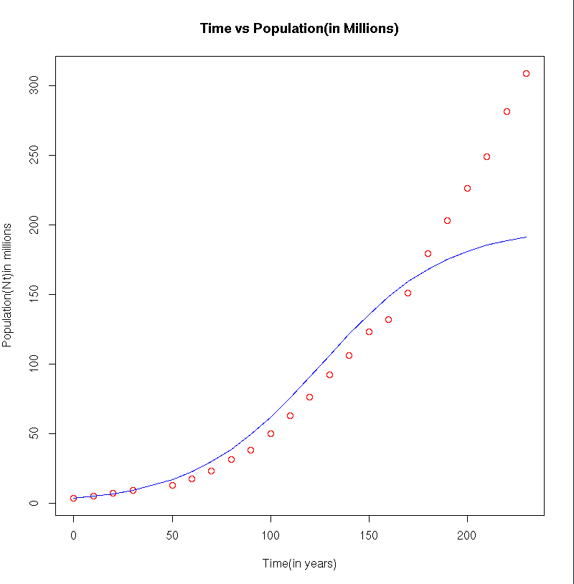
Comment:
a. The plot of time vs population of the data points is plotted in red. It shows a exponential growth
b. The blue line signifes the solution Nt_b<- (Nt[1]*exp(r*t))/(1+(Nt[1]/K)*(exp(r*t)-1)) of the logistic equation. Here we can observe a sigmoid curve.
The blue line follows the data until ~170 years, after which it starts to reach stationary phase.
The deviation of actual population from the equation could be of the industrial revolution along with improvement in the farming techniques around 1950s, this lead to the threashold of K(carrying capacity) to increase and thus we see population still increases.

Problem 2.
Code:
## problem 2
## dM=-e*M
## dB= e*M-c*B
## dL=c*B-delta*L
library("deSolve")
library("scatterplot3d")
model<-function(times,y,params){
e<-params[1]
c<-params[2]
delta<-params[3]
dM=-e*y[1]
dB= e*y[1]-c*y[2]
dL=c*y[2]-delta*y[3]
return(list(c(dM,dB,dL)))
}
initial<-c(y1=315, y2=0, y3=0)
# parameters
e <- 0.5
c <- 0.3
delta <- 0.4
params<-c(e,c,delta)
times<-seq(from=0, to=24, by=0.01)
# ODE calculation
out<- ode(times=times,y=initial ,parms=params,func=model)
par(mfrow = c(2, 2))
# part a
X11()
plot(out[,1], out[,2], xlab="Times(hours)", ylab="Amount of anaesthesia in mg",
main="Time vs M(t) and B(t)", type='l', col='blue')
lines(out[,1], out[,3], col='red')
# to observe 3D scatter plot
# x11()
# scatterplot3d(out[,c(1,2,3)])
head(out)
out<-data.frame(out)
# part b
time<-head(out[which(out[,2]<=(initial[1]/2)),], n=1)
time[,1] # 1.39 hr
# part c
# parameters 1
e <- 0.5
c <- 0.3
delta <- 0
params<-c(e,c,delta)
x11()
# ODE calculation using function from deSolve
out2<- ode(times=times,y=initial ,parms=params,func=model)
par(mfrow = c(2, 2))
plot(out2)
tail(out2) # ans : 314.4150 mg ends up in liver after 24 hrs

a. Blue: M(t) and Red: B(t)

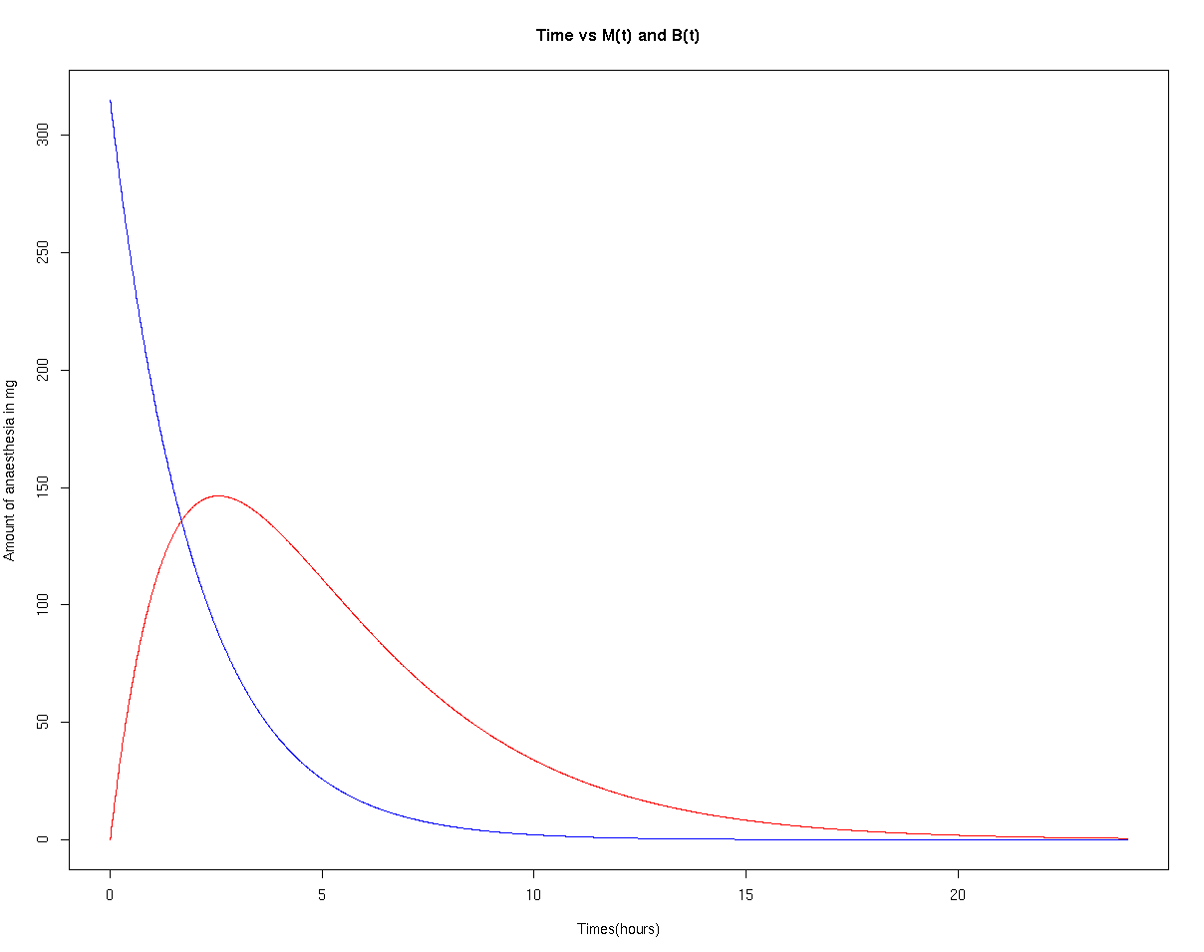
Comment: Here we can observe the amount of anesthesia in Muscle(blue) is decreasing with time and it flows to the blood. The amount of anestheia increases till first 3 hours then starts to decrease as it then goes to liver and is broken down. After 24 hrs there is almost no anesthesia in the muscle and blood.

b. How long does it take before half of the injected amount has flown from the muscle to
the blood?
Answer: 1.39 hr when

c. Suppose the degradation rate is slow, i.e., if δ tends to 0, how much anaesthesia will
ultimately end up in the liver? Making delta as 0
Answer: 314.4150 mg ends up in liver after 24 hrs. 0.585 mg of anesthesia is still left in blood and muscle.

Problem 3.
Code:
## problem 3
# pt-> prey; Pt-> predator
# dprey/dt= bp*pt-d*pt-e*pt*Pt
# dpred/dt= bP*Pt*pt-dP*Pt

library("deSolve")
library("scatterplot3d")
model<-function(times,y,params){
bp<-params[1] # birth rate per capita
dp<-params[2] # death rate per capita
ep<-params[3] # prey eaten rate per capita
# predator
bP<-params[4] # growth rate per capita
dP<-params[5] # death rate per capita
dPrey=bp*y[1]-dp*y[1]-ep*y[1]*y[2]
dPredator= bP*y[2]*y[1]-dP*y[2]
return(list(c(dPrey,dPredator)))
}
# set initial values
initial<-c(y1=15, y2=7)
# parameters
# for prey
bp<-3.5 # birth rate per capita
dp<-0.5 # death rate per capita
ep<-1 # prey eaten rate per capita
# predator
bP<-1 # growth rate per capita
dP<-3.2 # death rate per capita
params<-c(bp,dp,ep,bP,dP)

times<-seq(from=0, to=20, by=0.01)
# ODE calculation
out<- ode(times=times,y=initial ,parms=params,func=model)
# a. number of predator and prey as function of time.
X11()
plot(out[,1], out[,2], xlab="Times", ylab="Number of organisms",
main="Time vs Prey(t) and Predator(t)", type='l', col='blue')
lines(out[,1], out[,3], col='red')

# c. setting initial to 0 of prey or predator
# setting prey as 0
X11()
par(mfrow = c(1, 2))
initial<-c(y1=0, y2=7)
out_p0<- ode(times=times,y=initial ,parms=params,func=model)
plot(out_p0[,1], out_p0[,2], xlab="Times", ylab="Number of organisms",
main="Time vs Prey(t) and Predator(t); Prey(0)=0", type='l', col='blue')
lines(out_p0[,1], out_p0[,3], col='red')
# setting predator as 0
initial<-c(y1=15, y2=0)
out_P0<- ode(times=times,y=initial ,parms=params,func=model)
plot(out_P0[,1], out_P0[,2], xlab="Times", ylab="Number of organisms",
main="Time vs Prey(t) and Predator(t); Predator(0)=0", type='l', col='blue')
lines(out_P0[,1], out_P0[,3], col='red')
a. Prey= Blue; Predators =red
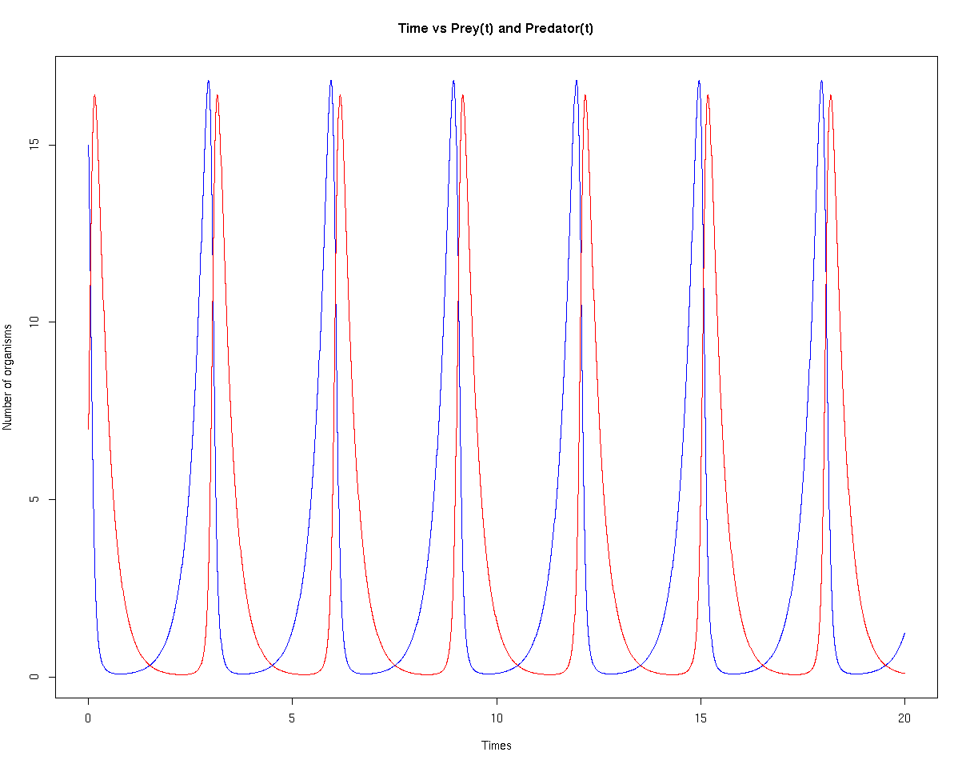
b. As we can see that the population of prey and predator oscilates within the time span of 0 to 20. This is because as the population of prey increases the resources is reduced due to population the predators starts to feed on them and there is a population burst. As the population of predator reaches the peak, there are less preys and the competition increases and the population decreases. As the population of predator slowly decreases, the population of prey increases as the resources are good enough now and the amount of predators is low enough to allow a population growth. As the prey population again increases, the increases in population of predators follows with a time difference. This model shows that in nature the population of prey and predators remain in an oscillation, never allowing prey or predator to increase unrestricted. The K(carrying capacity) of prey is the food resources as well as the population is affected by predators(NOTE: here K is not mentined; although this is what is expected in nature). The predators depend on the population of prey and their carrying capacity is based on the poulation of prey.

bp # birth rate per capita
dp # death rate per capita
ep# prey eaten rate per capita
# predator
bP# growth rate per capita
dP # death rate per capita
dprey/dt= bp*pt-d*pt-e*pt*Pt
dpred/dt= bP*Pt*pt-dP*Pt

c. Prey= Blue; Predators =red
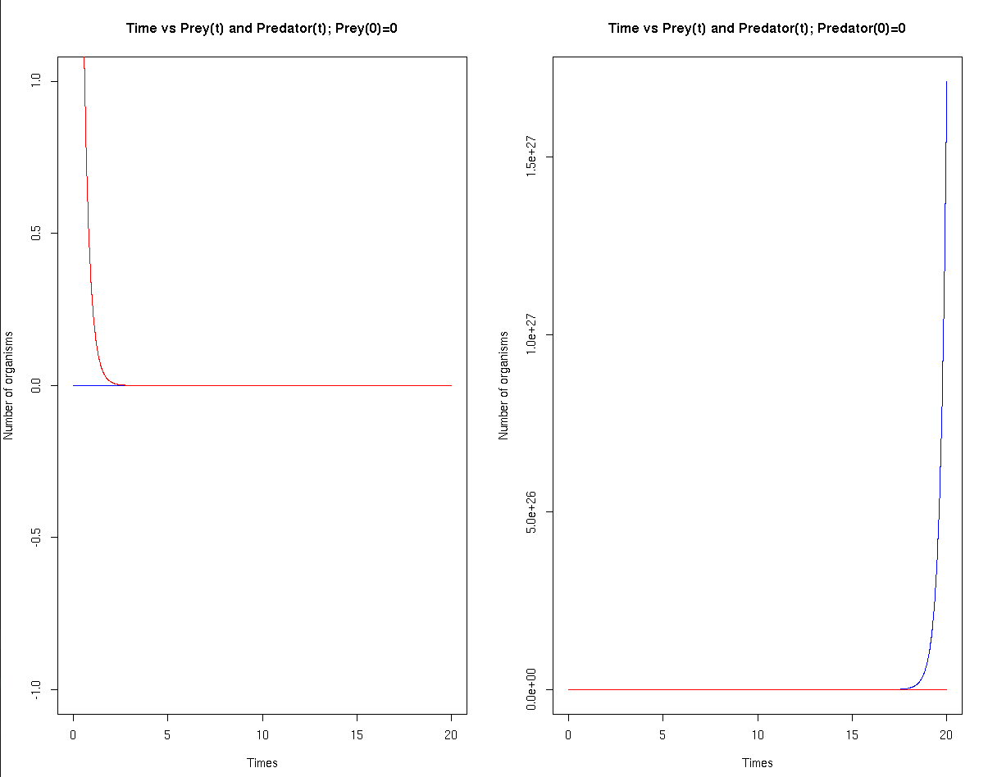
Comment: As we can observe when the prey is set to 0, the population of predators decreases and ultimately reaches 0, this is because the growth rate of predator is dependent on the population of prey. As birth and death rate of prey dependent on population of previous generation, which is 0 the prey population never increases.
On the other hand when we set the predator to 0; as we have not expressed the prey population as a logistic equation ith a carrying capacity; it keeps on increasing with time. The population of predator remains 0 as death and birth rate of predator is per capita, similar to prey.

