**Evaluation-2**

Implementation Phase-1

**Installation Process:**

1.Download the tool from our GitHub. <https://github.com/anmolgarg007/PBL-Project.git>

2.Open the File containing folder in any IDE (V.S Code).

3. “Tool.py” is the main file where the actual code has been written.

4.Install the “Requirements.txt” file as: pip install -r requirements.txt in the terminal window of IDE.

5. Run the tool.py

6. In the Input section give the file path which you want to scan.

* Right-click on the file
* Go to the properties, click on the security tab.
* Copy the object path and paste in the input section

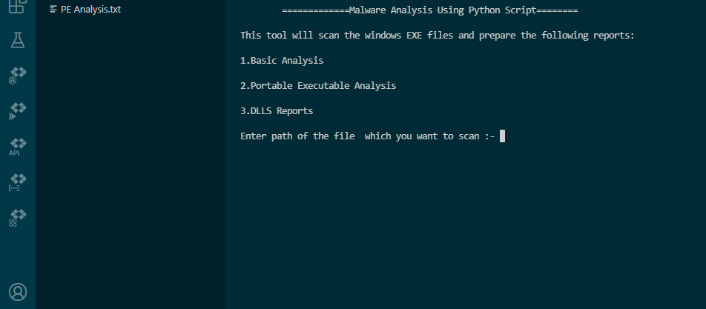**UI of Malware Analyzer**

7. After analyzing the exe file the tool will generate PE report in the same directory.

8.This PE report contains all the information about the scanned file.

**Output:**

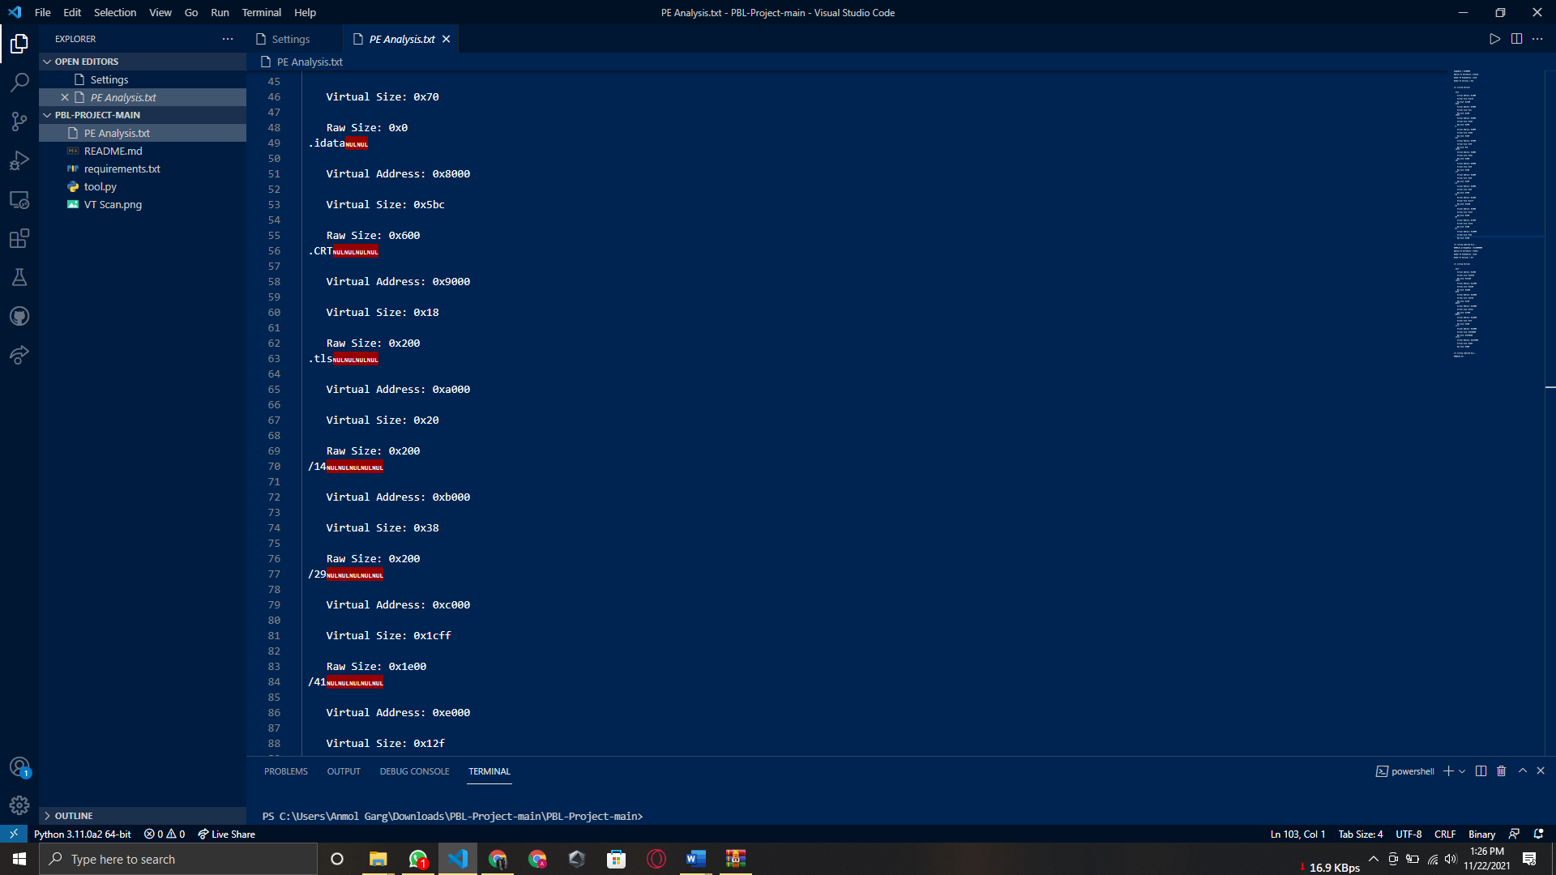**1.**

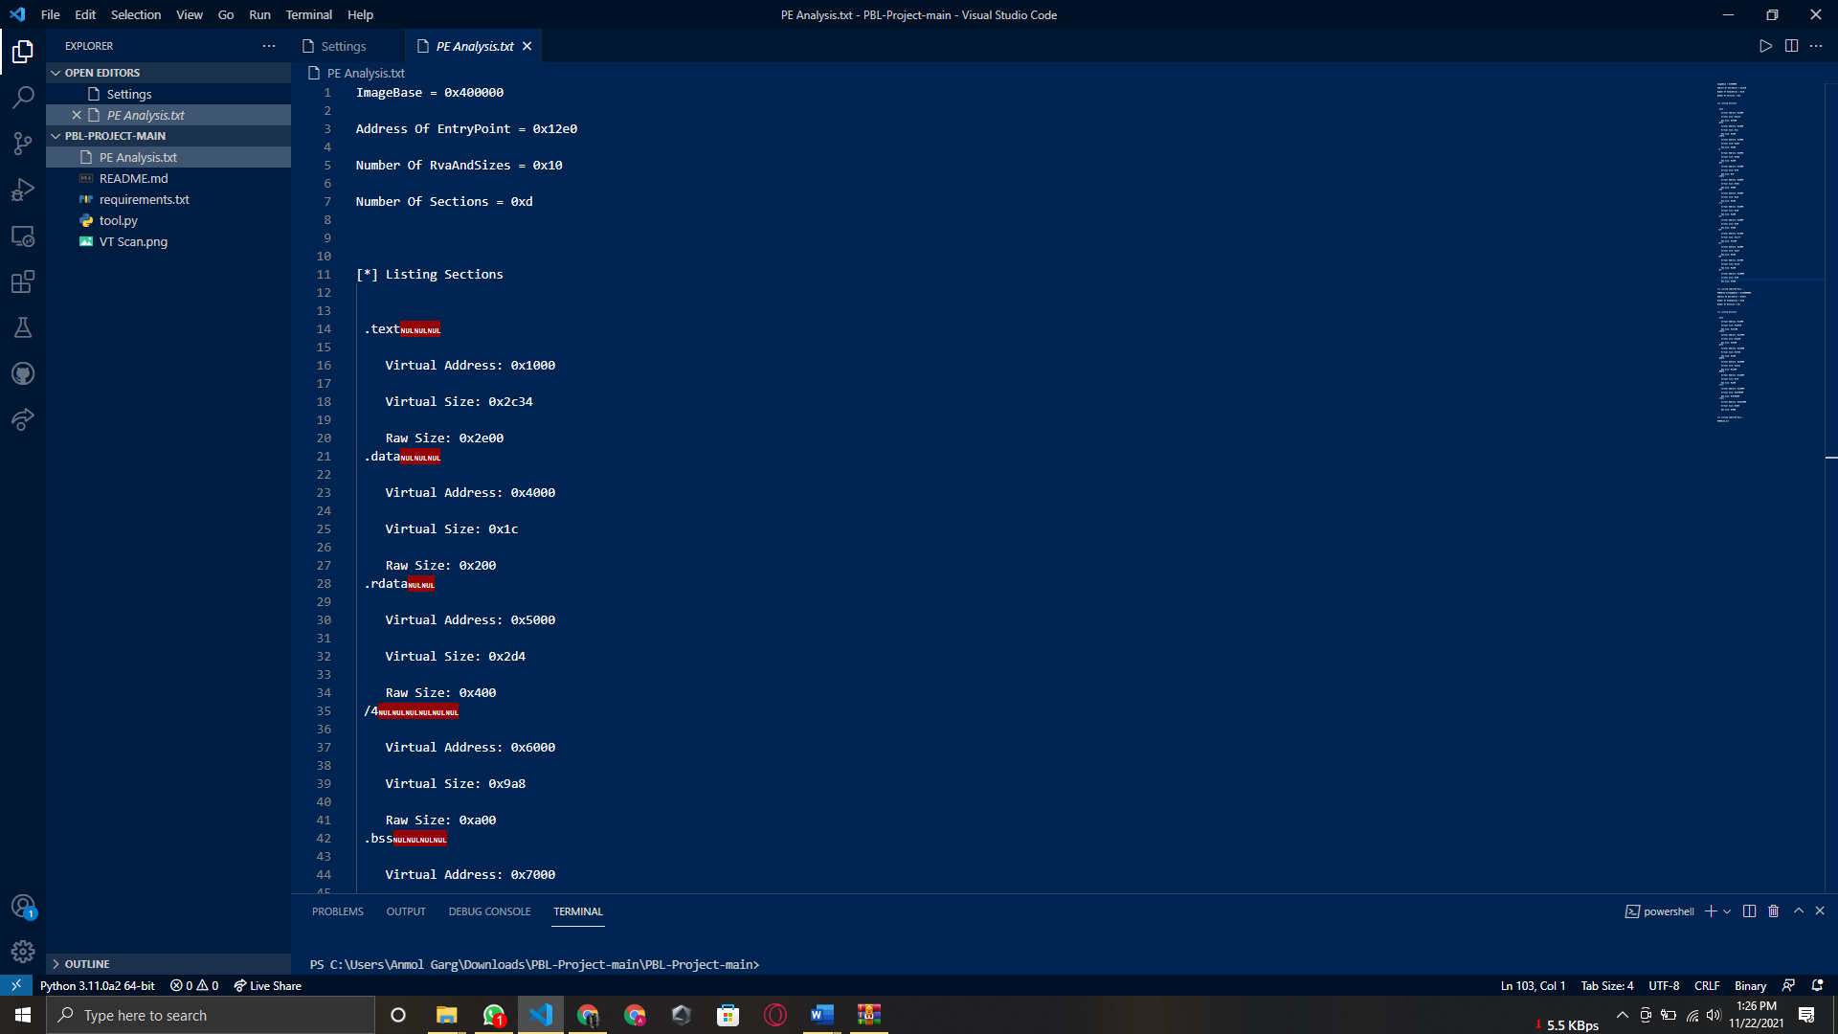 **2.**

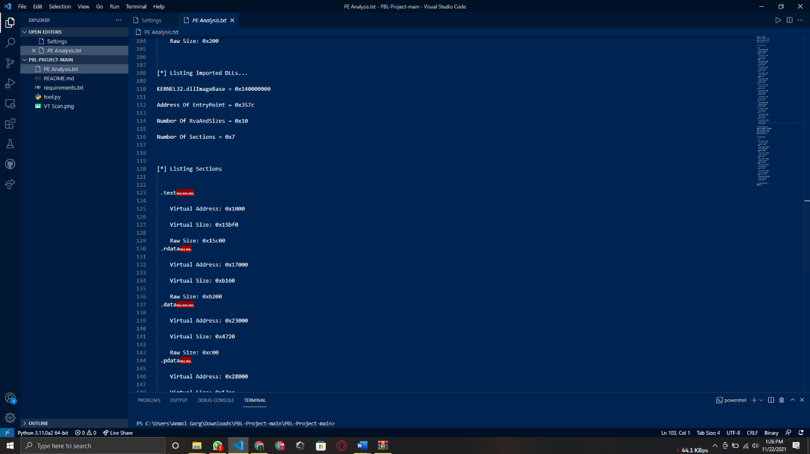3.

**Implementation Phase-2**

Installation process:

* Just download the application from our official git-hub.