**Evaluation-3**

TESTING PHASE

* We have tested 4 different software and prepared the PE file of each one.
* Out of four one software is a Malware

1. **Note Pad**

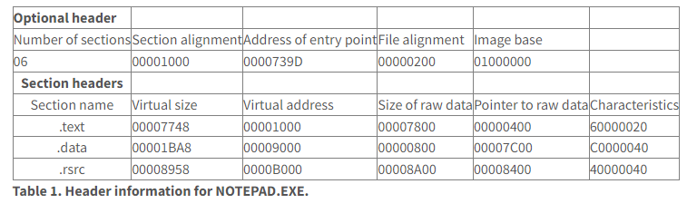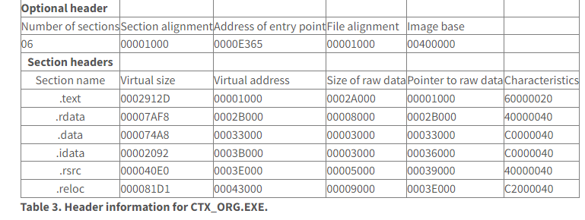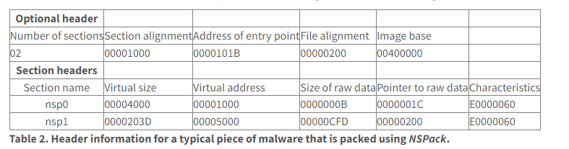

**3) I-tunes**

**2) A malware packed with NS pack**

**4) Disk-Cleanup**

|  |  |  |  |  |  |
| --- | --- | --- | --- | --- | --- |
| Name | Steps | Type of file | Expected Outcome | Our Outcome |  |
| 1.Note Pad |  | exe | Not a Malware | Not a Malware |  |
| 2.A malware packed with Ns |  | exe | Malware | Malware |  |
| 3.I-tunes |  | exe | Not a Malware | Not a Malware |  |
| 4.Disk Cleanup |  | exe | Not a Malware | Not a Malware |  |

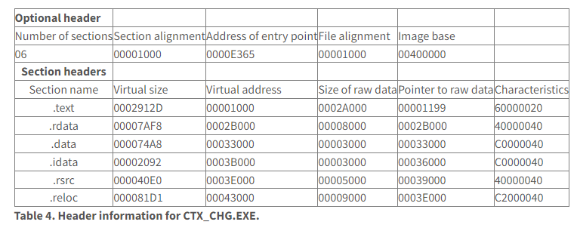

* If the tool give all the necessary information about the software like Image address, Relative Virtual Address, (.txt file), (.data file) ,Virtual Address ,resources and many other then the software is not a Malware.
* After analyzing the notepad, I-tunes, disk-cleanup all the necessary information have been collected but Ns malware has not provided full PE file report then we can conclude that it is Malware.

**Conclusion**