**SQL ASSIGNMENT**

**Descripton :**

* The dataset contains details about the customers, products, sales and profit of a Superstore
* It basically includes 5 tables namely cust_dimen (containing details about customer, their respective locations and the segment they belong to),prod_dimen (containing product category and their subcategories), orders_dimen (which provides us with the order date and order priority), shipping_dimen (which gives us the shipping details), and market_fact (which gives an overall idea about order quantity, sales value, discount, profit and shipping cost details etc)
* Different tables and their respective columns with datatype which is found using ‘describe’ feature in MySQL are provided below

1) CUST_DIMEN:

Customer_Name (TEXT): Name of the customer

Province (TEXT): Province of the customer

Region (TEXT): Region of the customer

Customer_Segment (TEXT): Segment of the customer

Cust_id (TEXT): Unique Customer ID

2)MARKET_FACT:

Ord_id (TEXT): Order ID

Prod_id (TEXT): Product ID

Ship_id (TEXT): Shipment ID

Cust_id (TEXT): Customer ID

Sales (DOUBLE): Sales from the Item sold

Discount (DOUBLE): Discount on the Item sold

Order_Quantity (INT): Order Quantity of the Item sold

Profit (DOUBLE): Profit from the Item sold

Shipping_Cost (DOUBLE): Shipping Cost of the Item sold

Product_Base_Margin (DOUBLE): Product Base Margin on the Item sold

3)ORDERS_DIMEN:

Order_ID (INT): Order ID(seems irrelevant in this dataset)

Order_Date (TEXT): Order Date

Order_Priority (TEXT): Priority of the Order

Ord_id (TEXT): Unique Order ID

4)PROD_DIMEN:

Product_Category (TEXT): Product Category

Product_Sub_Category (TEXT): Product Sub Category

Prod_id (TEXT): Unique Product ID

5)SHIPPING_DIMEN:

Order_ID (INT): Order ID

Ship_Mode (TEXT): Shipping Mode

Ship_Date (TEXT): Shipping Date

Ship_id (TEXT): Unique Shipment ID

**PRIMARY & FOREIGN KEYS :**

1. cust_dimen - Cust_id is the Primary Key, there are no foreign keys
2. prod_dimen - Prod_id is the Primary Key, there are no foreign keys
3. orders_dimen - Ord_id is the Primary Key, No foreign key
4. shipping_dimen - Shipping id as primary key and no foreign key.
5. market_fact - Ord_id, Prod_id, Ship_id and Cust_id are the foreign keys. There are no Primary Keys.

**QUERIES :**

1. ***Write a query to display the Customer_Name and Customer Segment using alias name “Customer Name", "Customer Segment" from table Cust_dimen.***

select Customer_Name as 'Customer Name', Customer_Segment as 'Customer Segment' from cust_dimen ;

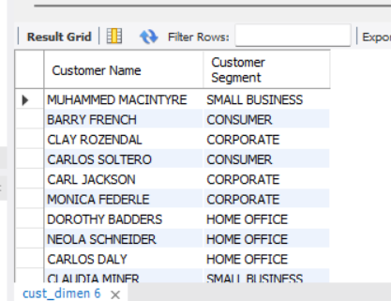

1. ***Write a query to find all the details of the customer from the table cust_dimen order by desc***

select * from cust_dimen

order by Cust_id desc ;

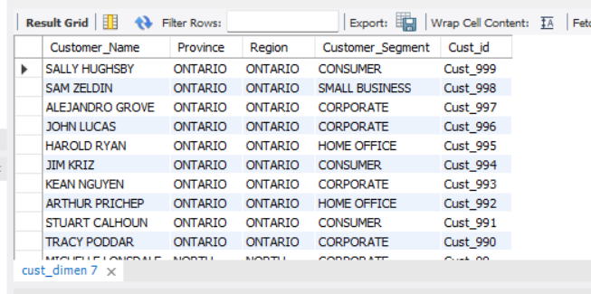

1. ***Write a query to get the Order ID, Order date from table orders_dimen where ‘Order Priority’ is high***.

select Order_ID,Order_Date from orders_dimen

where Order_Priority = "High" ;

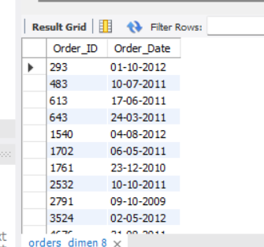

1. ***Find the total and the average sales (display total_sales and avg_sales)***

select sum(Sales) as total_sales, avg(Sales) as avg_sales from market_fact ;

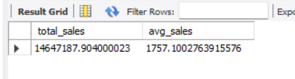

1. ***Write a query to get the maximum and minimum sales from maket_fact table***

select max(Sales) Max_Sales, min(Sales) Min_Sales from market_fact ;

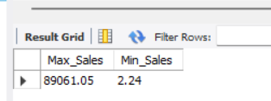

1. ***Display the number of customers in each region in decreasing order of no_of_customers. The result should contain columns Region, no_of_customers***

select Region,count(Cust_id) as no_of_customers from cust_dimen

group by Region

order by count(Cust_id) ;

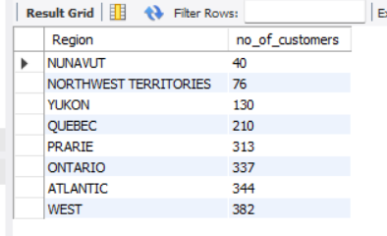

1. ***Find the region having maximum customers (display the region name and max(no_of_customers)***

select Region,max(no_of_customers) from

(select Region,count(Cust_id) as no_of_customers from cust_dimen

group by Region) as Maximum ;

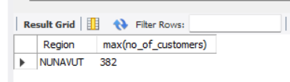

1. ***Find all the customers from Atlantic region who have ever purchased ‘TABLES’ and the number of tables purchased (display the customer name, no_of_tables purchased)***

select c.Customer_Name,sum(m.Order_Quantity) as no_of_tables_purchased

from market_fact as m join cust_dimen as c on m.Cust_id=c.Cust_id

join prod_dimen as p on m.Prod_id=p.Prod_id

where c.Region = "ATLANTIC" and p.Product_Sub_Category="TABLES"

group by c.Customer_Name

order by sum(m.Order_Quantity) ;

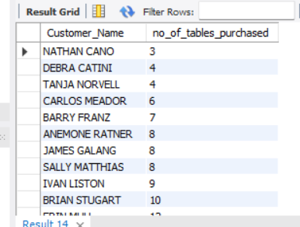

1. ***Find all the customers from Ontario province who own Small Business. (display the customer name, no of small business owners)***

*# due to some confusion after reading the question I am providing two solutions here*

a] select Customer_Name,Customer_Segment from cust_dimen

where Province= "ONTARIO" and Customer_Segment= "SMALL BUSINESS" ;

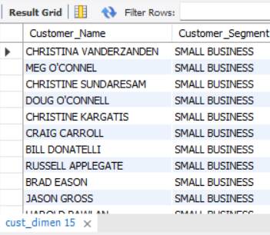

b] select customer_name,COUNT(*) as no_of_small_business_owner from cust_dimen where province='ontario' and customer_segment='small business' ;

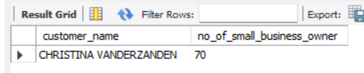

1. ***Find the number and id of products sold in decreasing order of products sold (display product id, no_of_products sold)***

select p.Prod_id,sum(m.Order_quantity) as no_of_products_sold

from market_fact as m join prod_dimen as p

on (m.Prod_id=p.Prod_id)

group by Prod_id

order by sum(m.Order_quantity) desc ;

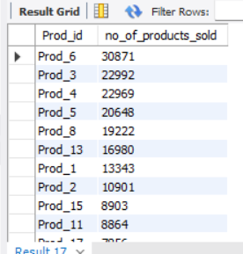

1. ***Display product Id and product sub category whose product category belongs to Furniture and Technology. The result should contain columns product id, product sub category***.

select Prod_id,Product_Sub_Category from prod_dimen

where Product_Category in ("FURNITURE","TECHNOLOGY") ;

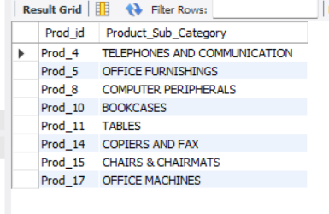

1. ***Display the product categories in descending order of profits (display the product category wise profits i.e. product_category, profits***)

select p.Product_Category,sum(m.Profit) from

market_fact as m join prod_dimen as p

on (m.Prod_id=p.Prod_id)

group by p.Product_Category

order by sum(m.Profit) desc ;

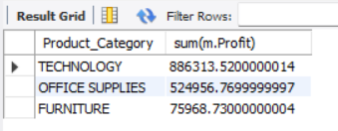

1. ***Display the product category, product sub-category and the profit within each subcategory in three columns.***

select p.Product_Category,p.Product_Sub_Category,sum(m.Profit) from

market_fact as m join prod_dimen as p

on (m.Prod_id=p.Prod_id)

group by p.Product_Sub_Category ;

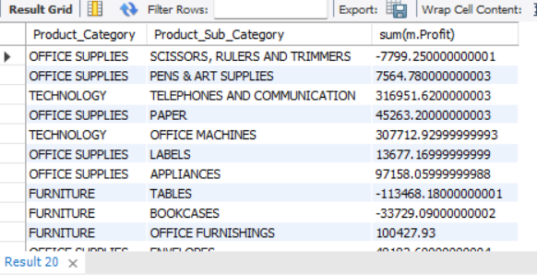

1. ***Display the order date, order quantity and the sales for the order.***

select o.Order_Date,m.Order_Quantity,m.Sales from

market_fact as m join orders_dimen as o

on (m.Ord_id=o.Ord_id);

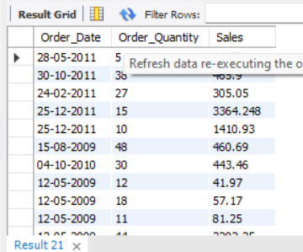

1. ***Display the names of the customers whose name contains the***
2. ***Second letter as ‘R’***
3. ***Fourth letter as ‘D’***

*# Due to some confusions after reading the question I am providing two solutions here*

a] select Customer_Name from cust_dimen

where Customer_Name like '_R%' or '___D%' ;

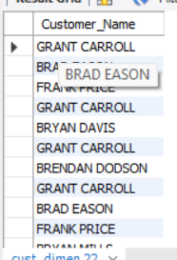

b] select Customer_Name from cust_dimen

where Customer_Name like '_R_D%' ;

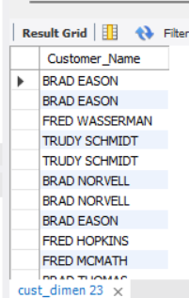

1. **Write a SQL query to to make a list with Cust_Id, Sales, Customer Name and their region where sales are between 1000 and 5000.**

select m.Sales,c.Customer_Name,c.Region,c.Cust_id from

market_fact as m join

cust_dimen as c

on (m.Cust_id=c.Cust_id)

where sales between 1000 and 5000 ;

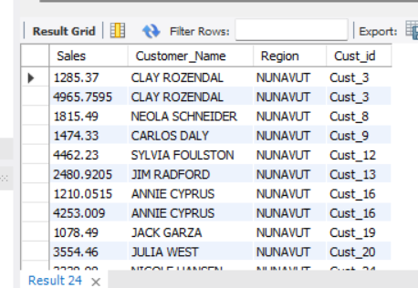

1. ***Write a SQL query to find the 3rd highest sales***

select Sales from (select Sales from market_fact

order by Sales desc

limit 3) as High_Sales

order by Sales asc

limit 1 ;

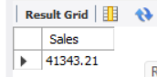

1. ***Where is the least profitable product subcategory shipped the most? For the least profitable product sub-category, display the region-wise no_of_shipments and the profit made in each region in decreasing order of profits (i.e. region, no_of_shipments, profit_in_each_region)***

***→ Note: You can hardcode the name of the least profitable product subcategory***

select c.Region,count(m.Ship_id) No_of_Shipments, sum(m.Profit) profit_in_each_region

from market_fact m

join cust_dimen c on m.Cust_id = c.Cust_id

join prod_dimen p on m.Prod_id = p.Prod_id

Where Product_Sub_Category =

( Select p.Product_Sub_Category from market_fact m

join prod_dimen p on m.Prod_id = p.Prod_id

group by Product_Sub_Category

order by sum(m.Profit)

LIMIT 1)

group by c.Region

order by sum(m.Profit) desc;

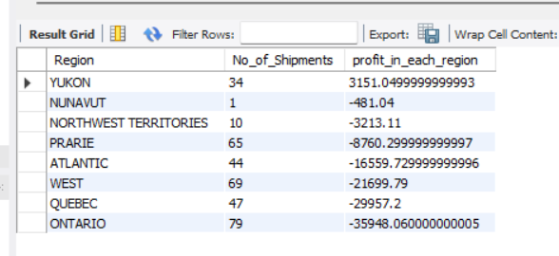

The least profitable product subcategory is ‘TABLES’

By

**Alwin Mathew**