

Dr. D.Y. Patil Unitech Society’s

Dr. D.Y. Patil Arts, Commerce and Science College, Akurdi Pune-44

2018-2019

A

Project Report

On

**BOOK SHOP MANAGEMENT SYSTEM**

Submitted in partial fulfilment of T.Y.B.B.A(CA)(Sem-VI) as laid down by the

Savitribai Phule Pune University

2018-2019

Under Guidance of

**Mrs. Malati Tribhuwan**

Submitted By

**Anmol Kumar**

**Sagar Patil**



Dr. D.Y. Patil Unitech Society’s

Dr. D.Y. Patil Arts, Commerce and Science College

Akurdi, Pune-44.

***CERTIFICATE***

This is to certify that **Anmol Kumar** & **Sagar Patil** has successfully completed the project titled “**Book Shop Management System**” for T.Y.B.B.A(CA)(Sem-VI) of Savitribai Phule Pune University for Academic year 2018-19.

**Project Guide Vice Principal Principal**

**Examiner 1: _______**

**Examiner 2: _______**

**ACKNOWLEDGEMENT**

Every task goes to completion but matters how it is done and in how much time it is done and what standard does it follows. Since its very short duration project this things maters lot.

So, we would like to sincerely thank all those who have helped us in making project a success. First of all, we would like to offer thanks to  **Mrs. MALATI TRIBHUWAN** Mamwho guided me and provided valuable information about Visual Basics and details of various products, without whom such an interactive project was impossible also for letting us this great opportunity to test our skills through the creation of our project part out syllabus.

We express our special thanks to Vice-Principal & HOD. Dr. Ranjit Patil and all staff members of Dr. D. Y. Patil Arts, Commerce and Science College, Akurdi, Pune, who assisted us throughout this project.

We finally thanks to all our collage staff and our colleagues for encouraging and helping us in doing such a big Project. Our sincere thanks go towards the faculty of our college for their kind co-operation and attention for the creation of this project.

Further, we wish to thank all persons, friends, who knowingly and unknowingly helped us in completion of this project.

If something is left, we are sorry for that.

**Sincerely,**

Anmol Kumar & Sagar Patil

**INDEX**

|  |  |  |
| --- | --- | --- |
| **Sr. No** | **Topics** | **Page No** |
| 1 | Introduction | 6-9 |
| 2 | Existing System | 10-11 |
| 3 | Proposed System | 12 |
| 4 | Fact Finding Techniques | 13-14 |
| 5 | Feasibility Study | 15-18 |
|  | 1. Technical Feasibility | 16-17 |
|  | 1. Operational Feasibility | 18 |
|  | 1. Economic Feasibility | 18 |
|  | 1. Behavioral Feasibility | 18 |
| 6 | Operating Environment | 19 |
|  | 1. Hardware Specification |  |
|  | 1. Software Specification |  |
| 7 | Analysis | 20 |
|  | 1. Entity Relationship Diagram | 21 |
|  | 1. Use Code Diagram | 22 |
|  | 1. Class Diagram | 23 |
|  | 1. Activity Diagram | 24 |
|  | 1. Sequence Diagram | 25 |
|  | 1. Component Diagram | 26 |
|  | 1. Deployment Diagram | 27 |
| 8 | Data Dictionary | 28-30 |
| 9 | Screen Layout | 31-41 |
| 10 | Testing | 42 |
| 9 | Limitation & Future Modification | 43 |
| 10 | Conclusion | 44 |
| 11 | Bibliography | 45 |

**TITLE OF PROJECT**

**BOOK SHOP MANAGEMENT SYSTEM**

**INTRODUCTION**

Computer is fast emerging as a daily need in walks of life. The knowledge of computers and programming language has become basic.

Skill need to service in today’s information-based society. Every business Institution and the corporate section, make a use of computer for making their operation efficient & effective.

Book distributors transaction handling is one of the complex process and it required computerized system to maintain overall transactions in an easier manner. Due to heavy demand of books in these competitive worlds, data increase so much. Books shop required up to date information about the customer who purchased books or about the suppliers from where books are purchased. The books shop requires large amount of data to record and to store, which are collected from the Book house.

Book Shop Management system is basically for management of incoming and outgoing material from the Book shop It also maintain management of all incoming and outgoing finance from the Shop account section. It will reduce paper work # work load of user. To reduce the paper work and provide fast service to customers. The main objective is to provide the customers fast and error free transaction. It can be used in any Book Shop for maintaining database details and their quantities. This project is used for handle user needs. It must be outgoing process to know requirements of customer during whole system development lifecycle

**INRODUCTION TO MANUAL SYSTEM**

Manual operating of the current system is having certain drawbacks.

Those are:

* Difficult for anyone to remember details of each item i.e. stock (whether available or not).
* Time consuming for owner as well as customer.
* Sometimes failing to fulfill the customer’s requirement.
* Particular distributor for a particular item is difficult to remember.
* Lot of paper work.
* Chances of getting jumbled for the item rates.

**SCOPE OF THE SYSTEM**

* This software has demands in private and public area.
* This software provides a great help in managing the data in a well3mannered order.
* This project is designed specially to maintain the data in a sequential manner and to save the tome and efforts of database Administrator.
* The project is structured according to today’s need.
* Due to time constraint it is possible that some points might remain uncovered by us.
* In future we will update our software to give valuable information left at present.

**ADVANTAGE OF THE SYSTEM**

* User-Friendly software.
* Easy to record all data about the Books and its details.
* It saves time of the user as well as prevent paper work.
* It provides the security to the database that is large amount of important data of the Book Shop.
* It provides more reliability for keeping information.

**EXISTING SYSTEM**

In the existing system, the book shop contains different types of books of various subjects with various quality according to the customer's needs and requirement. The main thing of the book shop is to maintain lot of records for the daily transaction of the business. It is necessary for every business to maintain all records, which show the profit and loss of the business.

In today's life people have very little time and many things to do. They have to manage all this unbalance workload, although everyone wants to achieve all their ambitions and dreams. And the present system of managing Books is very time consuming so it is very difficult to maintain good records and fast service. The paper work is becoming very difficult to handle day by day. Currently we have to keep track of each and every thing about the book shop on the paper or in register. We have to maintain lot of registers to enter these large volumes of data. This leads to the wastage of stationary. Furthermore, it is difficult to find where the problem is occurring or has already occurred.

The following are the major disadvantages of current examination management system:

* Existing system is not user friendly.
* System is not well organized and precise.
* It is time consuming.
* Information is redundant and inconsistent.
* It didn’t integrate all the modules.
* Decision making is difficult.
* It is not very cost effective.

**PROBLEM WITH EXISTING SYSTEM**

* Manual system involves a lot of paper work, so it becomes time-consuming and costly.
* The chances of errors in calculation of delivery of Books are more in the current manual system.
* The calculation of total collection for day or month or year is very difficult.
* Currently no security is provided to the large amount of data of every book detail.
* It becomes very difficult to maintain details of every Book as records increases day by day.

**PROPOSED SYSTEM**

Our proposed system will help a lot to reduce the drawbacks as mentioned earlier with the existing system. It is advantageous in numerous ways. Some of its advantages are:

* Easy to maintain stock details.
* Time saving for owner as well as customer.
* Quick interaction with distributors.
* Specific daily records.
* Customer’s satisfaction.
* Fast service

**FACT FINDING TECHNIQUES**

Fact Finding Techniques are core part of system analysis process. They help us to find working as well as the drawbacks of the current system. These also help in designing the efficient system so as to meet all the requirements of the users.

**The Techniques used as follows:**

**Interviews:**

Interview is the great help to find different facts about existing system. We had short conversation who handles current manual system.

* **Questionnaires:**

Questionnaires are the best way to find working as well as drawbacks of the current system. At times, user is more Sincere in working than actual conversation.

If Questionnaires use standard question formats, it can give more reliable information as compare to other fact-finding methods.

* **Record Review Method:**

Record review method is also efficient of fact finding. The statistical data records of existing system are gathered and thoroughly studied. Some studies provide valuable information about the system.

In record review method, we checked out registers previously maintained by the shopkeeper.

* **Observation:**

This method is allowing analyst to get the information that cannot be obtained from any other source of information of the other fact-finding technique.

Observation is very useful for analyst when he/she actually wants to observe what activities are exactly carried out in the organization.

**FEASIBILITY STUDY**

Depending on the results of the initial investigation the survey is now expanded to a more detailed feasibility study. “FEASIBILITY STUDY” is a test of system proposal according to its workability, impact of the organization, ability to meet needs and effective use of the resources. It focuses on these major questions:

1. What are the user’s demonstrable needs and how does a candidate system meet them?
2. What resources are available for given candidate system?
3. What are the likely impacts of the candidate system on the organization?
4. Whether it is worth to solve the problem?

During feasibility analysis for this project, following primary areas of interest are to be considered. Investigation and generating ideas about anew system does this. Steps in feasibility analysis eight steps involved in the feasibility analysis are

* Form a project team and appoint a project leader.
* Prepare system flowcharts.
* Enumerate potential proposed system.
* Define and identify characteristics of proposed system.
* Determine and evaluate performance and cost effective of each proposed system.
* Height system performance and cost data.
* Select the best proposed system.
* Prepare and report final project directive to management.

Feasibility study is the procedure to identify, describe the evaluate candidate system and select the best possible action for the job. The initial investigation culminated in a proposal summarized the thinking of the analyst, was presented to the user for review. The proposal initiated a feasible study to describe and evaluate the best system to choose in terms of economical, technical and behavioral constraints.

The terms constraints involved in feasibility analysis are:

* Technical
* Economical
* Operational
* Behavioral
* **Technical Feasibility:**

A study of resource availability that may affect the ability to achieve an acceptable system. This evaluation determines whether the technology needed for the proposed system is available or not.

* + - 1. Can the work for the project be done with current equipment existing software technology & available personal?
      2. Can the system be upgraded if developed?
      3. If new technology is needed then what can be developed?

This is concerned with specifying equipment and software that will successfully satisfy the user requirement. The technical needs of the system may include:

* Font-End and Back-End Selection:

An important issue for the development of a project is the selection of suitable front-end and back-end. When we decided to develop the project we went through an extensive study to determine the most suitable platform that suits the needs of the organization as well as helps in development of the project. The aspects of our study included the following factors,

* Front-End Selection:

1. It must have a graphical user interface that assists employees that are not from IT background.
2. Scalability and extensibility.
3. Flexibility.
4. Robustness.
5. According to the organization requirement and the culture.
6. Must provide excellent reporting features with good printing support.
7. Platform independent.
8. An Easy to debug and maintain.
9. Event driven programming facility.
10. Front-end must support some popular back end like MS-Access. According to the above stated features we selected Java 1.9 as the front-end for developing our project.

* Back-End Selection:

1. Multiple user support.
2. Efficient data handling.
3. Provide inherent features for security.
4. Efficient data retrieval and maintenance.
5. Stored procedures.
6. Popularity.
7. Operating System compatible.
8. Easy to install.
9. Various drivers must be available.
10. Easy to implant with the Front-end.

According to above stated features we selected MS-Access as the backend. The technical feasibility is frequently the most difficult area encountered at this stage. Itis essential that the process of analysis and definition be conducted in parallel with an assessment to technical feasibility. It centers on the existing computer system (hardware, software etc.) and to what extent it can support the proposed system.

* **Economic Feasibility:**

Economic justification is generally the “Bottom Line” consideration for most systems. Economic justification includes abroad range of concerns that includes cost benefit analysis. In this we weight the cost and the benefits associated with the candidate system.

And if it suits the basic purpose of the organization i.e. profit making, the project is making to the analysis and design phase. The financial and the economic questions during the preliminary investigation are verified to estimate the following:

* The cost to conduct a full system investigation.
* The cost of hardware and software for the class of application being considered.
* The benefits in the form of reduced cost.
* The proposed system will give the minute information" as a result the performance is improved which in turn may be expected to provide increased profits.
* **Operational Feasibility:**

Will the system be used if it developed and implemented? Will there be a resistance from the user to the new system? The system will provide timely information and status of the various activities to manage, to facilitate the user of the system. Thus, it is concluded that the system is technically, economically and operationally feasible.

* **Behavioural Feasibility:**

After considering the following point that the system is behaviorally feasible. The project is carried out on the request of the users. To a greater extent, the proposed system aims at maximizing user friendliness. This is intended to overcome resistance to change by the exiting staff. 6sers are suite experienced in handling the computerized system. 6sers are aware of the software and hardware environment.

**OPERATING ENVIRONMENT**

***i)Hardware Specification:***

* + - * Pentium 166 MHz or higher processor
      * 256 MB RAM
      * 50 MB free hard disc space
      * SVGA monitors
      * Printer.

***ii)Software Specification:***

* + - * Front End : JAVA
      * Language : JAVA
      * Back End : MS Access & MS Word
      * Operating system : Windows 98 , XP, 7, 8, 10

**ANALYSIS**

* **System Analysis:**

System analysis is the detail study of the various operation performed by the system and their relationship outside the system.

Here the key question is:

1. What all problems exist in present system?

2. What must to be done to solve the problem.

3. Analysis begins when user or manager begins the study of the program using existing system.

The commonly used tools in the system are UML Diagram, etc.Training experience and common sense is required for collection of relevant information needed to develop the system.

* **Requirement Analysis:**

Before designing the proposed system, it is necessary to have a clear idea about working of the system. This is done by gathering information with the help of Fact-finding Techniques.

Requirement analysis aims at establishing requests for the system to be acquired, developed and installed. It involves studying analyzing the ways of an organization currently processing the data to produce information. Analyzing the problem thoroughly forms the vital part of the system study. In system analysis, prevailing the situation of the problem is carefully examined by breaking them into sub problems. Problematic areas are identified and information is collected. Data gathering is essential for the designer with objectives, activates and the function the organization in which the system is to be implemented.

**SYSTEM DESIGN**

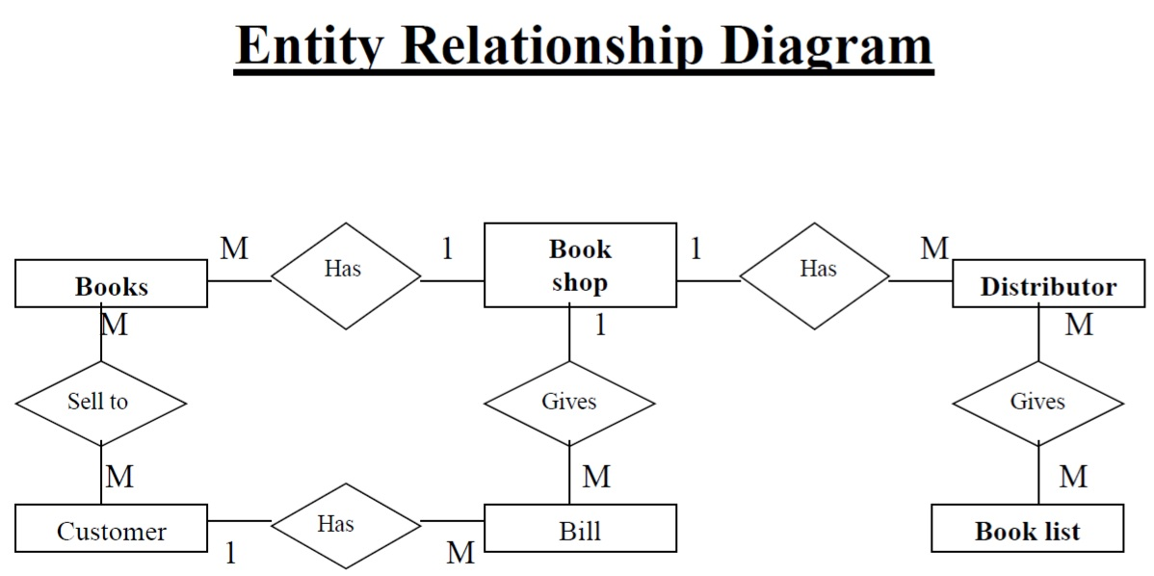

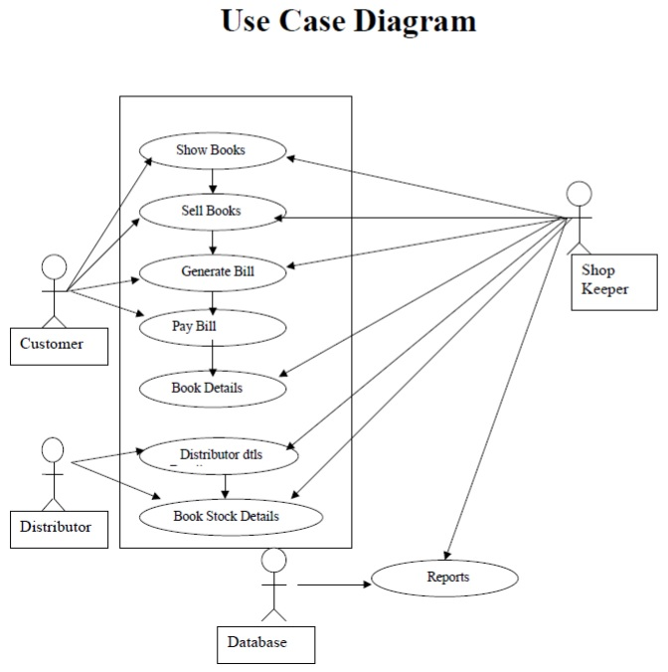

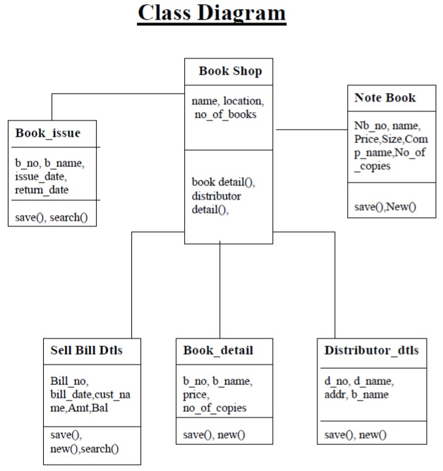

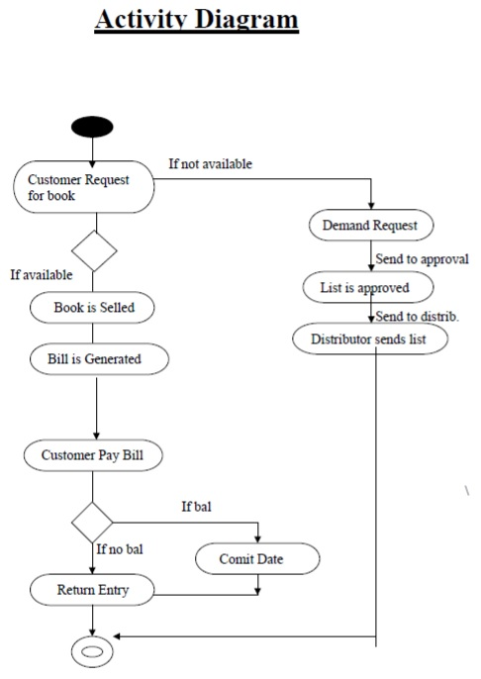

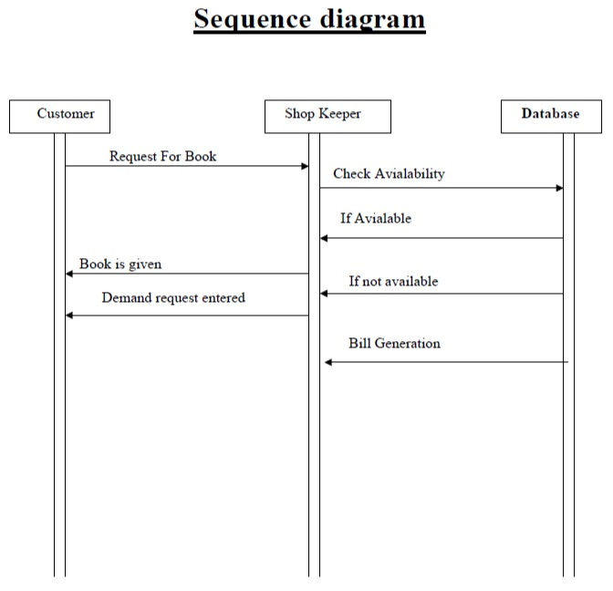

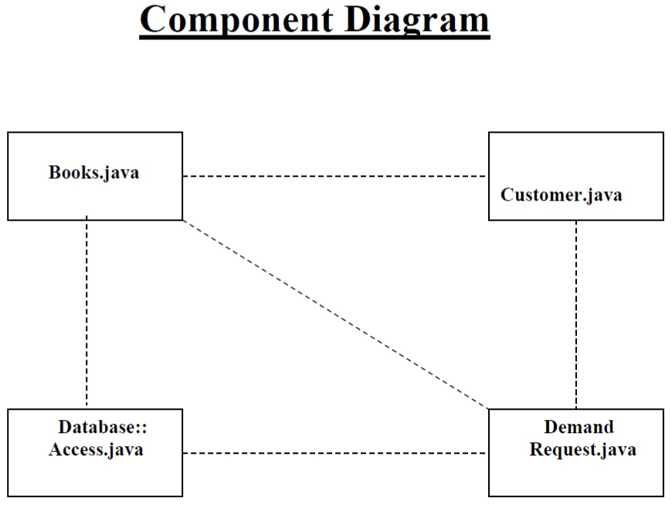

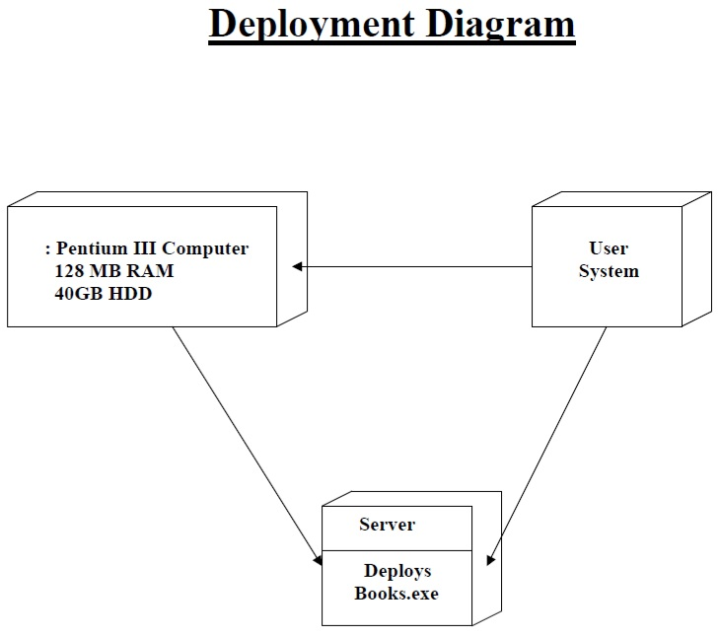

**DATA DICTIONARY**

A data dictionary is a catalogue repository of the elements in a system. This dictionary mainly talks about data and the way they are structured to meet user requirements and organizational needs.

**Book Details: -**

|  |  |  |  |
| --- | --- | --- | --- |
| **FIELD NAME** | **TYPE** | **SIZE** | **CONSTRAINT** |
| book_id | Text | 50 | Primary Key |
| book_name | Text | 50 |  |
| author | Text | 50 |  |
| publication | Text | 50 |  |
| Sale_cost | Number | Long Integer |  |
| Purchase_cost | Number | Long Integer |  |
| quantity | Number | Long Integer |  |

**Note Book Details: -**

|  |  |  |  |
| --- | --- | --- | --- |
| **FIELD NAME** | **TYPE** | **SIZE** | **CONSTRAINT** |
| nbookid | Text | 50 | Primary Key |
| nbookname | Text | 50 |  |
| company | Text | 50 |  |
| size | Text | 50 |  |
| type | Text | 50 |  |
| pages | Text | 50 |  |
| nbsale_cost | Number | Long Integer |  |
| nbpurchase_cost | Number | Long Integer |  |
| quantity | Number | Long Integer |  |

**Stationary Details: -**

|  |  |  |  |
| --- | --- | --- | --- |
| **FIELD NAME** | **TYPE** | **SIZE** | **CONSTRAINT** |
| stid | Text | 50 | Primary Key |
| stname | Text | 50 |  |
| manufacturar | Text | 50 |  |
| Sale_cost | Number | Long Integer |  |
| Purchase_cost | Number | Long Integer |  |
| Quantity | Number | Long Integer |  |

**Dist. info: -**

|  |  |  |  |
| --- | --- | --- | --- |
| **FIELD NAME** | **TYPE** | **SIZE** | **CONSTRAINT** |
| distid | Text | 50 | Primary Key |
| distname | Text | 50 |  |
| distaddr | Memo |  |  |
| distph | Text | 50 |  |
| distmob | Text | 50 |  |
| distfor | Text | 50 |  |

**Sale Bill: -**

|  |  |  |  |
| --- | --- | --- | --- |
| **FIELD NAME** | **TYPE** | **SIZE** | **CONSTRAINT** |
| BillNo | Number | 50 | Primary Key |
| Date | Text | 255 |  |
| CustName | Text | 50 |  |
| Phno | Text | 50 |  |
| totamt | Text | 50 |  |
| paid | Text | 50 |  |
| bal | Text | 50 |  |
| bpand | Text | 50 |  |

**Purchase Bill: -**

|  |  |  |  |
| --- | --- | --- | --- |
| **FIELD NAME** | **TYPE** | **SIZE** | **CONSTRAINT** |
| date | Number | 50 |  |
| distid | Text | 50 | Foreign Key |
| distname | Text | 50 |  |
| perti | Text | 50 |  |
| pcost | Text | 50 |  |
| qty | Text | 50 |  |
| amt | Text | 50 |  |
| amttype | Text | 50 |  |
| cdno | Text | 50 |  |

**SCREEN LAYOUT**

**Login Screen:**

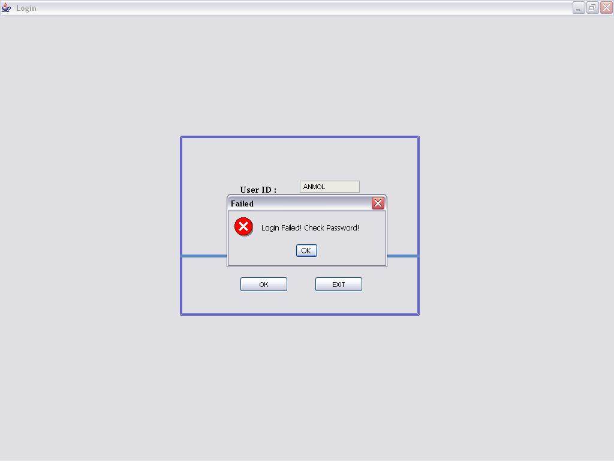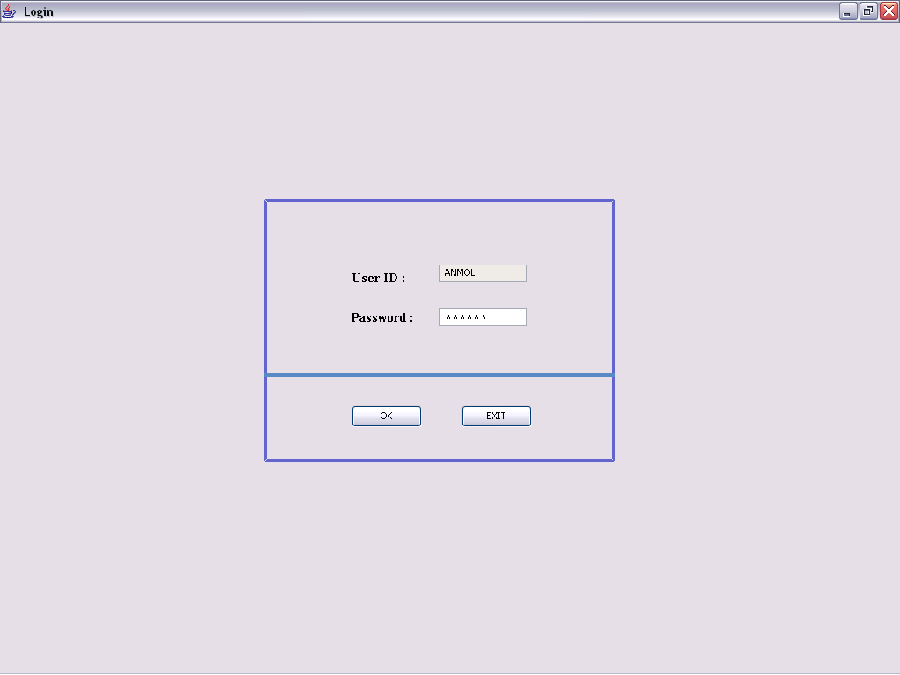

**Main Screen:**

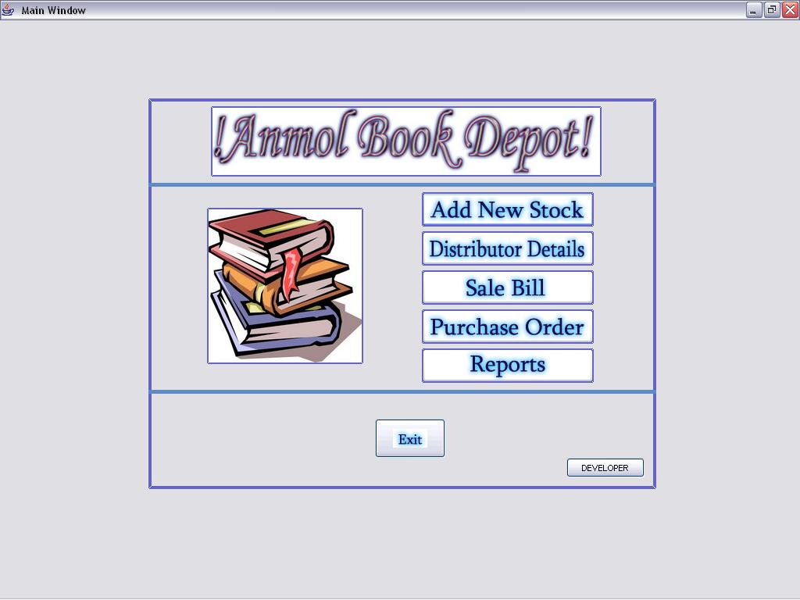

**Stock Screen:**

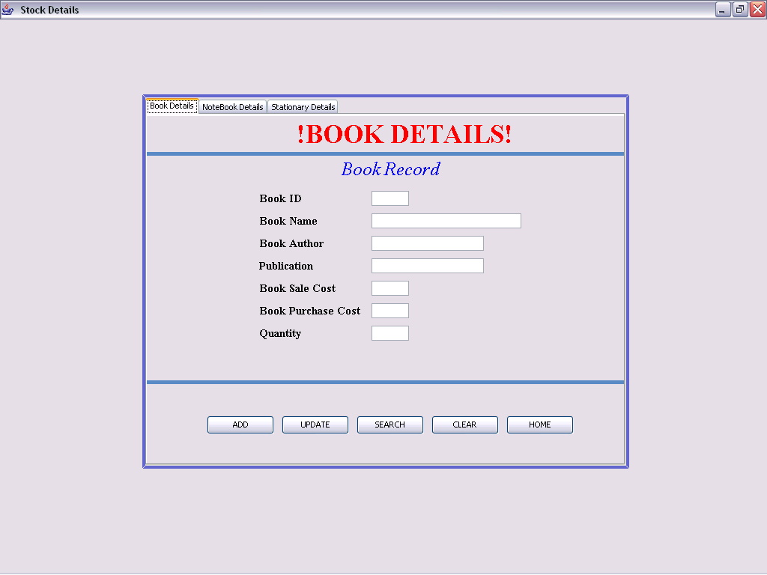

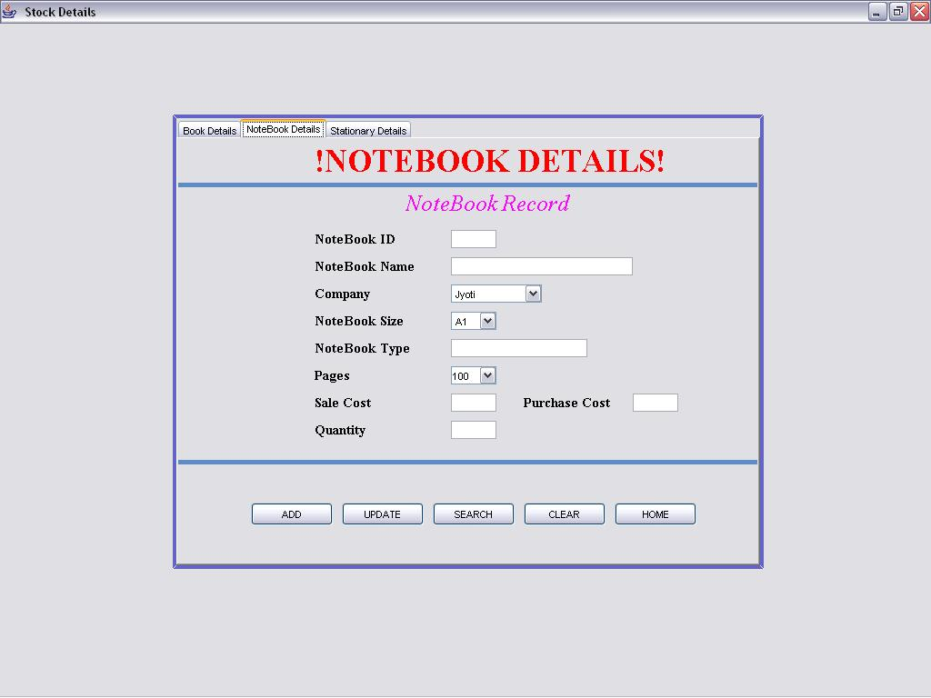

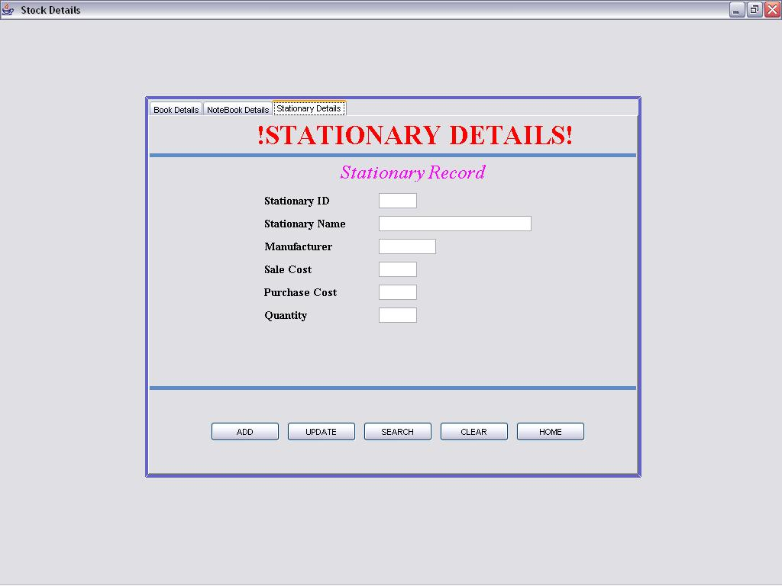

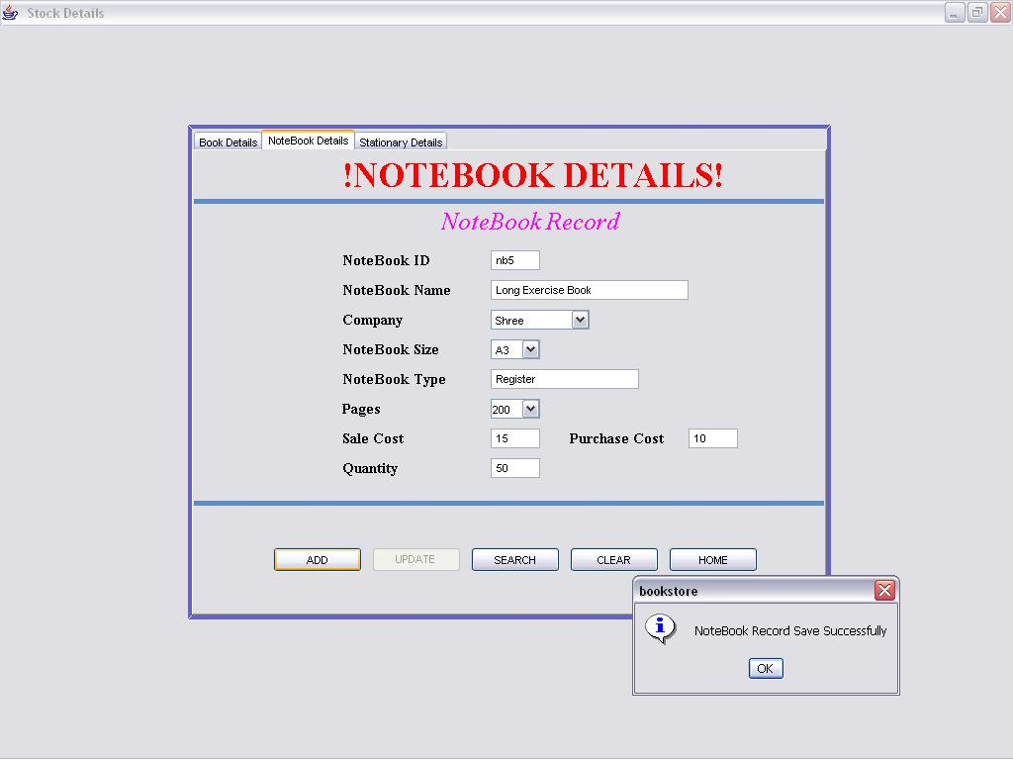

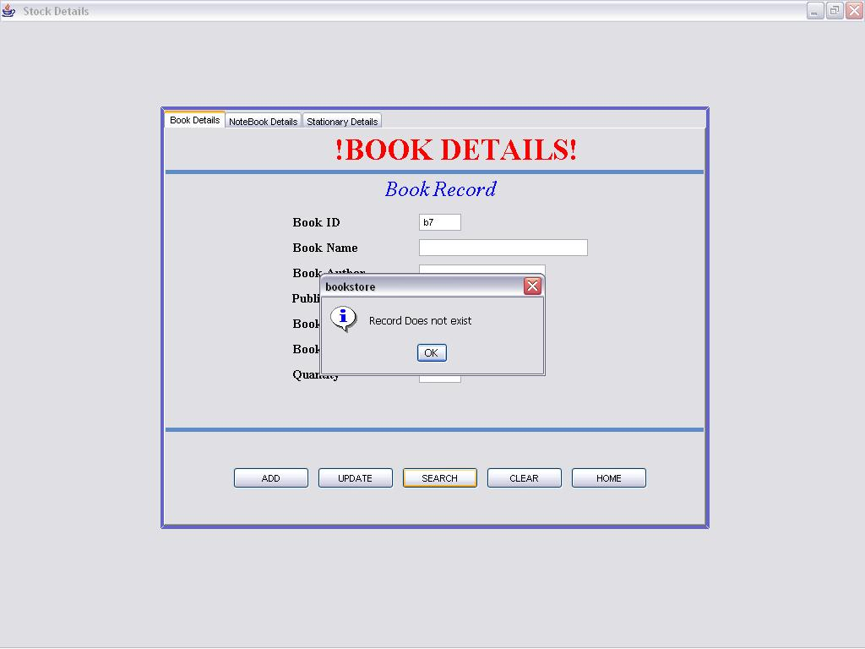

**Distributer Screen:**

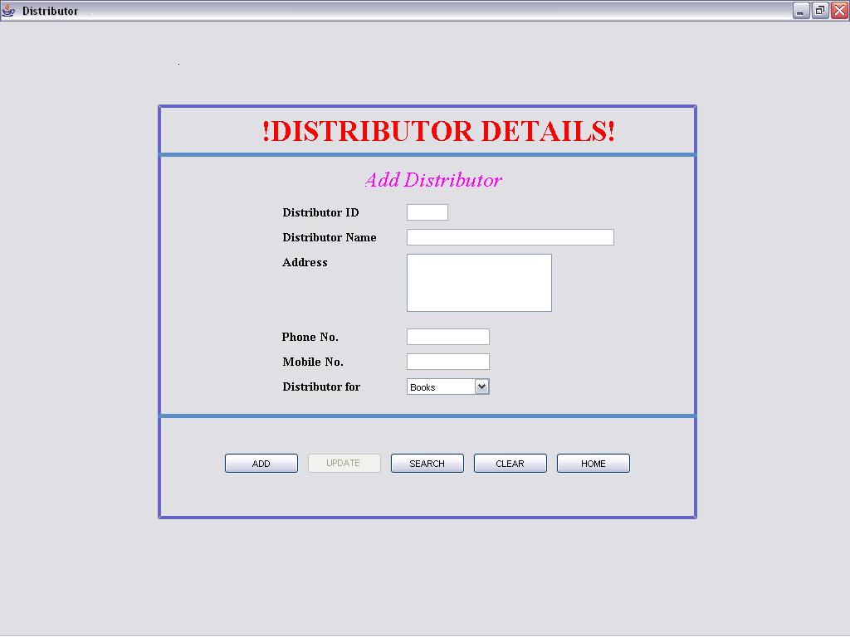

**Bill Screen:**

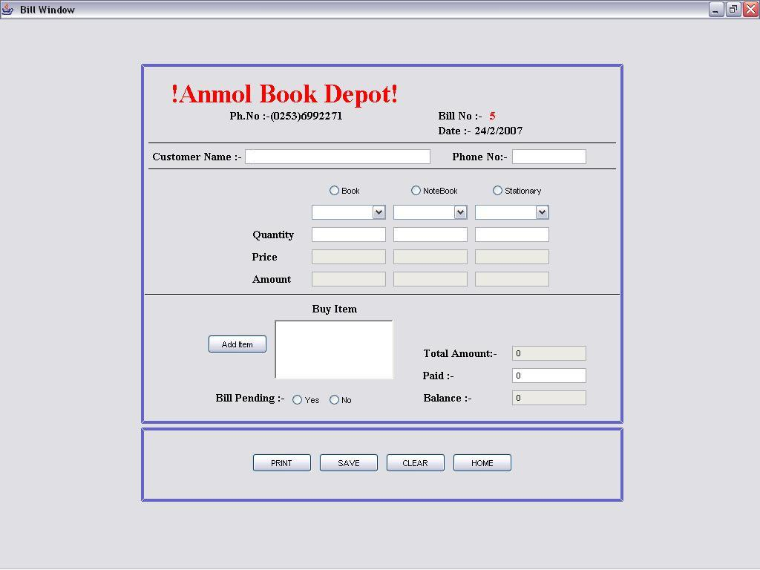

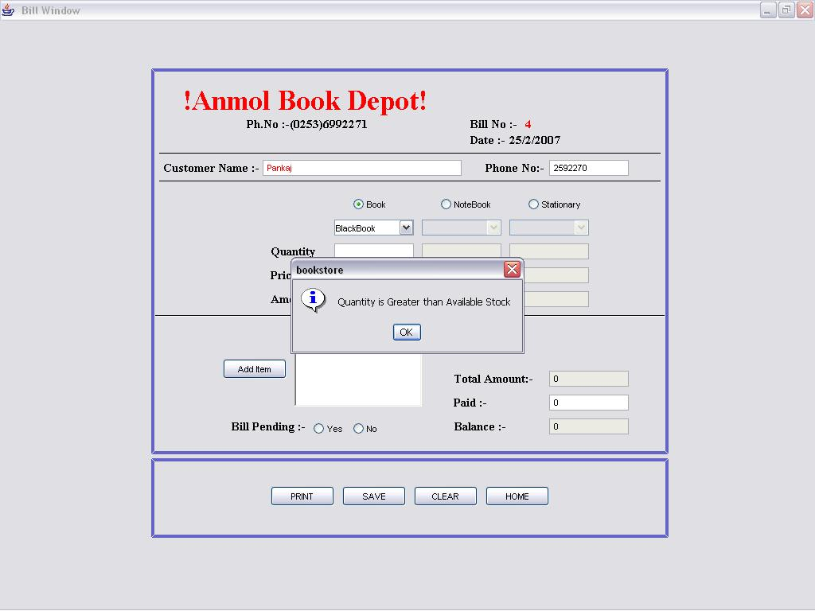

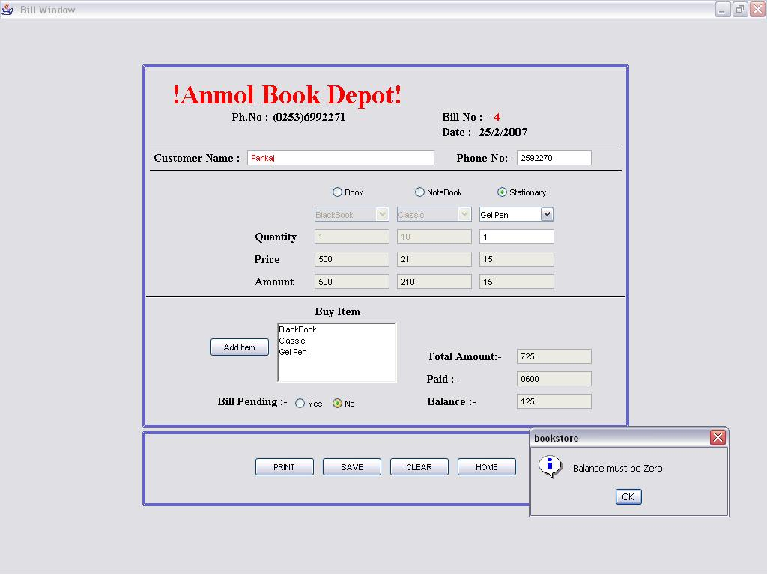

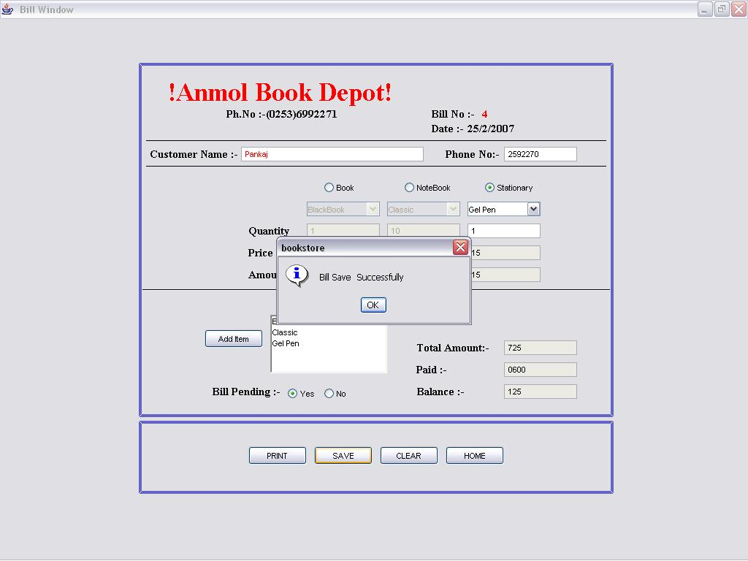

**Purchase Screen:**

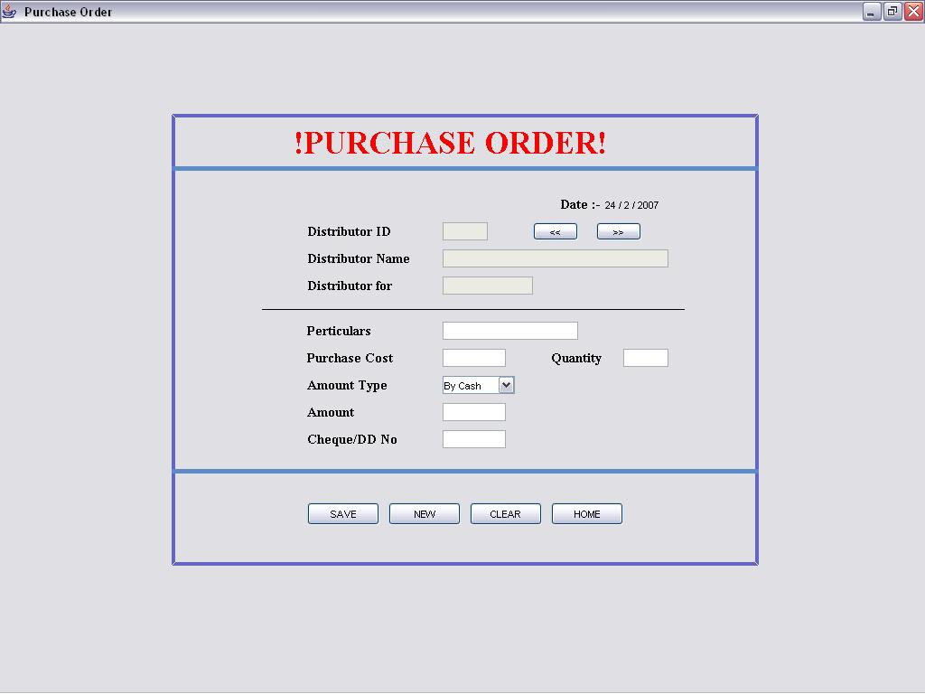

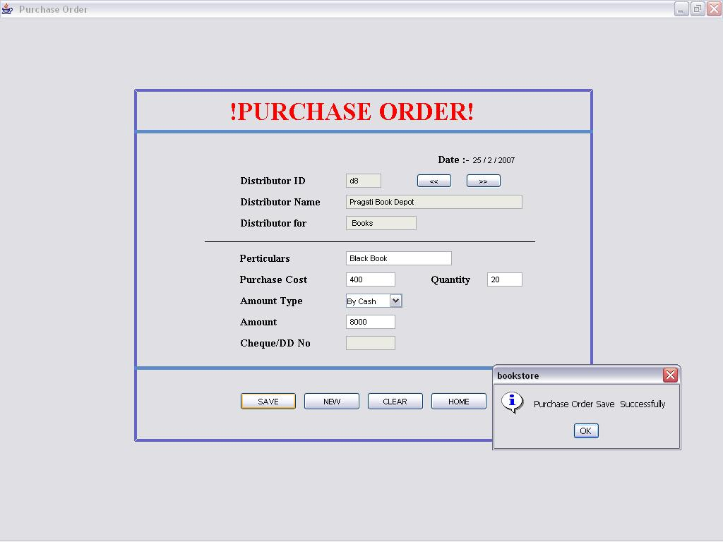

**Report Screen:**

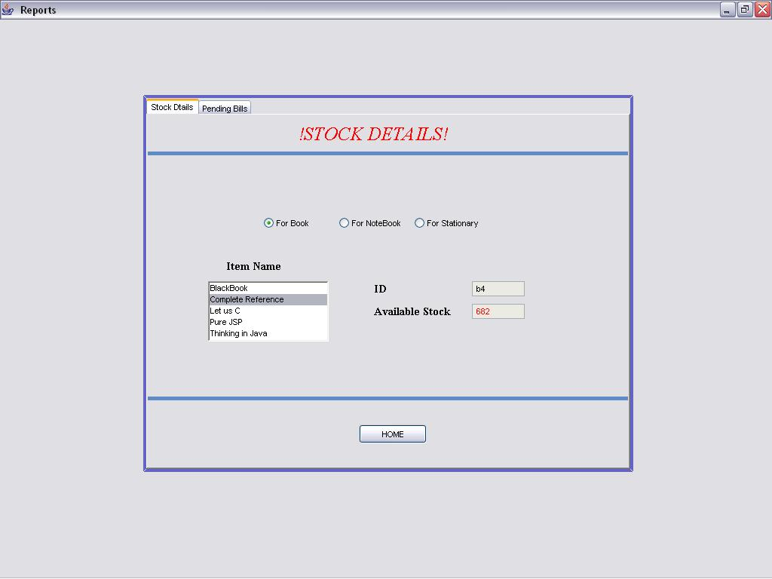

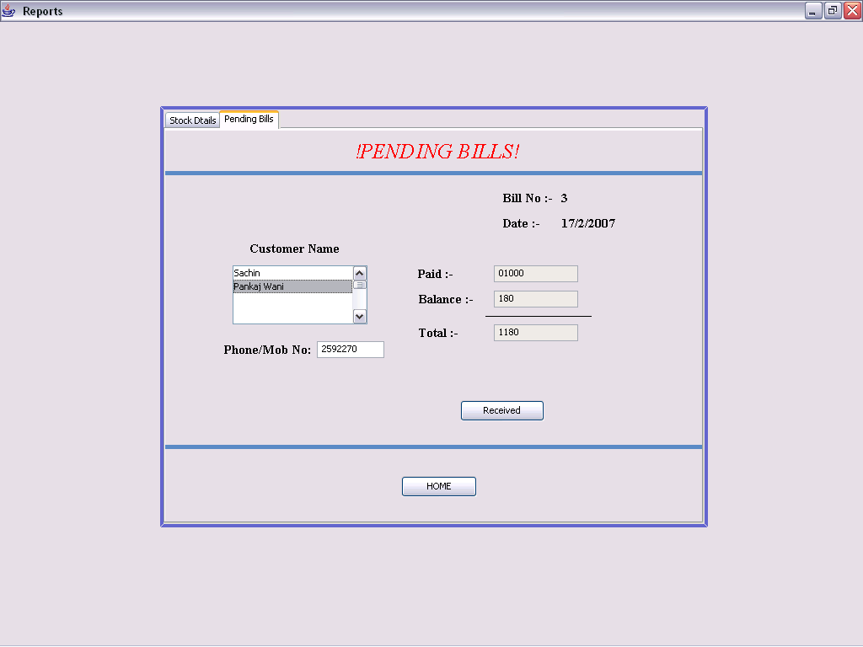

**Database Table Screen:**

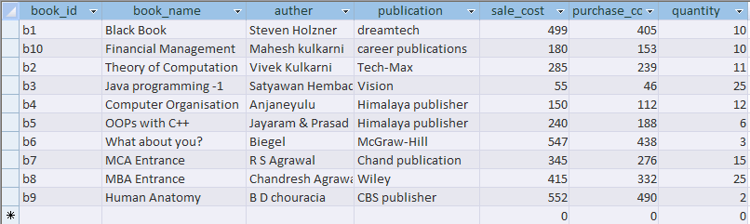

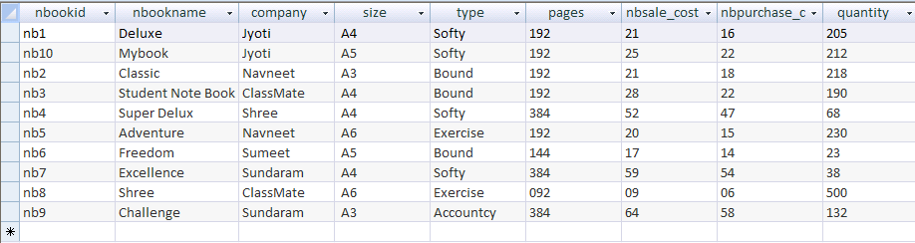

**TESTING**

Basic objectives of testing are to find errors. Software quality must be primary concern. Software testing and evaluations are traditional methods of checking software quality. Testing gives guarantee that the software does not fail and will run according to its specifications and in the way user expects. The people who are not involved in the initial system mostly do testing because it is a human nature that we ourselves can’t find any errors in our work.

The basic activities involved in testing phase are as follows:

1. Checking the individual program, its logic and interfaces between various programs.
2. Designing the test cases for checking the interfaces.
3. Checking the quality of code and its adherence to the established standards.
4. Checking whether system produce correct and desired results.

**LIMITATION & FUTURE MODIFICATION**

**LIMITATION:**

Every system has limitations. In the developed system there are some limitations.

1. The coding system is developed assuming the lengths of codes created is insufficient.
2. The data across the field size is supplied it would not supports the database.
3. The mi. Mentioned software and requirements are must else the system will not work.
4. The developed system is single user system.

**FUTURE MODIFICATION:**

1. More reports can be added to improve the system.
2. More security features for reports and transactions can be added to the system
3. All the other transactions carried out in the systems which are not included in the developed software can be considered in future.
4. The developed system can be modified to multi-user system.

**CONCLUSION**

This system computerizes the Book shop management process in any book shop. It manages the different operations in book shop such as maintain record of available books, Available Employee, Keeps records of sales & purchase and view progress of employee. and. It has the searching option along with managing capability. New features and modules can be added into the system as per user requirement.

Every system has its own merits and demerits in the era of computer such error negligible. Through this system is fast accurate user friendly and easy to use. This system helps the user to reduce their time or to save time.

While doing this project I came to know in and out java, GUI with its database and maintain it also.

**BIBLIOGRAPHY**

* **Reference Books:**

1. Black Book - Steven Holzner
2. Java 2: The Complete Reference - Herbert Schildt

* **Websites:**

1. www.google.com
2. www.ramdasbiradar.com
3. www.w3school.com