|  |
| --- |
| Binghamton University |
| Portfolio Website |
| Master’s Project |

|  |
| --- |
| Anmol Haksar  [anmolh09.github.io/](https://anmolh09.github.io/) |

1. *Introduction*

A portfolio showcases the skillset and experience that a person possesses. A developer portfolio is essential since it provides a summary of type of projects a person has worked on and skill level of each technology that the engineer has along with their contact details.

This is more convenient than a resume since it can be accessed from anywhere using a URL and a person can keep it updated without requiring sending the new version to each prospective employer.

1. *Tech Stack*
2. Angular

Angular is an open source framework for creating front ends and user interfaces. It uses Type Script by default which enables it to have type safety. It is a “batteries included” framework which includes additional functionality in the form of modules like Animations, Forms and Router Module which can be imported as required in an application.

1. Bootstrap

Creating uniform user interfaces for web application using Vanilla JS, CSS and HTML can be challenging. Bootstrap is a CSS framework which enables developers to create UI components with relative ease using predefined CSS classes. It also has the benefit of making the UI responsive i.e. adapting itself as per the screen size of the user.

1. Zone.js

Unlike other UI frameworks and libraries, in Angular we do not need to explicitly request it to update the UI after we modify the state of the application. In Angular it is done for you using Zone.js library. It tracks all the possible events that can update the state of the application and triggers a check across the entire DOM when it detects that a change might have occurred and accordingly updates the UI

1. *Features*
2. Leetcode Data Display

Leetcode expertise is vital in the job market. Leetcode problems are often asked in the initial rounds of the top companies. To showcase my Leetcode profile and also to keep me motivated to solved more problems, I have incorporated my Leetcode data into the website

For this I have utilized leetcode-stats-api ( <https://github.com/JeremyTsaii/leetcode-stats-api> ) to fetch my leetcode data and present it in a visually appealing format using animation

Below is sample data returned when the API is called with my username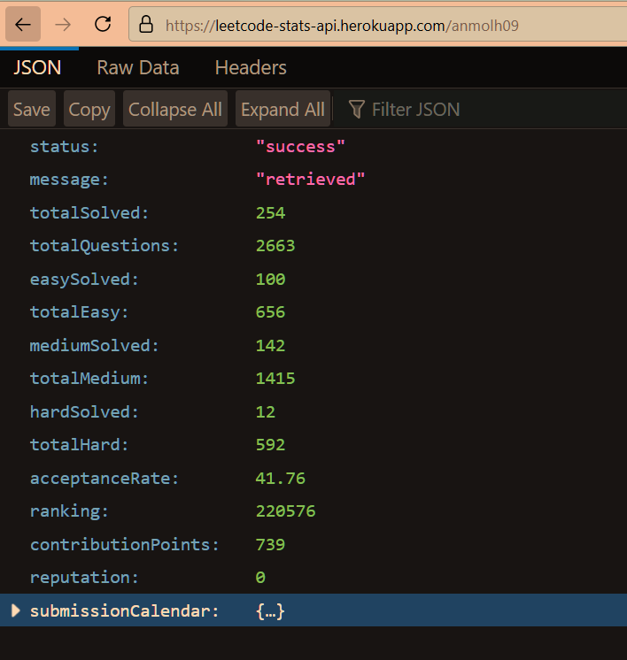

Below is a screenshot of how the data is represented on the UI.

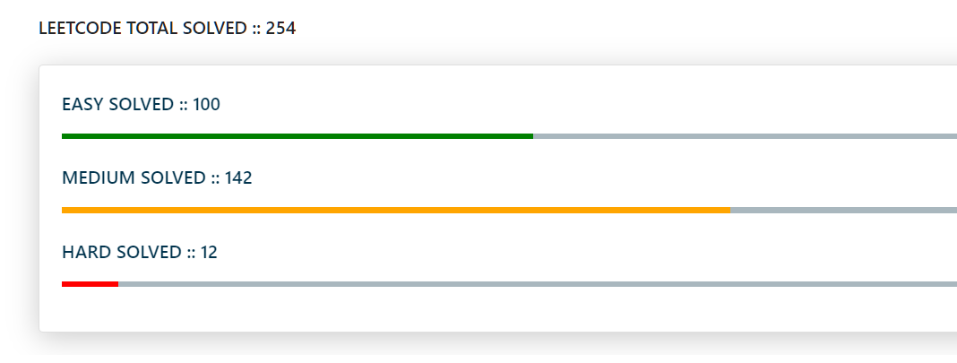

1. Animate on Scroll

Animations help engage the observer and make the site more appealing to browse.

I have used the Animate on scroll library ( <https://github.com/michalsnik/aos> ) to animate the components of the site into view when the user scrolls to the respective section. The graphs are also animated using this library to provide a dynamic effect.

The library provides ways to adjust the behaviour using data-aos-* attributes like shown below.

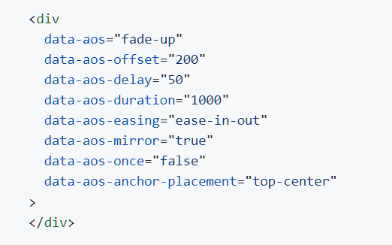

1. Animating Number Counters

For displaying a larger number a counting animation has been implemented to make the stats more eye-catching.

This is done by setting the value of the displayed number equal to zero at the start and incrementing the value after a specific interval using the setInterval() method

This is reusable code and an html element only needs to have as class of “num” to make use of this functionality.

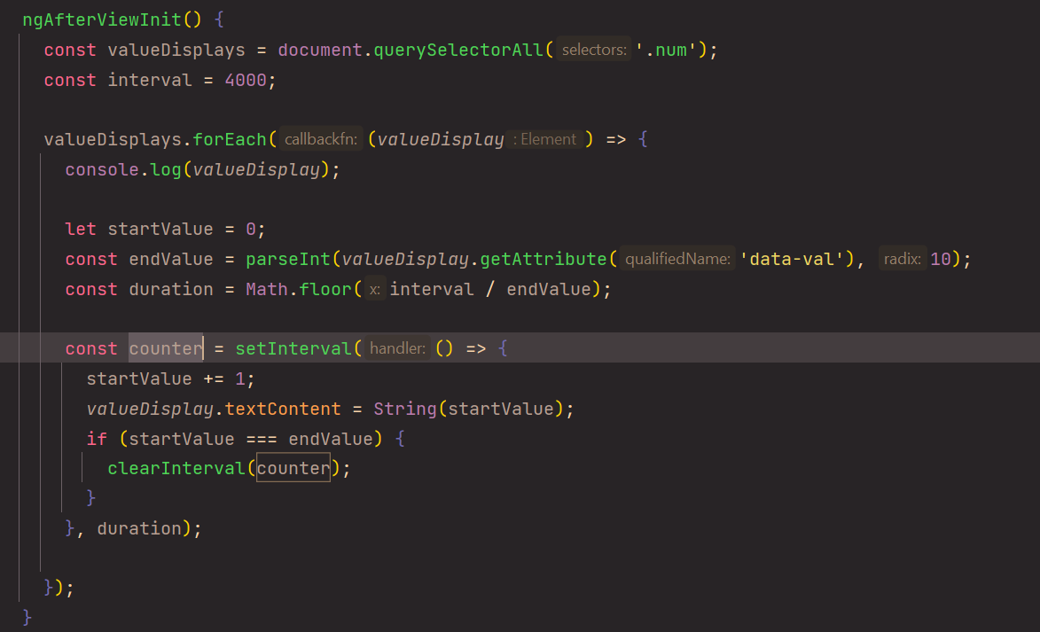



1. Github Deploy

I have utilized the github functionality to deploy a site to a custom URL which can be accessed via the internet. For this I have created a repository with my github username and it is accessible on <http://anmolh09.github.io>

1. *Screenshots*



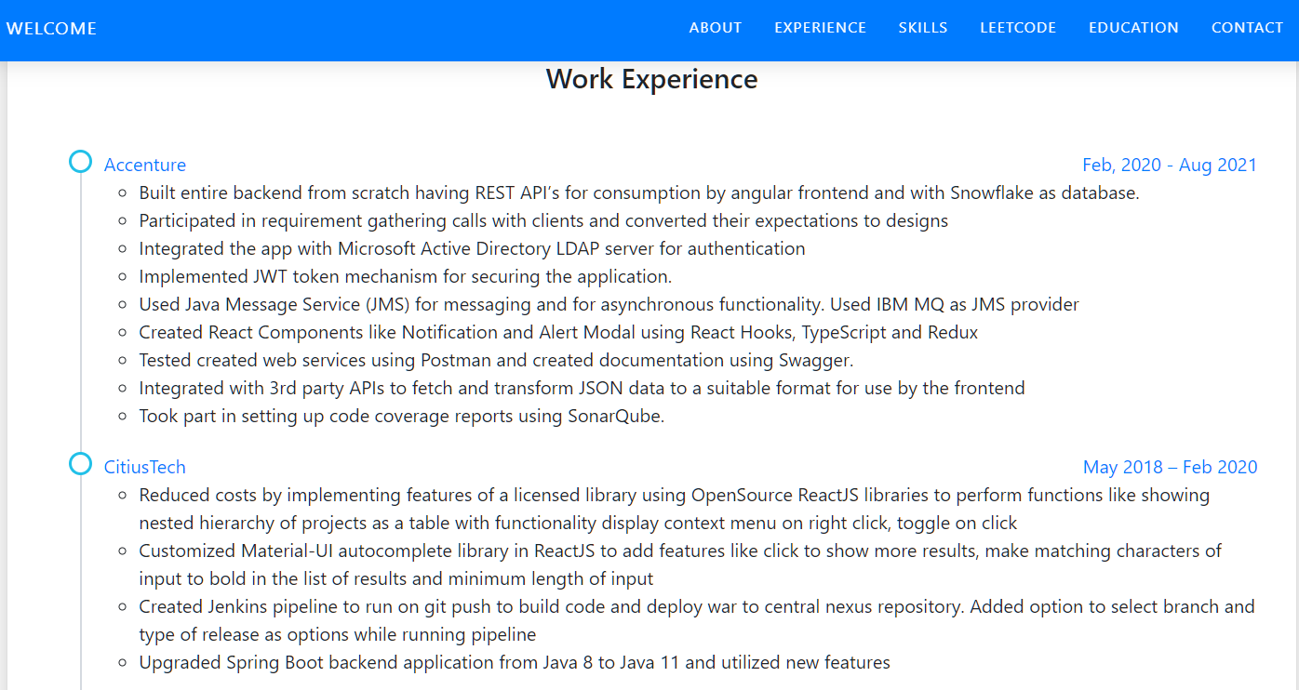

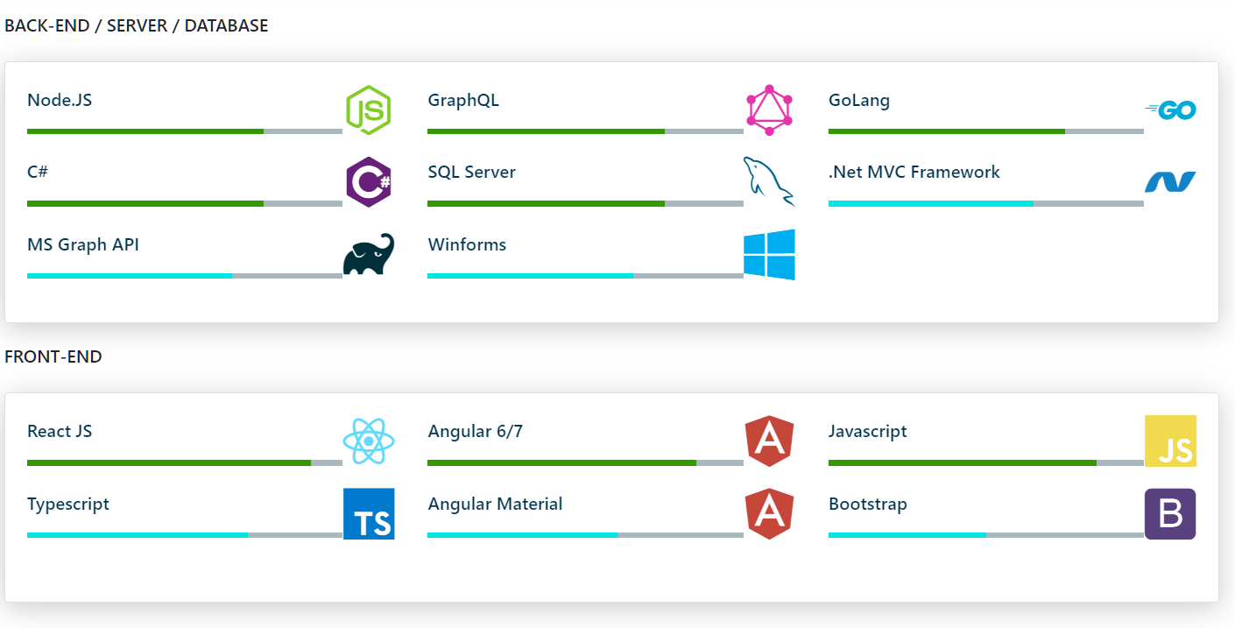

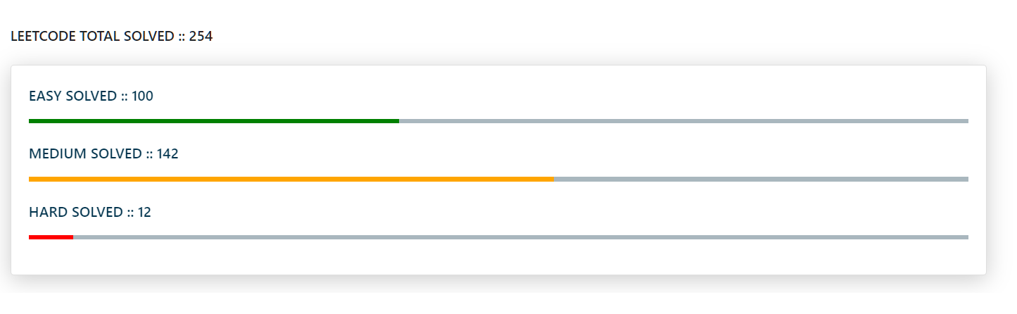

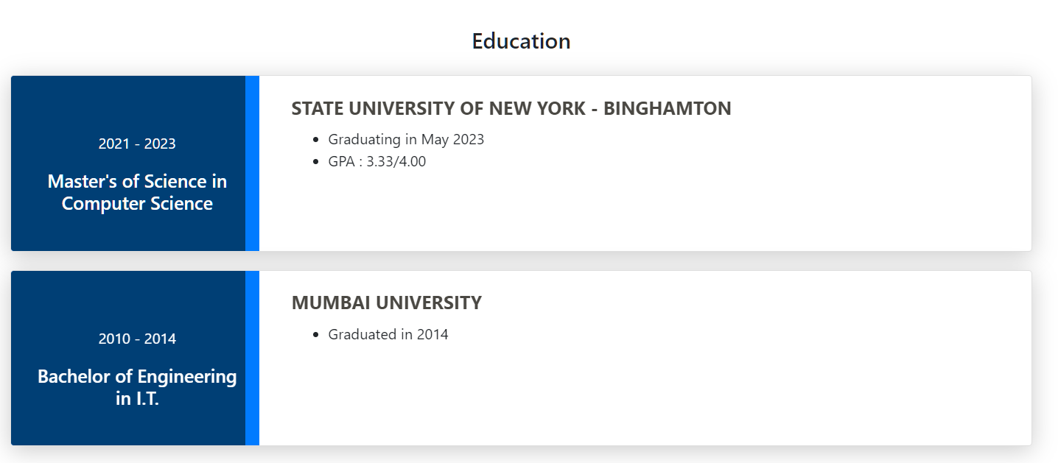

1. *Further Improvements*

* Externalize constants in the application.
* Cache the results of the web service calls used so that we can prevent additional calls to the external API.
* Reset the counters to zero when the user scrolls back up.

1. *Links*

* <https://anmolh09.github.io/> ( Live URL)
* <https://github.com/anmolh09/personal-site.git> ( Code Repository)
* <https://github.com/JeremyTsaii/leetcode-stats-api>
* <https://github.com/michalsnik/aos>
* <https://bootstrapcdn.com/bootstrap/4.1.1/js/bootstrap.min.js>
* <https://cdn.jsdelivr.net/gh/devicons/devicon@v2.15.1/devicon.min.cs>