**EmDrive : The Future of Space**

Niharika Agarwal

11510097

ECE Department, NIT Kurukshetra

Anmol J S Puri

11510556

CS Department, NIT Kurukshetra

***Abstract* -EmDrive is a proposed controversial reaction less engine model that has been worked upon for over a decade by several space agencies around the world with finally the China Academy of Space Technology claiming to have successfully realized the design. These devices use microwaves, produced by high power vacuum tubes or solid-state field-effect transistor RF generators, which are directed into a metallic, fully enclosed conically tapered high *Q* resonant microwave cavity. They have a greater area at one end of the device and, for some versions, a dielectric resonator added in front of the narrower end. They require an electric power source to run the microwave generator, but no propellant. The resonant condition can cause an increased radiation pressure and quantized inertia which can ultimately produce significant thrust for the rocket in zero gravity. We have tried to simplify and explain its working which is often said to be against Newtonian physics. Ramifications of such an invention are huge as it not only saves expensive fuel, reduces harmful gas emissions, makes long distance expeditions possible but most importantly leads to the reduction of the dead weight fuel payload a rocket has to carry.**

**Keyword- Electromagnetic Radiation, Emdrive, microwaves, Thrust, Newton.**

I. INTRODUCTION

This report documents the theoretical and experimental work carried out on a new concept of electrical propulsion for spacecraft. As this technology provides direct conversion from electrical energy to thrust, without expelling propellant, the implications for the space industry are profound. However these profound implications also give rise to some skepticism and over a number of years, considerable effort has been directed at answering the many questions that have been raised. The theory and test results that are presented in this report have therefore been independently reviewed. They offer what is believed to be a complete verification of the concept. The [heart of the Emdrive](http://en.wikipedia.org/wiki/EmDrive) is a resonant, tapered cavity filled with microwaves. According to Shawyer, the first person to propose this theoretical model in 2000, a [relativistic effect generates a net thrust](http://emdrive.com/faq.html), an effect confirmed by various Emdrives he has built as demonstrations. Critics say that any thrust from the drive must come from another source. Shawyer is adamant that the measured thrust is not caused by other factors.

While the argument over the drive’s impossibility continues, so does the engineering work. The problem is that nobody wants to talk about it. The thrust is the result of a [relativistic effect](http://emdrive.com/theory.html) and would not occur under simple Newtonian physics. Professor Yang Juan of the College of Astronautics at Northwestern Polytechnic University (NPU) in Xi’an, China and his team have been working o the concept for years have claimed to have finally found success in making a prototype of the model, though the thrust produced is too small to be of any practical use. The prototype model is rumored to be under test in the Earth orbit in Chinese space station.

II. THEORY

Thus if the EM wave travelling in a tapered waveguide is bounced between two reflectors, with a large velocity difference at the reflector surfaces, the force difference will give a resultant thrust to the waveguide linking the two reflectors. If the reflectors are separated by a multiple of half the effective wavelength of the EM wave, this thrust will be multiplied by the Q of the resulting resonant cavity. The principle of operation is based on the well-known phenomenon of radiation pressure. This relies on Newton’s Second Law where force is defined as the rate of change of momentum. Thus an electromagnetic (EM) wave, travelling at the speed of light has a certain momentum which it will transfer to a reflector, resulting in a tiny force.

If the same EM wave is travelling at a fraction of the speed of light, the rate of change of momentum, and hence force, is reduced by that fraction. The propagation velocity of an EM wave, and the resulting force it exerts, can be varied depending on the geometry of a waveguide within which it travels. The inevitable objection raised, is that the apparently closed system produced by this arrangement cannot result in an output force, but will merely produce strain within the waveguide walls.

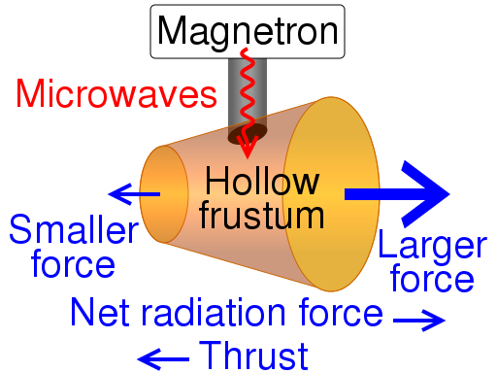

Fig. 1

However, this ignores Einstein’s Special Law of Relativity in which separate frames of reference have to be applied at velocities approaching the speed of light. Thus the system of EM wave and waveguide can be regarded as an open system, with the EM wave and the waveguide having separate frames of reference. This is the main contention between Shawyer and others who have been opposed to his design.

Consider a beam of photons incident upon a flat plate perpendicular to the beam. Let the beam have a cross-sectional area A and suppose that it consists of n photons per unit volume. Each photon has energy hf and travels with velocity c, where h is Planck’s constant and f is the frequency. The power in the incident beam is then

P  nhfAc. (1)

The momentum of each photon is hf/c so that the rate of change of momentum of the beam at the plate (assuming total reflection) is 2nhfA. Equating this change of momentum to the force Fo exerted on the plate, we find

F =nhfA= 2P/c , (2)

which is the classical result for the radiation pressure obtained by Maxwell (Ref 1). The derivation given here is based on Cullen (Ref 2). If the group velocity of the beam is v then the rate of change of momentum at the plate is 2nhfA(v/c), so that the force Fg on the plate is in this case given by

Fg = (2P/c)(v/c). (3)

We now suppose that the beam enters a vacuum-filled waveguide. The waveguide tapers from free-space propagation, with wavelength , to dimensions that give a waveguide wavelength of g and propagation velocity vg . This is the group velocity and is given by

Vg=(c/sqrt(rer))(/g). (4)

Then from (3) and (4) (with r = er = 1) the force on the plate closing the end of the waveguide is

Fg=(2P/c)(vg/c) (2P/c)(/g); (5)

Assume that the beam is propagated in a vacuum-filled tapered waveguide with reflecting plates at each end. Let the guide wavelength at the end of the largest cross-section be g1 and that at the smallest cross-section be g2. Then application of (5) to each plate yields the forces

g1=(2P/c)(/g1), g2=(2P/c)(/g2).

Now g2 > g1, due to the difference in cross-sectional area, and hence Fg1 > Fg2. Therefore the resultant thrust will be

T=Fg1-Fg2=(2P/c)(/g1 - /g2). (6)

This same thrust is the proposed force that R. Shawyer claims to power his engine from. The difference in the radiation pressure at the two circular ends of the cavity are unequal due to different areas of the two surfaces as is illustrated in Fig. 1. This resulted difference gives the necessary thrust to the engine to power a rocket with tonnes of weight. The power thus generated also depends upon the Q factor of the cavity which depends on several factors. These factors can be varied and thus optimized to yield a cavity of high Q factor.

* Material: The material out of which the cavity is made of contributes to the percentage of the em waves’ radiation to contribute towards thrust. A conducting and a good reflective metal results in better and sharper microwaves’ resonance which is the main contributor to the thrust formed inside cavity. Thus, the new theory of using superconductors as the material for cavities has gained steam which is reported to exceed the current thrust by several hundred times. This can be explained by a simple observation. The force, pressure and radiation that we are calculating is for a single photon which interacts with a single particle of the metal. The metal being a superconductor enables the particles of the cavity to be displaced at a much higher rate. This increase in thrust is much similar to the way in which conductivity of a conductor is increased at the superconducting temperature.
* Dimensions: The taper in the cavity is to provide the difference in the radiation pressure at the two ends of the cavity. But the notion that greater the difference in the area of the two circular surfaces, the greater the thrust produced is ill-conceived as it can result in grave structural irregularities which can cause the security and stability of the rocket to come down sharply. Each material has its own resonance frequency and thus the difference in the two surfaces’ area and the height of the cavity depend upon the resonating wavelength, of the chosen material for the cavity.

It uses a tapered waveguide and a cylindrical dielectric filled section resulting in dissimilar wave velocities at each end of the waveguide. Thus the rate of change of momentum as the wave is reflected from each end wall is different and hence different forces, designated F1 and F2 are produced. The waveguide assembly is designed to be resonant at the operating frequency and therefore the force difference is multiplied by the Q of the assembly, producing a useful resultant force on the thruster.

The thruster uses a magnetron as a source of microwave energy which is

fed to the thruster through a tuned waveguide assembly. The electromagnetic wave is launched

from a slot in the side wall of the thruster and propagates with an increasing guide wavelength (g) towards the dielectric section. As the waveguide cross section decreases, the waveguide impedance also decreases, such that, with correct dimensions, the impedance at the dielectric boundary is the same on both sides. This ensures propagation continues within the dielectric section without reflection at the boundary.

III. EXPERIMENT CONDITIONS

Despite all the studies showing the existence of some thrust produced by the EmDrive prototype engine, others contradicting this theory altogether attribute this thrust to be the result of several errors that may occur in a closed experimental setup. The main cause of such an inspection is the variance in the real use environment and laboratories. In reality, its an absolute impossibility to create a complete zero-gravity atmosphere or even a perfect vacuum. And the thrust measured in experiments so far is so small that it could be assigned to any of the several errors that may arise from any irregularity in setup the perfect environment. Still the latest experiments performed in China offer a greater thrust while negating all the causes of errors raised by various scientists around the globe, physicists who call it a contradiction of Newtonian Physics. The experiment took precautions for most of the errors to avoid any experimental errors in the data.

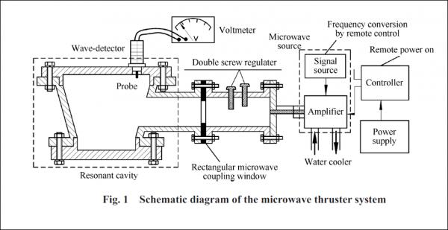Fig.2

With more and more funds being given to research for a propellant-less engine around the world, the tests performed today are under much better facilities. The following precautions and arrangements have been used in most of the tests that are being conducted on it around the world. These are-

* Buoyancy has been eliminated by hermetically sealing the thruster after the initial experiments to negate false high readings contributed by air present which is absent in a zero-gravity space. Even in an exceedingly strong vacuum its tough to make a 100% secure vacuum. So it still opens the chance of an uncertainty in the data by 15%.
* Convection currents did not affect the results, as measurements were taken with the thrust vector up, down and horizontal. Test runs were also carried out using a thermal simulation heater to quantify the effects of change of coolant temperature.
* Interactions between current-carrying conductors and between such conductors carrying RF currents and nearby metallic structures in which currents might be induced. Moreover, the field produced by the current carrying conductors may interact with earth’s field which is not a big factor in outer space*.* Stray electromagnetic effects are eliminated by testing two thrusters with very different mounting structures, and by changing the orientation by 90 degrees to eliminate the Earth’s magnetic field.
* Another cause blamed for such results has been the ionization within the air, which might cause electrostatic charging and resulting forces which would not happen in space as air is absent in space. But the electrostatic charges have been eliminated by the comprehensive earthing required for safety reasons, and to provide the return path for the magnetron anode current.
* To eliminate any spurious effects due to cooling fan operation, tests were carried out in a nominal configuration with both fan on and fan off.
* Thermal expansion effects could change the effective centre of gravity of the unit, giving rise to spurious torque values on the balance. To eliminate this effect, inversion of the unit was achieved by a "front to back" rotation. This rotation maintains symmetry in the vertical axis and hence the center line of thrust.
* Thus spurious torques due to thermal expansion would be common to both nominal and inverted operation and no test data differences between configurations can be attributed to thermal expansion effects.

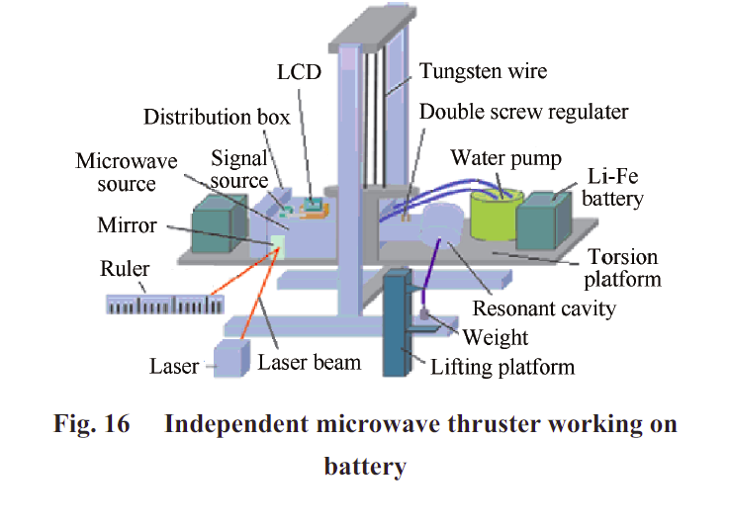

Fig.3

IV. MISCONCEPTIONS

A common misconception associated with this theory is that it is against the Modern Physics based on the principles of Einstein and Newton. On the contrary, we have shown that actually, the proposed thrust is an outcome of the formulas and paradigms given by Einstein about light and photons. The name actually creates a big ambiguity. We have studied and believed that according to the Newton’s Law of Conservation of Momentum, in a closed structure, no residual force shall exist as each pair of force acting in opposite direction must cancel each other out. But this model rather claims to use a residual thrust resulted as a reaction to a force exerted on a closed cavity containing the reflective electromagnetic waves. The paradigm can be easily explained using Einstein’s Theory of Relativity in conjunction to the Law of Conservation of Momentum. It is just the difference of frame of reference. From our perspective its a closed and bound system while in reality it is an interactive system with the microwaves, of which photons interacting with the cavity to produce unequal forces. The cavities have been designed such so as to nullify the lateral forces that may be generated at the conical surface of the cavity by radially spreading out the cavity geometrically.

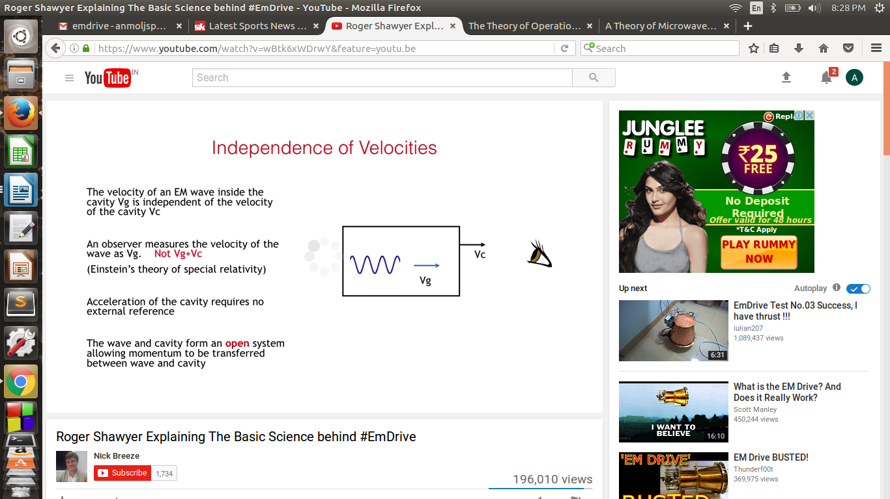Fig.4

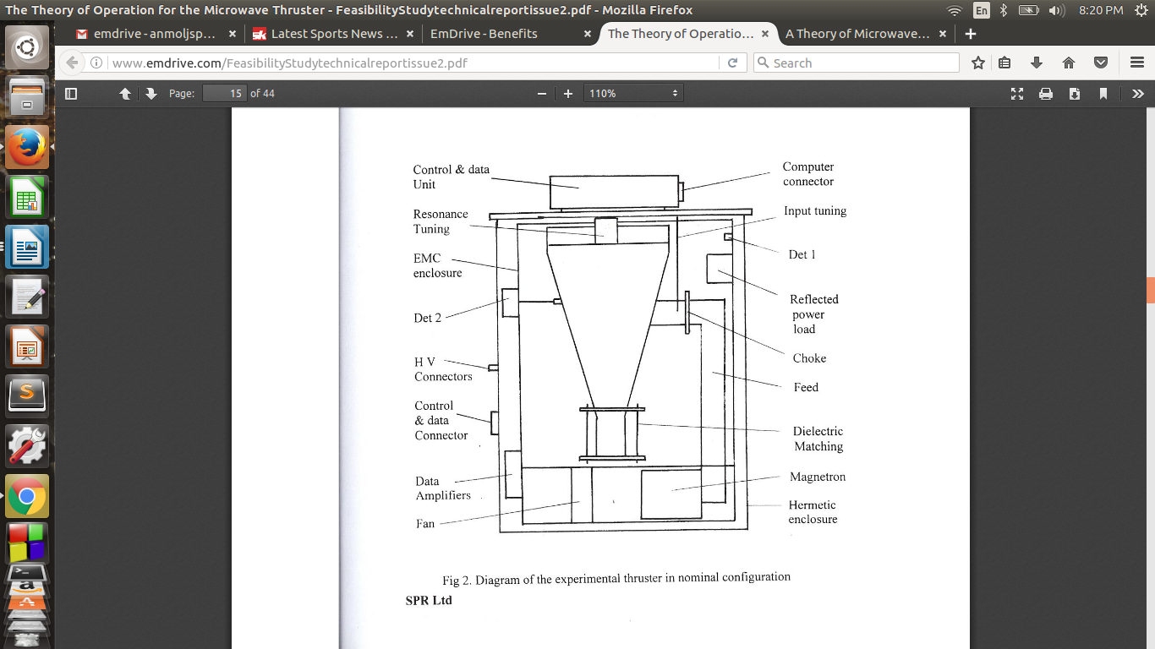As you can see in Fig.4, we observe the cavity to be moving at a speed of vc and the speed of light to be that to as well. But in reality the speed of the light waves inside the cavity is equal to vg+vc. This difference in velocities of the two causes collisions and interactions between them which over time result in a condition of resonance.

Fig.5

It is all about the frame of reference. For us its an inertial frame of reference while in actual, it is a non-inertial one since the light particles are being constantly accelerated inside the cavity as on each reflection, the direction of the photons change which consequently changes their velocity as well. Thus, it actually is a Non- inertial frame to which Newton’s Law Don’t apply. Even if we not discuss the concerned frame, the law of conservation of momentum states that the concerned system must be a closed and non-interactive which is violated by the cavity at the initial stage itself as the particles of both light waves and the cavity material are interacting with one another.

V. TEST RESULTS

TEST 1-A design model was proposed in which the basic geometry of thruster depended on many factors. It was based on that, the resonant frequency of a dielectric resonator depends on factors like diameter, lengths and most importantly, the total electric length of the resonator. To get a more accurate information about this theory, a test was performed at various tuning frequencies.

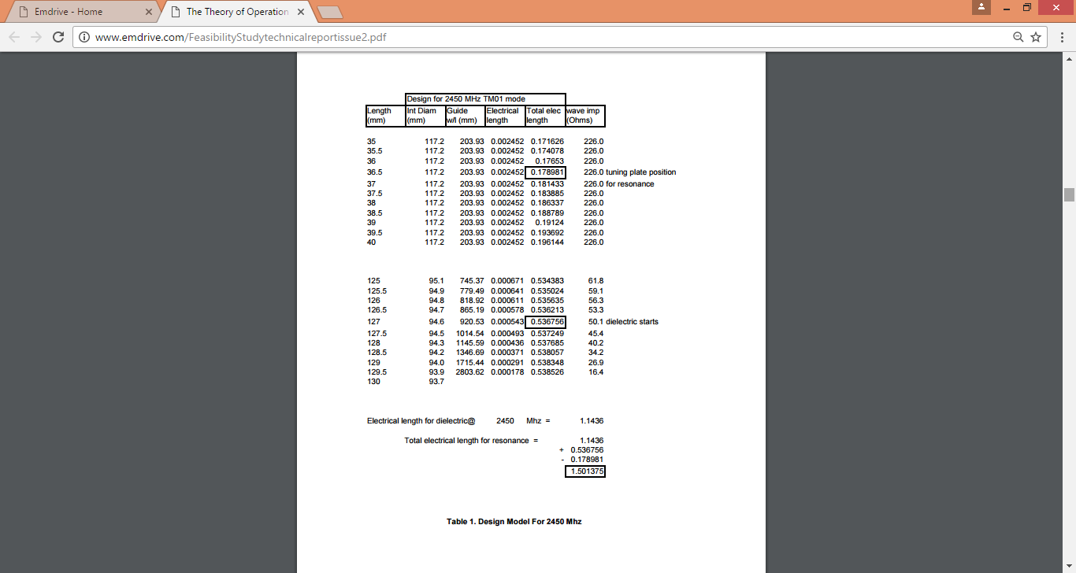

Fig.6

The initial tuning of the thruster was carried out using a 100mW crystal controlled source operating at 2450 mHz.

Number of readings were taken, noting all the possible quantities that may have effect on thrust produced. The resulting observations were as shown in the table The resulting position at a length of 127mm corresponds to the nominal 50 ohm impedance of the dielectric resonator. The final result concluded that at a frequency of 2450 mHz, the total length for resonance is 1.501375mm.

TEST 2- *Load Cell Tests* - The thruster module without the hermetic enclosure was mounted on a beam balance with the majority of the module mass being counterbalanced, as shown in Fig 7. The unbalanced mass was measured directly by a load cell connected to a digital meter via a low drift d.c. amplifier. Access to tuning plate adjustment and input tuning screw was at the top of the thruster module enclosure.

For each test run, a test sequence of 50 secs off, 50 secs on and 50 secs off was adopted with load cell readings taken every 5 secs.

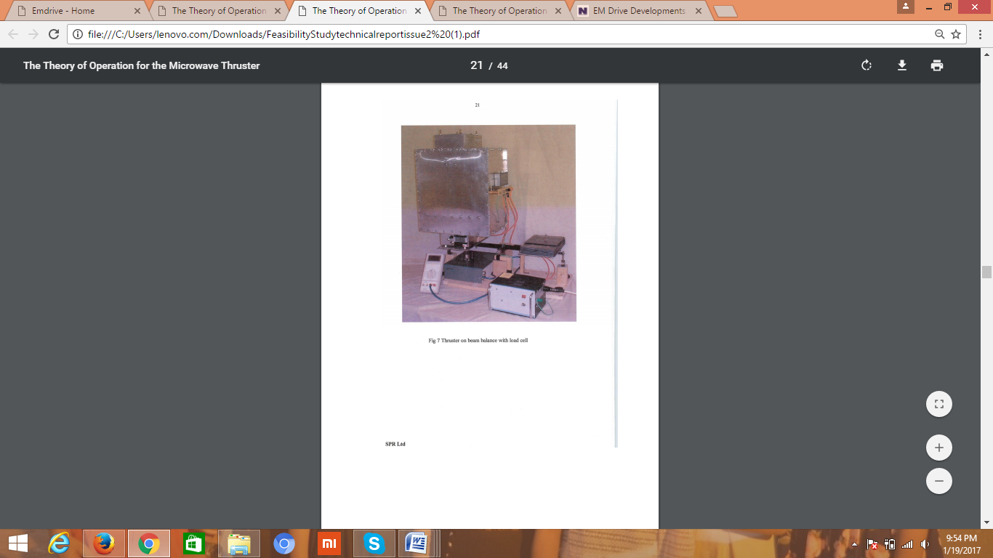

Fig.7-Thruster on beam balance with load cell.

The variation of thrust and input power with different tuning positions were noted and a graph was obtained as shown below. This graph not only proved, that there is a trust produced by the thruster, but also showed that the theory, that it depends on electric strength, tuning frequency and even its orientation is true.

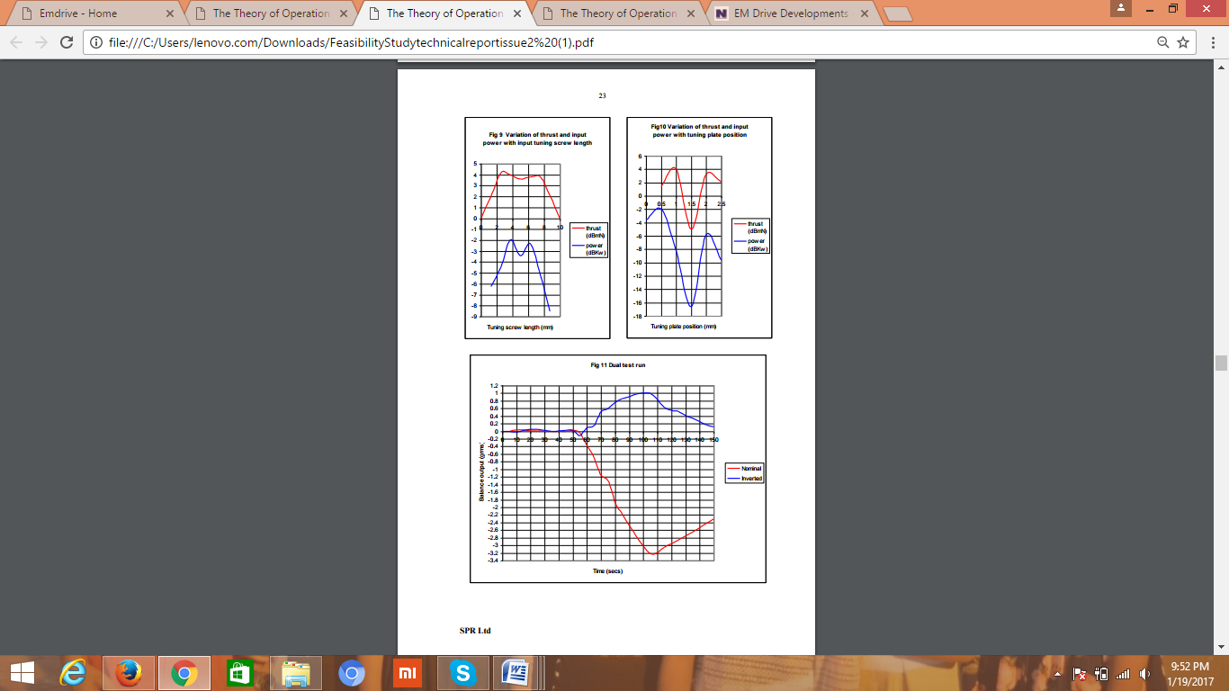

Fig.8-Variation of thrust with Electricity Intensity

VI. CONCLUSION

In the end we can conclude that though there is no theory that is completely free from any questions on its correctness, assuming the Newtonian physics and Einstein’s principles to be correct, the theory can be explained to be correct and implementable on paper.

The practical applications and benefits of such an innovation and its practical application in powering inter –space and extra-terrestrial expeditions is incredible and can revolutionize the space industry forever. This can make space a commercial field with several private players offering advanced and better facilities and technological support at better prices and quality.

The practical tests over the past couple of years have shown an exponential growth of this field with test data becoming more accurate and profound. The testing of an actual prototype in earth’s orbit can be seen as the sign of the bigger things to come in this field

REFERENCEs-

1. Hambling, David (5 November 2012). ["Propellentless Space Propulsion Research Continues"](http://aviationweek.com/awin/propellentless-space-propulsion-research-continues). [Aviation Week & Space Technology](https://en.wikipedia.org/wiki/Aviation_Week_%26_Space_Technology).
2. Hambling, David (6 February 2013). ["EmDrive: China's radical new space drive"](http://www.wired.co.uk/news/archive/2013-02/06/emdrive-and-cold-fusion). Wired UK. [Wired UK](https://en.wikipedia.org/wiki/Wired_UK).
3. ["Roger Shawyer – EM Space Drive – Articles & Patent"](http://rexresearch.com/shawyer/shawyer.htm)
4. ["EM Drive Developments, NASA spaceflight forums, discussion of Yang's 2016 paper"](https://forum.nasaspaceflight.com/index.php?topic=39772.1820). forum.nasaspaceflight.com.
5. White, Harold; March, Paul; Lawrence, James; Vera, Jerry; Sylvester, Andre; Brady, Davi; Bailey, Paul (17 November 2016). ["Measurement of Impulsive Thrust from a Closed Radio-Frequency Cavity in Vacuum"](http://arc.aiaa.org/doi/pdf/10.2514/1.B36120) (PDF). [Journal of Propulsion and Power](https://en.wikipedia.org/wiki/American_Institute_of_Aeronautics_and_Astronautics" \l "Journals). [doi](https://en.wikipedia.org/wiki/Digital_object_identifier):[10.2514/1.B36120](https://dx.doi.org/10.2514%2F1.B36120).
6. www.emdrive.com- <http://www.emdrive.com/FeasibilityStudytechnicalreportissue2.pdf>
7. <http://www.emdrive.com/reviewofexperimentalthrusterreport.pdf>
8. Propulsion Conference. [American Institute of Aeronautics and Astronautics](https://en.wikipedia.org/wiki/American_Institute_of_Aeronautics_and_Astronautics). [doi](https://en.wikipedia.org/wiki/Digital_object_identifier):[10.2514/6.2014-4029](https://dx.doi.org/10.2514%2F6.2014-4029)
9. Mary-Ann Russon (12 October 2016). ["EmDrive: Roger Shawyer is patenting a new design for next-gen superconducting thruster"](http://www.ibtimes.co.uk/emdrive-roger-shawyer-patenting-new-design-next-gen-superconducting-thruster-1585982). International Business Times.
10. [WO application 2016162676](https://patentscope.wipo.int/search/docservicepdf_pct/id00000035187289/PAMPH/WO2016162676.pdf), SHAWYER, Roger John & CARDOZO, Gilo, "Superconducting Microwave Radiation Thruster", published 2016-10-16, assigned to Satellite Propulsion Research Ltd.

.