**Artificial and Computational Intelligence**

**Assignment-6**

**Problem Statement**

Let us consider one traveling app like MakeMy trip. There are source and destination cities where the agent has to decide on which path he needs to travel. The following graph will give the cities with their time and fare. Here Start node is A and the Goal node is G.

Note that the edge value from A to B “500/3hr” represents 500 is maximum fare and 3hr is the maximum time taken to reach A to B or vice-versa.

Find the path which takes the least time to reach the destination.

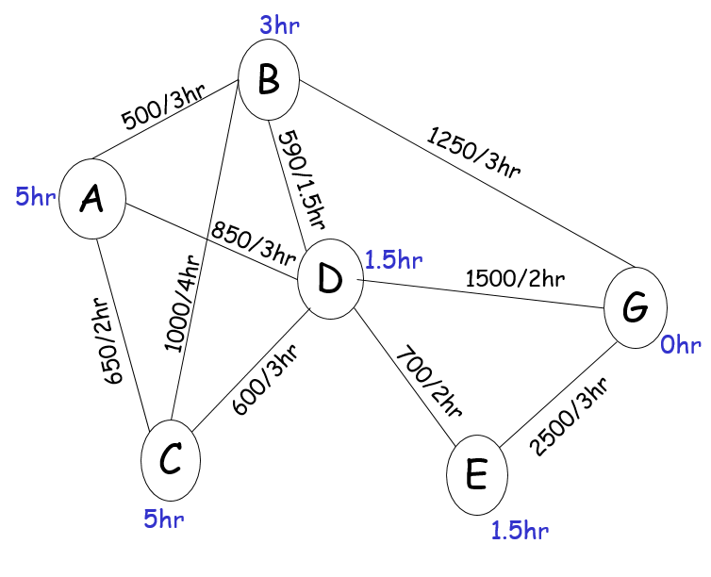

Note:

1. Explain the environment of the agent [20% weightage]
2. Find the path and cost with respect to time or fare based on the given question [60% weightage]
3. Use appropriate data structures and implement a search algorithm to find the path that the agent can visit all the cities in the graph. [20% weightage]
4. The input has to be taken from the user.

**Instructions:**

* You are provided with the python notebook/file template which stipulates the structure of code and documentation. You are free to add as many code cells as possible. Use well-intended python code.
* The implementation code must be completely original.
* Please keep your work (code, documentation) confidential. If your code is found to be plagiarized, you will be penalized severely. Parties involved in the copy will be considered equal partners and will be penalized severely.