**Importing/Indexing database/data (MySQL) in Solr; Use of Data Import Handler**

# Install Solr

Download and install Solr from <http://lucene.apache.org/solr/>.

Access to Solr admin can be made from any browser: <http://localhost:8983/solr/#/>

Default port : 8983

# MySQL connector

Download JDBC driver for MySQL from <http://dev.mysql.com/downloads/connector/j/>.

Copy file 'mysql-connector-java-*.jar' to the folder 'contrib/dataimporthandler/lib'

Note: Create 'lib' folder if needed.

# Create a new collection (Locally)

Create a new folder for a new collection – In my case it’s 'collection1'

The collection will be located in 'C:\solr-7.3.0\server\solr' folder.

Create folders conf and data in the collection folder:

* /solr/collection1/conf
* /solr/collection1/data

OR you can just ignore ‘/solr/collection1/data’. (choice)

## solrconfig.xml

Edit solrconfig.xml by simply adding path to the directories:



**IMPORTANT:** Make sure that 'dist' folder contains two files for data import handler:

* solr-dataimporthandler-7.3.0.jar
* solr-dataimporthandler-extras-7.3.0.jar

Add **RequestHandler**:

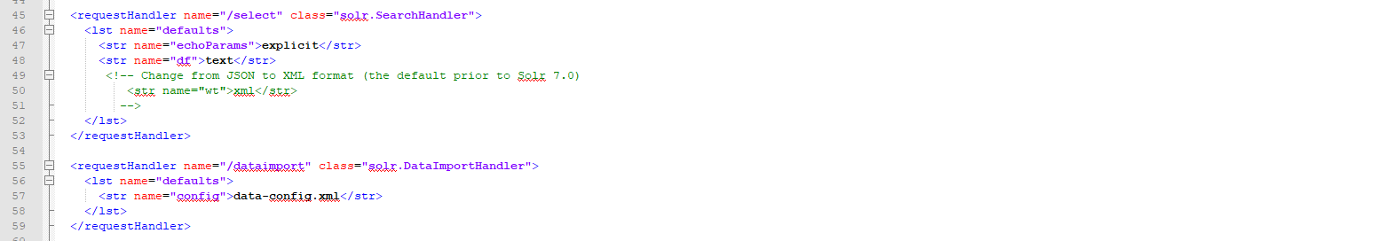

## data-config.xml for MySQL database

The file 'data-config.xml' will define data that we want to import/index from our datasource (MySql).

Assuming that our DB (schema) named test with table person with attributes ID, FNAME,LNAME and TOWN. (All varchar)

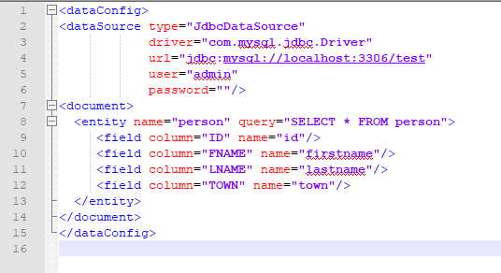

## schema.xml

Edit the file 'schema.xml' accordingly to fields defined in test schema:

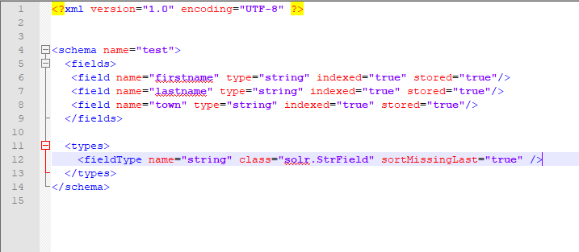

**FOR MYSQL (Test Schema):**

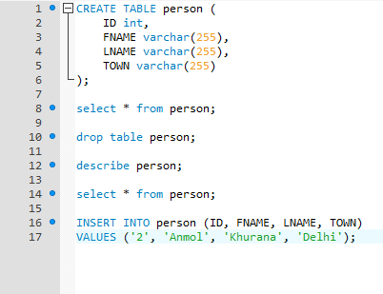

## Add collection to solr

Use admin interface in your browser to add a new collection.

Add core:

* name: collection1
* instanceDir: collection1
* dataDir: collection1

### Crawling and Searching

Now we can import data into Solr (crawl).

* To do this go to Solr URL <http://localhost:8983/solr/#/>.
* Then select collection1 as core from drop down list.
* Select dataimport from the last side menu.
* Select command "full-import" from the drop down list.
* Select 'person' from the entity drop down list.
* Click on Execute button and refresh to check status. You can see a screen like following.

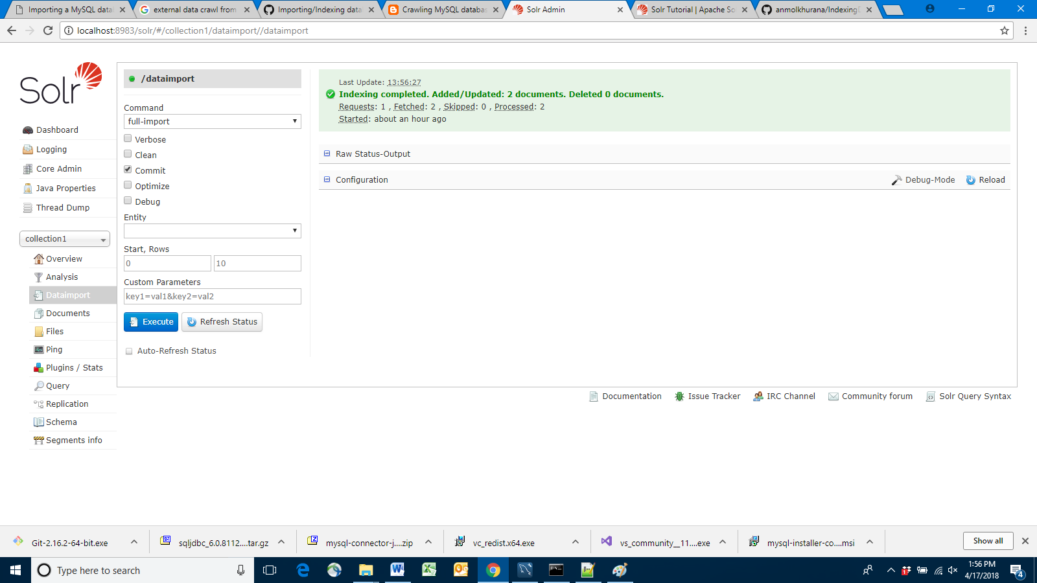

* Then go to the Solr search (click on the 'Query' item in the left hand menu)
* Give a query and do the search. You should be able to see results in output.

